# Introduction

For my twitter project, I analyzed the difference between tweets in the morning and in the night. I hypothesized that as a whole, people would have more positive tweets in the morning. I predicted that we start our day fresh and as the day goes on we can more pessimistic. This type of analysis could benefit Twitter to understand the usage patterns. It may also interest psychologists aiming to understand how our mood changes throughout the day.

# Data Collection and Analysis

I collected tweets using the Streaming API. I filtered for tweets that were within the Twin Cities, MN geographic location. I ran my tweeter-grabbing script once every hour on the hour for a duration of time minutes. This ran from 12/12/2016 8:00AM to 12/13/2016 8:00AM.

Next, I prepared the data. I added a column for the category of "morning" or "night". For this analysis, I defined morning as 5:00AM to 10:00AM and night as 4:00PM to 9:00PM. I then cleaned and processed the data by removing common words that are of little interest. Additionally, I standardized the words (e.g. "walked" and "walking" were treated as the same) Finally, I added a sentiment score. This attempts to rate where a tweet was negative or positive based on a number of criteria. The higher the score, the more positive the tweet was. Separately, I tagged the words that are nouns (e.g. "Trump" is a noun) for use in a word cloud.

As you can see from Figure 1., the boxplot is pretty similar for both morning and night. That being said, the morning did have a slightly larger range. The highest scores were slightly higher and the lower scores were slightly lower. Perhaps we have a broader range of emotions when we wake up. Some people are having good mornings and others not. It should be noted, as seen in Table 1, that the t-test did not show any *significant* difference between the scores at each time of day (p-value 0.2384).

The wordclouds for each group had unique differences. Of particular interest was the word "morning" in the morning group. I looked at the context of where the word "morning" was being used. It seemed that people start their morning with a "good morning", or a sarcastic variation such as "perfect way to start my god damn morning with a flat tire". Additionally, people talk about how their morning started such as "personally escorted to work this morning by these sun dogs". It seems as though we wake up and feel the need to share with the world. This is also supported by the fact that there is twice as many texts during the morning period as the night period.

# Conclusion

Much could be done to improve the richness of the analysis. For example, using a larger sample over many days may help show a true difference between the group. In addition, further research could benefit from looking at different geographic locations as well as different times of year.

For this analysis, I did not find a significant difference between tweets in the morning and night except perhaps for the way we start our day talking about our morning. Further research could quite possibly tease out more meaningful differences between the two groups.

*Figure 1. Boxplot of Compound Polarity Scores between Morning and Night Group*

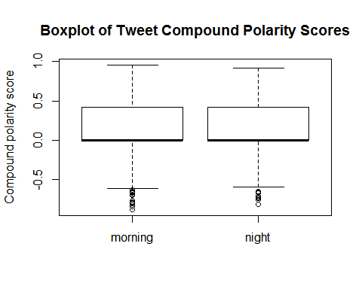

*Table 1. t-test of Compound Polarity Scores between Morning and Night Group*

##   
## Welch Two Sample t-test  
##   
## data: df$compound by df$ToD  
## t = 1.1799, df = 722.54, p-value = 0.2384  
## alternative hypothesis: true difference in means is not equal to 0  
## 95 percent confidence interval:  
## -0.01849660 0.07421052  
## sample estimates:  
## mean in group morning mean in group night   
## 0.155003 0.127146

*Figure 2. Wordcloud of Top 100 Words in the Morning Group*

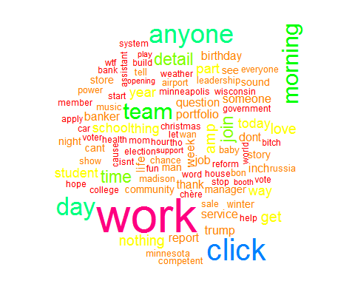

*Figure 3. Wordcloud of Top 100 Words in the Night Group*

