1. Get All Users
- Method: GET
- URL: http://localhost:5000/users
- Response Body (200 OK):
- JSON
[
{ "id": 1, "name": "Amit", "email": "amit@test.com" },
{ "id": 2, "name": "Riya", "email": "riya@test.com" }
]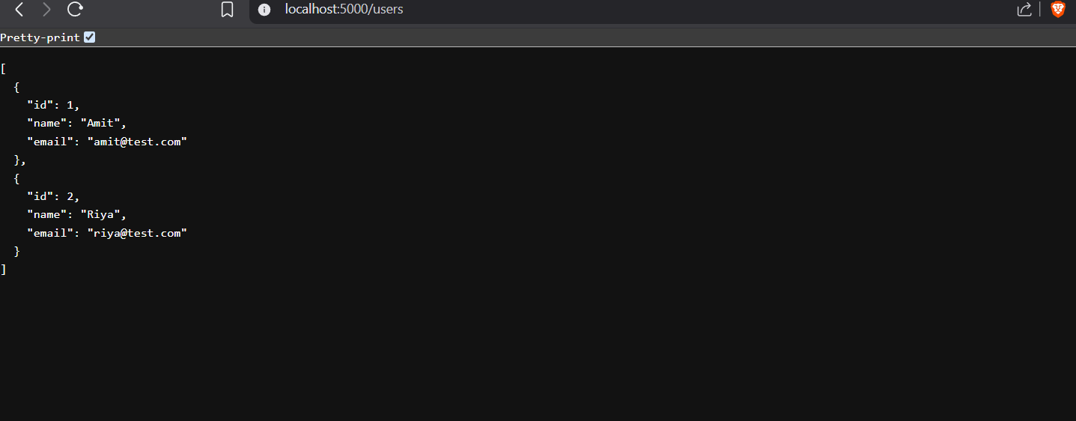

2. Get User By ID
- Method: GET
- URL: http://localhost:5000/users/1
- Response Body (200 OK):
- JSON
{ "id": 1, "name": "Amit", "email": "amit@test.com" }

- Response Body (404 Not Found if ID doesn't exist):
- JSON
{ "message": "User not found" }
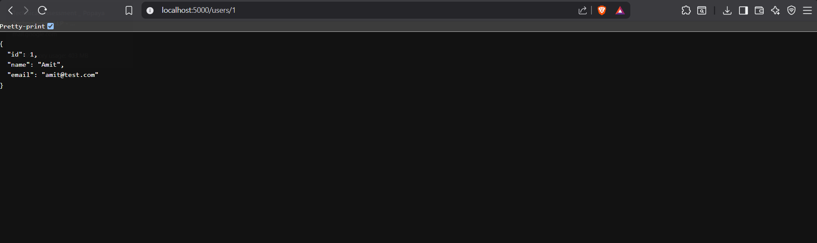

3. Get Total Notes Count
- Method: GET
- URL: http://localhost:5000/notes/count
- Response Body (200 OK):
- JSON
{ "total": 2 }
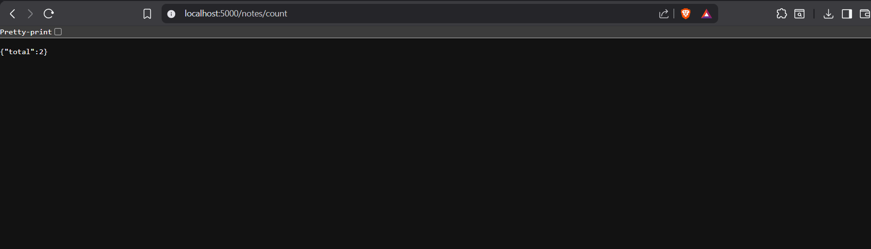

4. Fetch External Data Mockup
- Method: GET
- URL: http://localhost:5000/external-data
- Response Body (200 OK):
- JSON
{ "info": "External sample data payload" }
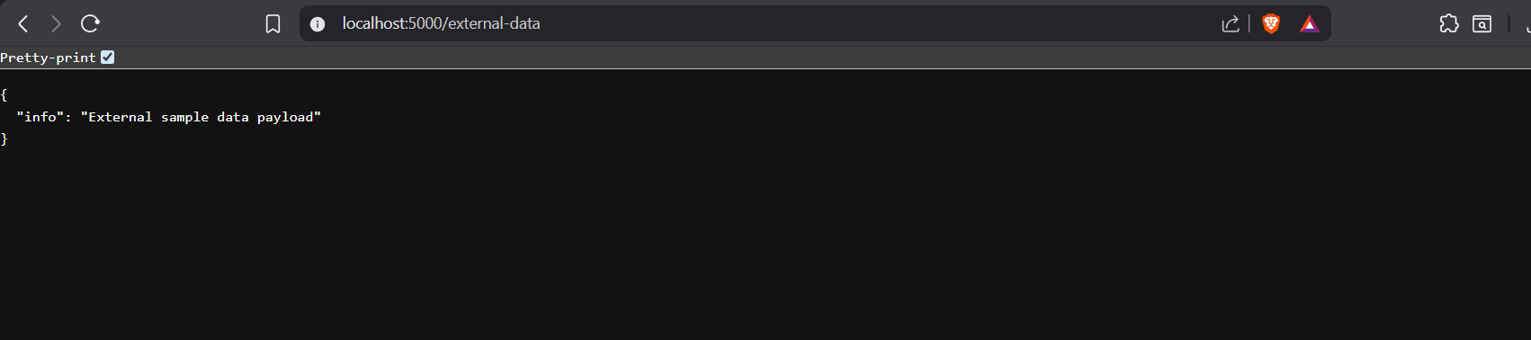

5. Get All Notes
- Method: GET
- URL: http://localhost:5000/notes
- Response Body (200 OK):
- JSON
[
{ "id": 1, "title": "Note 1", "content": "Content 1", "userId": 1 },
{ "id": 2, "title": "Note 2", "content": "Content 2", "userId": 2 }
]
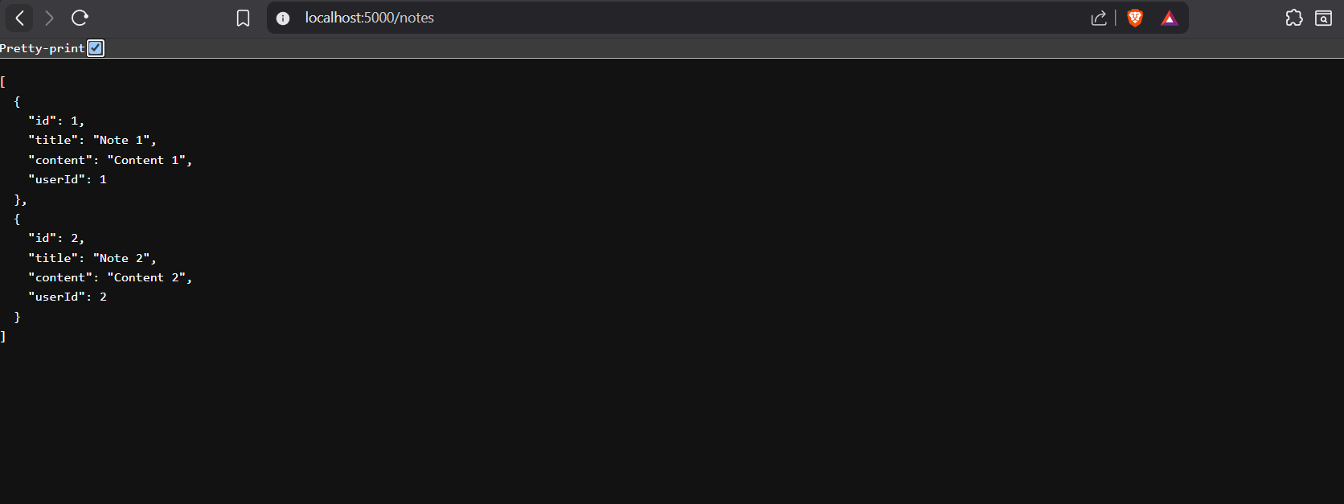

6. Create a New Note
- Method: POST
- URL: http://localhost:5000/notes
- Headers: Content-Type: application/json
- Request Body (JSON):
- JSON
{
"title": "Study Plan",
"content": "Complete fullstack core debugging assignment task.",
"userId": 1
}

- Response Body (201 Created):
- JSON
{
"id": 431,
"title": "Study Plan",
"content": "Complete fullstack core debugging assignment task.",
"userId": 1
}

- Response Body (400 Bad Request if missing fields):
- Plaintext
Invalid input: Title and content are required
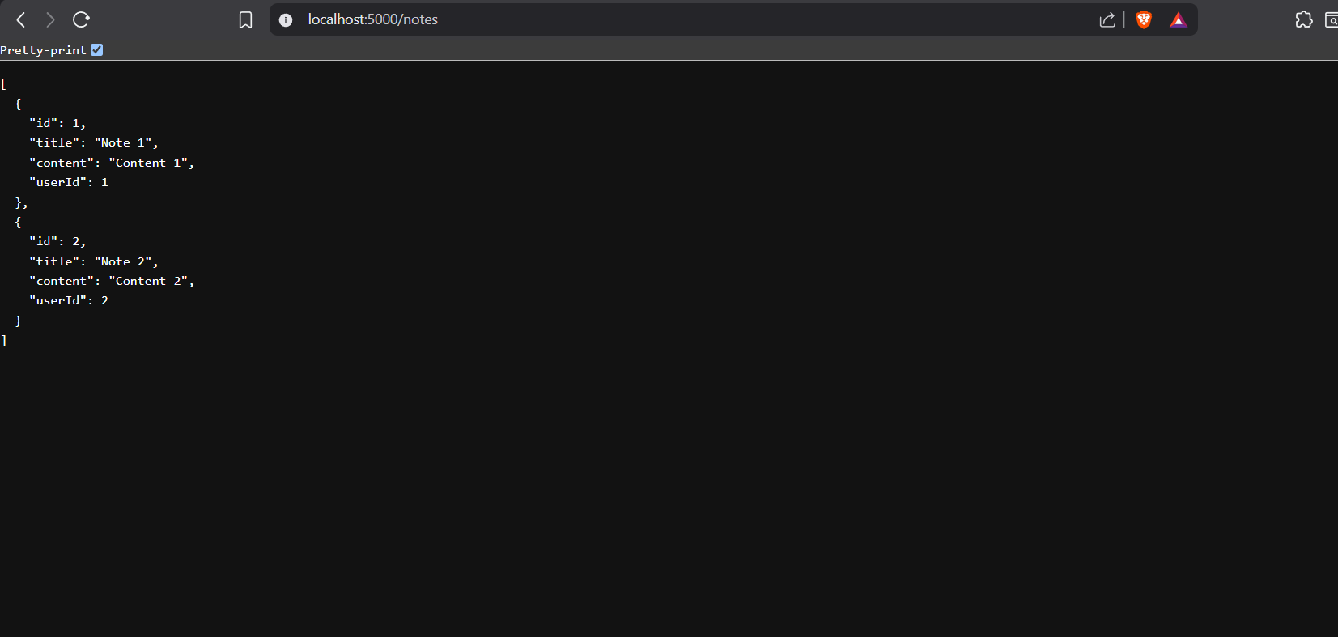

7. Delete a Note
- Method: DELETE
- URL: http://localhost:5000/notes/1
- Response Body (200 OK):
- JSON
{ "message": "Note deleted" }

- Response Body (404 Not Found):
- JSON
{ "message": "Note not found" }

8. Update User Name
- Method: PUT
- URL: http://localhost:5000/users/1
- Headers: Content-Type: application/json
- Request Body (JSON):
- JSON
{
"name": "Amit Sharma"
}

- Response Body (200 OK):
- JSON
{ "id": 1, "name": "Amit Sharma", "email": "amit@test.com" }

9. Get Notes Belonging to a Specific User
- Method: GET
- URL: http://localhost:5000/user-notes/1
- Response Body (200 OK):
- JSON
[
{ "id": 1, "title": "Note 1", "content": "Content 1", "userId": 1 }
]

10. Admin Secure Login
- Method: POST
- URL: http://localhost:5000/login
- Headers: Content-Type: application/json
- Request Body (Valid Credentials):
- JSON
{
"email": "admin@test.com",
"password": "123456"
}

- Response Body (200 OK):
- JSON
{ "message": "Login successful" }

- Response Body (401 Unauthorized if incorrect):
- JSON
{ "message": "Invalid credentials" }

11. View User Profile Name
- Method: GET
- URL: http://localhost:5000/profile/2
- Response Body (200 OK):
- Plaintext
Riya

12. Calculate Sum of Two Numbers
- Method: POST
- URL: http://localhost:5000/sum
- Headers: Content-Type: application/json
- Request Body (JSON):
- JSON
{
"a": 15,
"b": 25
}

- Response Body (200 OK):
- JSON
- { "total": 40 }

