Clearl



Life Insurance Solutions

Loans Procedure

Overview 5

Purpose 5

Product availability 5

Conditions or prerequisites 5

Section 1. General Loan Requirements and Guidelines 6

Requirements 6

Loan and Collateral Assignments 7

Guidelines 7

NIGO Items 10

Automatic Cash Loans vs Manual Checks 10

Section 2. Premiums by Loan 12

Requirements 12

Cross Loans 13

Guidelines 13

Paying Premium by Loan with Additional Funds Applied 14

POC Requests 14

Cross Loans 14

Process Work Steps for Obtaining a PLQ Quote 15

SSF 15

MRDP 15

Process Work Steps for Paying Premium by Loan in TREM 15

Process Work Steps for Paying Premium by Loan in SSF 17

Processing via the View>Quote Path 18

Processing via the Process>Trem Processes Path 19

Process Work Steps for Paying a Premium by Cross Loan 19

Process Work Steps for Paying Premiums on Multiple Policies by Loan 20

Process Work Steps for Deleting Pending Premium Loan, Cross Loan and Multiple Policy Loan Transactions 21

Deleting a Pending Transaction in TREM 21

Process Work Steps for Recalling Premium Loan, Cross Loan and Multiple Policy Loan Transactions 22

Process Work Steps for Reversing Premium Loan, Cross Loan and Multiple Policy Loan Transactions 22

Section 3. Cash Loans 23

Requirements 23

Guidelines 24

Process Work Steps for Obtaining Loan Value 27

SSF 27

MRDP 27

Process Work Steps for Automated Cash Loans in Common Monitor 27

Process Work Steps for Automated Cash Loans in SSF 28

Processing via the LVQ Button 29

Process Work Steps for Deleting/Modifying Automated Cash Loans 30

Process Work Steps for Manual Cash Loans in TREM 31

Deleting a Manual Check in CABS 32

Process Work Steps for Z-Loans 32

Process Work Steps for Loan Reversals 33

Automated Loan Checks 33

Manual Loan Checks 33

Section 4. Taxable Gain Calculations 35

Requirements 35

Guidelines 35

Process Work Steps for Approximate Taxable Gain Calculation for Loan Repayment When Withdrawing Dividends on Non-Modified Endowment Contracts 35

Process Work Steps for Taxable Gain Calculation When Withdrawing Dividends as Loan Repayment on Modified Endowment Contracts. 36

Section 5. Loan Payments 38

Requirements 38

Guidelines 38

Calculating Loan Payoff Amounts 39

Loan Repayment Effective Date 39

Full Loan Repayment via One-Time EFT 40

Calculating Policy Loan Interest (PLI) 40

Reporting Loan Interest 41

Loan Repayment Suspense and Letters Due to Overpayment 41

Process Work Steps for Loan Payments 42

Process Work Steps for Refunding Loan Overpayments 42

Section 6. Emergency Loan Procedure 44

Requirements 44

Process Work Steps for Emergency Loan Procedure 44

TREM Applied to Codes 46

Online Validation 47

Multiple Policy Loan Confirmation Letter Sample 48

Loan Check – L or B? 49

Manual Loan Interest Calculations 50

Loan Confirmation Letter 53

Multiple Policy Loan Confirmation Letter Sample 55

References 56

Procedure History 57

|  |
| --- |
| Overview This procedure applies to all service associates who process Loans on Traditional Life products. Purpose Loans can be processed if the policy contains a loan provision and there is sufficient value for the amount requested. Loan value is a percentage of a policy’s guaranteed cash value plus dividend value. A loan can be obtained from New York Life (NYL) or New York Life Insurance and Annuity Corporation (NYLIAC), using the policy as sole security, and does not have to be repaid, however loan interest is due annually. The specific criteria for processing loans are outlined in this procedure. A policy owner may request a cash loan for a specific amount, the maximum amount, a loan exclusive of dividends or a loan to pay premiums on the same or another policy or application, according to their personal preference or needs. Product availability Loans are available on the following products:  All Whole Life  Target Life  Universal Life  Loans are **not** available on Term Life products, policies on Extended Term insurance and 403(b) policies (an 02 field indicating 403B TSA Manual Tax Req will be present).  Loan requests on Variable Life Insurance (VLI) policies should be referred to VPSC for handling. Conditions or prerequisites Refer to the list of [Policy Number Ranges and Product Names](https://www.teams.newyorklife.com/Public/InsuranceGroupProcedureLibrary/Fixed/Shared%20Documents/Policy%20Number%20Ranges%20and%20Product%20Names.docx) to verify if the request is for a Traditional Life product. |
|  |
|  |

# Section 1. General Loan Requirements and Guidelines

## Requirements

* Customer Service Representatives must follow the Inforce Service & Operations (IS&O) [Verification Protocol Procedure](https://www.teams.newyorklife.com/Public/InsuranceGroupProcedureLibrary/Traditional/Shared%20Documents/TSC%20Verification%20Protocol/Verification%20Protocol%20Procedure.docx) for written correspondence.
* Customer Service Representatives must verify client callers using the Inforce Service & Operations (IS&O) [Verification Protocol Client Phone Procedure](https://www.teams.newyorklife.com/Public/InsuranceGroupProcedureLibrary/Traditional/Shared%20Documents/TSC%20Verification%20Protocol/Verification%20Protocol%20Client%20Phone%20Procedure.docx).
* CCD reviews any cases that meet AML/OFAC requirements, so there is no need to process an OFAC search.
* All foreign entity owners that NYL makes “withholdable payments” to must be compliant with FATCA regulations. If they are not, a mandatory 30% withholding will apply. (See the [FATCA Procedure](https://www.teams.newyorklife.com/Public/InsuranceGroupProcedureLibrary/Traditional/Shared%20Documents/TAX/FATCA%20Overview.docx) for further details). This withholding applies even if the disbursement is made payable to an alternate payee or collateral assignee.
  + Do not process any loan transactions involving DIV APPLIED in the TREM LOAN header, SSF Loan Repay by Div or SSFPay premium by loan screens on policies that are:
    - FATCA Non-Compliant
    - A MEC Status and/or over basis with gain
    - Have Interim Interest
  + The system will block any transaction for loans where dividends are applied and FATCA is Under Review or Non-Compliant

For more information please see the [FATCA and Loans for Traditional Policies](https://www.teams.newyorklife.com/Public/InsuranceGroupProcedureLibrary/Traditional/Shared%20Documents/Life%20Disbursements/Loans/FATCA%20and%20Loans%20for%20Traditional%20Policies.docx%20%20%20) reference

**Note:** Certain states may require that interest be paid on any late disbursement. For example, New York State requires that interest be paid starting at day 10 (business days), and six other states require interest if the disbursement is delayed 30 days or more (for specific state information, refer to the [State Statutory and Regulatory Survey on Paying Interest on Late Cash Disbursements for Life Insurance Policies](https://www.teams.newyorklife.com/Public/InsuranceGroupProcedureLibrary/Traditional/Shared%20Documents/TAX/State%20Statutory%20and%20Regulatory%20Survey%20on%20Paying%20Interest%20on%20Late%20Cash%20Disbursements%20for%20Life%20Insurance%20Policies.docx)). In these cases, consult with your manager regarding the amount of interest that is required (for NY, consult with your manager on day 9, reference the [NY York State Regulations](https://www.teams.newyorklife.com/Public/InsuranceGroupProcedureLibrary/Traditional/Shared%20Documents/Regulatory%20Compliance/New%20York%20State%20Regulations.doc) for more information). Once interest is determined to be due and the amount is calculated, a manual check must be requested, along with a Miscellaneous Loss accounting sheet, and sent to the client with a letter of explanation.

* If the policy is not paid within the current premium’s grace period a loan can be taken but if no APL on policy, NYL will hold the month’s premium. If the policy has APL, NYL will pay the premium by loan first. Except NYLAPLAN if not current, issue check manually when on NYLAPLAN, loans can be processed manually, however hold back loan value to process premiums due.

**Note**: NYL will only hold one month if its two months behind.

* For **absolute** assignments, only the assignee’s signature is required; the check will be made payable to the assignee only.
* **Please Note**: The rep will advise the agent via call or email that we need confirmation from the policyowner(s) not named on the bank account.

The rep will work with the agent to contact the client or advise the agent that we will be calling the client directly to request approval to proceed. The client’s confirmation can be taken at POC.

* **Quality Control**: Loan transactions are randomly sent to the Quality Control team for review via the normal standards. These transactions can be reviewed on a peer, supervisory, or QC level queue. All items listed on the Quality Worksheet must be correctly processed to pass the QC review.
* **Exception Processing**: Any request for exception processing from a client or agent must be presented to a Manager or Officer for review and approval. The AWF work item must show evidence of Manager or Officer Approval in AWF comments.

### Loan and Collateral Assignments

* If the policy is collaterally assigned and a loan request is received from the assignee, check AWF or DMS to determine if the collateral assignment allows the assignee to request a loan. If it does the loan check is be made payable to the assignee.
* If the policy owner is requesting a loan, one of the following must be submitted in order for the check to be made payable to the policy owner:
  + A Release of Collateral Assignment signed by the assignee
  + Authorization from the assignee (two signatures required on corporations)
* Signature requirements
  + American Bankers Association (ABA) prior to 10/01/1976: Signature of assignee **and** policy owner
  + ABA after 10/01/1976: Signature of assignee required; assignee alone can request loan. If the policy owner requests a loan, both the signature of the policy owner and assignee are required.
  + NYL: Signature of assignee **and** policy owner
* Check payees
  + ABA prior to 10/01/1976: One check payable to owner or assignee, as designated on loan request form
  + ABA after 10/01/1976: One check payable to owner or assignee, as designated on loan request form
  + NYL: One check payable to owner **and** assignee, unless otherwise designated on loan request form

## Guidelines

* For transactions in scope for Data Match, please see the [State Data Match Procedures](https://www.teams.newyorklife.com/Public/InsuranceGroupProcedureLibrary/Traditional/Shared%20Documents/Regulatory%20Compliance/State%20Data%20Match%20Procedures%20LIS.docx).
* Requests for loans can be submitted via the following:
  + In writing on form 21135PL (see [Forms Library](https://www.fts.newyorklife.com/formslibrary/individualFormsMainPage.jsp)), signed by the policy owner or authorized party (i.e., custodian, Power of Attorney, etc.)
  + Letter of instruction with appropriate signatures. ([See Signature Requirements Chart](https://www.teams.newyorklife.com/Public/InsuranceGroupProcedureLibrary/Traditional/Shared%20Documents/Regulatory%20Compliance/Signature%20Requirements.docx))
  + Point of call (POC) – up to $249,999 as an automated loan check (any amount over $250,000 up to $500,000 must be a manual loan check. Amounts $500,000 and over must be in writing.)
  + [Virtual Service Center (VSC)](https://www.vsc3.newyorklife.com/VSCRegWebApp/login?TYPE=33554432&REALMOID=06-ae0774b0-e850-1005-931f-839b2c470cb3&GUID=&SMAUTHREASON=0&METHOD=GET&SMAGENTNAME=-SM-E2ABS6DE0OajNAWQKXbTF8pnwQndwKYWxORqTL0BpoPe4rI48S9U86Gr3kv60i9IJr5I2O0eD8kF420bYcrwJr%2bgad9) Max Loan - $50,000
  + Fax (1-800-278-4117)
  + Agent request in writing or at POC (individually owned policies only)
* If a MEC, Review the owner’s Tax Withholding selection. Refer to the following references as needed to determine if there are any tax withholding considerations:
  + - [State Tax Withholding](https://www.teams.newyorklife.com/Public/InsuranceGroupProcedureLibrary/Traditional/Shared%20Documents/Life%20Disbursements/Loans/Loan%20Procedure%20Traditional.docx)
    - [Resident Alien And Foreign National Withholding Chart](https://www.teams.newyorklife.com/Public/InsuranceGroupProcedureLibrary/Traditional/Shared%20Documents/TAX/Resident%20Alien%20and%20Foreign%20National%20Tax%20Withholding%20for%20Loan%20Procedure.docx)
* Non-persons such as corporations, companies, trust, etc. or U.S. citizens living outside the United States cannot elect out of withholding.
* Federal Credit Unions are tax exempt – do not withhold unless they specifically request withholding.  For other tax-exempt organizations, review IRS website to confirm.
* Loans **cannot** be requested at POC if any of the following conditions exist:
  + If high verification was not passed by client or any disbursement over $25,000.00 and it had an address or bank change in the last 30 days.
    - If the address change was processed within 30 days but the client requests the funds be sent via Electronic Funds Transfer (EFT) into an existing valid bank account, then the loan request can be taken at POC. If the bank account was changed in the last 30 days, however the address of record has remained the same, we can mail the check to the client’s address of record.

**Note**: If there has been a recent address change on the policy but the bank information is unchanged the loan request can be processed without a signed form to the bank of record as an EFT.

* + Payment is going overseas
  + Social Security number (SSN) of the recipient (owner of record) is not valid
  + Policy is less than 90 days old
  + Request is for an alternate payee
  + The policy contains an assignment
  + The policy is trust or corporate owned
  + The policy has multiple owners
  + If the policy has a taxable gain and is a MEC
  + The requested amount is over $449,999
  + Loans are not permitted on 403B pension plans, 412I Pension Plans- refer to policy contract on P8 policies to determine if the Plan allows for loans
* Loan amount limitations
  + Maximum: Policy owners can borrow any amount up to the loan value of the policy. Minimum: There is no minimum loan amount.
* Types of loans
  + Cash Loan: Owner requests a specific amount.
  + Maximum Loan: Owner borrows full amount available as of effective date of request.
  + Loan exclusive of dividends
  + Loan to pay premiums on the same or another policy or application
* Effects of loans
  + Loans are not taxable events **except if** the policy is a Modified Endowment Contract (MEC). If a policy is a MEC, a loan may result in taxable income if there is a taxable gain on the policy. If there is gain, the lesser of the gain or the payment becomes taxable. A signed request is required only if a gain exists in the policy. See the [FATCA Procedure](https://www.teams.newyorklife.com/Public/InsuranceGroupProcedureLibrary/Traditional/Shared%20Documents/TAX/FATCA%20Overview.docx) for details regarding withholding for foreign entity policy owners).
  + A loan will affect the cash surrender value of the policy and its policy proceeds. If the policy is surrendered, if the policy terminates, or if a Life Insurance Benefit becomes payable under the policy, any outstanding loans (including any accrued loan interest) will be deducted from the cash value of the policy or the Life Insurance Benefit that is paid.
* The interest rate is either a variable or a fixed rate, which is outlined in the policy contract, and may be billed in advance or in arrears.
* An amount equal to the loan interest from the effective date of the loan up to the next anniversary will be held back when the net loan value is calculated.
* The loan agreement is printed on the front of loan checks for which we do not have a loan agreement. Automated loan transactions have a place for the CSR to indicate L (no loan agreement received) or B (loan agreement received) for loan agreement to be stamped on check or blank check. See appendix Loan Check – L or B to determine what code to use.
* All manual checks print without a loan agreement, however, check signers must stamp the loan agreement on loan checks without a loan agreement on file. (A separate loan agreement may be required in some cases, such as policies with multiple owners, loans for more than $499,999.00, corporate- and trust-owned policies, policies with collateral assignments, etc.).
* Loans can be paid to the policy owner via the following methods:
  + If nothing is specified on the request, a check is sent to the address on record.
  + A check can be sent to an alternate payee, but it must be made payable for the benefit of (FBO) the policy owner. **Exception:** If there is a collateral assignment on the policy and a loan is processed, the check is made payable to **both** the assignee and the policy owner (if they both signed the loan request).
  + A check can be sent via overnight mail, if the client provides their UPS account information and more is being done as an exception to prevent a compliant.
  + A check can be mailed to the client’s bank to be directly deposited into their bank account.
  + Electronic Funds Transfer (EFT), providing the policy has an existing Check-O-Matic arrangement on record.
    - The payor on the bank account must be the policy owner.
    - EFT is available for policies owned by corporations or trusts as long as the payor information matches the policy owner information.
* If the client has requested a change of address, in addition to the loan, the address change must be processed first.
* Confirmation Statements
  + EFT/Third Party Loans, Premium Paid by Loan or Loan Repayments automatically generate a confirmation statement when the transaction is processed.
  + Automated cash loan checks have the confirmation statement on the check stub.
  + The current loan interest rate is given in each of these confirmation statements.
* Loans are available on policies that have cash value. For Traditional policies, the effective date of the loan is the date the transaction is processed.
* Interest is charged on every policy loan issued by NYL or NYLIAC. The interest charge begins on the effective date of the loan and is billed annually on the policy anniversary date. In addition, each time a loan is increased, interest is brought up to date on the previous (smaller) loan before the new (larger) loan is recorded, to prevent overcharging.

### NIGO Items

If a request is received that appears to be Not in Good Order (NIGO), refer to the [NIGO Procedure](https://www.teams.newyorklife.com/Public/InsuranceGroupProcedureLibrary/Traditional/Shared%20Documents/General/NIGO%20Procedure.docx)

**Note**: If at a later date the complete requirements are received in good order, the loan will be processed as of the later date.

### Automatic Cash Loans vs Manual Checks

* Whenever possible, issue automated loan checks. Manual checks should be processed only in extenuating circumstances and not as an everyday practice.
* Benefits of automatic cash loans
  + The amount of an automated loan check will never create an overpaid loan
  + The check is printed and mailed from New Jersey so there is no Service Center staff involvement in these areas.
  + When a manual check must be issued due to a technical requirement or if the check is being sent via overnight mail or with a special cover letter, it must be processed through TREM/LOAN (refer to Process Work Steps for Manual Cash Loans in TREM in Section 3. Cash Loans for processing information).

# 

# Section 2. Premiums by Loan

## Requirements

Refer to Section 1. General Loan Requirements and Guidelines, along with the additional requirements below.

* Premium Loans are loans made on a policy to pay the premium due.
* The policy owner or the agent can request a premium loan.
* Requests to pay premium by loan must be submitted on signed form 21135PL (see [Forms Library](https://www.fts.newyorklife.com/formslibrary/individualFormsMainPage.jsp)) in the following situations:
  + The policy has a gain. (MEC status on a policy only requires a form if there is a gain and the policy is not individually owned)
    - On individually owned policies, the policy owner may take a loan on a MEC policy, with a taxable gain at point of call.
      * The policy owner has the option to change their withholding election at point of call for policies with a taxable gain.
  + The policy is collaterally assigned.
  + The policy is owned by one of the following:
    - Corporation
    - Trust
    - Multiple owners

**Note:** For corporate- or trust-owned policies, signatures should be accompanied by the proper title (i.e., President, Trustee, etc.). If a title is not present, review our records to determine whose signature is on the form. If you can determine it is a company officer or trustee, the request can be processed.

* Processing a cross loan to another policy if the policy owners are different.
* If the above conditions do not exist, requests to pay premium by loan can be submitted via the following methods:
  + Signed form 21135PL (see [Forms Library](https://www.fts.newyorklife.com/formslibrary/individualFormsMainPage.jsp)) signed by the policy owner or authorized party (i.e., custodian, Power of Attorney, etc.)
  + Letter of instruction with the appropriate signatures. ([See Signature Requirements Chart](https://www.teams.newyorklife.com/Public/InsuranceGroupProcedureLibrary/Traditional/Shared%20Documents/Regulatory%20Compliance/Signature%20Requirements.docx))
  + Fax (1-800-278-4117)
  + Agent request in writing or at POC (individually owned policies only)
  + Client POC Request (individually owned policies only)
* If a corporate- or trust-owned policy contains an APL provision and there is enough value, a verbal authorization at POC is allowed. A corporate officer or trust must give the verbal authorization. Standard [Verification Protocol Procedure](https://www.teams.newyorklife.com/Public/InsuranceGroupProcedureLibrary/Traditional/Shared%20Documents/Verification%20Protocol%20Procedure.doc) still applies. Should the request be received in writing and meets the criteria noted above, one signature with title is acceptable.
* Target Life and Term Life policies **cannot** be paid by loan.

### Cross Loans

* Borrowing from the cash value of one policy to pay a premium or do a loan repayment on another policy.
* A request for a cross loan with different owners must be submitted in writing with the appropriate signatures.
* The premium paid-to date on the policy from which you are borrowing must be within the grace period.
* SSF cannot be used for cross loans.

## Guidelines

Refer to Section 1. General Loan Requirements and Guidelines, along with the additional guidelines below.

* The loan value for a premium loan is the cash value, including the anticipated value to the end of the premium period being paid by the loan, plus dividends less any outstanding loan and accrued interest. Enough value is held back (discounted) to cover interest to the next anniversary.
* Policy owners may borrow against this current and anticipated cash value of their policy to pay premium and loan interest.
* Types of manual premium loans:
  + Straight premium loan: Pays one model premium
  + Balance loan: Pays to a particular date
  + Cross loan: Borrows from one policy to pay an amount due on another policy

**Note:**  If there is an existing loan on the policy, loan interest will be brought up to date each time the loan balance is increased.

* Obtain a premium loan quote (PLQ) in MRDP under the PLQ screen or in SSF under Quotes/Premium Loan.
* A PLQ includes loan interest due and any dividends in suspense.
* A PLQ ordered in the grace period may differ from a PLQ ordered outside the grace period for the following reasons:
  + If the request to pay a premium by loan is made **in** the **grace period**, interest on the new loan will start at the end of the grace period, resulting in less interest being charged for the year.
  + If the request is made **after the grace period**, interest on the new loan will start on the premium due date, resulting in more interest being charged for the year.
* Premium loan value may pay the entire amount due but, if not, the PLQ will advise how much money is needed out of pocket. The short amount, or “cash required,” will show in “CASH RQ” on the PLQ screen in MRDP, or in “MIN CASH REQUIRED” on the Premium Loan Quote screen in SSF. The cash required amount **must** be met.
* Target Life, Universal Life and Term premiums cannot be paid by loan from itself.
* A PLQ request can also be used to pay a premium on a new mode by paying a balance premium.
  + Using the same quote screen in SSF, add the date to which the premium is being paid to in the Premium Loan Calc Dt field. Then click Calculate.
* A premium can be paid by Automatic Premium Loan (APL). If elected, APL provides an automatic loan, which pays an overdue premium at the end of the grace period, subject to two conditions:
  + The loan value is sufficient to pay that premium
  + The maximum number of APLs has not been reached. To reset the provision, a premium must be paid manually by loan or by some other means.
* If the policy is on Check-O-Matic (COM) mode, the premium by loan has to be paid by using a linking screen as if it were a cross loan (no signed form necessary).
* The policy owner can submit more than the cash required as long as it does not equal or exceed the net due amount.
* If a check is received with the request to pay by loan, the check amount goes into the “funds applied/refund” field.
* If a dividend is to be applied from the same policy, the amount being taken is input into both the “funds applied/refund’ and “dividend applied” fields. The amount of dividend used must be less than or equal to the amount in the DIV field on the PLQ screen.
* Dividends from another policy can be used as the total cash required or in combination with money submitted by the policy owner.
* A ‘G’ trigger is needed when processing a mode change.
* The amount of loan value available after paying the premium is located in the ADL VAL field on the PLQ screen in MRDP or in the “ADDITIONAL VALUE” field on the Premium Loan Quote screen in SSF. This shows how much value will remain once the premium is paid by loan.

### Paying Premium by Loan with Additional Funds Applied

* If there is cash required, that amount must be paid. The policy owner may submit additional funds to pay a premium by loan, but if there is cash required, the amount sent in must be greater than or equal to the cash required. **The cash required cannot come from the MAX DIV field of the policy itself.**

### POC Requests

* See [Point of Call Loans Procedures](https://www.teams.newyorklife.com/Public/InsuranceGroupProcedureLibrary/Traditional/Shared%20Documents/Call%20Center/TSC%20POC%20Loans.docx)

### Cross Loans

* The following steps must be taken before processing a cross loan:
  + Review the Loan Value Quote (LVQ) screen in MRDP or SSF on the policy from which you are borrowing to make sure the maximum loan available (found in the MAX LN field) is enough to pay the other policy. If it is not, the additional funds must come from another source such as the value in another policy or the policy owner sending a check for the difference.
  + Check the 02 field/warning screens in MRDP or SSF for any warning(s) that may prevent a loan from being processed.
  + Check for any pending transactions or prior requests in MRDP or SSF

## Process Work Steps for Obtaining a PLQ Quote

### SSF

* Log into SSF
* Enter the Policy Number
* Click on View, Quotes, Premium Loan
* In the field Min Cash Required is the amount that is required to pay the premium by loan
* To obtain the amount required if there is a mode change being requested, also input the Premium Loan Calc Dt field with the date premiums will be paid to after the mode change
* See [FATCA and Loans for Traditional Policies](https://www.teams.newyorklife.com/Public/InsuranceGroupProcedureLibrary/Traditional/Shared%20Documents/Life%20Disbursements/Loans/FATCA%20and%20Loans%20for%20Traditional%20Policies.docx%20%20%20) reference for details pertaining to FATCA

### MRDP

* Log into MRDP
* Enter PLQ in the Response field, the policy number in the PL field and your initials in the INIT field and enter
* The CASH RQ field will populate with the amount that is required to pay the premium by loan
* See [FATCA and Loans for Traditional Policies](https://www.teams.newyorklife.com/Public/InsuranceGroupProcedureLibrary/Traditional/Shared%20Documents/Life%20Disbursements/Loans/FATCA%20and%20Loans%20for%20Traditional%20Policies.docx%20%20%20) reference for details pertaining to FATCA

## Process Work Steps for Paying Premium by Loan in TREM

1. Open PrmPyDivLN item in AWF (or create a PrmPyDivLn item if processing request at POC)
2. Review the Loan Request to confirm it contains the following requirements:
   1. Request submitted through the proper channel (i.e., form 21135PL, POC, etc.). (See Requirements in this section for details.)
   2. Policy number
   3. Type of loan
   4. Amount of loan, if necessary
   5. Appropriate signature(s) (See Requirements in this section for details.)
3. If any requirements are missing, follow the [NIGO Procedure](https://www.teams.newyorklife.com/Public/InsuranceGroupProcedureLibrary/Traditional/Shared%20Documents/General/NIGO%20Procedure.docx).
4. If the request includes an address change in addition to the loan request, take the following steps:
   1. Create an AWF address change work item, process the address and closed this work object with the appropriate business type.
      1. If you cannot process the address change, indicate in the comments that an address change must be processed before a loan can be processed so the check and/or confirmation statement will be sent to the correct address.
      2. Escalate the item by changing the priority to “Elevated” in the Override Assignment/Priority section of the item so that the AWF item can be processed timely.
   2. Click Create.
   3. Place the loan AWF item in the follow-up queue for 2 business days.
   4. Once the address has been updated, proceed to step 5.
5. Obtain a PLQ quote
6. Log in to TREM in Common Monitor.
7. Access the LOAN screen and complete the following fields if no additional money received:

|  |  |
| --- | --- |
| **Field** | **Input** |
| POLNO | Policy number |
| SURN | First three letters of client’s last name |
| TRANS CD | For loan increase, input MH |
| Mode | Mode on record or mode being changed to |
| EFF/NGCK DT | Date request processed |
| RATE | L = Paying PLI only  6 = Paying more than billed (balance or proportionate amount)  N= Paying a premium on a COM mode |
| DUDT | Date premium is due |
| ANTIC PDDT | Date premiums will be paid to once the transaction updates if using a 6 mode |

**Note:** You do not need to input the premium amount. The system will determine what needs to be added to the loan and will adjust the loan interest paid-to date accordingly.

1. If client is using funds from another source to offset the total amount of the loan, the following additional fields need to be completed:

|  |  |
| --- | --- |
| **Field** | **Input** |
| FUNDS APPLIED/REFUND | Total amount of funds applied from other sources (Check + Dividends). This amount cannot excess the net due amount on the PLQ. |
| DIV APPLIED | Total dividends applied from same policy |
| OFFSET FIELDS | Enter ‘b’ and the check amount in CABS suspense |

**Note:** When processing in TREM, the FUNDS APPLIED/REFUND and DIV APPLIED fields are completed **only** if additional funds (check or dividend) are being used. Only use the DIV APPLIED field on the LOAN screen if the dividends are coming from the same policy. If they are coming from a different policy, you will need to link it to a DIVD screen by typing DIVD in the Next Function field on the TREM screen. Once in the DIVD screen, complete the following fields:

|  |  |
| --- | --- |
| **Field** | **Input** |
| POL NO | Policy number |
| SURN | First three letters of client’s last name |
| TRANS CD | LC (for dividend withdrawal) |
| DIV APPLIED | Amount of dividends being applied to the other policy |
| DIVD APPLIED TO | ‘D’ followed by the policy number that dividends are being applied to |

**Note:** MH transactions using dividends will not be allowed if FATCA is Non-Compliant or Under Review (N or U) see [FATCA and Loans for Traditional Policies](https://www.teams.newyorklife.com/Public/InsuranceGroupProcedureLibrary/Traditional/Shared%20Documents/Life%20Disbursements/Loans/FATCA%20and%20Loans%20for%20Traditional%20Policies.docx) for more details.

**Funds applied must equal the total amount being paid (cash + dividends).** If only dividends are being used, the FUNDS APPLIED/REFUND field and DIV APPLIED field will be the same amount.

1. Hit F5.
2. Update comments in the AWF item and close the item under the Loan value Business Type. (A confirmation letter is automatically generated and mailed to the client; see sample).

## Process Work Steps for Paying Premium by Loan in SSF

1. SSF can only be used for a premium being paid completely by loan or a premium being paid by loan and dividends on the same policy.
   1. Additional funds cannot be accounted for through SSF. A request with additional funds must be reported through the TREM LOAN path.
2. Follow steps 1 through 5 for Process Work Steps for Paying Premium by Loan in TREM.
3. If request is from a POC, open AWF Create Work Object window.
   1. Input the policy number and click on the Add button or hit Enter (the full name of the insured will pre-fill. Choose Loans from the Work Type drop-down.
4. Log in to SSF. There are two ways to process premium loan transactions in SSF (both paths will lead to the same processing screen):
   1. Via View>Quote>Premium
   2. Via Process>Trem Processes

**Note**: See [FATCA and Loans for Traditional Policies](https://www.teams.newyorklife.com/Public/InsuranceGroupProcedureLibrary/Traditional/Shared%20Documents/Life%20Disbursements/Loans/FATCA%20and%20Loans%20for%20Traditional%20Policies.docx) reference for details regarding FATCA Withholding.

### Processing via the View>Quote Path

1. Enter the policy number on the Primary screen and hit Enter.
2. Click on View in the menu bar at the top of the next screen.
3. Click Quotes then choose Premium Loan.
4. If a pop-up message window appears, review the message(s) then click OK to view the Premium Loan information.

**Note:** MH transactions using dividends will not be allowed if FATCA is Non-Compliant or Under Review (N or U) see [FATCA and Loans for Traditional Policies](https://www.teams.newyorklife.com/Public/InsuranceGroupProcedureLibrary/Traditional/Shared%20Documents/Life%20Disbursements/Loans/FATCA%20and%20Loans%20for%20Traditional%20Policies.docx%20%20%20) for more details

**Note:** If there is an amount in the Min Cash Required field, that amount needs to come from outside this policy.

1. If the Min Cash Required field shows 0.00 and there is an amount in the Dividend Amount field these dividends are available to use as Funds Applied.
   1. The amount input into the Funds Applied cannot exceed the net amount due.
2. Click on Trem Processes at the bottom of the screen which may bring up the Verification screen.
3. Click Continue to close the Verification screen and be presented with the Processing screen.
4. Click on the Pay Prem By Loan tab at the top of the Processes screen.

**Note:** Be sure to click on the appropriate tab for your transaction as there are multiple transactions which can be performed from this tab.

1. SSF will pre-fill most of the information needed to process a Premium Loan transaction. Check the information for accuracy and input any additional information needed.
   1. Select the applicable transaction code from the Trans Code menu.
   2. Complete any necessary information (Div Applied Amt, etc.)
2. Click on the PayByLoan button at the bottom of the screen.
3. You will receive a pop-up window stating, “Your transaction is being processed.” Click OK.
4. Click Cancel to return to the Standard screen and then click ok.
5. Input details of the loan transaction in the AWF Comments field.
6. In the Action box, select Complete for File then Loans and click Submit.

### Processing via the Process>Trem Processes Path

1. Enter the policy number on the Primary screen and hit Enter.
2. Click on Process in the menu bar at the top of the next screen then choose Trem Processes.
3. Follow steps 7 through 14 above for Processing via the View>Quote Path.

## Process Work Steps for Paying a Premium by Cross Loan

1. Open PrmPyDivLn item in AWF (or create a PrmPyDivLn item if processing request at POC)
2. Review the Loan Request to confirm it contains the following requirements:
   1. Request submitted in writing
   2. Policy number
   3. Type of loan
   4. Amount of loan, if necessary
   5. Appropriate signatures (See Requirements in this section for details.)
3. If any requirements are missing, follow the [NIGO Procedure](https://www.teams.newyorklife.com/Public/InsuranceGroupProcedureLibrary/Traditional/Shared%20Documents/General/NIGO%20Procedure.docx).
4. If the request includes an address change in addition to the loan request, refer to step 4 under Process Work Steps for Paying Premium by Loan in TREM.
5. Log in to TREM
6. Access the LOAN screen and complete the following fields:

|  |  |
| --- | --- |
| **Field** | **Input** |
| POLNO | Policy number the loan is being taken from |
| SURN | First three letters of client’s last name |
| TRANS CODE | MH = Loan increase |
| EFF/NGCK DT | Today’s date, which should match the account date |
| LOAN AMT | Amount being borrowed |
| LOAN APPLIED TO | Appropriate code (C or D) followed by the policy number to which funds are being applied followed by the first three letters of the client’s last name (for example, C 12345678 doe)  C = Proceeds applied to premium payment, policy loan interest or balance due on same policy  D = Proceeds applied to premium payment, PLI, Loan or balance due on another policy  M = loan value being applied to multiple polices. See work process below.  (For further information on these codes, see TREM Applied to Codes in the References section.) |
| NEXT FUNCTION (links this screen to the screen on which you are applying the funds) | NPAB (for premium payment) or LOAN (for loan repayment), depending on the type of payment requested |

**Note:** With a cross loan, the RATE and DUDT fields are left blank on the policy from which you are borrowing.

**Note:** MH transactions using dividends will not be allowed if FATCA is Non-Compliant or Under Review (N or U) see [FATCA and Loans for Traditional Policies](https://www.teams.newyorklife.com/Public/InsuranceGroupProcedureLibrary/Traditional/Shared%20Documents/Life%20Disbursements/Loans/FATCA%20and%20Loans%20for%20Traditional%20Policies.docx) for more details.

1. Hit F5.
2. Update comments in the AWF item and close the item under the Loan Value Business Type. (A confirmation letter is automatically generated and mailed to the client; see sample).

## Process Work Steps for Paying Premiums on Multiple Policies by Loan

1. Follow steps 1 through 5 for Process Work Steps for Paying Premium by Cross Loans above.
2. Access the LOAN screen and complete the following fields:

|  |  |
| --- | --- |
| **Field** | **Input** |
| POLNO | Policy number |
| SURN | First three letters of client’s last name |
| TRANS CODE | For loan increase, input MH |
| EFF/NGCK DT | Today’s date, which should match the account date |
| LOAN AMT | Amount being borrowed |
| LOAN APPLIED TO | M, for multiple policies, followed by the policy number to which funds are being applied followed by the first three letters of the client’s last name (for example, M 12345678 doe)  (For further information on these codes, see TREM Applied to Codes in the References section.) |

**Note:** The ‘M’ code is only used when a loan transaction is being applied to more than one additional policy. If a loan transaction is being applied to only one other contract, do not use the ‘M’ code; use one of the other codes as applicable.

1. Hit Enter to go to the secondary screen (the policy number and surname entered on the Loan screen will be carried over from the primary screen as protected fields in the appropriate fields).
2. Under LOAN APPLIED TO, the policy number and first three letters of the client’s last name entered on the primary page will appear on the first line. Proceed to manually enter all policy numbers (up to 9) in the remaining available lines.

**Note:** If the transaction involves more than 10 policies, you must complete this transaction first and perform additional TREM entries.

1. Hit Enter.
2. The first three letters of the owner’s surname(s) will be display as protected. Verify these names to confirm you have entered the correct policy number(s).
   1. If any changes are needed, press F4 to cancel the current screen and revert to page 1. (F6 will also return you to page 1 to make adjustments but it will not cancel the transaction.)
   2. If no changes are needed, press F5 to validate and accept the information entered on this screen. You will be taken back to the primary LOAN screen.

**Note:** It imperative that the correct policy numbers are input on the second screen. There is no verification to the linked transactions so if a policy number is incorrect, the system-generated correspondence will also display the incorrect number.

1. In the NEXT FUNCTION field, input NPAB or LOAN, depending on the method of payment requested (NPAB – applies the payment premium; LOAN – where CSR takes the loan).
2. Press F5 to balance and complete the transaction.
3. Update comments in the AWF item and close the item under the Loan Value Business Type. (A confirmation letter is automatically generated and mailed to the client; see sample in the References section. This confirmation will contain all of the policies numbers you entered on the secondary screen.)

## Process Work Steps for Deleting Pending Premium Loan, Cross Loan and Multiple Policy Loan Transactions

**Note:** Since a TREM transaction does not stay in its initial application, you must go to CABS if you need to delete a **pending** TREM entry. If the transaction has already updated, you must reverse it.

### Deleting a Pending Transaction in TREM

1. Log into CABS.
2. Type 10 in the SELECTION field on the main menu and hit Enter.
3. Type 14 on the next screen and hit Enter.
4. On the next screen, in the REFERENCE TYPE/NUMBER field, enter p/policy number and hit Enter.
5. On the next screen, find the pending loan transaction (based on account date and audit code) and input a ‘D’ in the SEL field preceding the transaction to be deleted.
6. Hit Enter.
7. Type ‘Y’ in the prompt at the bottom of the screen to delete the transaction (typing ‘N’ will bypass delete) and hit Enter. (When the transaction disappears, and you are back at the common inquiries menu (10), your transaction has been deleted).
8. Create and close Remit Corr (work type) AWF work item with the business type payment reverse. If necessary, send item to follow up queue for additional processing. A confirmation letter is will be generated once the reversal is processed.

## Process Work Steps for Recalling Premium Loan, Cross Loan and Multiple Policy Loan Transactions

1. Log in to Common Monitor and type RREM in Rumba. (Transactions can be reviewed by policy number or batch.)
2. When the LOAN screen is presented, hit Enter to view the secondary screen.

**Note:** No modifications or deletions can be processed through RREM. If you need to make an adjustment, you must recall the transaction in CABS, delete it and its link entries, if any, and reprocess.

## Process Work Steps for Reversing Premium Loan, Cross Loan and Multiple Policy Loan Transactions

1. If there have been no subsequent loan transactions, reverse the entry through CABS and reverse the due date and paid-to date in TREM/REVL.
2. If there have been subsequent loan transactions, the case must be referred for a manual loan adjustment via a 1739.

# Section 3. Cash Loans

## Requirements

Refer to Section 1. General Loan Requirements and Guidelines, along with the additional requirements below.

* Always view current policy information.
* Check premium paid-to date on whole life policies; the premium must be paid within the grace period.
  + If the premium is more than 31 days past due, and does not have the APL provision, pay the premium by loan then, the next day, send out the remaining loan balance. If the policy has the APL provision, hold back enough to cover the premium(s) due and issue the loan for the amount available less the premium(s) due or the requested amount, if less.
* A policy on a NYL-A-Plan mode can have a loan taken if outside the grace period, but the loan check must be manual and the value of the premium to bring within the grace period will be withheld.
* If the current year’s dividend is on the record and premiums are paid to date but not paid to the anniversary, deduct the current dividend.
* Review for a Change Pending Indicator (CPI) present on record to determine if any other actions are required.
* The CSR must verbally provide the loan interest rate to the owner at POC for both cash and premium loans. If the request is from the agent, the CSR must inform the agent that they must provide the owner with the interest rate. A notation must be added to the AWF POC work item indicating the interest rate was given to the client or if the agent was told to inform the client of the loan interest rate.
* Tax Withholding Requirements
  + The client may now take a loan on a MEC policy, with a taxable gain, via phone or with a signed tax withholding section of the appropriate form.
    - When processing by phone the CSR must notify the client of their current withholding election and offer the opportunity to change it.
  + When request is made by phone the client must verbally confirm the withholding election.
  + If tax withholding is not indicated on a received form check the DVQ or LVQ screens in MRDP or SSF to determine if an election is already on record.
    - If the policy has a listed election we will use that election when processing the request.
    - If there is no election listed the CSR must attempt to contact the client.
      * If a phone number is provided, the CSR should attempt to call the client
        + If the client does not answer and a message is left for a return the call the CSR will suspend the item for two days.
        + If no return call is received when the item unsuspends the CSR will return the item as NIGO with a request to select a withholding election.
      * If no phone number is provided the CSR will return the item as NIGO with a request to select a withholding election.
        + When completing the NIGO letter advise the client they may contact us through the toll-free number to select a withholding election.

## Guidelines

Refer to Section 1. General Loan Requirements and Guidelines, along with the additional guidelines below.

* Requests for a cash loans must be submitted on signed form 21135PL (see [Forms Library](https://www.fts.newyorklife.com/formslibrary/individualFormsMainPage.jsp)) or as a written request (see Verification Protocol Procedure) in the following situations:
  + The loan is being sent to a temporary address.
  + The policy is collaterally assigned.
  + Power of Attorney or Custodian (Must have paperwork on file)
  + The loan proceeds are being transferred to a bank.
  + The policy is owned by one of the following:
    - Corporation
    - Trust
    - Multiple owners

**Note:** For **corporate-owned** policies, the signatures of two officers, accompanied by their title, are required. (If it is a sole proprietor, this must be indicated with the signature.) One check is issued. For **trust-owned** polices, the trustee(s) must include the title of “Trustee” with their signature(s). If a title is not included, review our records to determine whose signature is on the form. If you can determine it is a company officer or trustee, the request can be processed. One check is issued to the trust. For **Multiple Owners,** all owners must sign the request. One check is issued to all the owners.

* + The loan request is $500,000 or over.
* If the above conditions do not exist, requests for cash loans can be submitted via the following methods:
  + Signed form 21135PL (see [Forms Library](https://www.fts.newyorklife.com/formslibrary/individualFormsMainPage.jsp)) signed by the policy owner or authorized party (i.e., custodian, Power of Attorney, etc.)
  + Letter of instruction with the appropriate signatures. ([See Signature Requirements Chart](https://www.teams.newyorklife.com/Public/InsuranceGroupProcedureLibrary/Traditional/Shared%20Documents/Regulatory%20Compliance/Signature%20Requirements.docx))
  + POC – up to $499,999 (any loan over $249,999 must be done as a manual loan; any amount over $499,999 must be submitted in writing)
  + [Virtual Service Center (VSC)](https://www.vsc3.newyorklife.com/VSCRegWebApp/login?TYPE=33554432&REALMOID=06-ae0774b0-e850-1005-931f-839b2c470cb3&GUID=&SMAUTHREASON=0&METHOD=GET&SMAGENTNAME=-SM-E2ABS6DE0OajNAWQKXbTF8pnwQndwKYWxORqTL0BpoPe4rI48S9U86Gr3kv60i9IJr5I2O0eD8kF420bYcrwJr%2bgad9) Max Loan - $50,000
  + Fax (1-800-278-4117)
  + Agent request in writing or at POC (individually owned policies **only**)
* The maximum loan value includes dividend value, which will be held as security.
* When a cash loan is taken on a Whole Life or Universal Life policy, the policy loan interest is brought up to the loan transaction date.
* When a cash loan is taken on a Target life policy, the policy loan interest is paid to the next anniversary.
* Third Party Data may be used to override a “rights and title” condition **without** a signed form, or to send the check to a third party **with** a signed form.
* A cash loan can be issued if the policy shows an “IRS Backup Withholding” message; this message pertains to the withholding of dividend interest earned.

See [FATCA and Loans for Traditional Policies](https://www.teams.newyorklife.com/Public/InsuranceGroupProcedureLibrary/Traditional/Shared%20Documents/Life%20Disbursements/Loans/FATCA%20and%20Loans%20for%20Traditional%20Policies.docx) reference for more details about FATCA Withholding

* For checks sent to alternate payees:
  + No payment can be made directly to a third party if that payment results in a transfer of ownership.
  + If a loan payment is being sent to a third party and the third party provides us with their account number (manual check), enter the account number in the “reason” section. If proceeds are being sent via internal mail to NYL – CSR’s can place the policy number in the address section for reference.
* Loans should be processed through the automated path except in the following situations:
  + The amount is over $249,999.99
  + There is termination data disbursement on the policy
  + The policy is on any mode and is not paid within the grace period
  + The check is being sent via overnight mail or with a cover letter
  + There is an online variance of “manual processing required”
* In an effort to prevent excess loans from occurring in the event a recent payment is returned from the bank as unpaid, CSRs are required to perform a manual review to assure that the loan being issued does not create an excess loan
  + If the premium mode is NylaPlan or Government Allotment or the policy has Agent NylaPlan Loan Repayment:
* The CSR reviews the OLTR for any and all OPP, Non-Agent NylaPlan Loan repayments, TL/UL dump-ins etc. in the last 10 days and totals them
  + If no payments were made or if the total of all non-premium payments is **less than** **$15,000**, the CSR can process the loan for the maximum loan amount available on the loan value quote screen
  + If the total of all non-premium payments made in the last 10 days is **greater than** $**15,000**, subtract the total amount of the payments from the maximum loan available on the loan value quote screen
    - This is the new maximum loan amount
      * Loans should not be processed for amounts greater than this new loan amount
      * Loan requests up to this manually calculated amount can be processed as normally processed via SSF, the loan header, or TREM LOAN
  + If the mode is other than NylaPlan or Government Allotment:
    - The CSR reviews the OLTR for any and all out-of-pocket payments received (e.g., premium, OPP, Non-Agent NylaPlan loan repayment, TL/UL dump-in, etc.,) in the last 10 days and totals them
      * If no payments were made or if the total of any payments is **less than $15,000**, the CSR can process the loan for the maximum loan amount available on the loan value quote screen
      * If all payments made in the last 10 days are **greater than $15,000,** the CSR must subtract the total amount of the payment(s) from the maximum loan available on the loan value quote screen
        + This is the new maximum loan amount

Loans should not be processed for amounts greater than this new loan amount

Loan requests up to this manually calculated amount can be processed as normally processed via SSF, the LOAN header, or TREM LOAN

POC Loan Requests See [Point of Call Loans Procedures](https://www.teams.newyorklife.com/Public/InsuranceGroupProcedureLibrary/Traditional/Shared%20Documents/Call%20Center/TSC%20POC%20Loans.docx)

Z Loans

* Interest can be paid in advance in order to advance the interest paid-to date beyond the date to which it would normally be paid. (This usually occurs at or near the end of the year to advance the loan effective date to December 31st for income tax purposes or to avoid interest being added to the loan upon establishment of a Loan COM arrangement.)
* This advanced date cannot be more than 62 days in advance or 31 days after the account date.
* If the amount reported exceeds the amount necessary to bring the interest paid-to date up to the effective date, the balance of the funds will be applied as a loan repayment. The Statement of Policy Loan Account will contain a footnote that states, “Credits applied first to interest and then to principal.”

## Process Work Steps for Obtaining Loan Value

### SSF

1. Log into SSF
2. Enter Policy Number
3. Click on the LVQ button
4. Max Loan is the total loan value available for withdrawal
5. Max Loan Excl Div(s) is the maximum loan without including the dividends
6. Policies must be reviewed through OLTR for any payments made within the last 10 days
   1. If no payments made or the total of the payments made is **less than $15,000** process the loan request as normal
   2. If out of pocket payments were made in the last 10 days and are **greater than** **$15,000** and were made via methods other than premium payments on Nyla-plan or Government Allotment, or loan repayments made via Agents NylaPlan Loan Repayment, the CSR subtracts the total amount of the payment(s) from the maximum loan amount and this is the new loan amount

### MRDP

1. Log into MRDP
2. Enter LVQ in the Response Field, the policy number in the PL field and your initials in the INIT field.
3. Max Loan is the total loan value available for withdrawal
4. Policies must be reviewed through OLTR for any payments made within the last 10 days
   1. If no payments made or the total of the payments made is **less than $15,000** process the loan request as normal
   2. If out of pocket payments were made in the last 10 days and are **greater than** **$15,000** and were made via methods other than premium payments on Nyla-plan or Government Allotment, or loan repayments made via Agents NylaPlan Loan Repayment, the CSR subtracts the total amount of the payment(s) from the maximum loan amount and this is the new loan amount

**Note:** MRDP does not give the maximum loan value excluding dividends

## Process Work Steps for Automated Cash Loans in Common Monitor

1. Open Loan item in AWF (or create a Loan item if processing request at POC)
2. Review the Loan Request to confirm it contains the following requirements:
   1. Request submitted through the proper channel (i.e., form 21135PL, POC, etc.). (See Requirements in this section for details.)
   2. Policy number
   3. Amount of loan
   4. Appropriate signature(s) ([See Signature Requirements Chart](https://www.teams.newyorklife.com/Public/InsuranceGroupProcedureLibrary/Traditional/Shared%20Documents/Regulatory%20Compliance/Signature%20Requirements.docx))
3. If any requirements are missing, refer to [NIGO Procedure](https://www.teams.newyorklife.com/Public/InsuranceGroupProcedureLibrary/Traditional/Shared%20Documents/General/NIGO%20Procedure.docx).
4. If the request includes an address change in addition to the loan request, take the following steps:
   1. Click on Split Record in your AWF work item to create address change item (optional).
5. Login to COMMON MONITOR and type in LOAN to get to the input screen.
6. Complete the following fields:

|  |  |
| --- | --- |
| **Field** | **Input** |
| POLNO | Policy number |
| SURN | First three letters of client’s last name |
| CK AMT | Amount being requested |
| FED GN WH | Y or N (from form/request or company records) |
| ST GN WH | Y or N (from form/request or company records or mandatory requirement) |
| CK TYPE | B = Signed loan form received  L = No loan form received |
| OVERID | Use N (Y is only for authorized representatives) |
| EFT DISB OPT | Y, if funds are being sent electronically. If they are not, leave blank. |

**Note:** In order to send funds via EFT, the owner must have COM information on record, and the policy owner **must** also be the depositor on the bank account since the system will not prevent funds from being sent to someone else’s account.

1. Hit F8 to go to Third Party Check writing, if necessary (place new address here if address has changed). Enter third party data.
2. Type ACC at the top of the screen to accept and hit Enter.
3. Update comments in the AWF item and close the item under the Cash Loans Business Type. (A confirmation letter is not produced since the loan information is on the check stub.) For the state of NY, the item should be closed under the NYS Loan Business Type.

## Process Work Steps for Automated Cash Loans in SSF

1. Follow steps 1 through 4 for Process Work Steps for Automated Cash Loans in Common Monitor.
2. Log in to SSF. There are three ways to process cash loan transactions in SSF (all paths will lead to the same processing screen):
   1. Via the LVQ button
   2. Via View>Quote>Loan Value
   3. Via Process>Trem Processes

### Processing via the LVQ Button

1. Enter the policy number on the Primary screen and hit Enter.
2. Click on the LVQ button on the icon toolbar at the top, which will take you to the Verification screen.
3. Verify the client’s information.
4. Click on the Loan Value button at the bottom of the page.
5. You will receive a pop-up window showing the maximum loan amount and a prompt to ask the client (if the request is being made at POC) if they are considering a Max Loan.
   1. If you click Yes, you will be provided with talking points to share with the client.
   2. If you click No, you will be taken to the Loan Value Quote screen.
6. On the Loan Value Quote screen, click on Trem Processes at the bottom of the screen.
7. You will receive a Warning pop-up window showing any 02 fields, prior requests, pending transactions, etc. Click Continue.
8. You may receive another pop-up window with additional messages. Click OK to continue with the transaction.
9. The Process Loan Chk tab should be highlighted. If it is not, click on the tab at the top of the screen.
10. Complete the following fields:

|  |  |
| --- | --- |
| **Field** | **Input** |
| Loan Amount | Select Max Amt, Other Amt or Loan Chk Amt (MEC Only)  If you select Other Amt, you must fill in the exact amount of the loan check, including cents. |
| Loan Agreement | Enter B or L (refer to Loan Check – L or B in the References section for more information) |
| Fed Gain W/H | Y or N (from form/request or company records) |
| State Gain W/H | Y or N (from form/request or company records) |
| Request By | Select Policy Owner, Agent or Other |
| EFT Disb Option | Y, if funds are being sent electronically. If they are not, leave blank. |

**Note:** In order to send funds via EFT, the owner must have COM information on record, and the policy owner **must** also be the depositor on the bank account since the system will not prevent funds from being sent to someone else’s account.

1. If the check is being sent to the address on record, click on Proc Loan Chk at the bottom of the screen.
2. If the check is being sent to an address that differs from the one on record, click on 3rd Party Data at the bottom of the screen.
   1. Complete the name and address information on the Third-Party Data screen.
   2. If the check is being sent to a bank or subsidiary of NYL and needs to include an account number, take the following steps:
      1. Fill in the policy owner’s name and account number in the Name field and the policy owner’s address in the Address field under the alternate payee name and address section.
      2. Click on Contact Name & Address and fill in the bank’s name, or subsidiary’s name, and address without including the account number.
   3. If you click Cancel, the system will ask if you want to cancel. If you click Yes, it will return you to the original pre-filled Process Loan screen.

**Note:** If you receive any error messages, you will need to address the error before the loan can process. Often, the error is informational only. Click OK and then click Proc Loan Chk again.

1. You will receive a pop-up window stating, “Transaction has been processed.” Click OK and then Cancel to go back to the previous screen.
2. Update comments in the AWF item and close the item under the Cash Loans Business Type. For the state of NY, the item should be closed under the NYS Loan Business Type. (A confirmation letter is not produced since the loan information is on the check stub. If the check is issued to a third-party payee or sent to a contact party, a confirmation letter is sent to the policy owner, along with the Explanation of Benefits.)

## Process Work Steps for Deleting/Modifying Automated Cash Loans

**Note:** Automated cash loans processed through Common Monitor or SSF are all modified/deleted through Common Monitor in Rumba.

1. Log in to Common Monitor.
2. Type ROAN and hit Enter. (R is for Recall and is put in place of the first letter of the header used for a transaction, e.g., LOAN is ROAN, WDIV would be RDIV, etc.)
3. Type in the policy number in the policy number field and hit Enter.
4. Confirm the correct transaction displays.
5. To delete the transaction, type “delete” or “del” at the top of the screen and hit Enter.
6. To modify the transaction, take the following steps:
   1. Type “modify” or “mod” at the top of the screen and hit Enter.
   2. Make the necessary changes to the transaction and hit Enter.
   3. Type “accept” or “acc” at the top of the screen and hit F5 to complete the transaction.

## Process Work Steps for Manual Cash Loans in TREM

1. Open Loan item in AWF (or create a Loan item if processing request at POC)
2. Review the Loan Request to confirm it contains the following requirements:
   1. Request submitted through the proper channel (i.e., form 21135PL, POC, etc.). (See Requirements in this section for details.)
   2. Policy number
   3. Amount of loan
   4. Appropriate signature(s) ([See Signature Requirements Chart](https://www.teams.newyorklife.com/Public/InsuranceGroupProcedureLibrary/Traditional/Shared%20Documents/Regulatory%20Compliance/Signature%20Requirements.docx))
3. If any requirements are missing, follow the [NIGO Procedure](https://www.teams.newyorklife.com/Public/InsuranceGroupProcedureLibrary/Traditional/Shared%20Documents/General/NIGO%20Procedure.docx).
4. Log in to TREM and go to the LOAN header.
5. Complete the following fields:

|  |  |
| --- | --- |
| **Field** | **Input** |
| POLNO | Policy number |
| SURN | First three letters of client’s last name |
| TRANS CD | MH |
| EFF/NGCK DT | Today’s date (processed date)  If you are processing in the next day’s account, this will have to be manually changed to the next business day’s date. |
| Loan Amount | Amount of loan requested |
| FED GN WH | Y or N (from form/request or company records) |
| ST GN WH | Y or N (from form/request or company records, or mandatory requirement) |
| OVERID | Use N (Y is only for authorized representatives) |
| Loan Applied to | B 00000000 |
| OFFSET | ‘C’ followed by the check amount in 0.00 format |

1. Hit Enter.
2. On the next page, verify the name and address of the payee.
   1. If the payee info is correct and needs no changes, proceed to step 7d below.
   2. If the name and/or address need changing, or adding because it is missing altogether, type an ‘X’ in the NAME and/or ADDRESS fields on the first line.
   3. Input the correct name and/or address information in the NAME and/or ADDRESS and ZIP CODE fields on the right side of the screen.
   4. Under the REASON CODE line, input the appropriate explanation for the check (e.g., maximum loan), space bar over to the right side of the screen and input your initials/team name.
   5. Hit F5 to process.
3. Prepare your check item/folder if applicable with the following:
   1. A current Loan Value Quote MRB from Rumba.
   2. Overnight mailing information, if applicable.
   3. Copy of request if it was received in writing.
4. Update comments in the AWF item and close the item under the Cash Loans Business Type. For the state of NY, the item should be closed under the NYS Loan Business Type. (A confirmation letter is automatically generated and mailed to the client; see sample).

**Note:** Manual checks are not processed in SSF.

## Deleting a Manual Check in CABS

*Can only be deleted on the date the transaction was input

1. Log into CABS.
2. Type 10 in the SELECTION field on the main menu and hit Enter.
3. Type 14 on the next screen and hit Enter.
4. On the next screen, in the REFERENCE TYPE/NUMBER field, enter p/policy number and hit Enter.
5. On the next screen, find the pending loan transaction (based on account date and audit code) and input a ‘D’ in the SEL field preceding the transaction to be deleted.
6. Hit Enter.
7. Type ‘Y’ in the prompt at the bottom of the screen to delete the transaction (typing ‘N’ will bypass delete) and hit Enter. (When the transaction disappears, and you are back at the common inquiries menu (10), your transaction has been deleted).

## Process Work Steps for Z-Loans

1. Log into TREM and go to the LOAN header
2. Complete the following fields:

|  |  |
| --- | --- |
| **Field** | **Input** |
| POLNO | Policy number |
| SURN | First three letters of client’s last name |
| TRANS CD | MH |
| EFF/NGCK DT | The date to which interest is to be paid. It may not be more than 62 days in advance of or 31 days after the account date |
| FUNDS APPLIED/REFUND | Amount of loan interest being paid |
| DIV APPLIED | Amount of dividends being applied, if applicable |
| RATE | Enter Z |
| OFFSET | ‘B’ followed by the amount in CABS suspense, 0.00 format |

3. If a cash or premium loan is also being requested, on day 2, process the cash or premium loan. (Refer to Process Work Steps for Paying Premium by Loan in TREM in Section 2. Premiums by Loan or Process Work Steps for Automated Cash Loans in Common Monitor in Section 3. Cash Loans.

## Process Work Steps for Loan Reversals

### Automated Loan Checks

1. If the check is returned for cancellation within 31 days of the issue date and there have been no subsequent loan transactions, take the following steps:
   1. Log in to Rumba.
   2. Go to GDS and process a ‘Cancel and No Re-Issue’ or ‘Stop Payment and Re-Issue’ (if you do not have check).
   3. Prepare a 1739 with the check information and explanation in the reason.
   4. The next day, order an O3 calculation through TOFR and send to the policy owner showing the updated loan balance.
2. If the check is returned for cancellation after 31 days, it should be treated as a regular loan repayment, using the actual date received as the remitted date. (If check remains uncashed/stale for 6 months, NYL will place a stop payment on the check and reverse loan). Refer to the [Outstanding Check Procedure](https://www.teams.newyorklife.com/Public/InsuranceGroupProcedureLibrary/Traditional/Shared%20Documents/Disbursements/Returned%20Check%20Processing/Outstanding%20Check%20Procedure.docx) for further details. (See Process Work Steps for Loan Payments in Section 4. Loan Payments for further information).

### Manual Loan Checks

1. If the check is returned for cancellation within 31 days of the issue date and there have been no subsequent loan transactions, reverse the original transaction through CABS/CANCEL CHECK MENU as a ‘Cancel and No Reissue’.
2. Go into TERM, type REVL. Option 2 for Cancel check reversal. Enter bank ID and check number and hit enter. Change the loan amount to a negative and press F5.
3. If the check is returned for cancellation after 31 days, it should be treated as a regular loan repayment, using the actual date received as the remitted date. If original check is returned prior to the 31 days, then no interest is charged to the client. Go through the CABS/CANCEL CHECK MENU and process a ‘Cancel and No Reissue’ and offset with a Loan Payment. (See Process Work Steps for Loan Payments in Section 4. Loan Payments for further information.) If the resulting loan balance is $1.00 or less, the system will automatically clear the remaining loan.

**Note:** If the client defaces the check with the word “Cancel” or “Void” or any other notation that would make the check non-negotiable, process a CABS ‘Cancel Check’ transaction, if there has been no subsequent loan activity.

# Section 4. Taxable Gain Calculations

## Requirements

* See Section 1.

## Guidelines

* Please refer to the [Taxable Gain Surrender Calculation](https://www.teams.newyorklife.com/Public/InsuranceGroupProcedureLibrary/Traditional/Shared%20Documents/TAX/Taxable%20Gain%20Surrender%20Calculation.docx) for standard Taxable gain procedures for Traditional Life Policies
* These tax calculations are only required when the dividends that will be applied as a loan payment are held as collateral to secure the existing loan on record.
* Before processing any manual tax calculation, the loan payoff amount must be determined and the total dividends that can be applied as a loan payment must be confirmed.

## Process Work Steps for Approximate Taxable Gain Calculation for Loan Repayment When Withdrawing Dividends on Non-Modified Endowment Contracts

1. Using the TXD screen in MRDP, subtract the **Base Total Dividend** (BTD) from the **Base Total Premium** (BTP)
2. The difference is the **Net Premium Cost** (Cost basis) for the contract.

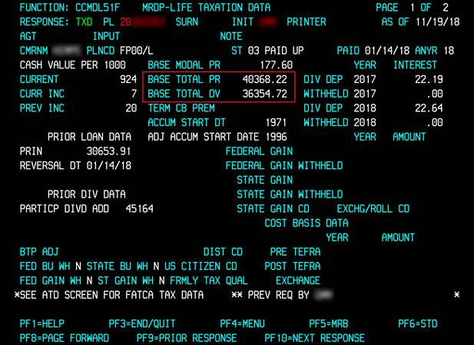

BTP less BTD = 4,013.50 (cost basis)

1. If any portion of the total dividends are being held as collateral to secure the loan on record and the total amount is being applied, then the approximate tax gain is the difference between the dividends withdrawn for the loan payment and the NPC, not the tax gain listed on the DVQ screen as that amount only applies to the Max Div amount.

**Note**: Will not be taxed if withdrawn to pay the premium on the policy in question

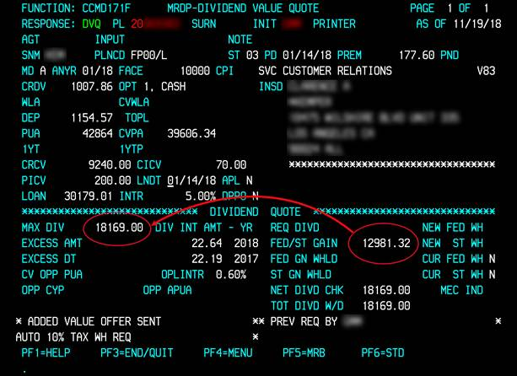

Example: Loan payoff as of 12/04/18 is $31,522.60.

Total dividends applied toward loan payment $31,522.60 less NPC $4,013.50 = Approximate Taxable Gain $27,509.10

## **Process Work Steps for** Taxable Gain Calculation When Withdrawing Dividends as Loan Repayment on Modified Endowment Contracts.

1. Review contract on MED screen in MRDP for Modified Endowment Status (MEC)

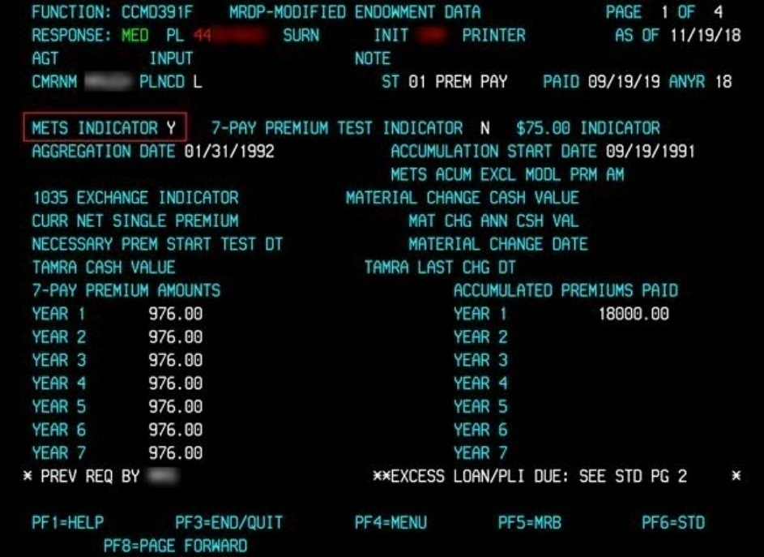

1. If Policy is a MEC policy, the policy owner will be taxed on the Withdrawl or the Gain, the lesser of the two.

**Note**: Will not be taxed if dividend is withdrawn to pay premium in question*

1. Review NVQ and DVQ screens in MRDP to compare the taxable gain, and use the larger of the two amounts.

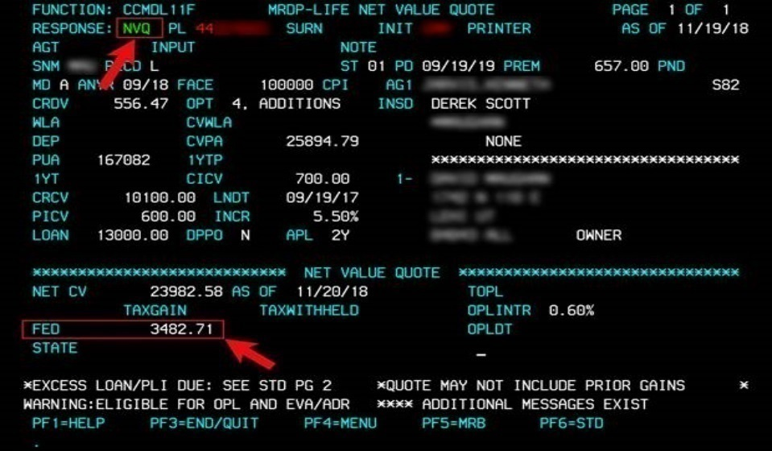

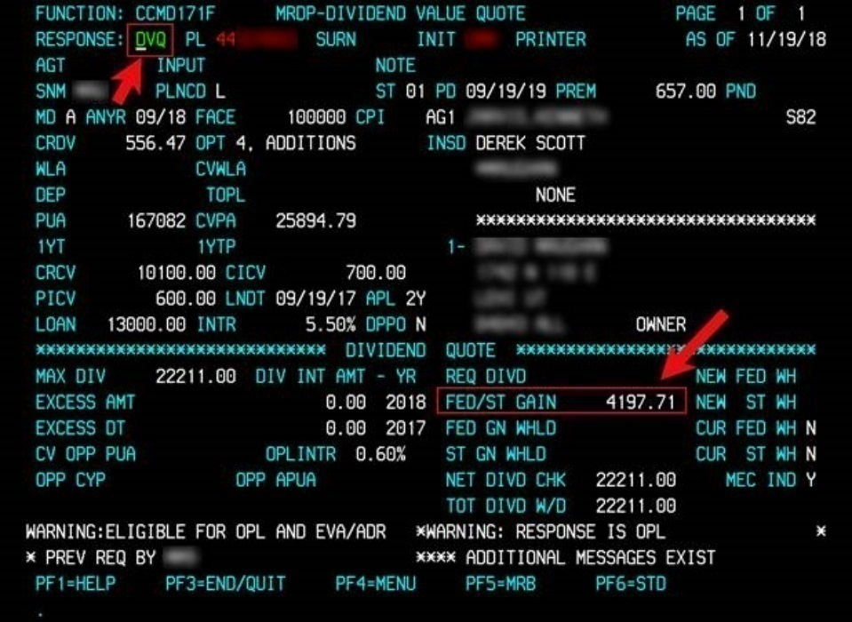

1. If amount to be withdrawn is less than the amount used in step 3, the lesser amount will be taxable. The tax gain will be the lesser of the dividends being withdrawn for the loan payment or the greater of the tax gain amounts on the NVQ and DVQ screens.

**Note**: For transactions where Dividends on Deposit are present, please be aware that these are not taxable at the time of withdrawal

# Section 5. Loan Payments

## Requirements

* See Section 1.

## Guidelines

* Loans (principal amount) do not have to be repaid.
* If the loan interest is not paid, it is added to the outstanding loan balance.
* If a loan is not repaid, it is deducted from the death benefit or the surrender amount.
* All or part of an unpaid loan can be repaid before the insured’s death or before the policy is surrendered.
* If the amount of any unpaid loans (including any accrued loan interest) is greater than the cash value, less any applicable surrender charges and any additional contract charge, we mail a notice to the policy owner at the last known address. We also send a copy of the notice to the last known assignee, if any. If the necessary amount is not paid within 31 days after the notice was mailed, the policy will be terminated.
* Accrued interest will always be taken from the payment before the balance is applied to the principal.
* Policy loan interest must be paid to date. LNDT/Loan Interest Paid to Date must be equal to or after the policy anniversary date for the current year.
* On Universal/Target Life policies always check the risk paid to date.
  + If it is not current, ensure that the loan repayment will be enough to bring the policy current by reviewing any lapse notices which may have been sent.
* Do not process if a CPI K exists on the policy. (In SSF, the CPI info will state, CS decrease/cancel.)
* All dividends are available to reduce the loan on the policy (the greater of the Max Div field compared to the amount in the Paid up Adds or Deposit fields).
* The Transaction Code for loan repayment is always ‘NY’.
* If policy loan interest is due, it must be paid on the ‘PLI’ field on the NPAB screen, unless it is past the PLI due date, in which case it will update with the repayment transaction.
* If you see “Do Not APL,” do not process; it must be removed prior to processing.
* Loans are not taxable distributions, but a taxable event will occur when the loan is considered in default and the outstanding balance is withdrawn from the accumulation value of the policy. The appropriate surrender charges and taxes will apply to the withdrawal amount, and form 1099-R will be produced indicating distribution code “L” (Deemed Distribution). (Refer to the [State Tax Withholding](https://www.teams.newyorklife.com/Public/InsuranceGroupProcedureLibrary/Traditional/Shared%20Documents/Life%20Disbursements/Loans/Loan%20Procedure%20Traditional.docx)  for current state tax withholding information).
* Watch for a CPI 3 on MRDP in the CPI field or in SSF – if one is present refer the payment to the individual who set the CPI.

### Calculating Loan Payoff Amounts

* In order to provide a loan payoff, the loan interest due must be calculated in SSF, which can calculate the interest due for a full loan repayment:
  + If the owner wants to send in a payment, the Loan Value Quote screen in SSF is used to calculate the payoff
    - The Loan Value Quote screen in SSF will show a Total Loan Payoff amount which includes an additional 10 days of interest (even if the 10-day mark crosses an anniversary) and a Loan Payoff Date, which is the date the quote is good until.
  + If the owner is calling in to make a one-time EFT payment or is using dividends to make the payoff the Dividend Value Quote in SSF is used to calculate the payor.
    - The Dividend Value Quote screen in SSF will show a Loan Payoff by Div amount which is the payoff as of that date.
  + Target Life policies will be calculated to refund the loan interest paid in advance. The calculations will also be done 10 days from the date of the request.
  + Universal Life will be calculated the same way as Whole Life as the interest on these products is paid in arrears.
* An AWF work object will be created by the analyst providing the quote. The payoff amount and payoff date provided to the agent or client at POC will be noted in the Comments field of the work object.
* The loan payoff should be remitted by the project date given by the analyst. The client may also want to provide the date and the amount in the memo section of the check.
* The client should be advised to send the check to the Minneapolis Service Center at the following address:

New York Life Insurance

PO Box 500

Minneapolis, MN 55440

### Loan Repayment Effective Date

* Loan repayments processed by the lockbox will always have an effective date of the date received and processed.

• Loan repayments processed by a CSR will typically have the AWF received date used as the effective date.

• If there is a POC AWF item and it indicates we gave a loan repayment quote, the AWF received date will be used as the effective date.

• If the payment appears to be a full loan repayment (the outstanding loan amount and loan interest is received) and there is no POC AWF work item, review the following to avoid a poor customer experience and to avoid complaints due to very small loans being left on the policy. An attempt should be made if at all possible, to repay the loan in full by using the appropriate received date as the effective date.

* + If the premium due, the loan interest due and the outstanding loan amount are received after the premium and loan interest due date, the received date will be the anniversary date as long as it is received within the grace period.

o If a full loan repayment is received with a Key Information Summary, and the outstanding loan amount and interest shown on that summary equal the total amount received, use the Key Information Summary as of date as the received/effective date as long as the payment is received within 2 weeks of the date on the Key Information Summary.

▪ If the payment was not received within 2 weeks, use the AWF received date or discuss with your Manager.

* + If a notation is written that the payment is for a full loan repayment, use the loan repayment calculator to determine the received date that would repay the loan in full. If the date is within a reasonable amount of time from when the payment was received use the date from calculator as the received/effective date.

### Full Loan Repayment via One-Time EFT

* Full and partial loan repayments are available through one-time EFT.
* Use the SSF Loan Payoff feature to obtain the loan payoff quote. The additional 10 days normally added will not be in this case as the payment is made at POC and interest due should only be brought up to the date of full payoff.
* Refer to the [One-Time EFT Payment Procedure](https://www.teams.newyorklife.com/Public/InsuranceGroupProcedureLibrary/Traditional/Shared%20Documents/One-Time%20EFT%20July%202014.doc) for further processing details.
* Process the loan repayment. See Process Work Steps for Loan Payments below.

### Calculating Policy Loan Interest (PLI)

* Outstanding policy loan interest needs to be repaid. If it is not, it will capitalize into the loan principal.
* Policy loan interest is due on each anniversary.
* Interest is calculated from the last loan interest paid-to date (LNDT) on the Loan Quote screen (Loan Interest Pd to Dt) in SSF or on the STD screen (LNDT) to the policy anniversary date. See Manual Loan Interest Calculations in the Appendix on how to calculate.
* Each time a loan is increased, the interest from the last LNDT on the Loan Quote screen (Loan Interest Pd to Dt) in SSF or on the STD screen (LNDT) to the transaction date is added to the loan principal. This way, the owner is paying loan interest on the proper amount of loan.
  + Example: LNDT = March

Original Loan $1,000.00

(PLUS) Loan Increase $2,000.00

(PLUS) 5% int for 6 mths

on $1,000.00 $25.20

New Loan $3,025.20

New LNDT = September 1st

* Each time a partial loan repayment is sent in, the amount of interest due is deducted from the payment based on the length of time that the client has had the money
  + Example: $1,000 loan taken September 1st and on October 1st a $100.00 loan repayment is received.

Original Loan $1,000.00

Repayment $ 100.00

(PLUS) 5% int for 30 days

on $100.00 $ 4.10

New Loan $ 904.10

* + The LNDT does not change on a loan repayment. However, when the client receives the interest bill for the next year the interest will be based on the loan balance at that time.
  + Calculator as the received/effective date.

### Reporting Loan Interest

* To report loan interest due, you must use the PLI field on the NPAB screen.
  + If you are paying a premium due on the anniversary, along with the loan interest, simply fill in the rate and the premium amount.
  + If you are paying loan interest along with a premium that is not due on the anniversary, you must report the payments on two separate screens. If you try to pay PLI with a due date other than the anniversary date, the system will not let you process the transaction.
* If you receive a loan repayment and annual loan interest is currently due, report the amount sent as an interest payment.
  + If the amount is less than the interest due, the system will APL the balance.
  + If the amount is more than the interest due, the balance will be applied to the loan principal.
    - If the excess is less than $1, add it to the PLI amount due and apply as PLI.
    - If the excess is $1 or more, apply the additional money received as a loan repayment on the TREM LOAN screen.

### Loan Repayment Suspense and Letters Due to Overpayment

* When a loan repayment is remitted, and the amount is more than the amount of the current loan and outstanding interest, the loan is repaid in full and the balance remaining falls into CMR loan (L) suspense.
* When the funds are placed in suspense a letter is produced and sent to the Traditional Service Center (TSC) of record. The analyst receiving the letter must clear the suspense from the records.
* Check the standard screen of SSF to verify the amount of loan suspense.
* If you have the loan repayment letter, check page 2 to verify that there is an overpayment.
* If you receive a letter but there is no money in suspense, just send the letter (unless the status is A6).
* When you clear the suspense, you can send the letter the same day.
* If you do not have the loan repayment letter, use the process date as the effective date in TREM.
* If the amount in suspense is over $100, check with the analyst who processed the loan repayment to make sure the excess should not have gone to another policy, the premium, etc. If not, this refund should be sent to the policy owner in cash. See Process Work Steps for Refunding Loan Overpayments.
* If the amount is $100 or less, the excess is applied to the dividends.

## Process Work Steps for Loan Payments

1. View current loan quote information on Loan Quote in SSF if a full loan repayment.
2. Check PLI paid-to date in MDRP on the STD screen or in SSF.
3. From COMMON MONITOR go to TREM then LOAN and complete the following fields:

|  |  |
| --- | --- |
| **Field** | **Input** |
| POLNO | Policy number |
| SURN | First three letters of client’s last name |
| TRANS CD | NY |
| EFF/NGCK DT | Depends on origin of loan repayment request. See **Loan Repayment Effective date** section above for proper date to use. |
| FUNDS APPLIED/REFUND | Amount of repayment |
| DIV APPLIED | Amount of dividends being applied, if applicable |
| OFFSET | ‘B (out suspense)’ followed by the suspense amount in 0.00 format |

1. Hit F5.
2. Close the AWF work item with the appropriate business type.

## Process Work Steps for Refunding Loan Overpayments

1. View Standard screen in SSF or MRDP to confirm Loan suspense.
2. Check to confirm that policy status is 01.
3. Complete the following fields in TREM NPAB:

|  |  |
| --- | --- |
| **Field** | **Input** |
| POLNO | Policy number |
| SURN | First three letters of client’s last name |
| RATE | Use “B” |
| DUDT | Any other date other than the modal date |
| PREM AMT | Negative suspense amount (-X.XX) |
| REFUND CD | 1 |
| NEXT FUNCTION | DIVD |
| Carry Over Policy NO | Y, to carry over the policy number and surname to the next screen |

1. Hit Enter or press F1 to link to the DIVD screen.

**Note:** If the overpayment is being sent in cash as the amount is over $100, there is no need to link it to a dividend screen. In OFFSET FIELDS, enter ‘C’ and the amount of the overpayment to issue the check. You will need to include the letter and a current MRB in your check item/folder if applicable.

1. On the DIVD screen, complete the following fields:

|  |  |
| --- | --- |
| **Field** | **Input** |
| POLNO | Policy number |
| SURN | First three letters of client’s last name |
| TRANS CD | LC |
| DIV APPLIED | Negative amount (-X.XX) |
| DIVD APPLIED TO | G LNOverPay (so that a confirmation letter is not sent) |
| ORIG DT | Date of letter (or transaction if you don’t have the letter) |
| FED WH | Y/N (whatever is on record) |
| ST WH | Y/N (whatever is on record) |

1. Hit F5 to process.

# 

# Section 6. Emergency Loan Procedure

## Requirements

* When a client or agent requests a loan check on a Traditional Life product to be printed in the General Office (GO) because of an urgent need, the following procedure applies.

**Note:** This procedure is applicable to loans up to but not exceeding $499,999. If the request is for $500,000 or greater, the check will need to be cut in the Service Center.

## Process Work Steps for Emergency Loan Procedure

1. Loan requests placed in the GO 344 Suspense account may only be requested by the Administrative Manager (AM) or, if the AM is out of the office, the Senior Specialist (SS). All agent requests must come through the AM or SS, who will determine the validity of the request.
2. The AM or SS will secure a current signed and dated loan agreement form and will send an email to the two Values Team managers in Cleveland and Dallas with a copy to the CVPs over the teams in both locations. The email will include a scanned image of the signed loan form with the policy number, amount being requested and whether any taxes will be withheld. The subject line of the email should state, “Same-Day Urgent Loan Request.”

**Note:**  If the agent (or the policy owner) calls the AM and requests an emergency loan for pickup later in the day, the AM can accept the signed loan agreement when the client arrives in the office, assuming the policy is not jointly, corporate- or trust-owned and requires multiple signatures. In this situation, the AM will obtain all necessary information over the phone (policy number, loan amount, taxes withheld). The AM will send an email to the Values Team managers advising that the loan request is verbal and provide the necessary information. The AM will be responsible for sending the loan form to DMS.

1. The Values Team manager will review the email, check to make sure the request is from the AM or SS, forward the email to AWF and copy in one of the Values Team analysts for review and processing.
2. The Values Team analyst will review the status and available loan value on the policy. If the request is in good order, the loan will be processed, and funds deposited into the GO’s 344 Suspense account under the policy number. (If the request is in good order and submitted before 2:00 pm CST, the loan will be processed the same day.)

**Note:** In the event that the request cannot be processed because proper requirements were not submitted, e.g., the policy is collaterally assigned and appropriate documentation was not provided, the Values Team analyst will reply back to the AM, with a copy to the Values Team manager, explaining why the request is NIGO and what requirements are necessary in order to process the loan transaction.

1. If the request is in good order, the Values Team analyst will process the loan and then reply to the AM, with a copy to the Values Team manager, advising that the loan has been processed and the funds are available in GO Suspense.
2. The AM or SS will process the check for the client and secure the appropriate identification prior to releasing the check to the client. The check is **not** to be given to the agent to deliver to the client.
3. The AM or SS does not have to request Zone approval in advance; however, they should advise the Zone Administrative Officer of the loan transaction.

# 

# TREM Applied to Codes

When processing a cross loan, TREM requires an Applied to Code. The code is dependent upon how the loan proceeds are applied to the other policy. Each code has a specific definition as shown below.

**Note:** This list of codes can be found in the LOAN Help screen in TREM. When you are processing in the LOAN screen, type HELP in the PFUNC field to access this list.

|  |  |
| --- | --- |
| **Applied to Code** | **Description** |
| B | MANUAL LOAN CHECK ISSUED |
| C | PREM PAYMENT, PLI, LOAN OR BALANCE DUE ON SAME POLICY Also used when doing a cross -loan on the same policy (Due to entry not updating on the loan screen in TREM) |
| D | PREM PAYMENT, PLI, LOAN OR BALANCE DUE ON ANOTHER POLICY |
| E APP NEW INS | APPLICATION FOR NEW INSURANCE |
| F | REDUCE OVERPAID DIVIDEND |
| G | UNUSUAL SITUATION NOT COVERED ABOVE |
| H | REINSTATEMENT ON SAME POLICY |
| M | MULTIPLE POLICIES |

Proper codes should be used at all times. There are certain situations, such as the repayment of an excess loan or where the automated confirmation does not satisfy the transaction processed, where a ‘G’ code can be used. The ‘G’ code suppresses the automated confirmation. Since all financial transactions must be confirmed, a manual confirmation must be sent when the ‘G’ code is used.

A control report is generated and reviewed by Experience Reviews, for all transactions in which the G Applied Code has been used to validate proper usage.

# 

# Online Validation

You will receive error messages in the following situations:

|  |  |
| --- | --- |
| **Error Message** | **Reason** |
| DIVD APPLIED TO LOGIC ERROR/ | LOAN APPLIED TO field is blank |
| INVALID POLICY NUMBER/CMR UNAVAILABLE FOR POLICY ENTERED/ | Policy number was not entered or is incorrect |
| SURNM DOES NOT MATCH CMR = (correct surname) | Surname was not entered or does not match policy number entered |
| SKIPPED LINES NOT ALLOWED/ | A line was skipped when inputting additional policy numbers on the secondary screen |

# Multiple Policy Loan Confirmation Letter Sample

Page 1

Pages 2 and 3

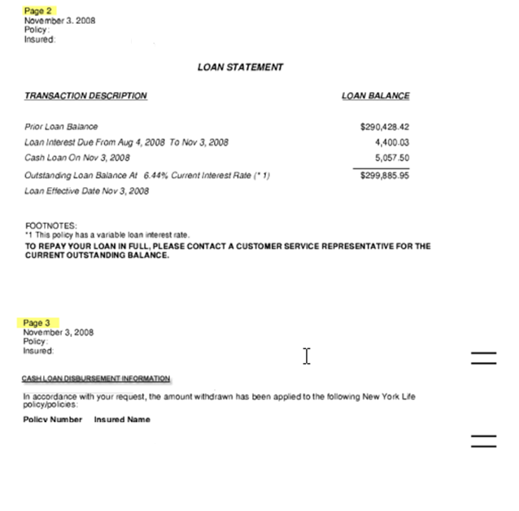

# Loan Check – L or B?

Loan Request Received

Issue ‘L’ check

No

Is a Loan Agreement needed?

No

Yes

Write for a Loan Agreement

Issue ‘B’ check

Yes

Loan Agreement received?

# Manual Loan Interest Calculations

Calculations for any interest rate can be made using the day-board (see sample on the following pages). This can be in connection with full loan repayments, reinstatement offers, dividend interest calculations, or any other situation that requires manual interest calculations.

1. Determine date to which you wish to figure interest. This is the “to” date. Find the fact for that date on the day-board.
2. Determine date from which you wish to figure interest. This is the “from” date. For loan repayments, this will be the loan interest paid-to date on record. If the interest rate is variable, you will also have a “from” date matching the dates the interest rate has changed. Find the factors for the dates you have identified as “from” dates.
3. Subtract the ”from” date factor from the “to” date factor. Again, in the case of variable loan interest, the “from” and “to” dates may often be the dates the interest rates have changed.
4. Figure one year’s interest on the loan balance for the date on record, or for each variable interest rate being used.
5. Multiply the one year’s interest amount by the factor(s) determined in step 4.

The resulting amount (or total of the resulting amounts) is the interest due for the partial year.

|  |  |  |  |  |  |  |  |  |  |  |  |  |
| --- | --- | --- | --- | --- | --- | --- | --- | --- | --- | --- | --- | --- |
|  | | **NEW YORK LIFE INSURANCE COMPANY** | | | | | | | | | | |
| DAY BOARD | | | | | SETT. & SERV. DEPT. | | | | 09-26-79 | | | | |
| .08333 | | | .16667 | | .25 | | .33333 | | .41667 | | .50 | | |
| 1 JAN. | | | 2 FEB. | | 3 MAR. | | 4 APR. | | 5 MAY | | 6 JUNE | | |
| 1 | .00274 | | 1 | .08767 | 1 | .16438 | 1 | .24932 | 1 | .33151 | 1 | .41644 | |
| 2 | .00548 | | 2 | .09041 | 2 | .16712 | 2 | .25205 | 2 | .33425 | 2 | .41918 | |
| 3 | .00822 | | 3 | .09315 | 3 | .16986 | 3 | .25479 | 3 | .33699 | 3 | .42192 | |
|  |  | |  |  |  |  |  |  |  |  |  |  | |
| 4 | .01096 | | 4 | .09589 | 4 | .17260 | 4 | .25753 | 4 | .33973 | 4 | .42466 | |
| 5 | .01370 | | 5 | .09863 | 5 | .17534 | 5 | .26027 | 5 | .34247 | 5 | .42740 | |
| 6 | .01644 | | 6 | .10137 | 6 | .17808 | 6 | .26301 | 6 | .34521 | 6 | .43014 | |
|  |  | |  |  |  |  |  |  |  |  |  |  | |
| 7 | .01918 | | 7 | .10411 | 7 | .18082 | 7 | .26575 | 7 | .34795 | 7 | .43288 | |
| 8 | .02192 | | 8 | .10685 | 8 | .18356 | 8 | .26849 | 8 | .35068 | 8 | .43562 | |
| 9 | .02466 | | 9 | .10950 | 9 | .18630 | 9 | .27123 | 9 | .35342 | 9 | .43836 | |
|  |  | |  |  |  |  |  |  |  |  |  |  | |
| 10 | .02740 | | 10 | .11233 | 10 | .18904 | 10 | .27397 | 10 | .35616 | 10 | .44110 | |
| 11 | .03014 | | 11 | .11507 | 11 | .19178 | 11 | .27671 | 11 | .35890 | 11 | .44384 | |
| 12 | .03288 | | 12 | .11781 | 12 | .19452 | 12 | .27945 | 12 | .36164 | 12 | .44658 | |
|  |  | |  |  |  |  |  |  |  |  |  |  | |
| 13 | .03562 | | 13 | .12055 | 13 | .19726 | 13 | .28219 | 13 | .36438 | 13 | .44932 | |
| 14 | .03836 | | 14 | .12329 | 14 | .20000 | 14 | .28493 | 14 | .36712 | 14 | .45205 | |
| 15 | .04110 | | 15 | .12603 | 15 | .20274 | 15 | .28767 | 15 | .36986 | 15 | .45479 | |
|  |  | |  |  |  |  |  |  |  |  |  |  | |
| 16 | .04384 | | 16 | .12877 | 16 | .20548 | 16 | .29041 | 16 | .37260 | 16 | .45753 | |
| 17 | .04658 | | 17 | .13151 | 17 | .20822 | 17 | .29315 | 17 | .37534 | 17 | .46027 | |
| 18 | .04932 | | 18 | .13425 | 18 | .21096 | 18 | .29589 | 18 | .37808 | 18 | .46301 | |
|  |  | |  |  |  |  |  |  |  |  |  |  | |
| 19 | .05205 | | 19 | .13699 | 19 | .21370 | 19 | .29863 | 19 | .38082 | 19 | .46575 | |
| 20 | .05479 | | 20 | .13973 | 20 | .21644 | 20 | .30137 | 20 | .38356 | 20 | .46849 | |
| 21 | .05753 | | 21 | .14247 | 21 | .21918 | 21 | .30411 | 21 | .38630 | 21 | .47123 | |
|  |  | |  |  |  |  |  |  |  |  |  |  | |
| 22 | .06027 | | 22 | .14521 | 22 | .22192 | 22 | .30685 | 22 | .38904 | 22 | .47397 | |
| 23 | .06301 | | 23 | .14795 | 23 | .22466 | 23 | .30950 | 23 | .39178 | 23 | .47671 | |
| 24 | .06575 | | 24 | .15068 | 24 | .22740 | 24 | .31233 | 24 | .39452 | 24 | .47945 | |
|  |  | |  |  |  |  |  |  |  |  |  |  | |
| 25 | .06849 | | 25 | .15342 | 25 | .23014 | 25 | .31507 | 25 | .39726 | 25 | .48219 | |
| 26 | .07123 | | 26 | .15616 | 26 | .23288 | 26 | .31781 | 26 | .40000 | 26 | .48493 | |
| 27 | .07397 | | 27 | .15890 | 27 | .23562 | 27 | .32055 | 27 | .40274 | 27 | .48767 | |
|  |  | |  |  |  |  |  |  |  |  |  |  | |
| 28 | .07671 | | 28 | .16164 | 28 | .23836 | 28 | .32329 | 28 | .40548 | 28 | .49041 | |
| 29 | .07945 | | 29 | .16438 | 29 | .24110 | 29 | .32603 | 29 | .40822 | 29 | .49315 | |
| 30 | .08219 | | 30 |  | 30 | .24384 | 30 | .32877 | 30 | .41096 | 30 | .49589 | |

|  |  |  |  |  |  |  |
| --- | --- | --- | --- | --- | --- | --- |
|  | **NEW YORK LIFE INSURANCE COMPANY** | | | | | |
| DAY BOARD | | | SETT. & SERV. DEPT. | | 09-26-79 | | |
| .58333 | | .66667 | .75 | .83333 | .91667 | .50 | |
| 7 JULY. | | 8 AUG. | 9 SEPT. | 10 OCT. | 11 NOV. | 12 DEC. | |

|  |  |  |  |  |  |  |  |  |  |  |  |
| --- | --- | --- | --- | --- | --- | --- | --- | --- | --- | --- | --- |
| 1 | .49863 | 1 | .58356 | 1 | .66849 | 1 | .75068 | 1 | .83562 | 1 | .91781 |
| 2 | .50137 | 2 | .58630 | 2 | .67123 | 2 | .75342 | 2 | .83836 | 2 | .92055 |
| 3 | .50411 | 3 | .58904 | 3 | .67397 | 3 | .75616 | 3 | .84110 | 3 | .92329 |
|  |  |  |  |  |  |  |  |  |  |  |  |
| 4 | .50685 | 4 | .59178 | 4 | .67671 | 4 | .75890 | 4 | .84384 | 4 | .92603 |
| 5 | .50950 | 5 | .59452 | 5 | .67945 | 5 | .76164 | 5 | .84658 | 5 | .92877 |
| 6 | .51233 | 6 | .59726 | 6 | .68219 | 6 | .76438 | 6 | .84932 | 6 | .93151 |
|  |  |  |  |  |  |  |  |  |  |  |  |
| 7 | .51507 | 7 | .60000 | 7 | .68493 | 7 | .76712 | 7 | .85205 | 7 | .93425 |
| 8 | .51781 | 8 | .60274 | 8 | .68767 | 8 | .76986 | 8 | .85479 | 8 | .93699 |
| 9 | .52055 | 9 | .60548 | 9 | .69041 | 9 | .77260 | 9 | .85753 | 9 | .93973 |
|  |  |  |  |  |  |  |  |  |  |  |  |
| 10 | .52329 | 10 | .60822 | 10 | .69315 | 10 | .77534 | 10 | .86027 | 10 | .94247 |
| 11 | .52603 | 11 | .61096 | 11 | .69589 | 11 | .77808 | 11 | .86301 | 11 | .94521 |
| 12 | .52877 | 12 | .61370 | 12 | .69863 | 12 | .78082 | 12 | .86575 | 12 | .94795 |
|  |  |  |  |  |  |  |  |  |  |  |  |
| 13 | .53151 | 13 | .61644 | 13 | .70137 | 13 | .78356 | 13 | .86849 | 13 | .95068 |
| 14 | .53425 | 14 | .61918 | 14 | .70411 | 14 | .78630 | 14 | .87123 | 14 | .95342 |
| 15 | .53699 | 15 | .62192 | 15 | .70685 | 15 | .78904 | 15 | .87397 | 15 | .95616 |
|  |  |  |  |  |  |  |  |  |  |  |  |
| 16 | .53973 | 16 | .62466 | 16 | .70950 | 16 | .79178 | 16 | .87671 | 16 | .95890 |
| 17 | .54247 | 17 | .62740 | 17 | .71233 | 17 | .79452 | 17 | .87945 | 17 | .96164 |
| 18 | .54521 | 18 | .63014 | 18 | .71507 | 18 | .79726 | 18 | .88219 | 18 | .96438 |
|  |  |  |  |  |  |  |  |  |  |  |  |
| 19 | .54795 | 19 | .63288 | 19 | .71781 | 19 | .80000 | 19 | .88493 | 19 | .96712 |
| 20 | .55068 | 20 | .63562 | 20 | .72055 | 20 | .80274 | 20 | .88767 | 20 | .96986 |
| 21 | .55342 | 21 | .63836 | 21 | .72329 | 21 | .80548 | 21 | .89041 | 21 | .97260 |
|  |  |  |  |  |  |  |  |  |  |  |  |
| 22 | .55616 | 22 | .64110 | 22 | .72603 | 22 | .80822 | 22 | .89315 | 22 | .97534 |
| 23 | .55890 | 23 | .64384 | 23 | .72877 | 23 | .81096 | 23 | .89589 | 23 | .97808 |
| 24 | .56164 | 24 | .64658 | 24 | .73151 | 24 | .81370 | 24 | .89863 | 24 | .98082 |
|  |  |  |  |  |  |  |  |  |  |  |  |
| 25 | .56438 | 25 | .64932 | 25 | .73425 | 25 | .81644 | 25 | .90137 | 25 | .98356 |
| 26 | .56712 | 26 | .65205 | 26 | .73699 | 26 | .81918 | 26 | .90411 | 26 | .98630 |
| 27 | .56986 | 27 | .65479 | 27 | .73973 | 27 | .82192 | 27 | .90685 | 27 | .98904 |
|  |  |  |  |  |  |  |  |  |  |  |  |
| 28 | .57260 | 28 | .65753 | 28 | .74247 | 28 | .82466 | 28 | .90950 | 28 | .99178 |
| 29 | .57534 | 29 | .66027 | 29 | .74521 | 29 | .82740 | 29 | .91233 | 29 | .99452 |
| 30 | .57808 | 30 | .66301 | 30 | .74795 | 30 | .83014 | 30 | .91507 | 30 | .99726 |
| 31 | .58082 | 31 | .66575 |  |  | 31 | .83288 |  |  | 31 | 1.0000 |

# Loan Confirmation Letter

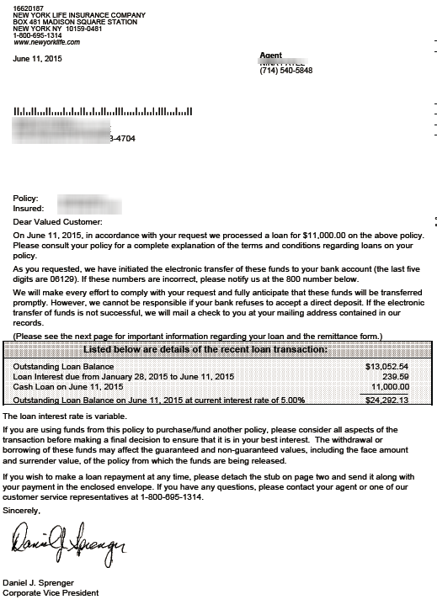

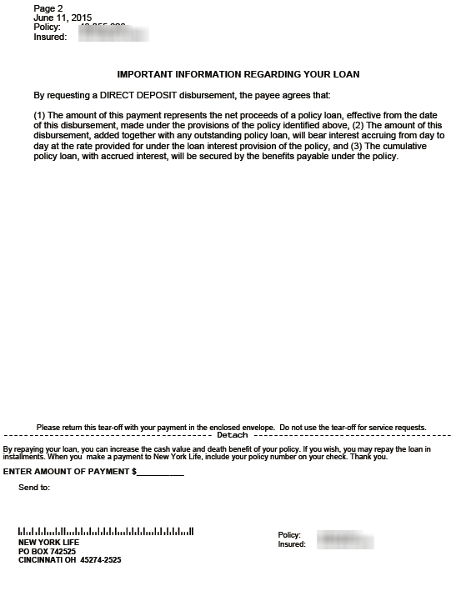

# Multiple Policy Loan Confirmation Letter Sample

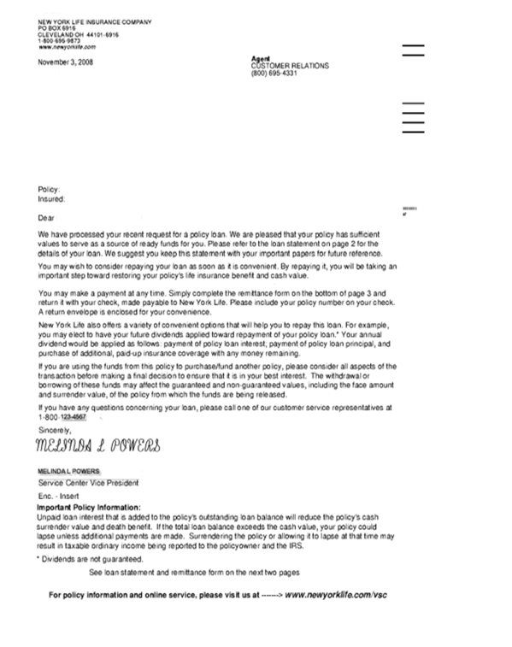

# References

[Policy Number Ranges and Product Names](https://www.teams.newyorklife.com/Public/InsuranceGroupProcedureLibrary/Fixed/Shared%20Documents/Policy%20Number%20Ranges%20and%20Product%20Names.docx)

[Verification Protocol Procedure](https://www.teams.newyorklife.com/Public/InsuranceGroupProcedureLibrary/Traditional/Shared%20Documents/TSC%20Verification%20Protocol/Verification%20Protocol%20Procedure.docx)

[Verification Protocol Client Phone Procedure](https://www.teams.newyorklife.com/Public/InsuranceGroupProcedureLibrary/Traditional/Shared%20Documents/TSC%20Verification%20Protocol/Verification%20Protocol%20Client%20Phone%20Procedure.docx)

[FATCA Procedure](https://www.teams.newyorklife.com/Public/InsuranceGroupProcedureLibrary/Traditional/Shared%20Documents/TAX/FATCA%20Overview.docx)

[State Statutory and Regulatory Survey on Paying Interest on Late Cash Disbursements for Life Insurance Policies](https://www.teams.newyorklife.com/Public/InsuranceGroupProcedureLibrary/Traditional/Shared%20Documents/TAX/State%20Statutory%20and%20Regulatory%20Survey%20on%20Paying%20Interest%20on%20Late%20Cash%20Disbursements%20for%20Life%20Insurance%20Policies.docx)

[Forms Library](https://www.fts.newyorklife.com/formslibrary/individualFormsMainPage.jsp)

[Virtual Service Center (VSC)](https://www.vsc3.newyorklife.com/VSCRegWebApp/login?TYPE=33554432&REALMOID=06-ae0774b0-e850-1005-931f-839b2c470cb3&GUID=&SMAUTHREASON=0&METHOD=GET&SMAGENTNAME=-SM-E2ABS6DE0OajNAWQKXbTF8pnwQndwKYWxORqTL0BpoPe4rI48S9U86Gr3kv60i9IJr5I2O0eD8kF420bYcrwJr%2bgad9)

[NIGO Procedure](https://www.teams.newyorklife.com/Public/InsuranceGroupProcedureLibrary/Traditional/Shared%20Documents/General/NIGO%20Procedure.docx)

[Outstanding Check Procedure](https://www.teams.newyorklife.com/Public/InsuranceGroupProcedureLibrary/Traditional/Shared%20Documents/Disbursements/Returned%20Check%20Processing/Outstanding%20Check%20Procedure.docx)

[GDS Check Pull Procedure](https://www.teams.newyorklife.com/Public/InsuranceGroupProcedureLibrary/Traditional/Shared%20Documents/Disbursements/Disbursements/GDS%20Check%20Pull%20Procedure.docx)

[State Tax Withholding](https://www.teams.newyorklife.com/Public/InsuranceGroupProcedureLibrary/Traditional/Shared%20Documents/Life%20Disbursements/Loans/Loan%20Procedure%20Traditional.docx)

[Resident Alien and Foreign National Tax Withholding](https://www.teams.newyorklife.com/Public/InsuranceGroupProcedureLibrary/Traditional/Shared%20Documents/TAX/Resident%20Alien%20and%20Foreign%20National%20Tax%20Withholding%20for%20Loan%20Procedure.docx)

[Tax Distribution Codes](https://www.teams.newyorklife.com/Public/InsuranceGroupProcedureLibrary/Traditional/Shared%20Documents/TAX/Tax%20Distribution%20Codes.docx)

[One-Time EFT Payment Procedure](https://www.teams.newyorklife.com/Public/InsuranceGroupProcedureLibrary/Traditional/Shared%20Documents/One-Time%20EFT%20July%202014.doc)

[Taxable Gain Surrender Calculation](https://www.teams.newyorklife.com/Public/InsuranceGroupProcedureLibrary/Traditional/Shared%20Documents/TAX/Taxable%20Gain%20Surrender%20Calculation.docx)

# Procedure History

|  |  |  |  |  |
| --- | --- | --- | --- | --- |
| Version | Date | Update Description | CM Intake # | Updated By |
| 1.0 | October 2016 | Process and Procedure reviewed in Sprint Session 2 of the SAP POD project. | N/A | Melinda Messick |
| 1.1 | 11-14-16 | FATCA updates regarding no mh or ny transactions with the use of dividends when the FATCA is Non-compliant or Under review (N or U) updates on pages 14, 15, 17, 26, 30; and an update requested by Brian Taylor occurs on pages 22 and 23 Process added when policy is paid via a method other than COM, Nyla-plan, or EFT the CSR must review the OLTR to determine if any payments have occurred in the last 25 days; if a payment has occurred via a method different from above and the loan amounts equal more than $100, the amount of the payment must be subtracted from the maximum loan quote and this will be the new loan amount available. Processing of the loan does not change. If the method of payment is via other than methods listed above and the amount of the payment(s) is less than $100, the CSR will process the loan request up to the maximum amount available. This procedure update was not approved in the Trad CM mtg of 11-10 as Brian Taylor wanted a few more individuals to review the FATCA resource/reference. Brian sent an email that the feedback he was getting was that the reference was ok to use. I have posted the FATCA reference in the Loan folder in Life Disbursements and linking to it from this document. | N/A | Tracy Wolf |
| 1.2 | 4-3-17 | As Per CM #109, two wrong statements under Section 2, Premiums by Loan were removed on page 10-(POC up to 249999 and VSC Max Loan-50,000). And on page 10, the following text was added: Client POC request (individually owned policies only). This was update was provided by Sandy Brennan. And it was sent back to Sandy Brennan for final approval. 4/3/2017: Approval to post to SharePoint received by Sandy Brennan. | 109 | Filomena (Phyllis) D’Agosto |
| 1.3 | 6/19/17 | Changes have been made to the cash loan parameters with changes to the minimum premium amount and time frame between premium payment and new cash loan when processing a cash loan. Time frame changed to 10 days from 25 and the amount changed to less than $15,000 process normally, if greater, that amount must be subtracted from the loan value quote amount. Methods of payment other than NylaPlan premium payments, Government Allotment and Agent NylaPlan Loan Repayment must be reviewed on the OLTR. Changes occur on pages 22, 23, and 24. Approved by Brian Taylor 6-16-17 | 238 | Tracy Wolf |
| 1.4 | 11-29-2017 | Changes made to trem code descriptions on pages 17 and 40. Updated charts to show description of Code C to match actual description listed. | 426 | D. Lilly |
| 1.5 | 6/21/2017 | As per M. Young – Removed old State Withholding charts and replaced it with a link to the 1099 State Withholding Chart on the SharePoint Library. Created new reference charts and internal links for the sections of the old chart that I was instructed to keep. (Resident Alien and Foreign National charts and the Tax Distribution Codes sections). Also, deleted the reference links in each section and updated the main reference listing.  As per Alice Pamer, the following text was added to page 7:  Non-persons such as corporations, companies, trust, etc. or U.S. citizens living outside the United States cannot elect out of withholding. Federal Credit Unions are tax exempt – do not withhold unless they specifically request withholding.  Approved and posted. 1-25-2018 Additional changes were made . Updated the Resident Alien and Foreign National Tax Withholding Chart. | 237 | P.D’Agosto |
| 1.6 | 2/27/2018 | Following changes were made to page 21 –   * Tax Withholding Requirements   + The client may now take a loan on a MEC policy, with a taxable gain, via phone or with a signed tax withholding section of the appropriate form.     - When processing by phone the CSR must notifiy the client of their current withholding election and offer the opportunity to change it.   + When request is made by phone the client must verbally confirm the withholding election.   + If tax withholding is not indicated on a received form check the DVQ or LVQ screens in MRDP or SSF to determine if an election is already on record.     - If the policy has a listed election we will use that election when processing the request.     - If there is no election listed the CSR must attempt to contact the client.       * If a phone number is provided, the CSR should attempt to call the client         + If the client does not answer and a message is left for a return the call the CSR will suspend the item for two days.         + If no return call is received when the item unsuspends the CSR will return the item as NIGO with a request to select a withholding election.       * If no phone number is provided the CSR will return the item as NIGO with a request to select a withholding election.         + When completing the NIGO letter advise the client they may contact us through the toll free number to select a withholding election.   + ~~A signed tax withholding election form is required before processing a loan on a policy that has a taxable gain and is a MEC so that the proper tax withholding code is used when processing.~~     - ~~If a tax withholding election is not made with the request, check the DVQ or LVQ screens in MRDP or SSF to determine if an election is already on record.~~   ~~CSR’s must confirm on the form the clients election for future disbursements and be changed accordingly.~~ | 579 | D. Lilly |
| 1.7 | 5.17.18 | On page 21 added the following: The CSR must verbally provide the loan interest rate to the owner at POC for both cash and premium loans. Sent to Stacy Geohaghan for review and approval. Also, fixed all broken NIGO links on 5.8.18. Stacy approved, submitted to CM for final approval. TDW  Final approval provided offline by Calinda Stringer. Advised in LIS CM meeting of 5.17.18 of approval. Posted. TDW | 716 | Tracy Wolf |
| 1.8 | 5.30.18 | Added to C in the chart on page 40: Also used when doing a cross -loan on the same policy (Due to entry not updating on the loan screen in TREM) Rita Amos approved on 5.15.18. TDW Approved by Calinda Stringer on 5.29.18 in an email forwarded to me by Stacy Mclaughlin. Posted | 720 | Tracy Wolf |
| 1.9 | 12/13/18 | Added New section for Taxable gain calculations and process work steps for : Withdrawing Dividends as Loan Repayment on Modified Endowment Contracts, Non-Modified Endowment when Dividend on Deposit is presen, and withdrawing Cash Value of Paid Up addition and/or Cash Value of OPP Additions on Non-Modified Endowment Contracts **on pages 33-35** | 978 | J. Innocent |
| 1.10 | 2.13.19 | The policy has a gain. (MEC status on a policy only requires a form if there is a gain and **the policy is not individually owned)**  **On individually owned policies, the policy owner may take a loan on a**  **MEC policy, with a taxable gain at point of call.**  **The policy owner has the option to change their withholding**  The bolded wording has been added to page 10 to clarify that individually owned policies can take a loan at poc if a MEC and a taxable gain as they can update their tax election at point of call. Non-individually owned policies must continue to supply a signed form in this instance. This was part of CM #579. As it really deals with POC the update was missed in this procedure. Completed and posted.  TDW 2.13.19 | 579 revisited | Tracy Wolf |
| 1.11 | 3/20/19 | Added to page 5:  **Note:** Certain states may require that interest be paid on any late disbursement. For example, New York State requires that interest be paid starting at day 10 (business days), and six other states require interest if the disbursement is delayed 30 days or more (for specific state information, refer to the [State Statutory and Regulatory Survey on Paying Interest on Late Cash Disbursements for Life Insurance Policies](https://www.teams.newyorklife.com/Public/InsuranceGroupProcedureLibrary/Traditional/Shared%20Documents/TAX/State%20Statutory%20and%20Regulatory%20Survey%20on%20Paying%20Interest%20on%20Late%20Cash%20Disbursements%20for%20Life%20Insurance%20Policies.docx)). In these cases, consult with your manager regarding the amount of interest that is required (for NY, consult with your manager on day 9, reference the NY York State Regulations for more information). Once interest is determined to be due and the amount is calculated, a manual check must be requested, along with a Miscellaneous Loss accounting sheet, and sent to the client with a letter of explanation. | 1269 & 1279 | J.Innocent |
| 1.12 | 8/6/19 | Added to page 6: **Please Note**: The rep will advise the agent via call or email that we need confirmation from the policyowner(s) not named on the bank account.  The rep will work with the agent to contact the client or advise the agent that we will be calling the client directly to request approval to proceed. The client’s confirmation can be taken at POC.  8/7/2019 Approved offline by Paul Pecorino.  Service Central # 5370. | 1545 | P.D’Agosto |
| 1.13 | 12/23/19 | Reformatted.  Pg 7 inserted:   * For transactions in scope for Data Match, please see the [State Data Match Procedures](https://www.teams.newyorklife.com/Public/InsuranceGroupProcedureLibrary/Traditional/Shared%20Documents/Regulatory%20Compliance/State%20Data%20Match%20Procedures%20LIS.docx).   12/18/19 Information provided by G.Bruno, S.Simbal, E.Spahr, and L.Walker.  12/20/19 Approved by E.Spahr and L.Walker. Sent to P.Pecorino for final approval.  12/23/19 Sent to G.Bruno for final approval. Approved.  12/24/19 Posted to SharePoint and Service Central (5370). | 1711 | A.MacTaggart |