**Nume:** Pop

**Prenume**: David

**E-mail:** [**Pop.Li.David@student.utcluj.ro**](mailto:Pop.Li.David@student.utcluj.ro)

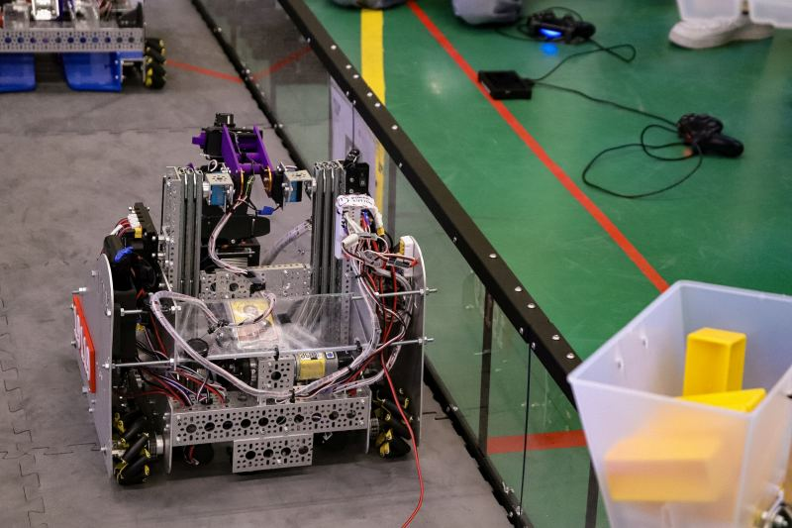

**Asteptari legate de educatie**:

* Sa trec toti ani

**Discipline**: <https://etti.utcluj.ro/fise-discipline/articles/tst-ro.html>

|  |  |  |
| --- | --- | --- |
| Disciplina | An | Link |
| Informatica Aplicata | 1 | <https://etti.utcluj.ro/files/Acasa/Site/FiseDisciplina/TstRo/06.pdf> |
| Componente si circuite pasive | 1 | <https://etti.utcluj.ro/files/Acasa/Site/FiseDisciplina/TstRo/05.pdf> |
| Programarea calculatoarelor și limbaje de programare I | 1 | <https://etti.utcluj.ro/files/Acasa/Site/FiseDisciplina/TstRo/04a.pdf> |
| Analiza matematica | 1 | <https://etti.utcluj.ro/files/Acasa/Site/FiseDisciplina/TstRo/01a.pdf> |
| Bazele electrotehnicii | 1 | <https://etti.utcluj.ro/files/Acasa/Site/FiseDisciplina/TstRo/13.pdf> |

**Hobby-uri**:

* Robotica
* Fotbal
* Handbal

**Elemente HTML:**

**<h1><h2>…<h6>**



**<p>**

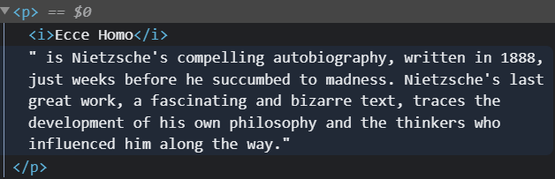

**<table>**

**<ul> sau <ol>**

**<img>**

**<div>**

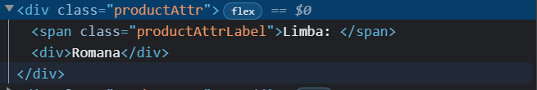

**<br>**

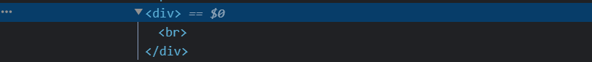

**Observatie**: imaginea utilizată în secțiunea ”Poza” a fost generată utilizând [https://generated.photos/humans/romanian-race#](https://generated.photos/humans/romanian-race) și nu aparține unei persoane reale.

**HTML Tutorial:** <https://www.w3schools.com/html/html_elements.asp>

**HTML Editor:** <https://www.w3schools.com/html/tryit.asp?filename=tryhtml_default>