|  |
| --- |
| Csc 436 |
| Kitchen Manager |
| Capstone Project |
|  |
| **Team: Cody Adams, Winston Belin, Ryann Case, Andre Edwards, Adanma Nkume** |
| **Thursday, February 11, 2010** |

|  |
| --- |
| This document consists of the interim Software Requirement Specifications. This includes the product scope, progress of the group schedule, project system hierarchy and texts, charts and diagrams relative to the Object Oriented Analysis method to software engineering. |

# Table of Contents

1 Table of Contents 2

2 Product Scope 3

3 Project Plans 5

3.1 Schedule 5

3.2 Administrative Assignments 6

4 System Hierarchy 7

5 Class List 8

6 Use Cases 10

6.1 Use Case Diagram 10

6.2 Use Case Text 11

7 Class, Responsibility and Collaborators 13

7.1 CRC Cards 13

8 Class Diagrams 21

8.1 Aggregations 21

8.2 Associations 21

8.3 Dependencies 21

8.4 Inheritances 22

9 Sequence Diagrams 23

# Product Scope

The system will consist of a closed-box, touch-screen user device with a barcode scanner. The device will allow the user to manage a running inventory of what foods they currently have in their kitchen. Options available to the user will be to scan in any food purchased in order to keep inventory. In the event the item doesn’t have a barcode the touch screen/keyboard will allow the user to manually enter the item into the system.

The device will have built-in Wi-Fi to allow it to connect to either a company branded Wi-Fi printer or any store-bought Wi-Fi printer connected to the user’s home network. The Wi-Fi will also allow the device to connect to the internet through the user’s router. Incorporation of downloadable nutrition information, recipes and meal plans will be enabled through a Wi-Fi connection. The optional printer will allow users to print off meal plans and or recipes to assist with cooking.

The device will allow users to keep track of just what exactly they are eating and will do the math on calories and other nutrition facts to alleviate end users of the tedious task of keeping track of what they eat themselves. Many people are discouraged from maintaining a proper diet because they simply don’t want to have to keep track of these things themselves but if an easy solution for tracking that information was available many would be inclined to take advantage of it.

The inventory system on the unit coupled with the optional printer will allow users to print off grocery list before heading to the grocery store. When a user goes into the kitchen to eat they can use the device to subtract an estimated amount of what they ate. An example would be a box of animal crackers. The nutrition facts provide the serving information and the end-user uses the touch-screen device to enter how many servings they ate. The inventory system subtracts the servings from the known total and updates the information into a database. When the user prompts a list of low quantity foods, it is printed from the optional printer assisting them in knowing what foods they need to buy when shopping.

The device will allow various users to keep track of their own eating patterns and habits by having different user boxes for each person in the family. At the user’s request or user pre-programmed intervals the meal information can be printed or uploaded to the internet where meal suggestions and other dietary assistance can be provided by professionals.

An option for a partnership with grocery store and retail chains presents the optional ability to have information directly added from the store itself. As an example, users could be provided with a membership card with a barcode that will allow the partner store to upload whatever purchases the end-user makes to servers and ultimately to the end-user’s device itself. The cashier would scan or swipe the card before processing the order and at the end of the order the items purchased would be uploaded then downloaded to that specific user’s system. This would further ease the user’s required work to use the system.

The ultimate goal of the device and system is to allow users a very easy way to manage what they eat and to further extend that into helping users adjust their diets with as little effort as possible. Various interfaces can be used to achieve this result. At the core of the system is the software itself which will be available as a standalone product at a much reduced cost allowing users to install a version of the software on their PC. Using the software in such a fashion would require much more effort on the part of the user but having the option would trade ease of use for cost.

# Project Plans

## Schedule

A schedule has been developed that display’s the anticipated start dates for each task of the project. The weight represents the approximate percentage of time spent on each task and is used to determine the number of days remaining to complete each task.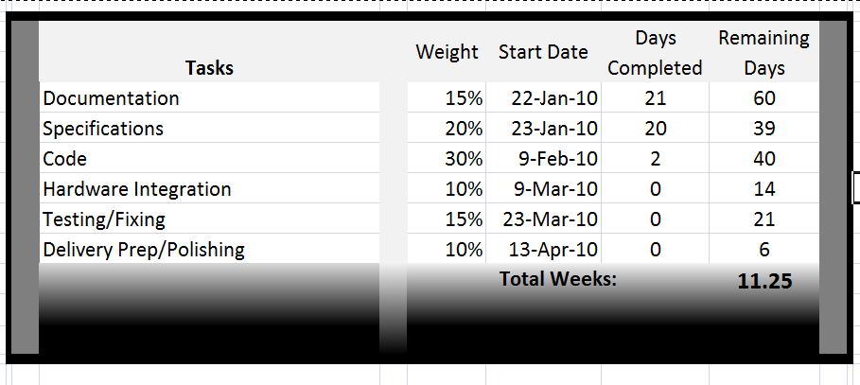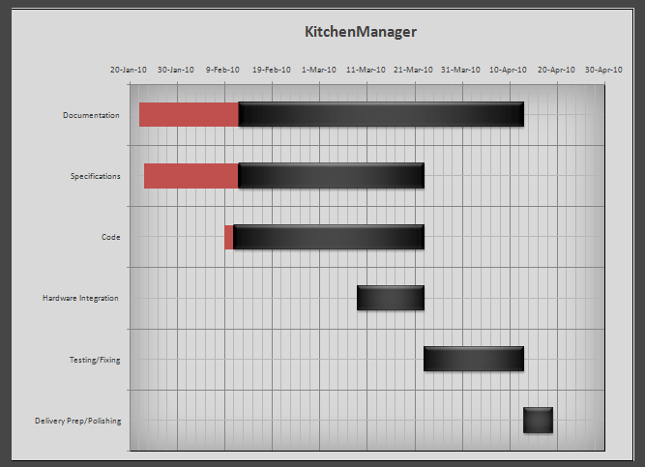

## Administrative Assignments

Cody and Winston will develop the product scope and handle the Project Management overview. They will be in charge of scheduling management, key deliverables, and making any necessary staffing plans. Furthermore, they will handle the prototype details and development of the code, with assistance from other team members if needed.

Ryann, Andre and Adanma will construct the documentation for the final project presentation, presented at the end of the term. Concurrently, they will handle the object-oriented analysis subject of the software requirements specification. This includes class diagrams, use cases, CRC cards, etc. They will also construct the system design, providing detail information to the software requirements including, but not limited to, any required OCLs relevant to the software requirements. The other team members may provide input as necessary.

Software Requirement Specifications

# System Hierarchy

# Class List

|  |  |
| --- | --- |
| Class | Stereotype |
| User | People |
| Touch-Screen Personal Computer | Service Provider |
| Touch Screen Keyboard | Service Provider |
| UPC Scanner / Customer Barcode Scanner | External Entity |
| Food Object Constructor | Structurer |
| Food Relationship Engine | Coordinator |
| User Database | Information Holder |
| Recipe Database | Information Holder |
| Nutrition Information Database | Information Holder |
| Food Inventory Database | Information Holder |
| Recommendations Database | Information Holder |
| Grocer Databases | Coordinator |
| First Time Set-Up Screen | User Interface |
| Main Screen | User Interface |
| User Account Screens | User Interface |
| Food Items Screen | User Interface |
| Item Search Screen | User Interface |
| Food Object Screen | User Interface |
| Food Item Entry Screen | User Interface |
| Item Cart Screens | User Interface |
| Shopping List Screen | User Interface |
| Wi-Fi Printer (Optional) | External Entity |
| USB Weight Scale (Optional) | External Entity |
| Grocer Membership Card w/ Personal Barcode(Optional) | External Entity |

# Use Cases

## Use Case Diagram

## Use Case Text

Name: User create new account

Actor: User

System: 1. User executes program

2. System display Kitchen Manager First-Time setup screen

3. User request log in ID

4. System display available user ID

5. User accept unique user ID

6. System display user information form

7. User enter personal information

8. System accept user information

9. User enter a password

10. System saves user’s personal information

Name: User purchases membership

Actor: User

System: 1. User enter URL into web browser

2. System display Kitchen Manager default page

3. User selects sign in icon

4. System valid sign on information

5. User selects membership option

6. System display membership terms

7. User enter payment information

8. System accept user membership request

Name: User enter food inventory level alert

Actor: User

System: 0. User login into homepage

1. System display user homepage
2. User select food inventory icon
3. System display food inventory preference options
4. User select food inventory minimal level
5. System display food inventory database

Name: User add food to inventory

Actor: User

System: 0. User login into system

1. System display food inventory
2. User scans/keys new food into inventory database
3. System shows Food Item Entry Screen
4. User updates quantity via button or repeat scanning of barcode
5. System stores input and waits for more
6. User selects done or scans/keys new item
7. System updates food inventory database

Name: User deletes food from inventory

Actor: User

System: 0. User login into homepage

1. System display user homepage
2. User select food inventory icon
3. System display food inventory preference options
4. User enter updated food level into inventory database
5. System display updated food inventory database

# Class, Responsibility and Collaborators

## CRC Cards

|  |  |
| --- | --- |
| Name: User | |
| Knows:  Name  Does:  Create account  Login  Add items  Remove items | Collaborates with: |

|  |  |
| --- | --- |
| Name: Add new user screen | |
| Knows:  Input required    Does:  Stores new user | Collaborates with:  User list |

|  |  |
| --- | --- |
| Name: User details screen | |
| Knows:  Current user info    Does:  Shows calorie intake  Display user info | Collaborates with:  User list  Checkout screen |

|  |  |
| --- | --- |
| Name: Switch user screen | |
| Knows:  Current user  Other users  Does:  Add new user  Show user details | Collaborates with:  List of users |

|  |  |
| --- | --- |
| Name: Delete user screen | |
| Knows:  Current user  Other users  Does:  Removes user | Collaborates with:  List of users |

|  |  |
| --- | --- |
| Name: Add food screen | |
| Knows:  Current user  Food inventory  Does:  Adds food to inventory list | Collaborates with:  Inventory database |

|  |  |
| --- | --- |
| Name: Remove food screen | |
| Knows:  Current user  Food inventory  Does:  Removes food from inventory list | Collaborates with:  Inventory database |

|  |  |
| --- | --- |
| Name: In-Stock inventory screen | |
| Knows:  Current user  Food inventory  Does:  Pick a food item  Sort items  Quick add to cart  Items in inventory | Collaborates with:  Inventory database |

|  |  |
| --- | --- |
| Name: In-Stock sort screen | |
| Knows:  Current user  Food inventory  Does:  Sorts by category  Sorts alphabetically | Collaborates with:  Inventory database |

|  |  |
| --- | --- |
| Name: Depleted sort inventory screen | |
| Knows:  Current user  Food inventory  Does:  Sorts by category  Sorts alphabetically | Collaborates with:  Inventory database |

|  |  |
| --- | --- |
| Name: Depleted inventory screen | |
| Knows:  Current user  Food inventory  Does:  Pick a food item  Sort items  Quick add to shopping list  Show low items | Collaborates with:  Inventory database |

|  |  |
| --- | --- |
| Name: System preferences screen | |
| Knows:  Current user preferences  Available color choices  Available language choices  Does:  Changes color  Changes language | Collaborates with:  List of users  Color options  Language options |

|  |  |
| --- | --- |
| Name: View cart screen | |
| Knows:  Current user  Items in cart  Does:  Stores items  Clear list  Save list  Load previous cart  Edit item in list | Collaborates with:  User save cart file |

|  |  |
| --- | --- |
| Name: Checkout screen | |
| Knows:  Current user  Items in cart    Does:  Stores items  Remove items | Collaborates with:  Inventory database |

# Class Diagrams

## Aggregations



## Associations



## Dependencies







## Inheritances



# Sequence Diagrams



