
University of Michigan – Flint
CSC 123 – On Line class

Assignment #2- Creating a Research Paper!

- Run through the whole project, starting on page WD74 – WD 125. Save the file as “biometrics paper.doc” and send it to me through the assignment link. Your first and last name must be on all documents as a header.

- Create your own research paper with at least 3 pages long not including a title page and a works Cited. You pick the subject. Must have a title page and References (Works Cited). Suppress the page number for the title page and make the page number start at 0. Set it through the toolbar when creating the header. There is a page setup button and a format page button on the header/footer toolbar. Save the file as “myresearch.doc” and send it to me through the assignment link.
See Title page example:
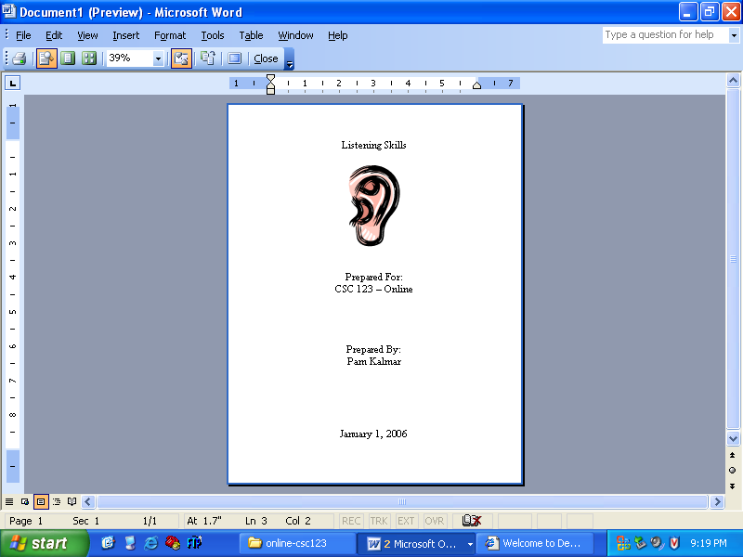

Using blackboard send both the documents to me through the assignment link.

