CSC 265-1 Name__________________________________________
Final Exam December 13, 2000

1. ( 32 pts.) Matching; Answers may be used 0, 1 or more times. Select the ONE BEST choice.

- AND gate
- NAND gate
- Asynchronous
- Bus
- Combinational Circuit
- Sequential Circuit

Decoder
- Multiplexor
- Encoder
- Dynamic RAM
- Static RAM
- ROM
- IP, IA or PC
- Memory Address Register ( MAR)
- Memory Buffer Register ( MBR )
- Propagation Delay Time
- Small Scale Integration (SSI)

______ A channel or path for transferring binary data and electric signals.
______ A measure of the speed with which a signal can travel from the input to the output of a digital logic device.
______ A circuit whose outputs depend solely on its current input.
______ A Circuit constructed of AND, OR, EXOR, NOR, and NAND gates exclusively.
______ The least expensive type of memory.
______ This type of memory has the fastest access time.
______ An eight bit shift register is an example of this type of circuit.
______ Memory constructed from flip-flops, such that values stored remain intact as long as power is on.
______ Non-erasable, permanently programmed memory.
______ Any circuit can be designed using this gate type exclusively, it is functionally complete.
______ Special register in the Processor Unit which contains the address of the next instruction to be executed.
______ Storage for the data to be written into or read from a memory location.
______ The output of this circuit is a function of both the input and the current STATE of the circuit.
______ Very volatile RAM memory which must be "refreshed" at frequent intervals to avoid loss of data. Built with a capacitor.
______ An IC device with N input lines and up to 2^{N} output lines. All of the output lines will be low except for the selected line which will be high.
______ A data selector IC device. Selection lines determine which of the many input lines will be selected to transfer the single output line.

2. (2 pts.) How many SELECTION LINES are required for a Multiplexer with 19
input lines?______

3. (10 pts. total) Use the Truth Table and Kmaps below to design a Full Adder. ( You do not have to draw the circuit, just derive the equations for Sum and Carry out.
a | b | C_{in} | Sum | C_{out} |  |  |  |  |  | \C_{in}  A B\ |  | 0 | 1 |  | \C_{in}  A B\ |  | 0 |  | 1
0 | 0 | 0 |  |  |  |  |  |  |  | 0 0 |  |  |  |  | 0 0
0 | 0 | 1 |  |  |  |  |  |  |  | 0 1 |  |  |  |  | 0 1
0 | 1 | 0 |  |  |  |  |  |  |  | 1 1 |  |  |  |  | 1 1
0 | 1 | 1 |  |  |  |  |  |  |  | 1 0 |  |  |  |  | 1 0
1 | 0 | 0 |  |  |  |  |  |  |  |  | Sum |  |  |  |  | Cout
1 | 0 | 1 |  |  |  | Sum =
1 | 1 | 0
1 | 1 | 1 |  |  |  | Cout=

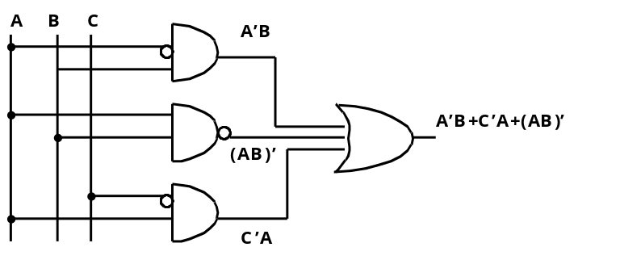
4. (4 pts) Gate Transformations Convert this circuit to one constructed out of all NAND gates. Do not simplify the circuit using boolean algebra.

5. (12 pts) Design a binary counter using D flip-flops that behaves as follows:
count sequence: when x =0 0ð3ð1ð2ð0ð3ð1ð2ð
when x =1 0ð2ð1ð3ð0ð2ð1ð3ð

Draw State Transition Diagram for this circuit.
Present State |  | Input | Next State |  | Flip Flop Inputs
Q₁ | Q₂ | X | Q₁ | Q₂ | D₁ | D₂
0 | 0 | 0
0 | 0 | 1
0 | 1 | 0
0 | 1 | 1
1 | 0 | 0
1 | 0 | 1
1 | 1 | 0
1 | 1 | 1

\X  Q₁Q₂\ | 0 | 1 |  |  | \X  Q₁Q₂\ | 0 | 1
0 0 |  |  |  |  | 0 0
0 1 |  |  |  |  | 0 1
1 1 |  |  |  |  | 1 1
1 0 |  |  |  |  | 1 0
D₁ = |  |  |  |  | D₂ =

6. (8 pts.) Draw the State Transition Diagram for a Mealy circuit (output a factor of state transitions ) to recognize a 1001 input sequence where overlapping sequences are ignored. You WILL NOT design this circuit, simply draw the STD.

0 1 0 0 1 0 0 1 0 0 1 1 1 0 0 0 1 0 0 1 Given Input Data
0 0 0 0 1 0 0 0 0 0 1 0 0 0 0 0 0 0 0 1 Corresponding Output

State | Meaning
A = 00
B = 01
C = 11
D = 10
PS NS | J K input
0ð0
0ð1
1ð0
1ð1

7. (4 pts) Fill in the JK flip flop excitation table, then use the table to derive the flip-flop inputs required to cause the present state/ next state transitions specified in the table below.

8. (14 pts.) A Moore type, sequential circuit has one input, one output and four states, represented by the STD below. Design the circuit using JK flip flops.
A
0
C
0
B
0
D
1
1
1
0
0
0
1
1
0
input
state
output

State Assignments: |  |  |  | Present State |  |  |  |  | input |  | Next State |  |  |  | output |  |  |  |  | Flip Flop Inputs
 |  |  |  | Q₁ | Q₂ |  |  | X |  | Q₁ |  |  | Q₂ |  |  | Z |  |  | J₁ |  |  |  | K₁ |  | J₂ | K₂
A = 00 |  |  |  | 0 | 0 |  |  | 0
 |  |  |  | 0 | 0 |  |  | 1
B = 01 |  |  |  | 0 | 1 |  |  | 0
 |  |  |  | 0 | 1 |  |  | 1
C = 11 |  |  |  | 1 | 0 |  |  | 0
 |  |  |  | 1 | 0 |  |  | 1
D = 10 |  |  |  | 1 | 1 |  |  | 0
 |  |  |  | 1 | 1 |  |  | 1
 | \ X  Q1Q2 \ | Input  0 | 1 |  |  |  | \ X  Q1Q2 \ |  |  |  |  | Input  0 |  | 1 |  |  |  |  |  |  | \ X  Q1Q2 \ |  |  | Input  0 |  |  | 1
 | A=00 |  |  |  |  |  | A=00 |  |  |  |  |  |  |  |  |  |  |  |  |  | A=00
 | B=01 |  |  |  |  |  | B=01 |  |  |  |  |  |  |  |  |  |  |  |  |  | B=01
 | C=11 |  |  |  |  |  | C=11 |  |  |  |  |  |  |  |  |  |  |  |  |  | C=11
 | D=10 |  |  |  |  |  | D=10 |  |  |  |  |  |  |  |  |  |  |  |  |  | D=10
 | Output Z= |  |  |  |  | J₁ = |  |  |  |  |  |  |  |  |  |  |  |  |  |  |  | K₁ =

\ X  Q1Q2 \ | Input  0 | 1 |  | \ X  Q1Q2 \ | Input  0 | 1
A=00 |  |  |  | A=00
B=01 |  |  |  | B=01
C=11 |  |  |  | C=11
D=10 |  |  |  | D=10
J₂ = |  |  | K₂ =

9. (2 pts.) If a processor unit uses 5 bits to represent an operation code, how many different instructions could this processor implement? ___________
10. (12 pts.) Use the diagram on the next page, of the processor unit we have studied in class the last couple weeks. Complete the table below, refering to the table following the diagram, indicating control word field assignments. When a field, does not effect the result, place XXX in place of bit positions.

 | Control Word Bits
MicroOperations |  | A | B | D |  | F | H
R1⇐ R2 + R1
R3⇐ R3 – R2
R7 ⇐ R7 - 1
R2 ⇐ R6 ⊕ R4
R6 ⇐ 0
R7⇐SHR (R7+R3)
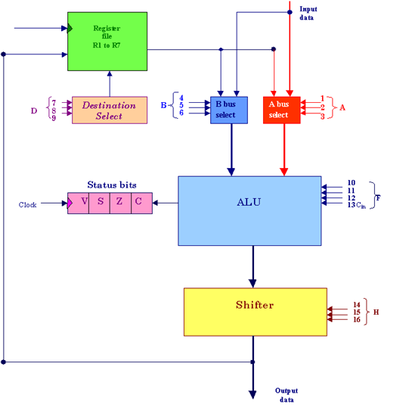
1 | 2 | 3 | 4 |  | 5 | 6 | 7 |  | 8 | 9 | 10 |  | 11 | 12 | 13 | 14 | 15 | 16
A |  |  |  | B |  |  |  | D |  |  |  | F |  |  |  | H

Control word

Encoding of Control Word: Function of selection fields
binary  code | A | B | D | F with  Cin = 0 | F with  Cin = 1 | H
000 | input | Input | Input | F = A | F = A + 1 | No shift
001 | R1 | R1 | R1 | F = A + B | F = A + B+1 | SHL
010 | R2 | R2 | R2 | F = A + B' | F = A - B | SHR
011 | R3 | R3 | R3 | F = A - 1 | F = A | Bus=0
100 | R4 | R4 | R4 | F = A^B (and) | - | -
101 | R5 | R5 | R5 | F = AvB (or) | - | ROL
110 | R6 | R6 | R6 | F = A⊕B | - | ROR
111 | R7 | R7 | R7 | F = A' | - | -

