CSC 265-1 Name__________________________________________
Final Exam December 12, 1996
1. (18 pts.) Matching; Select the ONE BEST choice.
A) Combinational Circuit G) Static RAM
B) Sequential Circuit H) Dynamic RAM
C) IP, IA or PC I) Small Scale Integration (SSI)
D) Memory Address Register ( MAR) J) Bus
E) Memory Buffer Register ( MBR ) K) Propagation Delay Time
F) ROM L) Asynchronous
J A channel or path for transferring data and electric signals.
K A measure of the speed with which a signal can travel from the input to the output of a digital logic device.
A Circuit whose outputs depend solely on its current input.
G Memory constructed from flip-flops, such that values stored remain intact as long as power is on.
F Non-erasable, permanently programmed memory.
C Special register in the Processor Unit which contains the address of the next instruction to be executed.
E Storage for the data to be written into or read from a memory location.
B The output of this circuit is a function of both the input and the current STATE of the circuit.
H Very volatile RAM memory which must be "refreshed" at frequent intervals to avoid loss of data. Built with a capacitor.

2. (4 pts.) Use 5 BINARY DIGITS to illustrate the following signed numbers representations

Sign-Magnitude: | 12 | 0 1 1 0 0 | -12 | 1 1 1 0 0
Two's complement: | 12 | 0 1 1 0 0 | -12 | 1 0 1 0 0

- (2 pts.) How many SELECTION LINES are required for a Multiplexer with 21 input lines? 5

4. (6 pts.) Illustrate the SUBTRACTION operation using addition and two's complement, with SIX binary digits.
21 | 0 1 0 1 0 1 | 0 1 0 1 0 1
- 9 | 0 0 1 0 0 1(+9) | 1 1 0 1 1 1(+9)
12 |  | 0 0 1 1 0 0

5. (4 pts.) Fill in the truth table for the function F(a,b), where extra columns have been included for computing intermediate outputs; Oa, Ob & Oc.
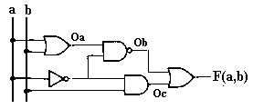
a | b | Oa | Ob | Oc | F(a,b)
0 | 0 | 0 | 1 | 0 | 1
0 | 1 | 1 | 0 | 1 | 1
1 | 0 | 1 | 1 | 0 | 1
1 | 1 | 1 | 1 | 0 | 1
6. (3 pts.) Write the logical expression for the circuit diagram in question #5 in terms of inputs a & b..

F(a,b)= ((A+B)*A’)’ + A’*B

7. (3 pts.) Re-draw the equation in question #5, using only NAND gates & inverters where necessary. ( If the circuit output is not exactly the same as that in question 5 you will receive 0 points. If you have extra unnecessary gates points will be deducted.)
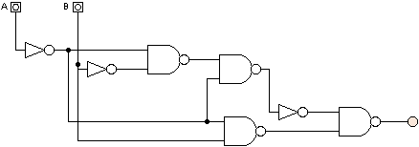

8. (4 pts. total) Use the Truth Table and Kmaps below to design a Full Adder. ( You do not have to draw the circuit, just derive the equations for Sum and Carry out.

A B | C_{in} | C_{out} | Sum |  | \ C_{in}  A B\ | 0 | 1 |  | \ C_{in}  A B\ | 0 | 1
0 0 | 0 |  |  |  | 0 0 | 0 | 1 |  | 0 0 | 0 | 0
0 0 | 1 |  |  |  | 0 1 | 1 | 0 |  | 0 1 | 0 | 1
0 1 | 0 |  |  |  | 1 1 | 0 | 1 |  | 1 1 | 1 | 1
0 1 | 1 |  |  |  | 1 0 | 1 | 0 |  | 1 0 | 0 | 1
1 0 | 0
1 0 | 1 |  |  |  | Sum = A’B’C + A’BC’+ABC+AB’C’  = A ⊕ B ⊕ C |  |  |  | C_{out}= AB + AC_{in} + BC_{in}
1 1 | 0
1 1 | 1

9. ( 4 pts.) BIOS- Basic Input Output Service routines are an example of ROM memory, while registers inside the processing unit are constructed from Static RAM memory.

10. (4 pts.) List advantages and disadvantages of the following types of memory.

DYNAMIC RAM | Adv | Disadv
Higher packing density  Lower power consumption  Less expensive |  | Requires complicated refresh circuitry  Slower access time
STATIC RAM | Adv | Disadv
Faster access time |  | Higher power consumption  Takes up more space

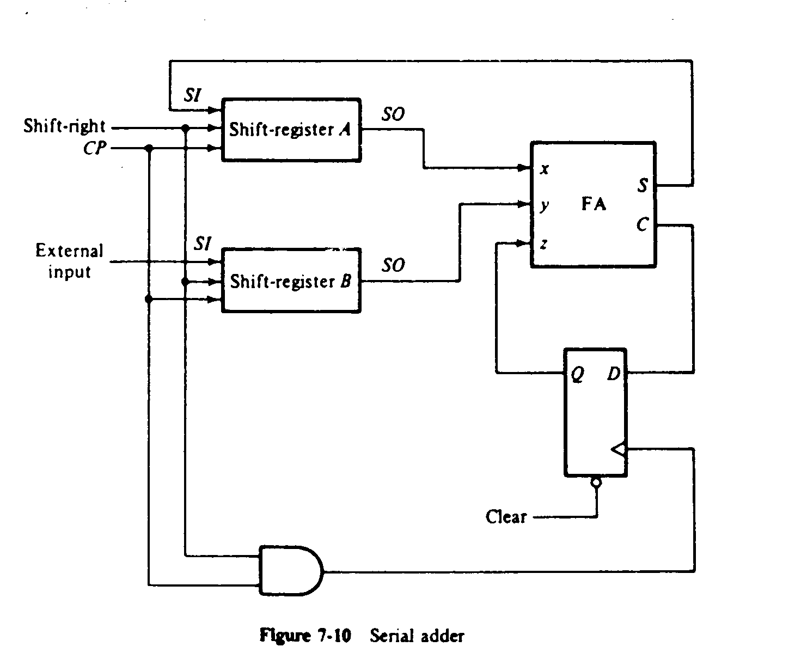
- (6 pts. total) In the following serial adder, trace the contents of registers A & B, at each clock pulse, given initial values specified for the two four bit shift registers, A & B .

Disregard This Question

Initial Data: | A₃ | A₂ | A₁ | A₀ | Clock Pulse | B₃ | B₂ | B₁ | B₀
Reg. A | 0 | 1 | 0 | 1 | T₀ | 0 | 0 | 1 | 1 | Reg. B
 | 0 | 0 | 1 | 0 | T₁ | x | 0 | 0 | 1
 | 0 | 0 | 0 | 1 | T₂ | x | x | 0 | 0
 | 0 | 0 | 0 | 0 | T₃ | x | x | x | 0
 | 1 | 0 | 0 | 0 | T₄ | x | x | x | x

12. (6 pts. total) Derive a MINIMIZED function for the following K-Maps in both Sum of Products and Product of Sums form.

\ CD  A B \ | 0 0 | 0 1 | 1 1 | 1 0
0 0 | 1 | 1 | 1 | 1
0 1 | 0 | 1 | 1 | 0
1 1 | 0 | 1 | 0 | 0
1 0 | 1 | 1 | 0 | 1
\ CD  A B \ | 0 0 | 0 1 | 1 1 | 1 0
0 0 | 1 | 1 | 1 | 1
0 1 | 0 | 1 | 1 | 0
1 1 | 0 | 1 | 0 | 0
1 0 | 1 | 1 | 0 | 1

f(A,B,C,D) = (A’+C’+D’)*(B’+D) f(A,B,C,D) = C’D + A’D + B’D’
POS minimized function SOP minimized function

13. (4 pts. total) Fill in the JK flip flop excitation table, then use the table to derive the flip-flop inputs required to cause the present state/ next state transitions specified in the table that follows.

Present State |  |  | Next State |  | Flip Flop Inputs
Q₂ | Q₁ | Q₂ |  | Q₁ |  | J₂ | K₂ | J₁ | K₁
0 | 0 | 0 |  | 1 |  | 0 | d | 1 | d
0 | 1 | 1 |  | 0 |  | 1 | d | d | 1
1 | 0 | 1 |  | 0 |  | d | 0 | 0 | d
1 | 1 | 0 |  | 1 |  | d | 1 | d | 0
PS NS | J K input
0ð0 | 0d
0ð1 | 1d
1ð0 | d1
1ð1 | d0

14. (8 pts. total) Design a binary counter using D flip-flops that behaves as follows:
when x =0 count sequence: 0ð2ð1ð3ð0ð2ð1ð3ð
x =1 count sequence: 0ð3ð1ð2ð0ð3ð1ð2ð

Draw the State Transition
Present State |  | Input | Next State |  | Flip Flop Inputs
Q₂ | Q₁ | X | Q₂ | Q₁ | D₂ | D₁
0 | 0 | 0 | 1 | 0 | 1 | 0
0 | 0 | 1 | 1 | 1 | 1 | 1
0 | 1 | 0 | 1 | 1 | 1 | 1
0 | 1 | 1 | 1 | 0 | 1 | 0
1 | 0 | 0 | 0 | 1 | 0 | 1
1 | 0 | 1 | 0 | 0 | 0 | 0
1 | 1 | 0 | 0 | 0 | 0 | 0
1 | 1 | 1 | 0 | 1 | 0 | 1

00
10
01
11
X=0
X =1

\X  Q2Q1\ | 0 | 1 |  |  | \X  Q2Q1\ | 0 | 1
0 0 | 1 | 1 |  |  | 0 0 | 0 | 1
0 1 | 1 | 1 |  |  | 0 1 | 1 | 0
1 1 | 0 | 0 |  |  | 1 1 | 0 | 1
1 0 | 0 | 0 |  |  | 1 0 | 1 | 0
D2 = Q₂’ |  |  |  | D1 = Q₁ + Q₂ + X
- (5 pts. total) Bit Sequence Detector Circuit: You are to begin the design of a Moore type circuit, to detect an input sequence of 110. You are not required to design the entire circuit, just the following:
- Draw the STD for this circuit,
- Label the states with binary assignments and descriptive meanings for the states.
- Fill in the truth table to derive an equation for the output only.

Draw the State Transition Diagram
A
0
B
0
C
0
D
1
1
1
1
0
0
0
0
1
 | \ X Q2Q1 | Input  0 | 1
 | = 00
 | = 01
 | = 11 | 1 | 1
 | = 10
Output Z = Q2Q1

16. (12 pts.) A sequential circuit has one input, one output and four states, represented by the STD below. Design the circuit using whatever type of flip flop you prefer.
State | Binary Code | Meaning
A= | 00 | Waiting for first 1 input
B= | 01 | First or potential first 1 has been input
C= | 10 | Last 2 inputs were 1
D= | 11 | Recognized input of 110

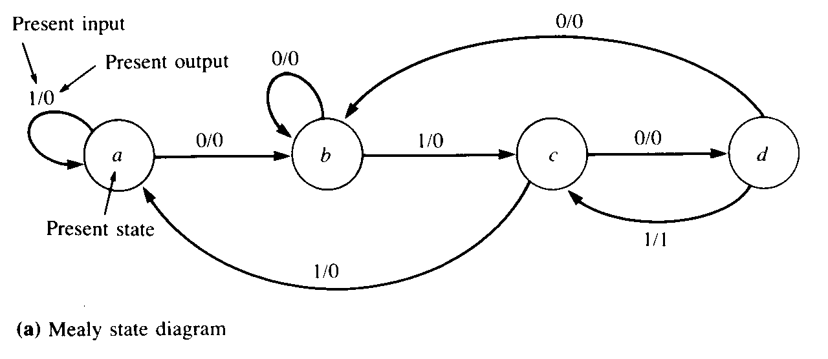

State | Binary Code | Output | Meaning
A= | 0 0 |  | Waiting for first zero
B= | 0 1 |  | Potential first zero has been input
C= | 1 0 |  | Last 2 inputs were 01
D= | 1 1 |  | Last 3 inputs were 010

\ X  Q2Q1 \ | Input  0 | 1 |  | \ X  Q2Q1 \ | Input  0 | 1 |  | \ X  Q2Q1 \ | Input  0 | 1
A = 00 | B/0 | A/0 |  | =00 | 0 1 | 0 0 |  | =00 | 0 | 0
B =01 | B/0 | C/0 |  | =01 | 0 1 | 1 0 |  | =01 | 0 | 0
D =11 | D/0 | A/0 |  | =11 | 1 1 | 0 0 |  | =11 | 0 | 0
C =10 | B/0 | C/1 |  | =10 | 0 1 | 1 0 |  | =10 | 0 | 1

State/Output Transitions | Next State Transitions Q2Q1 (T+Δ) | Output Z = Q₂Q₁’X

 | \ X  Q2Q1 \ | Input  0 | 1 |  | \ X  Q2Q1 \ |  | Input  0 | 1 |  | \ X  Q2Q1 \ |  | Input  0 | 1
 | 0 0 | 0 | 0 |  | 0 0 |  | 0d | 0d |  | 0 0 |  | 0 | 0
 | 0 1 | 0 | 1 |  | 0 1 |  | 0d | 1d |  | 0 1 |  | 0 | 1
 | 1 1 | 1 | 0 |  | 1 1 |  | d0 | d1 |  | 1 1 |  | d | d
 | 1 0 | 0 | 1 |  | 1 0 |  | d1 | d0 |  | 1 0 |  | d | d
Q_{2(T+Δ)} Transitions |  |  |  |  |  | J₂ K₂ Excitations |  |  |  |  | J₂ = Q₁X
 | \ X  Q2Q1 \ | Input  0 | 1 |  | \ X  Q2Q1 \ |  | Input  0 | 1 |  | \ X  Q2Q1 \ |  | Input  0 | 1
 | 0 0 | d | d |  | 0 0 |  | 1 | 0 |  | 0 0 |  | 1d | 0d
 | 0 1 | d | d |  | 0 1 |  | 1 | 0 |  | 0 1 |  | d0 | d1
 | 1 1 | 0 | 1 |  | 1 1 |  | 1 | 0 |  | 1 1 |  | d0 | d1
 | 1 0 | 1 | 0 |  | 1 0 |  | 1 | 0 |  | 1 0 |  | 1d | 0d
K₂= Q₁’X’ + Q₁X |  |  |  |  |  | Q_{1(T+Δ)} Transitions |  |  |  |  | J₁ K₁ Excitations

\ X  Q2Q1 \ | Input  0 | 1 |  |  | \ X  Q2Q1 \ | Input  0 | 1
0 0 | 1 | 0 |  |  | 0 0 | d | d
0 1 | d | d |  |  | 0 1 | 0 | 1
1 1 | d | d |  |  | 1 1 | 0 | 1
1 0 | 1 | 0 |  |  | 1 0 | d | d
J₁ = X’ |  |  |  | K₁= X

Label the flip flop type then complete the Final Circuit Diagram

Z
X
Q₂
clock
Q₂’
Q₁
clock
Q₁’
clock

17. ( 7 pts.) Fill in the control word bits and symbolic description for the specified microperations of the processor model below.
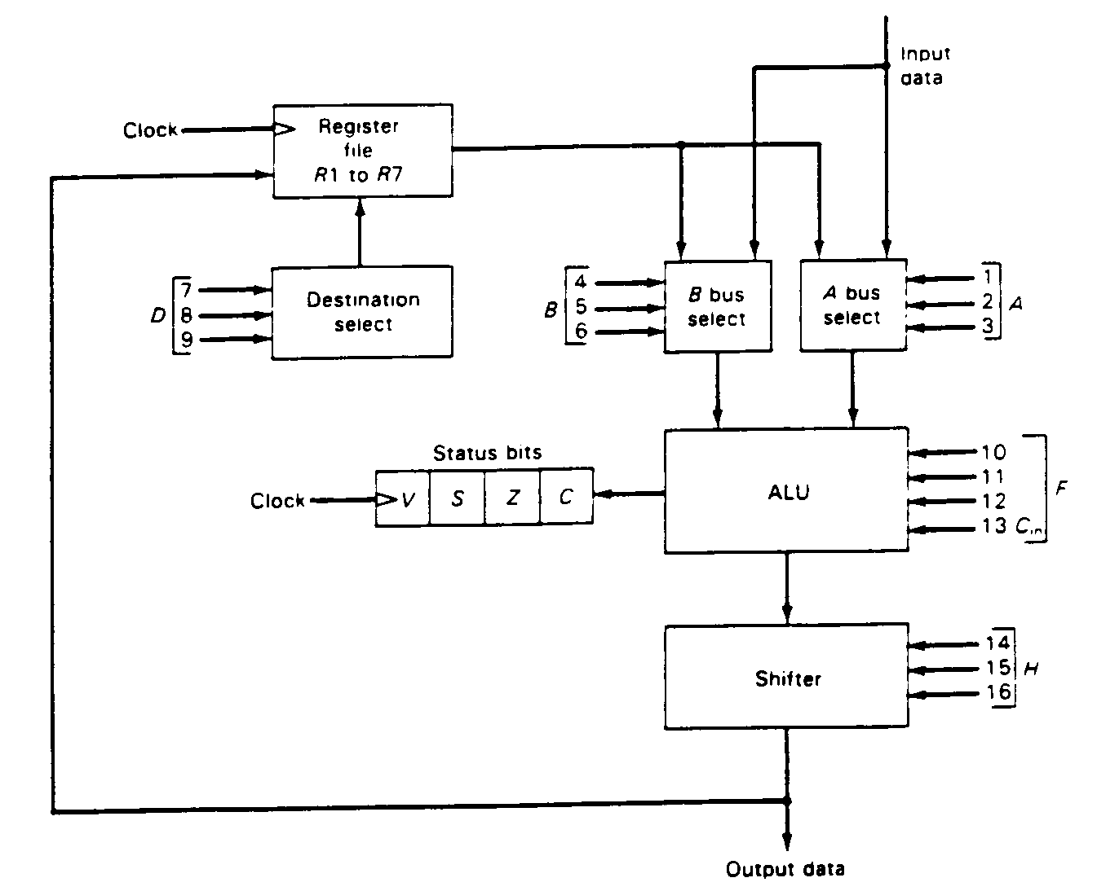
Figure 7-20: Processor Unit with Control Variables (a) Block diagram

(b) Control Word
1 2 3 | 4 5 6 | 7 8 9 | 10 11 12 13 | 14 15 16
A | B | D | F | H

Encoding of Control Word for Processor Unit: Function of selection fields
Binary |  |  |  | F with | F with
code | A | B | D | Cin = 0 | Cin = 1 | H
000 | input | Input | Input | F = A | F = A + 1 | No shift
001 | R1 | R1 | R1 | F = A + B | F = A + B+1 | SHL
010 | R2 | R2 | R2 | F = A + B' | F = A - B | SHR
011 | R3 | R3 | R3 | F = A - 1 | F = A | Bus=0
100 | R4 | R4 | R4 | F = A^B (and) | - | -
101 | R5 | R5 | R5 | F = AvB (or) | - | ROL
110 | R6 | R6 | R6 | F = A⊕B | - | ROR
111 | R7 | R7 | R7 | F = A' | - | -
Complete the table below, the partial answer to the first Symbolic Designation field has been filled in.

MicroOperations |  | Symbolic designation |  |  |  |  | Control Word Bits
 | A |  | B | D | F | H |  | A | B | D | F | H
R1⇐ R2 + R1 | R2 |  | R1 | R1 | A+B | No shift |  | 010 | 001 | 001 | 0010 | 000
R3⇐ R3 -Input | R3 |  | input | R3 | A-B | No shift |  | 011 | 000 | 011 | 0101 | 000
R7 ⇐ R7 –1 | R7 |  | --- | R7 | A-1 | No shift |  | 111 | --- | 111 | 0110 | 000
R2 ⇐ R6 ⊕R4 | R6 |  | R4 | R2 | A⊕B | No shift |  | 110 | 100 | 010 | 1100 | 000
R7 ⇐ 0 | --- |  | --- | R7 | --- | Bus=0 |  | --- | --- | 111 | ---- | 011

