CC 265 LAB #1- 20 points NAME_______________________________________
Due Demonstration Combined Circuit:____________ Date_______
Demonstration Simplified Circuit:____________ Date_______

Experiment 1 - Analysis, Construction, and Testing of Binary Circuits. Pages 34-37 of text Digital Design by Peter Purger.

OVERVIEW:
Two combinational binary circuits are constructed in this experiment. The first has three inputs and two outputs; the second, two inputs and one output. You will fill in Truth Tables for both circuits with Predicted output data derived thru paper analysis of the circuits. Next you will construct each circuit, testing the Actual experimental output to verify your predictions.

After building and testing the individual circuits, they will be combined. The output lines of the first circuit will be used as input to the second. You will again make analytical predictions as to the output generated by this combined circuit and verify those predictions by experimentation. You will demonstrate your combined circuit to the lab assistant.

The final portion of this lab has you deriving a simplified circuit equivalent in behavior to your combined circuit. Boolean algebra simplification will be used to reduce the circuit. A correct simplified circuit will have the same behavior as your combined circuit i.e. the truth table output columns will be equivalent. You will construct the simplified circuit to verify its' behavior.

The Digital Works file you submit in Blackboard should contain, BOTH the combined circuits, and the simplified circuits.

PART I. CIRCUIT #1: You will be assigned one of the 4 circuits below, to implement as your circuit 1. See http://packard.csesp.umflint.edu/~hickslm/266/Lab1CircuitAssign.htm for your assigned circuit. (This file is also in my progdata folder 266.)

- Circle the circuit you have selected to implement.

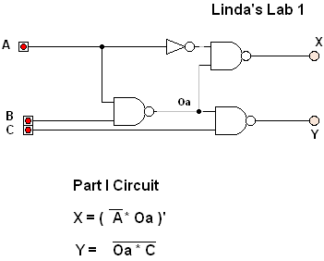

2. Analytically predict the output of this circuit, by filling in the Predicted output columns Xp & Yp, in
Truth Table 1-1.

3. Construct the circuit and test the output produced by the circuit you've built. Fill in the Actual output columns Xa & Ya, in the truth table below. Does it match your Predicted output? If not review your predictions and assembled circuit to deter-mine which is in the error.

Truth Table 1-1
 |  | Inputs |  | ignor for circuit 1A | Predicted Behavior |  | Actual as Implemented
A’ | A | B | C | OA | XP | YP | XA | YA
1 | 0 | 0 | 0 | 1 | 0 | 1 | 0 | 1
1 | 0 | 0 | 1 | 1 | 0 | 0 | 0 | 0
1 | 0 | 1 | 0 | 1 | 0 | 1
1 | 0 | 1 | 1 | 1 | 0 | 0
0 | 1 | 0 | 0 | 1 | 1 | 1
0 | 1 | 0 | 1 | 1 | 1 | 0
0 | 1 | 1 | 0 | 0 | 1 | 1
0 | 1 | 1 | 1 | 0 | 1 | 1

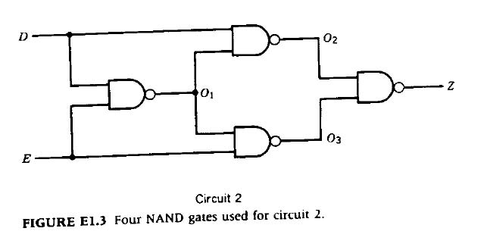

PART II CIRCUIT #2:

Everyone will construct the same version of circuit #2. Fill in Truth Table 1-2 with output predictions, construct the circuit and verify its' behavior. Locate and correct any errors.

Truth Table 1-2

Inputs |  | Intermediate Outputs |  |  | Predicted  Behavior | Actual as  implemented
D | E | O₁ | O₂ | O₃ | Z_{P} | Z_{A}
0 | 0 | 1 | 1 | 1 | 0
0 | 1 | 1 | 1 | 0 | 1
1 | 0 | 1 | 0 | 1 | 1
1 | 1 | 0 | 1 | 1 | 0

PART III. COMBINED CIRCUIT:

Combine the two circuits you have built, by connecting outputs X and Y of circuit 1 to inputs D & E of circuit 2. Fill in Truth Table 1-3 with predicted output Z_{P} by filling in column D with values copied from Table 1-1 columns Xp=Xa, likewise fill in column E with values taken from columns Yp=Ya.
Since Table 1-2 specifies outputs for all combinations of inputs on the D & E lines, fill in predicted output column Zp given the D & E inputs in table 1-3.

Truth Table 1-3 |  |  |  |  | Predicted | Actual
A | B | C | D=X | E=Y | Z_{P} | Z_{A}
0 | 0 | 0 | 0 | 1
0 | 0 | 1 | 0 | 0
0 | 1 | 0 | 0 | 1
0 | 1 | 1 | 0 | 0
1 | 0 | 0 | 1 | 1
1 | 0 | 1 | 1 | 0
1 | 1 | 0 | 1 | 1
1 | 1 | 1 | 1 | 1

Next experimentally test your circuit to determine the actual output, Z_{A} values. When the predicted and experimental output columns agree, demonstrate your circuit to the Instructor or Lab. Assistant. In Digital Works, select your combined circuit and copy it to the clipboard. Open this word document file and paste your combined circuit here:

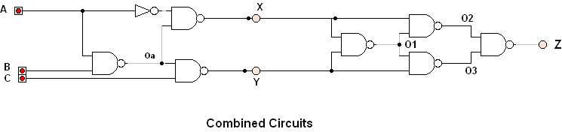

PART IV. SIMPLIFIED CIRCUIT:
Define output variables first in terms of intermediate variables, apply rules of Boolean Algebra where applicable then replace intermediate variables with their simplified representation arrived at earlier.

Show each step taken in the process of arriving at a simplified logic expression in Sum Of Products form.
Circuit #1______
Oa =_______________________________________________________________________________________________

Y =________________________________________________________________________________________________
___________________________________________________________________________________________________
___________________________________________________________________________________________________

X = ________________________________________________________________________________________________
___________________________________________________________________________________________________
___________________________________________________________________________________________________

Circuit #2
O1=________________________________________________________________________________________________
___________________________________________________________________________________________________

O2=________________________________________________________________________________________________
___________________________________________________________________________________________________

O3=________________________________________________________________________________________________
___________________________________________________________________________________________________

Z=_________________________________________________________________________________________________
___________________________________________________________________________________________________

When Z has been expressed solely in terms of variables D & E replace D and E with the simplified representation of X and Y. Your final logical expression will have three inputs A,B & C one output Z and be in Sum of Products ( SOP ) form.

Z =________________________________________________________________________________________________
___________________________________________________________________________________________________

___________________________________________________________________________________________________

___________________________________________________________________________________________________

___________________________________________________________________________________________________

If you have not made an error in Boolean Algebra, the predicted output column of Truth Table 1-4, Z_{P} should match the output of the combined circuit in Truth Table 1-3. Fill in the actual output column Z_{A}, of Truth Table 1-4 by building and testing this simplified Sum Of Products circuit. When you have implemented a correct simplified circuit, demonstrate your working circuit to and instructor or lab assistant.

Truth Table 1-4 |  |  |  | Predicted |  | Actual
A | B | C |  |  | Z_{P} | Z_{A}
0 | 0 | 0
0 | 0 | 1
0 | 1 | 0
0 | 1 | 1
1 | 0 | 0
1 | 0 | 1
1 | 1 | 0
1 | 1 | 1

If you have not made an error in Boolean Algebra, the predicted output column of Truth Table 1-4, Z_{P} should match the output of the combined circuit in Truth Table 1-3. Fill in the actual output column Z_{A}, of Truth Table 1-4 by building and testing this simplified SOP circuit.

When you have implemented a correct simplified circuit, demonstrate your working circuit to and instructor or lab assistant. Select your simplified circuit in Digital Works, copy it to the clipboard, and then paste it into this document here:

