CSC 265 LAB #2- 20 points NAME __Cody Adams_________________
Due Date:Wednesday October 5th Date & Verified By:________________________

You are to build a circuit to generate three Boolean functions of two variables. The three groups of functions are listed below, labeled O1, O2 and O3. Select one function from each group for implementation. A black box view of this lab is presented below.

O1
O2
O3
A
B

In implementing this lab, I am asking that you design the circuits in a step-wise fashion. (Something like you are encouraged to do, when you are developing a large software project.) The first step has you building the three separate circuits to generate the three outputs. In Step 2, I’m asking you to look for gates that can be eliminated because that function is already implemented. (such as A*B for O1 and (A * B) as part of O3. The last, Step 3, has you converting this combined circuit to one constructed using all NAND gates. Here you are minimizing the number of IC’s used to create the circuit.

Lab 2 Function Options from pages 58-63 Digital Design
Functions you have selected to implement
O1 | O2 | O3
 | A' + B |  |  | O1= | A * B
A * B | A + B' | (A * B') + (A' * B) |  | O2= | A' * B
A + B | A' * B | (A * B) + (A' * B') |  | O3= | (A * B) + (A' * B')
 | A * B'

Truth Table for 3 functions selected, with extra columns for computing intermediate outputs.

A | B |  | O1 |  | O2 |  | A’ * B’ | O3
0 | 0 |  | 0 |  | 0 |  | 1 | 1
0 | 1 |  | 0 |  | 1 |  | 0 | 0
1 | 0 |  | 0 |  | 0 |  | 0 | 0
1 | 1 |  | 1 |  | 0 |  | 0 | 1

Step 1:
Circuit diagrams of three functions selected as implemented in Digital Works.: (Copy the circuits from Digital Works and paste them below.)
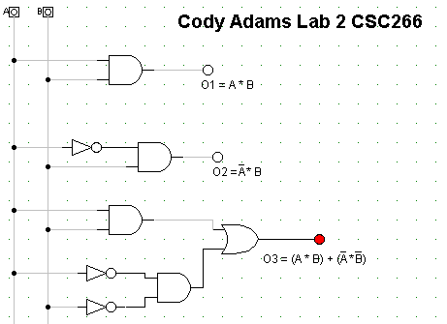

Step 2:
The internal construction of the circuit you build is constrained by allowing only two types of gates: either all NAND and INVERTER gates or all NOR and INVERTER gates. Your goal is to build a circuit of 2 inputs and 3 outputs using the minimum number of IC's. First examine the three separate circuits to determine if you can, combine all or portions of two different functions. (Note: depending no the three functions, you’ve selected to implement, you may not be able to combine portions of two different functions.)
Circuit diagram for 3 functions where duplicate gates are combined: : Construct the three circuits after redundancies are eliminated, copy the diagrams from Digital Works and paste them below.

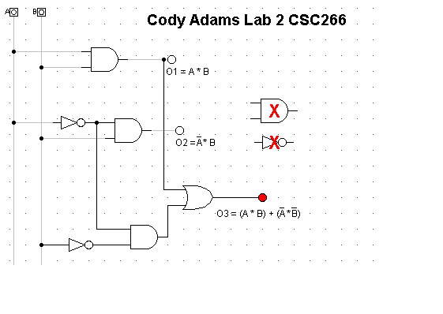
Step 3:
Next make appropriate gate transformations to convert the circuit to all NAND / INVERTER gates.
Make gate transformation on the above circuit to create a circuit constructed of all NAND/inverter gates. ( For all NAND gates first convert AND's to NANDs then convert OR's to NANDs. ) Construct your circuit made with all NAND or NOR gates in Digital Works, then copy and paste the circuit below:

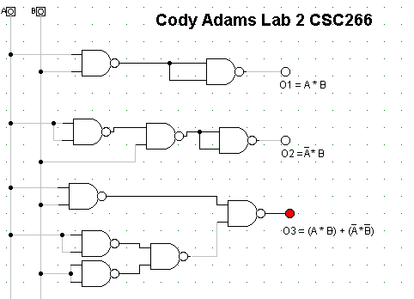

Construct and experimentally verify the behavior of your circuit, built using a minimum number of IC's. Demonstrate the circuit to a lab assistant or instructor.

Output of Final Combined Circuit Boolean functions from the diagram above.
A | B | O1 | O2 | O3 |  | O1=
0 | 0 | 0 | 0 | 1
0 | 1 | 0 | 1 | 0 |  | O2=
1 | 0 | 0 | 0 | 0
1 | 1 | 1 | 0 | 1 |  | O3=

NOTE: Before you hand this lab assignment in, make a record of this truth table and the functions you have selected. You will need this information for the next two lab assignments.

