CSC 265 LAB #8 - 30 points Sec. #_____ Name:________________________________________
Due Date: Wednesday Dec. 7th Complete Circuit Demo/Date__________
NO LATE LABS Wednesday Dec. 7th is the last day you may receive credit for Lab 8!
For this experiment you will design and build a three-function SERIAL PROCESSING UNIT. Input data will be input serially from Least Significant Bit to Most Significant Bit, with four clock pulses required to input two four bit data values. Two control input lines are used for the selection of the required arithmetic operations, and to synchronize the operations. Figure E8.3 describes the internal organization of the serial data processor.
The serial processor you build should connect the sum output from the full adder R to a 4-bit shift register. Connect each bit in the shift register to a light to verify your output result.
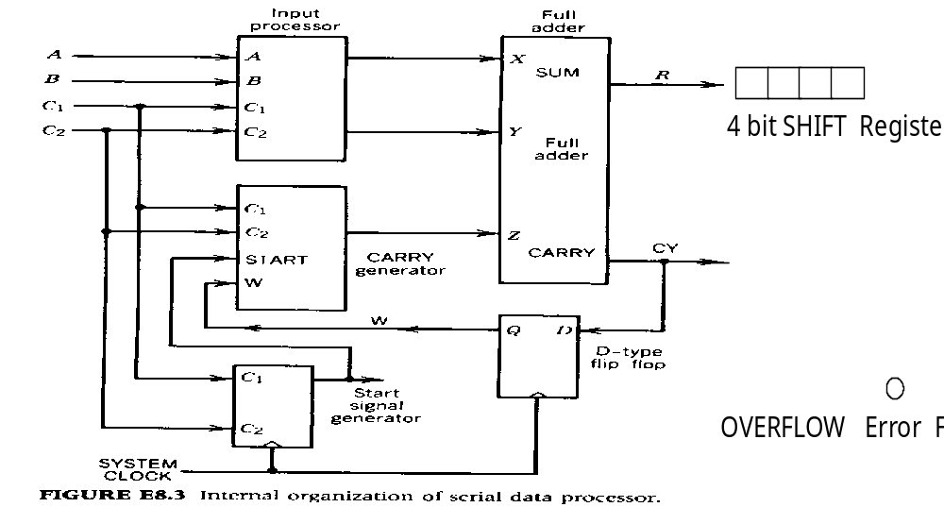
Select three Arithmetic operations that process 2 serial input values to implement, then label your control variable assignments. (The functions you select must include at least one which requires an A serial input and at least one that requires a B serial input value.)

 | Function 1 | Function 2 | Function 3 |  | Control Variable Assignments
 | A+B | A-B | A |  | C1 C2 | Function
 | A+1 | B-A | B |  | 0 0 | IDLE
 | B+1 | -A | A' |  | 0 1 | A+B
 | A-1 | -B | B' |  | 1 0 | B-A
 | B-1 |  |  |  | 1 1 | A
You are to design and build your circuit in a modular fashion. Use the tables below to design the other three blocks in the functional diagram above. Build and test the input processor, then build and test the carry generator and start signal generator portions. Finally combine and test the combined circuit.
I) Partial Circuit Implementation & Testing - INPUT PROCESSOR: Define X & Y in terms of constants, ( 0, 1 ) or input variables ( A, B). Use Kmaps to derive functions for X & Y.

C1C2 | X | Y |  | A |  |  |  |  |  |  |  | B
0 0 | 0 | 0 |  | C1C2 | 0 |  | 1 |  |  |  | C1C2 |  | 0 |  | 1
0 1 |  |  |  | 0 0 |  |  |  |  |  |  | 0 0
1 0 |  |  |  | 0 1 |  |  |  |  |  |  | 0 1
1 1 |  |  |  | 1 1 |  |  |  |  |  |  | 1 1
 |  |  |  | 1 0 |  |  |  |  |  |  | 1 0
 |  |  |  | X= |  |  |  |  |  |  |  |  | Y=
Input Processor Circuit Diagram:
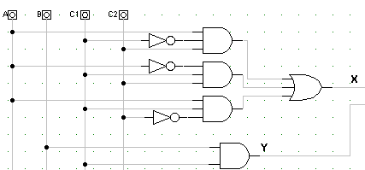
Demo & Date___________

2. CARRY generator: Input = C1, C2, START, W Output = Z

Define Z in terms of constants, ( 0, 1 ) or carry input variable W. Use Kmaps to derive function for Z.

Function | C1C2 | Start | Z |  | Start W
idle | 0 0 | 0 |  |  | C1C2 | 0 0 |  | 0 1 |  | 1 1 |  | 1 0
idle | 0 0 | 1 |  |  | 0 0
 | 0 1 | 0 |  |  | 0 1
 | 0 1 | 1 |  |  | 1 1
 | 1 0 | 0 |  |  | 1 0
 | 1 0 | 1
 | 1 1 | 0 |  |  | Z=
 | 1 1 | 1

Carry generator Circuit diagram: Demo & Date_________

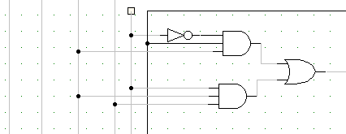

3. Start Signal Generator: Inputs = C1, C2 Output = START

The behavior of this circuit is specified by the STD on page 273 of your text and included on the next page.

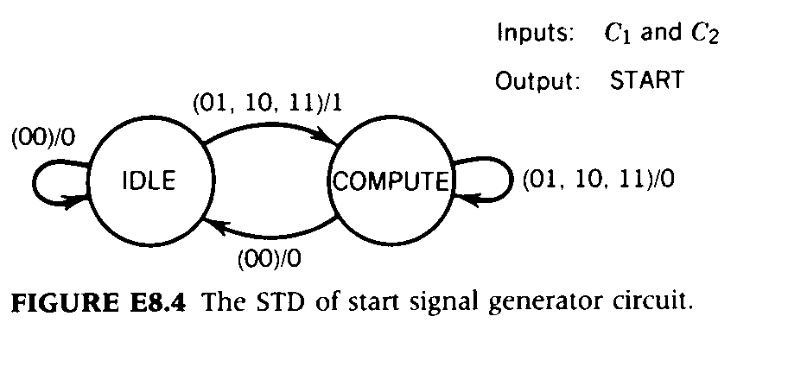
State | Assignments
IDLE = | ____________
Compute = | ____________

The only time the output START is equal to Logic 1 is when the Control inputs (C1C2) change from IDLE=(00) to any other combination. The Logic 1 output SIGNAL's the beginning of input i.e. the TRANSMISSION of the LEAST SIGNIFICANT BITS of the Serially Input Data A0 B0.

 | P.S. |  | N.S. | output
 | Q(t) | C1C2 | Q(t+Δ) | START
 | 0 | 0 0 |  |  |  | C1C2
 | 0 | 0 1 |  |  |  | Q(t) | 0 0 |  | 0 1 |  | 1 1 |  | 1 0
 | 0 | 1 0 |  |  |  | 0
 | 0 | 1 1 |  |  |  | 1
 | 1 | 0 0
 | 1 | 0 1
 | 1 | 1 0 |  |  |  | D=
 | 1 | 1 1

Start Signal Generator Circuit diagram:
C1 | C2
Q(t) | 0 0 | 0 1 | 1 1 | 1 0
0
1
Start=

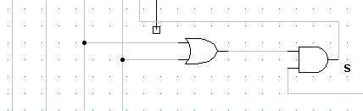

Screen capture of your complete Complete Circuit:

