- CSC - 275-1 Program#1: Student Grade Reports
- Due Date: at the end of class Thursday, February 1, 2007
- 100 Points Possible (See grading rubric on page 4 for breakdown.)
Write a program to process end of semester student records for the course CSC 123, taught by Prof. S.W. Packages. The following data will be read as input by your program.

 | STUDENT NAME | 20 characters
 | STUDENT ID | 5 characters
 | QUIZ#1, QUIZ#2, QUIZ#3 | integer (valid range 0..30)
 | MIDTERM | integer (valid range 0..100)
 | FINAL | integer (valid range 0..100)

Your program will compute the following two additional data values for each student record maintained.

WEIGHTED AVERAGE real range 0.0..100.0
GRADE character range 'A'..'E'

INPUT DATA:
You may test your program on data file: g:\progdata\hicks\275\progs\d1.txt The data file will contain the fields; STUDENT NAME, STUDENT ID, QUIZ#1, QUIZ#2, QUIZ#3, MIDTERM & FINAL, respectively. The Student Name field is 20 characters/spaces, while the ID field is 5 characters. Each student record will appear on a separate line in the data file. The maximum number of students that may enroll in this class is 30, although there may be fewer students actually enrolled. Format of input data:
Name
3 Quiz scores
ID
Final Exam
Boyd,Michael 11985 30 29 29 99 87
Roberts,Sally 13777 30 28 22 89 90
Green,Gene 50377 30 30 30 78 77
Midterm

COMPUTATIONS:
The WEIGHTED AVERAGE is determined by using the following weight factors:

MIDTERM determine 30% of WEIGHTED AVERAGE
QUIZZES determine 20% of WEIGHTED AVERAGE
FINAL determine 50% of WEIGHTED AVERAGE
i.e.
WEIGHTED_AVG = FINAL*50% + MIDTERM*30% + (ADJUSTED_QUIZ_AVERAGE)*20%

Adjusted Quiz Average: The maximum points for each quiz is 30, for a maximum total of 90 points for all quizzes. Therefore to calculate the adjusted quiz average for each student, you total their quiz scores, divide by 90, then multiply the result by 100.

GRADES are to be assigned based on the weighted average using the following straight scale:
 | 89.6-100: 'A' | 79.6-89.5: 'B' | 69.6-79.5: 'C' | 59.6-69.5: 'D' | below 59.5: 'E'

OUTPUT:
Produce a summary report which lists students in alphabetical order by their name, one record per line, displaying all student record information.

Each summary will include:
- Your Name plus, CSC 275-01 standard hearer information.
- A title specifying the course & instructor. (CSC 123, taught by Prof. S.W. Packages)
- Column labels for each field of the student record displayed.

Sample program output run with data file d1.txt follows:
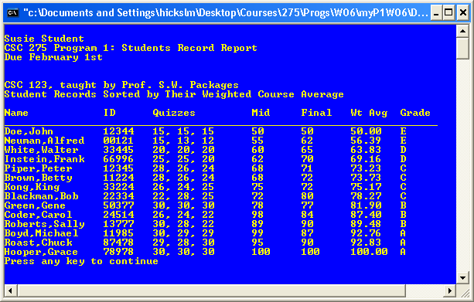

ADDITIONAL REQUIREMENTS:

This assignment serves as a practice in manipulating arrays of structures in C++, as well as practice in implementing good structured programming style. Your program must minimally include the five functions below, with the parameters specified:
- Function to read data named readData, to read from data file d1.txt into and array of structures ( Parameters include the array with a counter, both uninitialized on entry, but loaded with data within this function.)
- A void function to Compute Weighted Average, named computeWeightedAvg, that assigns a the calculated value to the Weighted_Average field of the student structure. ( One single student record as parameter.)
- Function to Assign Grade named assignGrade ( One single student record as parameter.) returns the char grade
- A function To Sort Records By Weighted Average, named sortByAvg ( Parameters include: struc array & a counter.)
- Function to Print Reports named printReport – ( Parameters include: struc array & a counter.)

You should be able to use the following main program to test your functions:
int _tmain(int argc, _TCHAR* argv[])
{
student students[CLASS_SIZE_LIMIT];
int count;

printHeader ();

readData ( students, count);

// For all students in the class, calculate the weighted average
// and Assign grades.
for (int i = 0; i< count; i++)
{
computeWeightedAvg(students[i]);
students[i].grade = assignGrade(students[i]);
}

sortByAvg( students, count);
printReport (students, count);

return 0;
}

Implementation Notes:

- You can assume there will be no more than 50 students in a class, but your program should be able to work correctly for a class that contains anywhere from 2 to 50 students. (Read Data loop, should read until data file is empty, or count of records reaches 50.)
- When you open the data file for reading DO NOT include a PATH NAME with the file name, in your open statement. i.e. infile.open ("str.dat"); should NEVER have a path in the filename. infile.open ("H:\275\str.dat");
To get around this requirement, always place program data files in the same directory as program solution files.
Grading Rubric for Student Records Program #1

Pts Pos. | Earned | Item # & Description
20 |  | - Your program follows good structured programming rules. Do NOT reference any GLOBAL variables within your functions. Documentation, pre & post conditions for functions/procedures, plus main program comment blocks
5 |  | - Print the Standard Output Header program information.
16 |  | - Your program has a Function To Read Data named readData, to read from data file d1.txt into and array of structures. Parameters include the array of student records with a counter .
10 |  | - Do NOT hard code the path to the input filename.
12 |  | - Your program has a function to Assign Grade (named assignGrade ) Has parameter of one single student record as parameter. returns the char grade
13 |  | - Your program has a void function to Sort Records By Weighted Average named sortByAvg . Parameters include the array of student records with a counter
12 |  | - A void Function to Compute Weighted Average (named computeWeightedAvg ) and assign it to the Weighted_Average field of the student structure. ( There will be one single student record as parameter.)
12 |  | - Your program has a function to Print Reports named printReport , which includes all fields of all records in the student array, along with column headers. Fields included in each student record include:  Name,ID,3 Quiz scores, Midterm, Final, Weighted Average & Grade (Parameters include: struc array & a counter.)
100 |  | Points Earned
 |  | To earn these points your program must compile correctly and with output correct and complete as specified Points Deducted for incorrect/incomplete output.

