Program #2: Vector of Strings – Sort and Search
Due Feb. Tuesday February 20th
Points: 100

Write the Implementation code for a sortedList class, where data is maintained as a vector of strings. I wrote the main driver program and the class prototype statements. Your task to to implement my sortedList class member functions. My class header code:

class sortedVList {
public:
// constructors
sortedVList ();
// This constructor, prompts the user to enter the name of a data
// file, then invokes getData with the input external file name,
// to load the contents of the input data file into the private
// vector names (see below)

// Function prototype
void getData( char *fname);

void sortList( );
` // Sorts the vector of names in ascending order

int search (string key);
` // Searches the vector of names for the string argument
// Returns the location of the match within the list if the key
// value is located, otherwise returns -1

bool removeName (string name);
//If the argument name is in the vector list of names,
// removes the name and returns true, otherwise returns false
void insertName (string name);
// Adds the argument name to the list of names, while keeping the
// order sorted.
void displaySortedNames( );
// Outputs to standard output the list of names,
// one name per line.

private:
vector<string> names;
string upperCaseIt(const string);
// This is a private utility function, I created to help implement
// searches and sorting that was not case sensitive.
};
My main program is in my progdata folder hicks\275\progs\p2Student
Implementation Notes:
After each member function is used, the list should remain in sorted order.
void sortList( ); You can use and modify any of the simple sorting routines I have on progdata, but if you can implement the sort as a QuickSort you will receive extra credit.
int search (string key); You can use a linear search lookup, but if you implement this as a binary search you will receive extra credit.
My main program instantiates a sortedVList object, the constructor will load the vector with names then the program will display a menu which gives the user these options;
Menu Options
My main programs handles this menu, display.
List Names
Insert Name
Remove Name
Search Names
Exit
List Names: Display the contents of the vector of strings in sorted order
Insert Name: Add a new name to your vector of strings
Remove Name: Prompt the use to enter the name to be removed. (Here you can use your Search function)
Search Name: Prompt the user to enter a name to search for in your vector. Implement a Boolean Search Function that takes as input the vector, the name string to search for and an undefined integer parameter. If the name is located in the vector, this function returns true and assigns it's position within the vector to the integer reference parameter. If the name is not located in this vector, then the function just returns Boolean value false.
Menu option 5 should cause your program to terminate.
Screen capture of sample program execution using a smaller data file on the last page.
Grade Rubric
Pts Pos. | Task | Item # & Description
10 | A. | Your program follows good structured programming rules. Do NOT reference any GLOBAL variables within your functions. Documentation, pre & post conditions for functions/procedures, plus main program comment blocks.
10 | B. | Constructor implemented correctly: sortedVList ()
10 | C. | Implements method void getData( char *fname) correctly. getData reads all data from the external file, whose name is passed in the parameter list.
15 | D. | Correctly implements method: void sortList( ); (10 points extra credit for using a quicksort here see below)
15 | E. | Correctly implements method: int search (string key); (10 points extra credit for using a binary search here, see below) Works with mixed case alphas, all upper or lower case.
10 | F. | Correctly implements method: bool removeName (string name)
10 | G. | Correctly implements method: void insertName (string name)
10 | H. | Correctly implements method: void displaySortedNames( );
10 | I. | After every operation on the sorted list, the data remains sorted.
 |  | Extra Credit 10 points extra credit for using a quicksort in the sortList( ); method.
 |  | Extra Credit 10 points extra credit for using a binary search in the search method
100 |  | Points Earned

Note: If you change my class prototype definition, you will have at least 25 points deducted from your score.
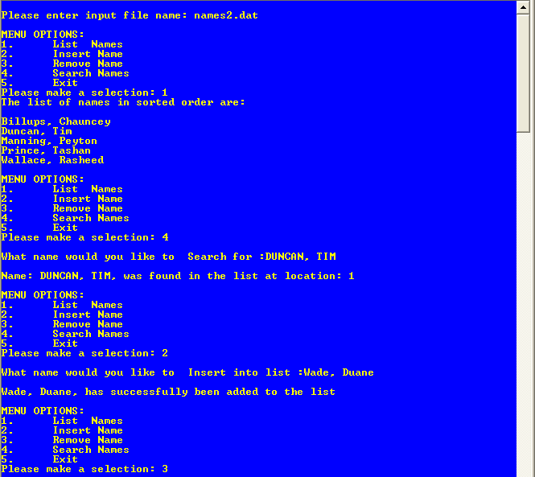
Smaller data file, used to limit screen output
Selected option # 1
Note the names in the data file are in mixed case, while I enter this name in all upper case letters
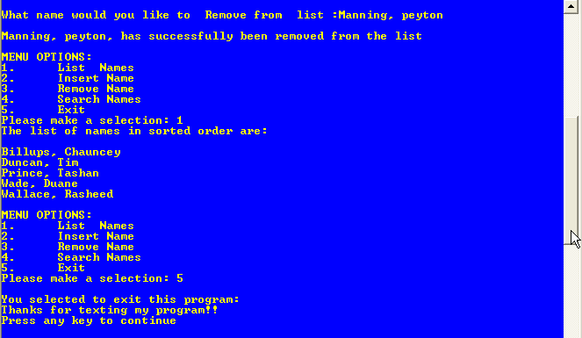
See the changes have been implemented:
Manning, Peyton has been removed, and
Wade, Duane has been inserted into the list
And any time changes made, the list remains in sorted order

