CSC - 275 Program#3: Operator Overload Class Example
Due Date: Tuesday, March 6th 2007
In this program you will be enhancing my JarType class definitions. Copy file P3.cpp from progdata.
You will be overloading arithmetic and stream operations to the JarType class. I have written the client driver program P3.CPP which will be used to test your JarType operations. You will add code to my P3.cpp to print out the standard output header information. Other than inserting output instructions, you should not modify my client driver main code.
You can insert the JarType prototype and implementation code within this main program, as was done with your textbook examples of the Money class, or you may choose to separate the JarType implementation into two files JarType.h and JarType.cpp, then include these within the main driver using an include directive. You are to build on the JarType we've been looking at in class. The lastest version of JarType is in the folder named JarVereq which will be contained within the folder p3main, under the Progs folder on progdata: hicksk/275/Progs/p3main
Specifically you are to overload the following following operations for JarType.
Arithmetic Operations (+, -, *, /)
+ Addition Operation:
- Add the numUnits field of both operands.
- Returns data of type JarType
- Defined as a friend function so that both of these operations work:
5 + jarTypeObj and jarTypeObj + 5
- Subtraction Operation:
- Subtracts Op2.numUnits from Op1.numUnits.
- If the result is < 0 assigns 0 to numUnits.
- Returns data of type JarType
* Multiplication Operation:
- Multiplies Op1.numUnits times Op2.numUnits.
- Returns data of type JarType
- Defined as a friend function so that both of these operations work:
5 * jarTypeObj and jarTypeObj * 5
/ Division Operation:
- Integer Divides Op1.numUnits by Op2.numUnits
- Returns data of type JarType
Relational Operators ( <, >, ==, !=)
< Less Than Operation:
- Returns true of the numUnits of the first jar is less than the numUnits of the second jar.
- Returns Boolean value
> Less Than Operation:
- Returns true of the numUnits of the first jar is greater than the numUnits of the second jar.
- Returns Boolean value
== Equavalence Operation:
- Returns true of the numUnits of the first jar is equal to the numUnits of the second jar.
- Returns Boolean value
!= Not Equal Operation
- Returns true of the numUnits of the first jar is NOT equal to the numUnits of the second jar.

Stream Extraction Operators ( << , >>)
<< Output operator
- Uses iostream
- Defined as a friend function or non-member function.
>> Input operator
- Uses iostream
- Define as a friend function, since it will have to access the private data, numUnits.

Here is a screen capture of a correctly working program (without header information):
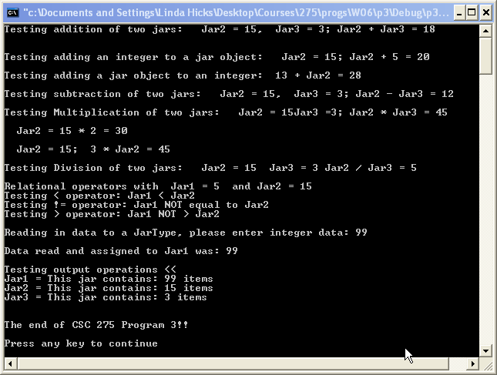

When your program is working correctly, zip together the entire project, and send to Digital Drop box for grading.
Grading Rubric
Pts Pos. | Earned | Item # & Description
15 |  | - Documentation, pre & post conditions for functions/procedures, plus main program comment blocks.
5 |  | - Print the Standard Output Header program information.
10 |  | - Correctly implements Arithmetic Operations + as a friend function of JarType.
10 |  | - Correctly implements Arithmetic Operations * as a friend function of JarType.
10 |  | - Correctly implements Arithmetic Operations -.
10 |  | - Correctly implements Arithmetic Operations /
20 |  | - Correctly implements Relational operations <, >, ==, !=
10 |  | - Correctly imements the Stream Extraction Operators <<
10 |  | - Correctly imements the Stream Extraction Operators >>
100 |  | Points Earned
 |  | To earn these points you MUST USE my main program without modification (except adding output header) Up to -50 off for modification
 |  | To earn these points your program output, must be correct and complete as specified Points Deducted for incorrect/incomplete output.
15 |  | Extra Credit: JarType class is contained in external files JarType.h & JarType.cpp
 |  | Total Points Earned

