
CSC 275 Program #7: An Amazing Problem
Due Thursday March 29th

The rat-in-a maze experiment is a classical one from experimental psychology. A rat (or mouse) is placed through the door of a large box without a top. Walls are set up so that movements in most directions is obstructed. The rat is carefully observed by several scientists as it makes its way through the maize until it eventually reaches the other exit where there is a nice hunk of cheese.

You are to write a computer program which will help the rat find his way out of the maze. The maze will be represented by a10 by 10 matrix of 1's and 0's , where a value of 1 implies a blocked path, and a 0 means the rat can walk right on through. You are to assume that the rat starts at MAZE [1, 1] and the exit is at MAZE [10,10].
The rat may only move in horizontal or vertical directions. From any position within the maze there are at most four possible moves that the rat could make, north or south horizontally or east or west vertically. The number of moves will of course be restricted when the rat is located in a border location. (In ether rows or columns 0 or 9 .)
There are a number of different techniques that you could use to solve this problem, but you will be required to use RECURSION for this solution, that is to find the path out of the maze.
You can test your program on the file maze.dat in progdata folder hicks/275/progs. The data will consist of a single maze, that is ten rows each containing ten zeros or ones, with a space between each data element. A 0 in the datafile means that is an open door, a 1= a closed door.
Your program should do the following:
- Print the output header program information.
- Read and Echo print the data file. (maze.dat) (This echo print is to verify you are working with the correct data. In this example below, I am printing the maze along with the border of closed doors around the maze, a suggested solution technique.)
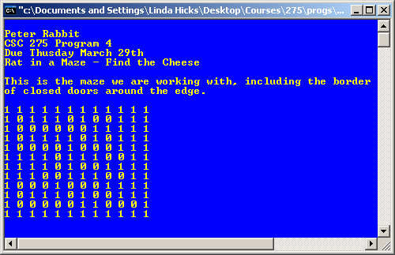

- If possible print ONE escape route from Entrance [1,1] to Exit [10,10] in the form of row and column coordinates of cells visited on the way to the exit door at cell [10][10]. In your attempt to find an escape route you will come upon may dead end paths, and will have to backup to some previous position to find a valid escape route. DO NOT include these dead end locations in your escape route. (see table below)
0 | 1 | 1 | 1 | 0 | 1 | 0 | 0 | 1 | 1 |  | Cells shaded as ➔  are part of a dead end route and shouldn’t be included on the escape route.  Escape route is shaded as: ➔
0 | 0 | 0 | 0 | 0 | 0 | 1 | 1 | 1 | 1
0 | 1 | 1 | 1 | 1 | 0 | 1 | 0 | 1 | 1
0 | 0 | 0 | 0 | 1 | 0 | 0 | 0 | 1 | 1
1 | 1 | 1 | 0 | 1 | 1 | 1 | 0 | 0 | 1
1 | 1 | 1 | 0 | 1 | 0 | 0 | 1 | 1 | 1
1 | 1 | 0 | 0 | 1 | 1 | 1 | 0 | 0 | 1
0 | 0 | 0 | 1 | 0 | 0 | 0 | 1 | 1 | 1
0 | 1 | 1 | 1 | 0 | 1 | 0 | 0 | 1 | 1
0 | 0 | 0 | 0 | 0 | 1 | 1 | 0 | 0 | 0

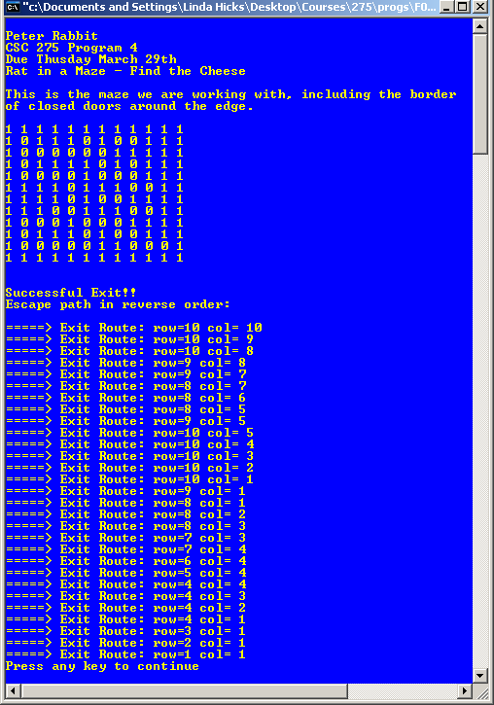
- If there is no exit out of the maze, print a message indicating as such.
- There may be multiple exit routes, but you are required to print only one.
Possible program output might look
as follows if the path is printed in reverse order:

Hints and Guidelines for Maze Program Solution
- Your recursive procedure should be a simple as possible to solve the problem. The only task your recursive procedure should accomplish is find and record an exit path out of the maze.
In your recursive procedure, DO NOT initialize the array, print the path or do any other house keeping tasks not related to finding an exit route.
- Your recursive procedure SHOULD NOT INCLUDE any WHILE, FOR or DO LOOPS. Looping through the maze is accomplished by the recursive calls.
- Parameters to your recursive procedure should include: the maze array, along with row and column coordinates of your current location, some data structure used to keep track of your exit path and probably a Boolean flag to indicate a successful escape..
- I would suggest that you surround the maze with a border of closed doors, then every location within the maze will have 4 walls.
- Generally the solution to the problem is something like this:
  - If row=10 & col= 10, then you have successfully escaped
    - Otherwise:
The order of doors you try is not relevant.
    - Try to escape via the South door
    - If not successful; Try to escape via the East door.
    - If not successful; Try to escape via the West door.
    - If not successful; Try to escape via the North door.
  - If you have successfully escaped from this position; then print out the current cell positions on your escape path list.
- Watch out for cycles, which will cause end less loops because you repeatedly visit the same cell only to run around in a circle. You should visit each cell only once. Try to escape through all 4 doors; if not successful then this cell is a dead-end, the recursive call terminate for this cell.
- When you've found an exit route, print the row/col coordinates of each cell on the route. The path you print will be in reverse order, that is the first entry will be row=10, col=10 and the last entry will be row=1, col=1.
An algorithm for this recursive findExit function follows on the next page, where the Maze is a global variable. Called from the main program as findExit (1, 1, success), with success = false initially.
NOTE: If you follow this algorithm EXACTLY your program will generate the correct output.
Algorithm for recursive function: findExit (row, col, success)
- Mark this cell as visited. (maybe change value to 3).
- If ( row = 10) and (col=10) then success = true.
- Check for escape routes (here order can be changed, just so you try all 4 directions). NOTE: The success flag is used as a stopping condition, to prevent endless recursive calls. Recursive calls are highlighted in yellow below.
  - If NOT success and cell to the east hasn't been visited already and is open i.e.
(Maze(row, col+1) ==0) then try to escape to the east. i.e. findExit(row, col+1, success)
  - If NOT success and cell to the south hasn't been visited already and is open i.e.
(Maze(row+1, col) ==0) then try to escape to the south. i.e. findExit(row+1, col, success)
  - If NOT success and cell to the north hasn't been visited already and is open i.e.
(Maze(row-1, col) ==0) then try to escape to the south. i.e. findExit(row-1, col, success)
  - If NOT success and cell to the west hasn't been visited already and is open i.e.
(Maze(row, col-1) ==0) then try to escape to the east. i.e. findExit(row, col-1, success)
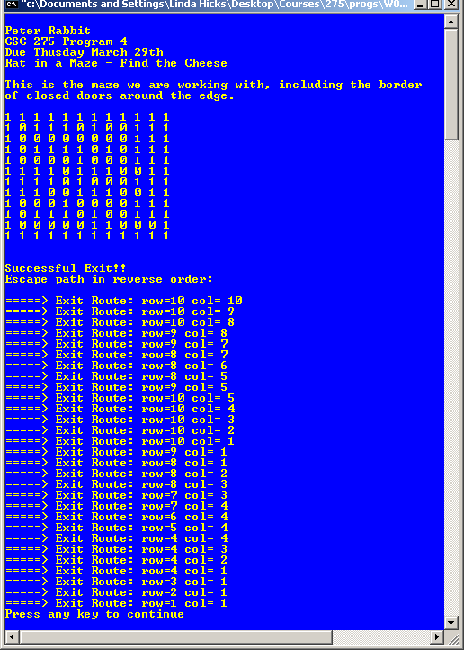
Program output using datafile maze3.dat
- If success is true, then print out the current row & col values, and terminate, otherwise just terminate.
Have Fun and GOOD LUCK!!!
If you would like to try your program on different data sets, files maze2.dat is a maze without an exit route, and file maze3.dat represents a maze with multiple exit routes. Screen captures of output using these two data files appear here.
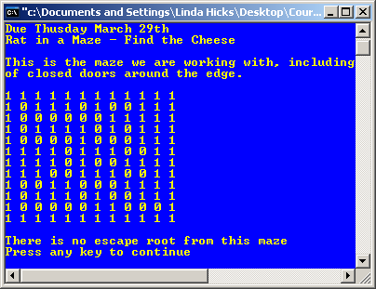
Program output using data file maze2.dat
Grading Rubric for Maze Game
Pts Pos. | Earned | Item # & Description
10 |  | - Structured format and output header program information
10 |  | - Read and Echo print the data file. (maze.dat) (This echo print is to verify you are working with the correct data. In this example below, I am printing the maze along with the border of closed doors around the maze, a suggested solution technique.)
45 |  | - Your program uses Recursion to find an exit path out of the maze.
15 |  | - You print out the escape route by row & col of cells used to exit, (probably starting with the last cell in your exit route, and ending with the first cell in your exit route.)
10 |  | - Cells that are part of a dead end route, shouldn’t be included on the escape route
10 |  | - If there is no exit out of the maze, print a message indicating as such
Earned |  | 100 Total Points Possible
30 |  | In addition, your program will have 30 points deducted if you use any kind of looping construct within your recursive function. (except of course for the recursive call itself.)

