- CSC 275 Program #5
- Due Monday April 9th
- Binary Search Template

Write a template version of the iterative binary search from Display 13.8 (pg. 599)., OR Write a template version of the recursive binary search from Display 13.6 (pg. 595).

You will embed your template within my driver program p5main.cpp. My main program creates three arrays to test your binary search procedure, an array of integers, strings and objects of type BankAccount. It loads the arrays of strings and BankAccounts from external data files indat.txt and names.txt. These files must be in the same folder as the file p5main.cpp, for the program to read correctly. You also must have the file BankAccount.cpp in this folder. Copy my entire folder p5main from my progdata directory 275/Progs/p5main

The three invocations of the BinSearch procedure within my p5main.cpp are:
BinSearch(intList, 0, finalIndex, key, found, location);
BinSearch(names, 0, count - 1, aName , found, location);
BinSearch(Customers, 0, count - 1, searchRec, found, location);

Because your template must work within my main program your procedure must be compatible with my procedure calls within the program. That is the name must be BinSearch , and it must have 6 parameters, representing:
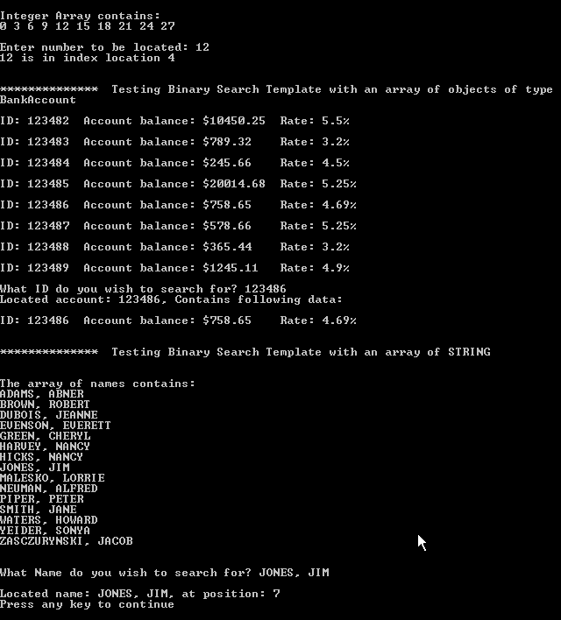
- the array to be sorted
- starting index within array
- index of last element in array
- a key item to search for within the array
- a Boolean flag to indicate if the key value was located, this must be a reference parameter.
- and if located the index within the array where it was found, also a reference parameter.

The entire driver program p8main appears at the end of this document. You may add additional code to this driver, for instance to include output header statements. But please DO NOT MODIFY ANY OF THE CODE I HAVE WRITTEN.

A screen capture of a correctly working program ➔:

Grading Rubric for program

Pts Pos. | deduct | Item # & Description
10 |  | - Documentation, pre & post conditions for functions/procedures, plus main program comment blocks
10 |  | - Print the output header program information.
15 |  | - Your BinSearch function has 6 parameters matching those specified above.
40 |  | - You have ONE BinSearch function template that works with all three of the invocations of the function BinSearch in my p5main.cpp.
25 |  | - Your BinSearch function returns the correct values for reference parameters, found and location for all searches.
100 |  | 100 Total Points Possible
 |  | In addition, up to 30 points may be deducted from your program, if you modify any of my code in the main program. Except of course for removing the comments from the calls to your BinSearch function i.e. // BinSearch

Insert all of your BinSearch template within p5main.cpp, where indicated by comments.
Make sure this file is in the same folder as p5main.cpp

// p5main.cpp : Defines the entry point for the console application.
//

#include "stdafx.h"
#include "BankAccount.cpp"
#include <fstream>
#include <iostream>
#include <string>
#include <cmath>
#include <cstdlib>
using namespace std;

/* INCLUDE YOUR BinSearch TEMPLATE CLASS HEADER AND CODE HERE */

/* END OF BinSearch HERE */

void testIntSearch ();
void testStringSearch ();
void testRecSearch ( );

//************************************************************************************
int main( )
{
string line;
// Test Search template on an array of integers
cout << "\n\n*********** Testing Binary Search Template with an array of INTEGERS\n";
testIntSearch ();

cout << "\n\n*********** Testing Binary Search Template with an array of objects of type BankAccount\n";
testRecSearch ( );

// Get rid of the end of line character left over from reading last search key
cin.ignore ( 1000,'\n');

cout << "\n\n************ Testing Binary Search Template with an array of STRING \n";
testStringSearch ();
return 0;
}// end main

void testIntSearch ()
{ // precondition: none
// postcondition: Procedure intialized an array of integers in ascending order, then prompts
// the user for a key value to search for. Tests the Binary Search template with integers

const ARRAY_SIZE = 10;

int intList [ARRAY_SIZE];
const int finalIndex = ARRAY_SIZE - 1;

int i;
for (i = 0; i < ARRAY_SIZE; i++)
intList[i] = 3*i;

cout << "\n\nInteger Array contains:\n";
for (i = 0; i < ARRAY_SIZE; i++)
cout << intList[i] << " ";
Remove these comments markers, when you have inserted your BinSearch template. Right now they allow you to build the program without error.
cout << endl;

int key, location;
bool found = false;

cout << "\nEnter number to be located: ";
cin >> key;

//BinSearch(intList, 0, finalIndex, key, found, location);

if (found)
cout << key << " is in index location " << location << endl;
else
cout << key << " is not in the array." << endl;

return;
}// end testIntSearch

///////////////////////////////////////////////////////////////////////
void testStringSearch ()
{ // Preconditions: File names.txt contains names in ascending order and
// is located within the current folder.
// Postconditions: Opens file names.txt, loads an array with these names, prompts the user to enter a
// key, then tests the Binary Search template with the array of names and the key.
// Closes file before exit.
string names [30] ;
string aName;
bool found = false;
int location;

Make sure this file is in your folder with p5main.cpp

// Test the binary search template using an array of BankAccounts
ifstream inf;
// Input text file contained in same directory as this program
inf.open( "names.txt");
if (inf.fail())
{
cerr << "************** ERROR: Can not open file names.txt for input"<<endl;
return ; //failure return
}

// Load BankAccount array from data file
int count = 0; // will hold the number of records read in, also used as a subscript
while (!inf.eof() )
{
//inf >> names [count];
getline (inf,names [count]);
count++;
}

cout << "\n\nThe array of names contains:\n";
// Show what is stored in the array of customers
for (int index = 0; index < count; index ++)
cout << names[index]<< endl;

// Prompt user to enter a search key value
To test your template, you must remove these comment markers.
cout << "\nWhat Name do you wish to search for? ";
getline (cin,aName);

//Search for the input name

//BinSearch(names, 0, count - 1, aName , found, location);

if (found)
cout << "\nLocated name: " << aName << ", at position: "<< location << endl;
else
cout << "\nThat NAME is NOT located in Names List"<< endl;

inf.close();
return;
} // testStringSearch

///////////////////////////////////////////////////////////////////////

void testRecSearch ( )
{ // Preconditions: opens and reads file data into an array of records.
// Postconditions: Created an array of BankAccount records, displayed them to the user, asked for a search
// key, then tested the Binary Search template with the array of BankAccounts.
// Closes file before exit.

// Test the binary search template using an array of BankAccounts
BankAccount Customers [25] ;
ifstream inf;
// Input text file contained in same directory as this program
inf.open( "indat.txt");
Make sure this file is in your folder with p5main.cpp
if (inf.fail())
{
cerr << "************** ERROR: Can not open file: for input"<<endl;
return ; //failure return
}

// Load BankAccount array from data file
double balance;
double iRate;
BankAccount anAccount;
int count = 0;

while (! inf.eof() )
{
inf >> balance >> iRate;
anAccount = BankAccount(balance, iRate);
Customers[count] = anAccount;
count++;
}
// Show what is stored in the array of customers
for (int index = 0; index < count; index ++)
Customers[index].output();

// Prompt user to enter a search key value
int key;
Remove to test template.
bool found = false;
int location;
BankAccount searchRec;
cout << "\nWhat ID do you wish to search for? ";
cin >> key;

//Create a BankAccount with the key input as ID, then search for that record
searchRec.setID(key);

// BinSearch(Customers, 0, count - 1, searchRec, found, location);

if (found)
{
cout << "Located account: " << key << ", Contains following data: "<< endl;
Customers[location].output();
}
else cout << "Key value not located in Customers"<< endl;

inf.close();
return;
}

