Chapter 1, Data Structures and Algorithms:
-----------------------------------------

This chapter was primarily an introduction, but it includes a number of
definitions with which you should be familiar.

Know these Definitions/Concepts:

* efficient – solves problems within resource constraints
* cost of a solution – the amount of resources that are consumed, typically time.
* type – collection of values
* data type – is a type together of operations to manipulate
* data item – piece of information
* member – variable that define the space required by a data item
* simple data item – int, char, float
* aggregate data item – collection of data within a class
* abstract data type – is a data type that one has to define, i.e. class

* Logical form – type, operations header file
* physical form – subroutines or implementations including storage space along with the data
* Function – set of operations that can receive a domain of value and output a range of values with parameters given the actual date set
* Problem – a task to be performed with inputs and matching outputs.
* algorithm – a sequence or process to solve a problem
* program – instantiation of an algorithm in a programmer language
* Properties of an algorithm –
1) must be correct
2) concrete steps
3) no ambiguity
4) finite steps
5) must terminate

Chapter 2, Mathematical Preliminaries:
-------------------------------------

Understand these Definitions/Concepts:

* set – is a collection of values in no particular order
* base type – members of a data type
* element – single item in a set
* primitive element – member of a base type
* linear order – if every pair of distinct elements in a partial order are comparable, then the order is linear
* finite sequence – a sequence which has a beginning and an end
* The logarithmic properties –
1) log nm = log n + log m
2) log n/m = log n- log m
3) log n^{r} = r log n
4) log_{a} n = log_{b} n/lob a
* recursive algorithm – an algorithm that calls itself
* The closed-form solutions to certain summations (equations 2.1 through 2.9)
Pg 31-32

Understand how to perform a proof by contradiction and a proof by
mathematical induction, and be familiar with the estimation problems.
Make sure you study the proof examples on the web page that are linked
in here (I have a couple of different pages; one is several proofs by
contradiction and the other is just some examples of other problems
from the end of Chapter 3).

Induction – step
- base case (n = 0 ) 2⁰ + 2¹ + 2² … 2^{n}
- induction step * assume ( n + 1)

  - the equation 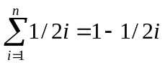using mathematical induction
Base Case: n=1 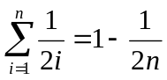= 
Induction Hypothesis: 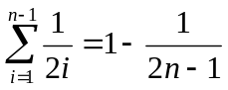
Induction Step: 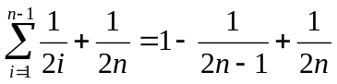
= 1 - 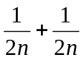
= 1 - 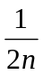

2.20 The equation 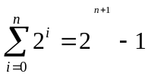 by mathematical induction

Base Case: for n=0 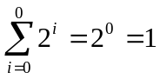
Induction Hypothesis: true for the first term
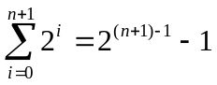
Induction Step: 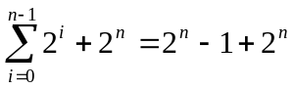
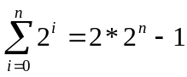
= 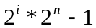
= 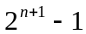

Problem 10) How many basketballs would it take to fill up 104 MSB?

Rough (very rough) outline of MSB 104
20 feet across (W)
40 feet deep (L)
8 foot tall ceiling (H)
30 roughly inches Basketball circumference (C)
W * L * H = SF
20 * 40 * 8 = 6400 SF
6400 * 12 inches = 76800 inches
76800 / 30 = 2560 basketballs

Additionally, there was C++ That I Associated With Chapter 2:

* C++ classes:
+ template functions
+ template classes
+ Friend classes and functions

If you are asked to write code (you will be), then you will be provided
with some necessary information (for example, I will give you the public
portion of a list class declaration in C++).

Chapter 3, Algorithm Analysis:
-----------------------------

Know these Definitions/Concepts:

* growth rate – the cost of which the algorithm grows as the size of the input grows
* Best case – rate of growth is less than one value
* worst case – rate of growth is longer
* and average case inputs - n /2 values
* O(f(n)) – growth rate is the same or greater (BIG O)
BIG O 5n² ≤ cn²
BIG OMEGA 5n² ≥ cn²
Big Theta cn²

* Omega(f(n)) -
* Theta(f(n))
*How to find constants c and n0 (according to the definitions).
*How to do speedup calculations or "increased problem size" calculations.
*Multiple parameters

Be familiar with the problems you did in your exercises from Chapter 3.

3.5 computer runs 100 times faster than competitor
n n2 n3 n2

