Homework #3 – ECN 201 Section 4 – Fall 2007

1. Here are some data for the economy of Madeupland. Calculate its GDP.

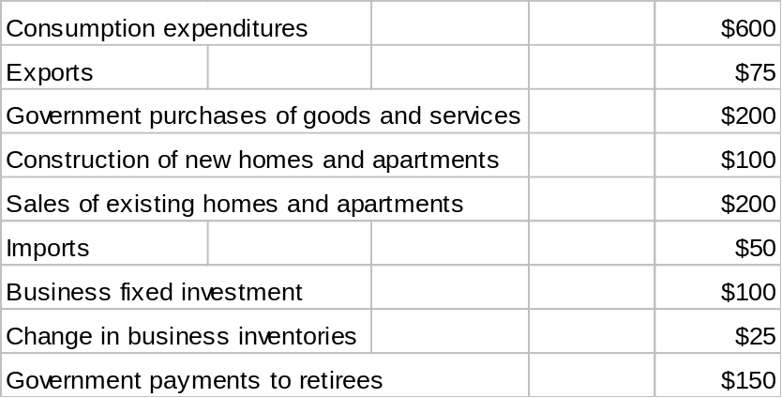

2. The nation of Potchatoonic produces hockey pucks, cases of root beer, and back rubs. Here are data on prices and quantities of the three goods in the years 2000 and 2007.

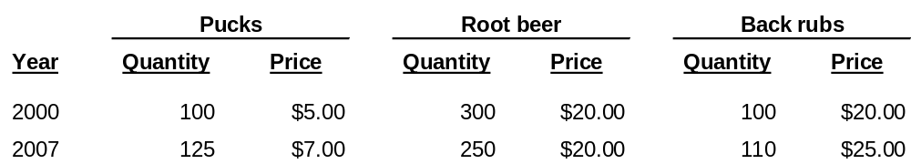

Assume that 2000 is the base year. Find nominal GDP and real GDP for both years.

3. Assume that for the current month there are 145,900 individuals employed; 7,000 individuals unemployed; and 77,700 individuals not in the labor force. What is the unemployment rate? What is the labor force participation rate? Show your work.

