1. The aggregate demand and aggregate supply model explain fluctuations in
- nominal GDP and the price level.
- real GDP and the interest rate.
- real GDP and the price level.
- nominal GDP and the inflation rate.
2. The aggregate demand curve shows the relationship between the
- inflation rate and the quantity of consumer goods and services demanded.
- price level and the quantity of consumer goods and services demanded.
- inflation rate and the quantity of real GDP demanded.
- price level and the quantity of real GDP demanded.
3. An increase in the price level leads to a decrease in the quantity of real GDP demanded because the increase in the price level
- makes U.S. exports less expensive and foreign imports more expensive, decreasing net exports.
- leads consumers to switch to goods and services whose prices have not increased.
- lowers the real value of household wealth, decreasing consumption.
- lowers interest rates, decreasing investment.
4. Which of the following will NOT cause the aggregate demand curve to shift? A change in
- the price level.
- investment spending because businesses believe they will be more profitable in the future.
- personal income taxes.
- government purchases.
5. In the long run, the level of real GDP is determined by the
- price level, the number of workers, the capital stock, and the available technology.
- price level, the number of workers, and the available technology.
- number of workers, the capital stock, and the available technology.
- number of workers and the available technology.
6. The long-run aggregate supply is vertical because in the long run changes in the price level do NOT
- affect interest rates.
- affect the prices of inputs.
- affect the number of workers, the capital stock, or technology.
- shift aggregate demand.
7. The short-run aggregate supply curve slopes upward because over the short run as the prices of final goods and services rise the
- price of inputs rise more rapidly.
- price of inputs like wages tend to be “sticky” and rise more slowly.
- prices of inputs are fixed forever.
- quantity of inputs are fixed so firms always use the same quantity of inputs.
8. A technological advance that increases worker productivity will
- shift the short-run aggregate supply curve to the right, but will not shift the long-run aggregate supply curve.
- not shift the short-run aggregate supply curve, but will shift the long-run aggregate supply curve to the right.
- shift both the short-run aggregate supply curve and the long-run aggregate supply curve to the right.
- neither shift the short-run aggregate supply curve nor the long-run aggregate supply curve.
9. In the basic aggregate demand and aggregate supply model, an increase in government purchases will in the short run lead to ________ in real GDP and ________ in the price level.
- an increase; a decrease
- an increase; an increase
- a decrease; an increase
- a decrease; a decrease
10. The adjustment of the economy to potential GDP in the long run from a level of real GDP below potential GDP occurs as workers and firms adjust to a
- lower price level than expected, which decreases wages and prices.
- lower price level than expected, which increases wages and prices.
- higher price level than expected, which decreases wages and prices.
- higher price level than expected, which increases wages and prices.
11. In the basic aggregate demand and aggregate supply model, an increase in government purchases will in the long run run lead to ________ in real GDP and ________ in the price level.
- no change; no change
- no change; an increase
- an increase; no change
- an increase; an increase
12. In the basic aggregate demand and aggregate supply model, an increase in oil prices will in the short run will lead to ________ in real GDP and ________ in the price level.
- an increase; an increase
- an increase; a decrease
- a decrease; an increase
- a decrease; a decrease
13. If the Federal Open Market Committee wants to decrease the money supply through open market operations it will
- buy U.S. Treasury Securities.
- sell U.S. Treasury Securities.
- increase the discount rate.
- decrease the discount rate.
14. Which of the following best describes how banks create money?
- Banks charge higher interest rates on loans than they pay on deposits.
- Banks charge fees for providing financial advice.
- Banks create checking account deposits when making loans from excess reserves.
- Banks make loans from excess reserves.
15. If the required reserve ratio is 10 percent, an increase in bank reserves of $1,000 can support an increase in checking account deposits (including the original deposit) in the banking system as a whole of up to
- $100.
- $1,000.
- $10,000.
- $100,000.
16. To increase the money supply, the Federal Reserve could
- raise the discount rate.
- decrease income taxes.
- raise the required reserve ratio.
- conduct an open market purchase of Treasury securities.
17. According to the quantity theory of money, if the money supply grows at 20 percent and real GDP grows at 5 percent, then the inflation rate (assuming velocity is constant) will be
- 15 percent.
- 20 percent.
- 25 percent.
- 100 percent.
18. If the Fed raises the interest rate, this will ________ inflation and ________ real GDP in the short run.
- reduce; raise
- increase; lower
- increase; raise
- reduce; lower
19. An increase in the money supply will
- increase the interest rate.
- decrease the interest rate.
- have no affect on the interest rate.
- decrease the equilibrium quantity of money in the economy.
20. Contractionary monetary policy on the part of the Fed results in
- an increase in the money supply, an increase in interest rates, and an increase in GDP.
- a decrease in the money supply, an increase in interest rates, and a decrease in GDP.
- an increase in the money supply, a decrease in interest rates, and an increase in GDP.
- a decrease in the money supply, a decrease in interest rates, and a decrease in GDP.
21. Fiscal policy is defined as changes in federal ________ and ________ to achieve macroeconomic objectives such as price stability, high rates of economic growth, and high employment.
- taxes; interest rates
- taxes; the money supply
- interest rates; money supply
- taxes; purchases

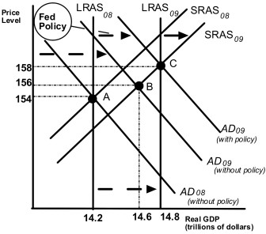
22. Based on the above diagram, without any policy action by the Fed, the economy in 2009 will be
- at potential GDP.
- above potential GDP.
- below potential GDP.
- remain in equilibrium at point A.
23. In order to have the economy at potential GDP in 2009, the Fed should
- leave the money supply alone.
- increase the money supply.
- decrease the money supply.
- increase the reserve requirement so that banks keep a higher percentage of reserves against their deposits.
24. Crowding out refers to a decline in ________ as a result of an increase in ________.
- tax revenues; unemployment
- government purchases; tax rates
- government purchases; private expenditures
- private expenditures; government purchases
25. Decreasing government spending ________ the price level and ________ equilibrium real GDP.
- decreases; increases
- increases; decreases
- increases; increases
- decreases; decreases
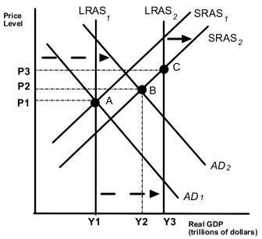
26. Given that the economy has moved from A to B in the graph above, which of the following would be the appropriate fiscal policy to achieve potential GDP?
- increase taxes
- increase government spending
- contractionary fiscal policy
- decrease interest rates
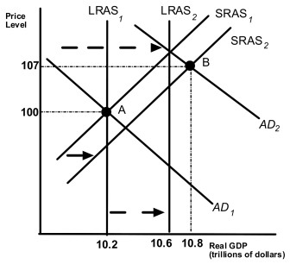

27. Given the that the economy has moved from A to B in the graph on the bottom of page 5 above, which of the following would be the appropriate fiscal policy to achieve potential GDP?
- increase taxes
- increase government spending
- expansionary fiscal policy
- increase interest rates

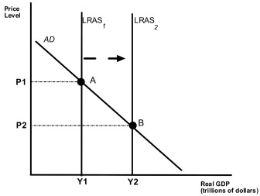
28. Suppose Congress reduces income taxes. Assume that the movement from A to B represents normal growth in the economy before the tax change. Also assume that aggregate demand does not change. If the tax change is effective and labor supply and savings increase because of the tax change, then the tax change will
- increase the price level above P2.
- decrease output to less than Y2.
- not change the price level.
- increase potential real GDP above Y2.

