QUIZ 2 ECN 202-4
Winter 2006 S. Darragh

Circle the best answer to each of the following.

1. Which of the following would be categorized as an implicit cost?
- wages of workers
- foregone wages for business owners
- the potential return from foregone investment opportunities
  - (i) and (iii)
  - (ii) and (iii)
  - (iii) only
  - All of the above are correct.
2. When adding another worker leads to an increase in output that is smaller than increases in output that resulted from adding previous workers, we have the property of
a. diminishing labor.
b. diminishing output.
c. diminishing marginal product.
d. negative marginal product.
3. The marginal product of labor is equal to the
a. extra cost associated with a one unit increase in labor.
b. extra profit associated with a one unit increase in labor.
c. increase in labor necessary to generate a one unit increase in output.
d. increase in output obtained from a one unit increase in labor.
4. Diminishing marginal product suggests that
a. additional units of output become more costly as more output is produced.
b. marginal cost is upward sloping.
c. adding more of the variable input (for example, more workers) will result in a smaller addition to output than the increases in output that occurred with previously hired units of the variable input.
d. All of the above are correct.
5. Economists normally assume that the goal of a firm is to
a. maximize its total revenue.
b. maximize its profit.
c. maximize its sales volume.
d. minimize its total cost.
6. Which of the following is NOT a characteristic of a monopolistically competitive market?
a. Firms are price takers.
b. Firms have difficulty entering the market.
c. There are many sellers in the market.
d. Goods offered for sale are at least somewhat different from seller to seller.

7. A fundamental source of monopoly market power arises from
- perfectly elastic demand.
- perfectly inelastic demand.
- barriers to entry.
- availability of "free" natural resources, such as water or air.

Use the information on The Cider Store in the table below to complete questions 8-12. You may need to fill in the missing information.

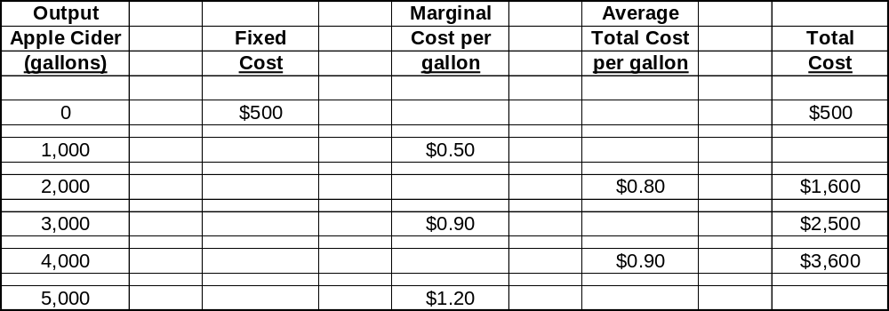

8. What is the marginal cost per gallon of producing the second batch of 1,000 gallons (i.e., going from producing 1,000 gallons to producing 2,000 gallons)?
- $0.50
- $0.60
- $0.80
- $1.00

9. What is the average total cost per gallon of producing 5,000 gallons of apple cider?
- $0.90
- $0.93
- $0.96
- $1.20

10. Now assume that The Cider Store is a firm operating in a perfectly competitive industry. The market price for cider is $1.10 per gallon. How many gallons of cider does The Cider Store produce and sell?
- 0
- 3,000
- 4,000
- 5,000

11. Based on the information available you can tell that The Cider Store is
- earning positive economic profits.
- earning an economic loss (profits are negative).
- breaking even since price equals average total cost.
- There is not enough information to answer this question.

12. Based on the current situation in the market for apple cider, cider producers will
- enter the market.
- exit the market.
- neither enter nor exit the market since the market is in long-run equilibrium.
- There is not enough information to answer the question.
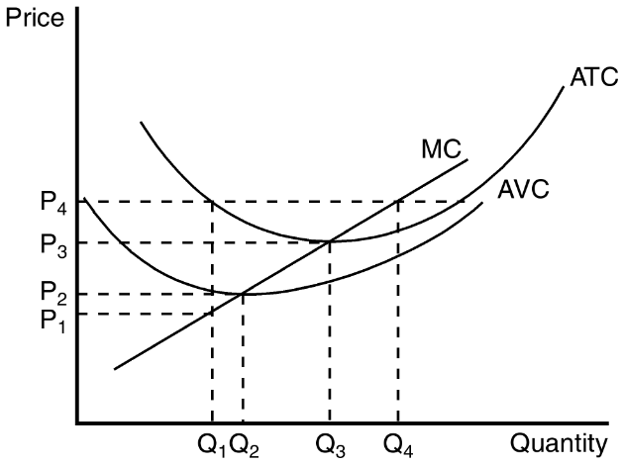

13. At a price of P₃, the competitive firm pictured above finds that
- marginal cost is less than average fixed cost.
- the best it can do is earn zero profit.
- positive profits are possible if the firm produces more than Q₃.
- it would be better off by shutting down and producing nothing.

14. If the market price is equal to P₄ this competitive firm would produce where price equals marginal cost.
- True
- False

For questions 15 and 16, assume a certain firm in a perfectly competitive industry is producing 800 units of output (so Q = 800). At Q = 800, the firm’s marginal cost equals $6 and its average total cost equals $9. The firm sells its output for $11 per unit.

15. At Q = 800, the firm’s profit amounts to
- -$200.
- $0.
- $800.
- $1,600.

16. To maximize its profit, the firm should
- increase its output.
- continue to produce 800 units.
- decrease its output, but continue to produce.
- shut down.

17. Monopolistic competition differs from perfect competition because in monopolistically competitive markets
- there are barriers to entry.
- all firms can eventually earn long-term economic profits.
- there is no product differentiation between sellers.
- each of the sellers offers a product that is somewhat different.

18. Price discrimination requires the firm to
- separate customers according to their willingness to pay.
- differentiate between different units of its product.
- dislike some customers because of their race.
- All of the above are true.
19. The deadweight loss that arises in monopoly is a consequence of the fact that the monopoly
a. price is higher than the price that would achieve efficiency.
b. price exceeds marginal cost.
c. output is lower than the level of output that would achieve efficiency.
d. All of the above are correct.
20. As a group, oligopolists would be better off if they would act collectively
a. as if they were each seeking to maximize their own individual profits.
b. in a manner that would prohibit collusive agreements.
c. as a single monopolist.
d. as a single perfectly competitive firm.
21. The prisoners’ dilemma provides insights into the
a. benefits of government ownership of monopoly.
b. benefits of avoiding cooperation.
c. difficulty of maintaining cooperation.
d. ease with which oligopoly firms maintain high prices.
22. The profit-maximizing rule for a monopolist is to select the quantity at which
a. marginal revenue is equal to marginal cost.
b. average total cost is equal to marginal revenue.
c. average total cost is at its minimum value.
d. average revenue exceeds average total cost.
23. In monopolistically competitive markets, economic profits
a. signal some incumbent firms to exit the market.
b. signal new firms to enter the market.
c. are maintained through government-imposed barriers to entry.
d. are never possible.

24. Suppose that monopolistically competitive firms in a certain market are experiencing losses. In the transition from this initial situation to a long-run equilibrium,
- the number of firms in the market decreases.
- each incumbent firm experiences a decrease in demand for its product.
- each firm experiences upward shifts of its marginal-cost and average-total-cost curves.
- All of the above are correct.

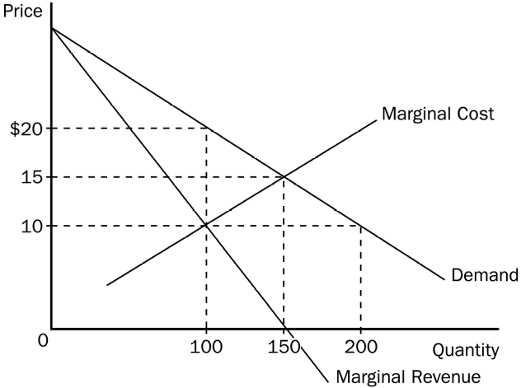

25. Which of the following outcomes would maximize total surplus?
a. 100 units of output and a price of $10 per unit
b. 150 units of output and a price of $10 per unit
c. 150 units of output and a price of $15 per unit
d. 200 units of output and a price of $10 per unit
26. To maximize its profit, a monopolist would choose which of the following outcomes?
a. 100 units of output and a price of $10 per unit
b. 100 units of output and a price of $20 per unit
c. 150 units of output and a price of $15 per unit
d. 200 units of output and a price of $20 per unit

