PHY 145 Lab 10: Lenses

Goals

 Develop an understanding about how refraction is related to lenses.

Measure the focal length of a lens and use the thin lens equation and see how it relates to ray diagrams.

Gain a sense for chromatic aberration.

Create optical instruments with lenses such as a telescope and a microscope.

Activity 1: Making Lenses

From the supply table, obtain a ruler and a protractor.

- Using the model of a prism on the next sheet, a protractor, and Snell’s Law find the path of the ray as it exits the far side of the prism.

- The incident ray was initially headed right towards the prism. How did the direction of the incident ray change after passing through the prism?

- If you inverted the prism (so the pointy side was down) how would the direction of the incident ray change after passing through the prism?

Incident ray
n = 1.5
All prism angles 60°

- Consider parallel light incident on the structures below.

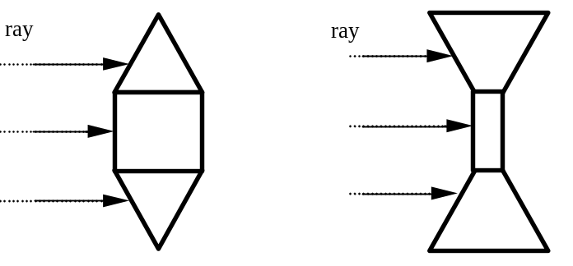

What happens to parallel light rays that strike their surfaces?

Activity 2: Real Images

From the optics kit, obtain the light box and track, crossed arrow target, viewing screen, 50 mm convex lens, and three component holders. This experiment should be performed in a darkened room.

- Arrange the components on the magnetic track as shown below. The light box should be placed at one end of the track. The crossed arrow target should be placed over the aperture of the light box. The lens and the viewing screen should be held in place with the component holders.

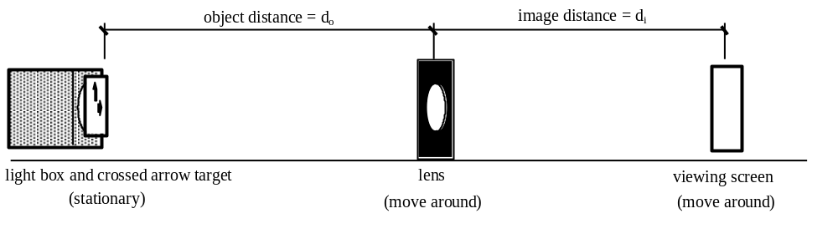
- Turn on the light box and move the lens and viewing screen around until a focused image appears on the viewing screen. This is a real image because real rays form the image.

- Is the image magnified or reduced?

- Is the image inverted?

- Predict what will happen if you cover half the lens with a piece of paper. Try it out. Draw a ray diagram to explain what is going on.

- The thin lens equation is 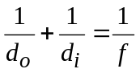, with 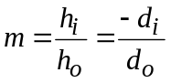. Use your experimental apparatus to complete the table below. Set the object distance (d_{o}) at the given value and measure the image distance (d_{i}) for a focused image and the height of the image (h_{i}).

d_{o} (mm) | Measure  d_{i} (mm) | Measure  h_{i} (mm) | Calculate  1/d_{o} + 1/d_{i} | Calculate  f (mm) | Calculate  h_{i}/h_{o} | Calculate  -d_{i}/d_{o}
400
350
300
250
200
150
100

- Did all of your values agree with the thin lens equation? If not, to what do you attribute the discrepancies?

- Now that you have determined the focal length for your lens, calculate the image distance for an object distance of 50 mm.

- Where will this image be located? Will you be able to focus the image on the viewing screen? Explain why.

- Set up your apparatus for an object distance of 50 mm and check your predictions.

Activity 3: Chromatic Aberration

Obtain a red filter and a blue filter from the optics kit.

- Using the setup from Activity 2, remove the crossed arrow target from the light box. Move the lens and screen around until you obtain a real image of the light bulb filament.

- Determine the focal length for red light using the red filter. Keep in mind that the light bulb is located inside the light box—you will need to devise a method of finding how far the bulb is inside the box.

- Repeat step 2 for the blue filter.

- Remove the filter. Slide the screen back and forth along the track. Observer and not carefully how the colors of the borer change as the screen passes through the image plane.

- Draw ray diagrams that explain what you just saw.

Activity 4: Optical Instruments
Obtain the convex 75 mm lens from your instructor.
- Remove all items from the magnetic track. Place each lens on a component holder. Put the 75 mm lens on the magnetic track close to one end. Put the 150 mm lens on the magnetic track a distance of 225 mm away from the first lens. Congratulations! You have just created a telescope. While looking through the 75 mm lens, adjust the distance between the lenses to bring a distant object into focus.

- Draw a ray diagram for this situation.

- Measure the magnification of the telescope. To do this, look through the telescope with one eye and look directly at the object with the other eye. Compare the size of the two images. (A ruler makes a good object.)

- Switch the position of the two lenses and repeat the above experiment. How does the new magnification value compare with the results previously attained?

- Put the viewing screen on a component holder and put it on the magnetic track on the end away from the lenses. Adjust the 75 mm lens until the distance between the viewing screen and the 75 mm lens is 150 mm. The order of components on your magnetic track should be viewing screen, 75 mm lens, and 150 mm lens. Congratulations! You have just created a microscope. While looking through the 150 mm lens, adjust the distance between the lenses until you see a clearly focused image of the viewing screen.

- Draw a ray diagram for this situation.

- Is the image magnified? How does the magnification compare to using the 75 mm lens alone?

- While looking through the 150 mm lens, slowly move the 75 mm lens closer to the viewing screen. Adjust the 150 mm lens as needed to maintain a focused image.

- Does the magnification increase? Does a focusing problem develop?

