PHY 145 Lab 11: Interference

Goals
 Gain an understanding of interference from two sources by observation.

Gain an understanding of how diffraction may be used to measure the wavelength(s) of a light source.

Measure the wavelength of laser light by using a two-slit interference pattern and a diffraction grating.

Measure the range of wavelengths for each color in the spectrum using a diffraction grating.

Activity 1: Water Wave Interference

A water wave table is set up at the front of the laboratory classroom for this activity.

- Sketch the pattern you observed on the paper under the water wave table.

- Two wave sources were present in this set-up. In the areas where the water was smooth and flat, what was the phase difference between the two waves? What was the phase difference in the areas that were rippled?

3. Waves are a traveling disturbance that carries energy. This set-up gave an opportunity to view the superposition of two waves. With this in mind, were waves present in the smooth, flat areas seen in the demonstration? Was energy being carried through those areas?

Activity 2: Two-Slit Interference

From the supply table obtain a laser, three lab jacks and two meter sticks. From your optics kit, obtain the diffraction plate and one component holder.
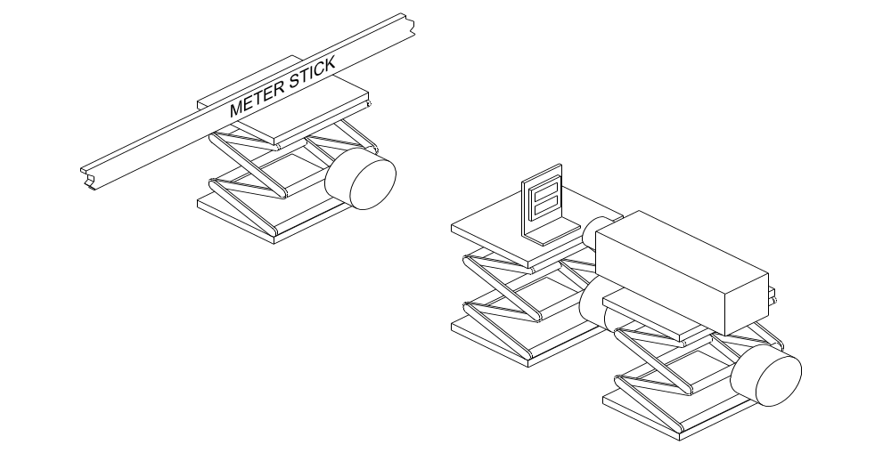

Fig. 1
1. CAUTION! Do NOT look directly into the laser beam. Do NOT shine the laser toward others. Serious eye injury could result. Choose a direction for your set-up that will shine the laser toward an unoccupied area. Figure 1 shows the set-up for this activity.

2. Begin by placing the laser on one of the lab jacks. Place the meter stick on a second lab jack, approximately 1 meter in front of the laser, perpendicular to the laser’s beam.

3. Turn on the laser and adjust the height of the lab jacks and the position of the meter stick so that the laser’s beam strikes the meter stick near the top of the 50 cm mark.

4. Put the diffraction plate on the component holder with slit pattern “D” toward the top. Place the diffraction plate assembly on the third lab jack, near the laser. Adjust the height and location of the diffraction plate so that the beam passes through both slits of pattern “D.”

- When properly set up, this will result in an interference pattern consisting of light and dark fringes or maxima and minima. Analogous to the water wave table demonstration, these are areas of constructive and destructive interference are due to the superposition of waves emanating from two sources; In this case, the two slits through which the laser beam passes. Figure 2 shows the geometry of this situation.

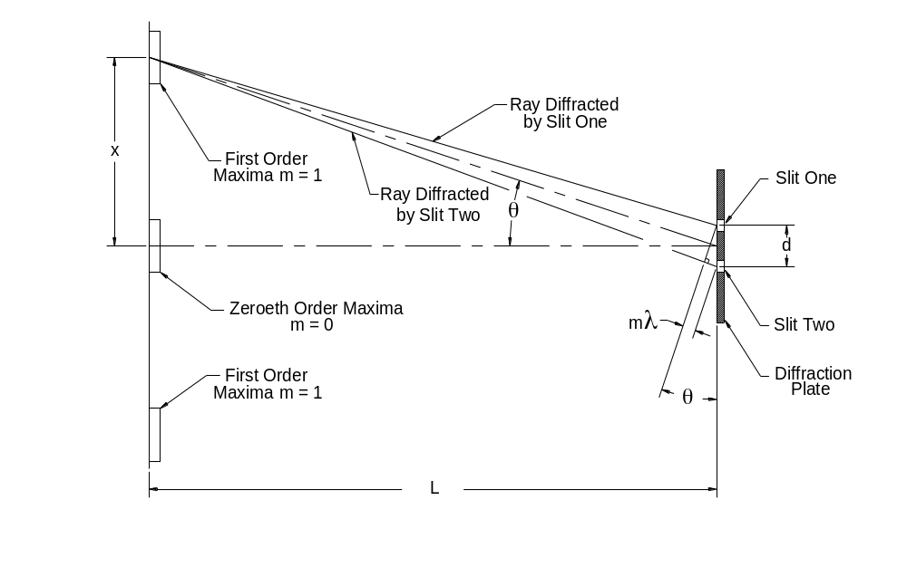
Fig. 2

- The incident laser beam strikes the right side of the diffraction plate. As the beam passes through the slits, it diffracts, or bends, near the edges of the slits. The closer the portion of the beam is to the edge of the slit, the more it bends. Figure 2 focuses on the two portions of the beam that create the first order maxima. Note that for the sake of discussion, figure 2 is not drawn to scale. Namely the slit spacing is greatly exaggerated. In reality the two diffracted beams are very close together and nearly parallel to one another. The actual path of the beams is illustrated in the figure by the dashed lines.

- In order for constructive interference to occur, both wave sources must be in phase. In other words, the path-length of one beam must be some whole number (m) of wavelengths (λ) longer than the other. In the case of the first order maxima illustrated, the path of the ray diffracted by slit two is one full wavelength longer than the path of the ray diffracted by slit one.

- With both rays nearly parallel, we find that the small triangle formed at the diffraction plate (hypotenuse “d” and side “mλ”) is congruent to the triangle with sides “x” and “L.” Using the measurable distances “x” and “L”, we can solve for the angle “θ” by using the tangent function, i.e. θ = tan⁻¹(x/L). Knowing “θ” then allows us to solve for the path length difference “mλ” by using the sine function, i.e. d sinθ = mλ, or solving directly for λ we have λ = (d/m) sinθ.

- Now that we have developed and understanding of the set-up, use your measured values to fill out table 1 below.

Order of Maxima "m" | Slit Spacing "d" | Measured "x" | Measured "L" | Calculated "θ" tan⁻¹(x/L) | Calculated "λ" (d/m) sin θ
1 | .125 mm
2 | .125 mm
3 | .125 mm

Table 1

What was your average value for λ?

________________ nm

10. Move the diffraction plate so that the laser beam passes through slit pattern “E” (slit spacing .250mm) and then again so that it passes through pattern “F” (slit spacing .500mm). What happened to the diffraction pattern as the slit spacing was increased? From this, what can we say about the relationship between slit spacing and the degree to which the beam bends?

Activity 3: Diffraction Grating

From your optics kit, obtain the diffraction grating.

1. Remove the diffraction plate and replace it with the diffraction grating.

2. A diffraction grating has many very fine parallel slits, so fine in fact, that they are generally called lines. The grating in our optics kit has 5276 lines/cm. From this value, calculate the slit spacing in mm.

d = ________________mm/line

3. Employing the same line of reasoning we used with the two slit interference, measure the values for “x” for the two first order maxima that appear on the meter stick. Take the average of these two values and record it below.

Avg. “x” value _______________mm

4. Measure the distance “L” from the diffraction grating to the meter stick and record it below.

L = _________________mm

5. Solve for the wavelength of the laser light.

d sin(tan⁻¹(x/L)) = λ = _______________nm

Activity 4: Color Spectrum of Light

From your optics kit obtain the magnetic track, light source, ray table base, diffraction scale, diffraction grating and one component holder.

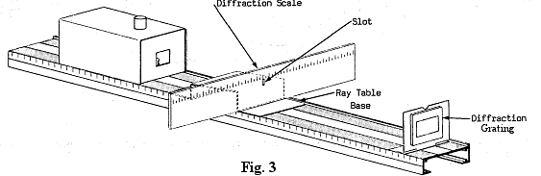
1. Figure 3 shows the set-up for this activity. Place the components so as to maximize the distance between the diffraction scale and the diffraction grating. Adjust the position of the light source bulb so that you can see the filament through the slot in the diffraction scale.

2. Look through the diffraction grating at the diffraction scale. You should see a first order spectrum left and right of center. You may need to move your head from side to side to facilitate this.

3. Enter the value you found in activity 3 for “d”, mm/line, in table 2. Measure and record the distance “L” from the diffraction scale to the diffraction grating in table 2.

4. Looking at the spectrum to the right of the slot in the diffraction scale, measure the distance x_{1violet}, from the slot to the left edge of the violet colored light in the spectrum. Record your value in table 2. Now measure x_{2violet}, from the slot to the right edge of the violet light in the spectrum. Calculate λ_{1 violet} and λ_{2 violet} as indicated in table 2. This is the range of electromagnetic wavelengths that appear violet to our eyes. Continue your measurements and calculations for the remainder of the colors in the spectrum.

Color | Enter  d (mm) | Measure  L  (mm) | Measure  x₁  (mm) | Measure  x₂  (mm) | Calculate  λ₁=d sin(tan⁻¹(x₁/L)) (mm) | Calculate  λ₂=d sin(tan⁻¹(x₂/L)) (mm)
Violet
Blue
Green
Yellow
Orange
Red
Table 2

5. Compare your calculated values with the accepted values found in your textbook.

