PHY 145 Lab 2: Electric Potential

Goals

 Experience how to create an electrical charge imbalance on an object.

Experience a method used to store electrical charge.

Develop an understanding on how energy is stored in a capacitor.

Activity 1: Construct and Use an Electrophorus

A simple electrophorus can be made using a Styrofoam cup, an aluminum pie plate, and a piece of blue Styrofoam insulation. Create an insulating handle for the aluminum pie plate by taping the Styrofoam cup to the plate as shown below.

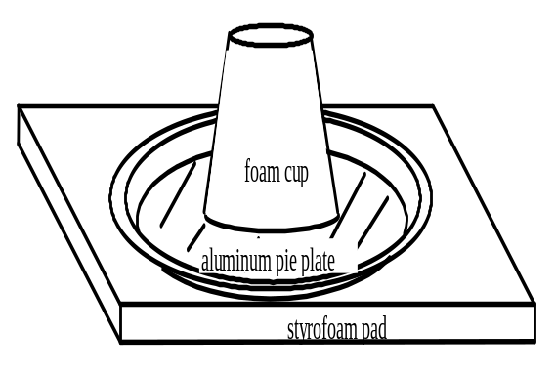

Simple electrophorus

To use the electrophorus, charge up the blue Styrofoam piece and the felt cloth by rubbing them together. By holding onto the Styrofoam cup, position the aluminum pie plate over the blue Styrofoam piece and move it so that it is very near to, but not touching the surface of the blue Styrofoam. Now touch your finger to the aluminum pie plate.

1. Did you feel anything as you brought your finger near the aluminum pie plate? Why?

2. Is the blue Styrofoam piece charged or neutral before rubbing with the felt cloth? Draw a diagram showing the charges on the blue Styrofoam piece after rubbing.

3. Explain what happens to the charges in the aluminum pie plate as you bring it near the surface of the blue Styrofoam piece. Draw a diagram to support your explanation.

4. Using the diagrams you have just created, explain what happens as you bring your finger near the aluminum pie plate.

- Does what you feel depend upon how long you rub the blue Styrofoam piece? Why do you think this is so?

√ Have the instructor or assistant check your results at this point.

Activity 2: Storing Charge, the Leyden Jar

What if you needed a larger charge than you are able to produce with your electrophorus? What are some ways that you may be able to create a larger charge? If there was some way to store charge, you could repeatedly charge your aluminum pie plate and then transfer the charge to a storage device. Historically, this storage device is known as a Leyden Jar.

Leyden jars can be constructed from foil cup cake liners, a hard plastic drinking cup, and a paper clip. To construct a Leyden jar, carefully glue the foil cup cake liners to the inside and outside of the plastic drinking cup. Use a second drinking cup to help press the foil cup cake liners flat against the inside and outside of the cup, being careful not to crack the cup. Bend the outer leg of the paper clip straight and slide it over the edge of the cup so that the extended leg contacts the inner foil. The completed Leyden jar is shown below.

Leyden Jar

1. Charge your aluminum pie plate using the technique developed in the previous activity. Now hold the jar by its foil covering and touch the paper clip with the charged aluminum pie plate. Describe your observations.

2. Still holding the jar by its foil covering, touch your finger to the paper clip. Did you feel anything? Why?

3. Try charging the jar several times. Now touch your finger to the paper clip. Do you feel anything different than before?

√ Have the instructor or assistant check your results at this point.

Activity 3: Equipotential Contours

1. Open EM Field by double clicking on the icon. A message box about locked files will open, choose OK. The copyright page opens; click anywhere to continue. A page about the program directions should now be displayed.
2. Use the mouse to highlight the Sources menu and choose 3D point charges.
3. Drag the  charge from the bottom to the center of the screen.
4. Use the mouse to highlight the Field & Potential menu and choose Potential.
5. Position and click the mouse several times. For each mouse click, the program calculates the potential at that point.

Q1. What is the sign of the potential values? What is the difference between values close to and far away from the charge?

6. To clean the screen, use the mouse to highlight the Display menu and choose Clean up screen.
7. To remove the charge, drag it to the bottom of the screen.
8. Repeat the above with a  charge.

Q2. Only potential differences are physically meaningful. When the program calculates a potential value, what reference is being used?

9. Clean the screen and again place a charge near the center of the screen.

10. Use the mouse to highlight the Field & Potential menu and choose Equipotentials.

11. Position and click the mouse. After clicking the mouse, be patient. Allow the program to finish drawing the equipotential before clicking the mouse again.

Q3. What is the shape of the equipotential contour? How much work is done when moving a charge along an equipotential contour? Why?

12. Clean the screen and place a  charge near a  charge. Position and click the mouse to draw the equipotential contours. Without cleaning the screen, draw the E field lines. To draw the E field lines, use the mouse to highlight the Field & Potential menu and choose Field lines. Position and click the mouse to draw the field lines.

Q4. What is the angle of intersection of an equipotential contour with the field lines?

13. Open the parallel plate capacitor file. Use the mouse to highlight the File menu and choose Get charges or currents from file. Open P-145 alias. Open qplates.emf copy.

14. Position and click the mouse to draw the equipotentials. Again, be patient after clicking the mouse. Allow the program to finish drawing the equipotential before clicking the mouse again.
Q5. Away from the edges of the capacitor, describe the shape of the equipotential contours. What does this tell you about the field lines?

√ Have the instructor or assistant check your results at this point.

Activity 4: Capacitance and Energy
Consider the parallel plate capacitor below. At 100 V it stores 0.05 C of charge. The following questions concern this capacitor.

1. What is the capacitance of this capacitor?

2. What is the direction of the force a positive charge located between the plates would experience? Sketch in the electric field between the plates of this capacitor. Which side is positively charged, and which side is negatively charged?

3. How much work is done by the electric force on + 1 nC of charge if it moves from the high voltage side of the charged capacitor to the low voltage side?

- The energy stored in a capacitor is actually Q(1/2V) = 1/2CV2
Try to identify a reason why the stored energy is less than the answer to Question 3.

5. While the capacitor above is still charged, a container of water is moved between the capacitor plates (see picture). Will the electric field in the water be greater than, less than or equal to the electric field at the same point before the water was moved in? Why? (Hint: Think about the behavior of neutral molecules in the presence of a charged object.

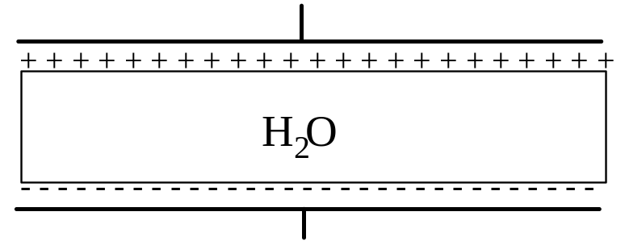

√ Have the instructor or assistant check your results at this point.

