PHY 145 Lab 4: Circuits, Batteries, and Magnets

Goals

 Practice using a voltmeter and an ammeter to measure voltages and currents in a circuit.

Gain an understanding of the difference between real and ideal batteries.

Develop ideas about magnetic poles and fields and the earth’s magnetic poles.

Gain further understanding about the vector nature of magnetic fields.

Activity 1: Resistors in Series and Parallel

1. Obtain two meters with leads, one nichrome resistance wire, one battery, one battery holder, and several connecting wires.

2. Look carefully at the nichrome resistance wire. We will model a resistor by one length, approximately one meter, of thin nichrome wire. Decide how you could connect to the nichrome wire to make both a two resistor series and two-resistor parallel circuit. Check your plan with your instructor.

3. Configure one meter as a voltmeter.

Refer to Lab 3 Activity 2 for the correct procedure.

4. Configure the other meter as an ammeter.

Refer to Lab 3 Activity 3 for the correct procedure.

5. Construct the series circuit shown below. Each resistor in the diagram is one length of nichrome wire.
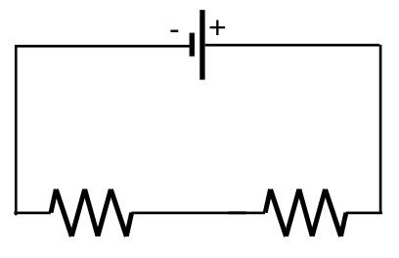

6. Measure the voltage across each circuit component and the current through the circuit, and record your readings in the table on the next page. Recall that a voltmeter measures voltage by connecting the leads across a component, while an ammeter measures current by becoming part of the circuit. If you are uncertain how to connect the meters, ask your instructor.

7. Compare the voltage rises to the voltage drops for the entire circuit. What can be said about these values?

8. Determine the resistance for each piece of nichrome wire by using Ohm’s Law. Determine the power dissipated in each wire. How much power does the battery supply?

9. Construct the parallel circuit shown below. Again, each resistor in the diagram is one length of nichrome wire.
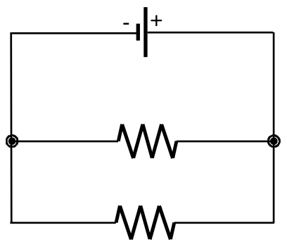

10. Measure the voltage across each circuit component and the current through each resistor and the battery.

11. Determine the resistance for each piece of nichrome wire by using Ohm’s Law. Compare to values determined previously. Determine the power dissipated in each wire. How much power does the battery supply? How does this compare with a series circuit?

Series Circuit:
Component | Measured Voltage (V) | Measured Current (A) | Calculated Resistance (Ω) | Calculated Power (W)
Battery |  |  | N/A
1st Resistor
2nd Resistor

Parallel Circuit:
Component | Measured Voltage (V) | Measured Current (A) | Calculated Resistance (Ω) | Calculated Power (W)
Battery |  |  | N/A
1st Resistor
2nd Resistor

Activity 2: Real Batteries

1. Measure the “open circuit” voltage of the battery using a voltmeter as shown in the diagram below.
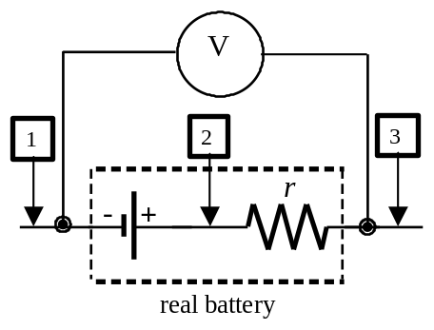

Assign 1 as the zero voltage reference. Measure the voltage at 3: _______. Is there any current flowing through the battery? Explain.

Compute the voltage drop across the internal resistance, r.

Compute the voltage at 2.

Compute the emf of the battery.

2. Construct the circuit shown below. The resistor is approximately a one-meter length of nichrome wire.
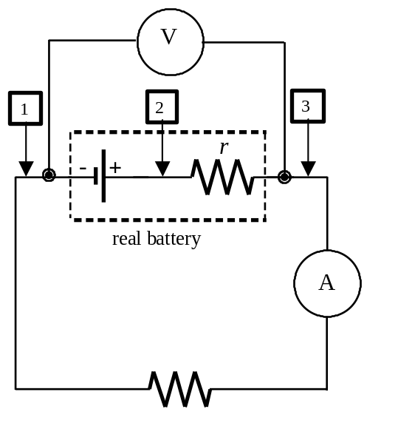

- Assign 1 as the zero voltage reference. Measure the voltage V₃ - V₁: ______
Do you expect the voltages at 2 and 3 to be the same as before? Why?

Compute the voltage at 2 using the emf of the battery and the voltage drop (V₃ - V₁) across the external resistance, R.

Then, compute a value for the internal resistance of the battery, r.

4. Determine the power dissipated by the nichrome wire. How much power is “wasted” by the internal resistance of the battery?

Activity 3: Magnetic Poles

Consider an Alnico (aluminum-nickel-cobalt) bar magnet.

1. If a magnet were cut in half, what kind of poles would each piece have?

2. What would happen if each of those pieces were cut in half?

3. Consider cutting these pieces in half again. What kind of poles would each piece have? At what point must this process stop? What are you left with?

4. Which poles attract and which poles repel?

5. Demonstrate that a compass needle must be a magnet with two poles.
6. The compass needle has a “North-seeking” and “South-seeking” end. Which pole of the magnet attracts the “North-seeking” end of the compass needle?

7. If the earth behaves like a big magnet, how does a compass assist with navigation or orienteering?

8. Which type of magnetic pole is a compass’s “North-seeking” end?

9. Use a compass to “map” the magnetic field lines of the Alnico magnet. How are these lines related to the electric field lines of an electric dipole?

Activity 4: Strength of a Magnet

Now, consider the interaction between an Alnico bar magnet and a compass more carefully:
- Put the compass near you and temporarily put the bar magnet far away from the compass.
- Rotate the compass case so that north on the case sits under the north-seeking end of the compass needle.
- Place the bar magnet reasonably close to the compass so that it is aligned with the east-west axis of the compass case and the compass needle is turned about 30° off the north-south axis of the compass case.
- Make a drawing of the compass/bar magnet system. Indicate the magnetic field vectors for the magnetic fields due to the Earth and to the bar magnet and the resultant net magnetic field vector at the center of the compass.

- The horizontal component of the Earth’s magnetic field is about 20 µT. Devise a method to calculate the strength of the bar magnet’s magnetic field and the resultant net magnetic field.

