PHY 145 Lab 5: Magnetic Fields

Goals

 Develop a magnetic field model.

Understand that moving charges create a magnetic field.

Develop an understanding of the relationships between current, magnetic field, and magnetic force.

Activity 1: _Poles and Magnetic Fields

Obtain a blue Welch power supply, coil, a large compass, and a small compass. Connect the coil to the DC outputs of the power supply. Align the coil so its axis points north-south. Turn the dial on the power supply to half scale. Put a sheet of paper on the table and hold the coil against the side of the table. Use the compasses to deduce the magnetic field lines for the current carrying loop. Draw the magnetic field lines on the paper. You will want to use the small compass in the interior of the coil and close to the coil. You will want to use the large compass further away. Mark a collection of starting points near the coil. Starting with the small compass, set it so that one end of the needle points at the mark, and make a new mark at the other end of the needle. Use this mark as your new mark, and continue the process, switching to the large compass when you are further away.

- Why is there a magnetic field? What creates it?

- Can this loop of wire be considered a magnet?

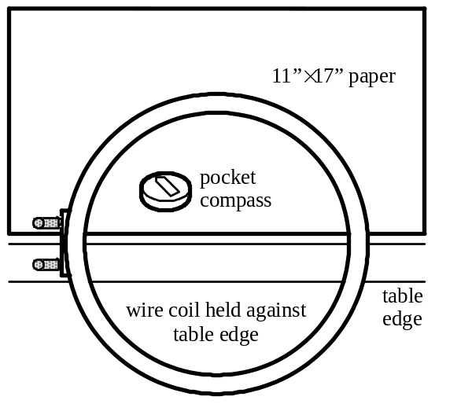

- How do you think the magnetic field of this current loop differs from that of a magnet? What must the magnetic field lines be doing "inside" of a magnet?

- Where are the "poles"?

- Can you get an isolated north or south pole? Explain why or why not.

- Why does the magnetic field cease looking like a dipole far away from the coil?

Activity 2: ______Simulating Magnetic Fields

1. Open EM Field by double clicking on the icon. A message box about locked files will open, choose OK. The copyright page opens; click anywhere to continue. A page about the program directions should now be displayed.

2. Use the mouse to highlight the Sources menu and choose 2D line currents (magnetism).

3. Drag the current from the bottom to the center of the screen.

4. Use the mouse to highlight the Field & Potential menu and choose Field lines.

5. Position and click the mouse. After clicking the mouse, be patient. Allow the program to finish drawing the magnetic field line before clicking the mouse again. Draw several magnetic field lines.
6. Use the mouse to highlight the Field & Potential menu and choose Field vectors.

7. Position and click the mouse. The program draws a magnetic field vector with the tail to the vector located at the position the mouse was clicked.

Q1. What is the direction is the current? How did you know that?

8. To clean the screen, use the mouse to highlight the Display menu and choose Clean up screen.

9. To remove thecurrent, drag it to the bottom of the screen.

10. Repeat steps 2 through 9 with a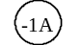 current.

11. Now arrange a pair of currents.

12. Use the mouse to highlight the Field & Potential menu and choose Field lines.

13. Position and click the mouse. After clicking the mouse, be patient. Allow the program to finish drawing the magnetic field line before clicking the mouse again. Draw several magnetic field lines.

14. Use the mouse to highlight the Field & Potential menu and choose Field vectors.

15. Position and click the mouse. The program draws a magnetic field vector with the tail to the vector located at the position the mouse was clicked.

Q3. How does this arrangement represent current flowing in a circular loop? How could you determine the direction of the magnetic field without using the program?

16. Clean the screen and drag both currents to the bottom of the screen.

17. Use the mouse to highlight the File menu and choose Get charges or currents from file. Open P-145. Open isheets.emf.

18. Repeat steps 12 through 15.

Q4. How does this arrangement represent current flowing in a long coil? Which ends are the north and south poles?
Q5. Suppose you have a wire loop like in activity 2. How can you determine which side of the loop acts like north and which side acts like south?

Activity 3: Thinking about Magnetic Forces

- This activity is a thought experiment only. Do not actually do the activities!
- Consider connecting a wire across a battery. (This is called a short circuit. Connecting such a circuit for more than a few seconds excessively drains the battery!) Consider connecting another wire across another battery, and then holding them so the two wires are parallel, near each other, and the currents flow in the same direction.
- What would happen to the wires? Draw diagrams below, showing the relevant magnetic fields and magnetic and gravitational forces.

- Consider the situation in step 2, except this time with the currents flowing in opposite directions.
- What would happen to the wires? Draw diagrams below, showing the relevant magnetic fields and magnetic and gravitational forces.

- Devise a method that would allow you to estimate the strength of the magnetic force on one wire due to the other wire (without knowing the currents). What assumptions did you make?

