PHY 145 Lab 6: Electromagnetism

Goals

 Build an electromagnet. Develop ideas about ferromagnetism.

Increase understanding of magnetic fields due to current flow.

Develop ideas about the induced field and the induced current that are consistent with Lenz’s Law.

Activity 1: Ferromagnetism

From the supply table, obtain a nail, a brass rod, a battery, a battery holder, a length of insulated wire, a compass, a paper clip, and two clip leads.

1. Use the compass to determine if the nail is a magnet. If the nail is a magnet its tip will attract one end of the compass needle and repel the other end of the needle.

2. Wrap the wire around the nail. Wrap so that the coils are close together, but do not wrap so tightly that you will not be able to later remove the nail. Or use a ready-made coil.

3. With the wire wrapped around the nail, connect the ends of the wire to the battery. Note, for each task below, only connect to the battery long enough to make your observations and then disconnect.

4. Hold the nail next to a paper clip. Does the nail attract the paper clip? Why do you think this happens?

5. Use the compass to find the north and south poles of the nail. Sketch the magnetic field lines. Which direction is the current flowing in the wire? How do you know that?

6. Carefully slide the nail out of the coil of wire. Try not to deform the coil while doing this.

7. Now hold the coil next to the compass. Does the compass behave differently than before? Why do you think this is so?

8. Carefully slide the brass rod inside the coil. Brass is an alloy containing copper and zinc. What happens when you try to attract a paper clip? Use the compass to identify the north and south poles of the coil. What do you find?

9. Why does the steel nail behave differently than the brass rod?

10. Use the compass to determine if the brass rod is a magnet. What do you find?

√ Have the instructor or assistant check your results at this point.
Activity 2: Magnetic Fields from Current

You will need a Welch (blue) power supply, a 130-Ω coil, a meter, and two red and black leads.

- Configure the meter as an ammeter. Refer to Lab 3, Activity 3 for the procedure.
- Connect the positive terminal of the battery to the red socket on the ammeter. Connect the black socket on the ammeter to the red connection on the 130-ohm coil (much more resistance than the coil used in Activity 1.) Connect the black connection on the coil to the negative terminal on the battery.
3. Using this symbol for a coil 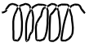, draw the circuit diagram. Check your diagram with your instructor.

4. On the circuit diagram, draw the direction of the current.

5. Record the ammeter value: _____________.

6. Switch the connections on the positive and negative terminals of the battery. Draw the circuit diagram for this circuit. Draw the direction of current on the circuit diagram.

7. Record the ammeter value: ____________. Is it the same as before? Is there a difference in the sign as well as the value?
8. If current flows into the red socket and out of the black socket on the ammeter, what will be the sign of the current value? What if the current flows into the black socket and out the red socket?

9. Replace the battery with the blue power supply. Make the connections to the DC outputs on the power supply and in a way that will result in a positive ammeter value. Turn the dial on the power supply to half scale. Record the ammeter value:____________.

10. Use a compass to find the north and south poles of the coil.

11. Switch the connections on the power supply. Use a compass to find the north and south poles of the coil. Are the poles in the same place as before? What has happened? What does the ammeter read?

12. From your observations above, determine the direction of the current in the coil windings.

√ Have the instructor or assistant check your results at this point.

Activity 3: Induction and Lenz’s Law

Obtain an additional 130-Ω coil and a magnet.

1. Connect one coil to the DC outputs of the power supply and the other coil to the ammeter. Turn the power supply off.

2. Adjust the sensitivity of the ammeter by depressing the button below the 20 m.

3. Use the compass to find the north and south poles of the magnet.

4. Starting with the arrangement shown below, move the magnet briskly towards the coil and observe the ammeter.

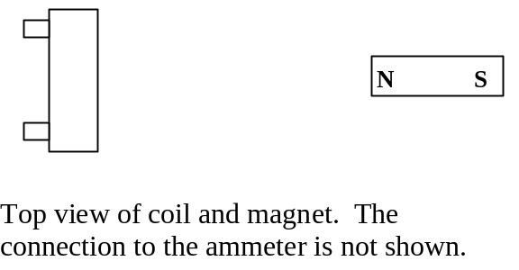

5. Is the magnetic field through the coil increasing or decreasing? What is the direction of the field through the coil? According to Lenz’s Law, which direction must the induced magnetic field point? What is the direction of the induced current in the coil?

6. As you moved the magnet, what happened to the ammeter? Which direction is the current flowing according to the ammeter? Does this agree with your results from step 5?

7. Start with the magnet close to the coil and move it briskly away. Repeat steps 5 and 6

8. Turn the magnet around and repeat steps 5-7.

9. Arrange the two coils back to back as shown below. Turn the dial on the power supply to half scale.

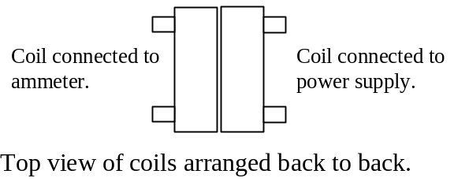

10. Arrange the power supply connections so that the current flows counterclockwise in the coil. With the current flowing counterclockwise, which direction does the field point? Check this with your compass.

11. Slide the coil connected to the ammeter away from the coil connected to the power supply to end up in the position shown below.
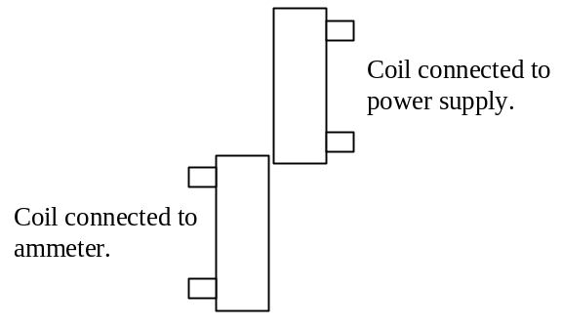

12. Is the magnetic field through the coil increasing or decreasing? What is the direction of the field through the coil? According the Lenz’s Law, which direction must the induced magnetic field point? What is the direction of the induced current in the coil?

13. Return the coil to the starting position and move it again this time observing the ammeter. Does the ammeter agree with your predictions?

14. Start with the coils apart and slide together. Repeat steps 12 and 13.

15. Reverse the direction of current in the coil and repeat steps 12-14

