PHY 145 Lab 7: Electromagnetic Spectrum and Polarization

Goals

 Develop ideas about oscillating magnetic fields and the creation of electromagnetic waves.

Gain some familiarity with the electromagnetic spectrum.

Observe the polarization of light.

Develop a sense of the applications for polarization of light.

Activity 1: Oscillating Magnetic Field

From the supply table, obtain a function generator, a meter, a compass, a 3000-turn coil, and two red and black leads.

- Configure the meter as an ammeter. Refer to Lab 3, Activity 3 for the procedure.

- Configure the function generator as follows:

Turn the function generator ON by depressing the button under the LINE heading located in the upper left-hand corner of the front panel.

Next to the power button is a row of seven buttons under the RANGE Hz heading. Depress the button located under the .1 value.

Next to the range buttons is a row of three buttons under the FUNCTION heading. Depress the middle button located under the wavy line.

Turn the large dial to setting 2.

Turn the DC OFFSET knob to the middle of its range so that the mark on the knob is aligned with vertical mark located under the word OFFSET.

Turn the AMPLITUDE knob fully clockwise.

- Construct a circuit consisting of the function generator, the ammeter and the coil according to the following steps:

The outputs on the function generator are located in the lower right-hand corner of the front panel under the 600 Ω OUTPUT heading.

Connect the HI output of the function generator to the red socket on the ammeter.

Connect the black socket on the ammeter to the red connection on the coil.

Connect the black connection on the coil to the LO output of the function generator.

- Using this symbol for a coil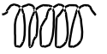, and this symbol for a function generator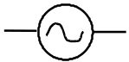, draw the circuit diagram. Check your diagram with your instructor.

- Hold the compass next to the coil. Is the magnetic field changing? How do you know that?

- Describe the ammeter readings. Is the ammeter reading a constant value, or many different values with a distinct minimum and maximum?
- Suppose you have one loop of wire. What information do you need to calculate the strength of the magnetic field at the center of the loop?

- The coil consists of 3000 loops of wire. Calculate the strength of the magnetic field using the maximum current value. For the radius of the loop, should you use the inside radius of the coil, the outside radius of the coil, or some value in between?

- Since we know that the strength of the magnetic field can never be a negative number, what does the negative current value mean?

- Hold the compass next to the coil and measure how long it takes for the north pole to move from one side of the coil to the other side and back again.

- Consider a top view of your circuit; choose the positive direction to be towards the right as shown in the diagram below.

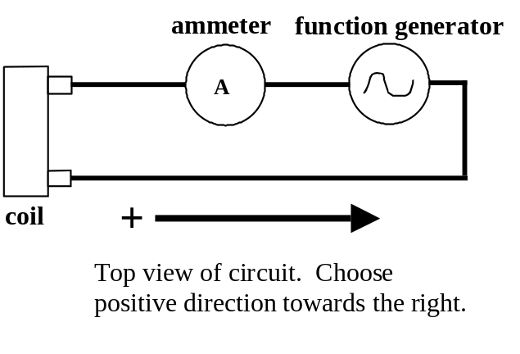

12. Using your calculations and measurements above, plot the strength of the magnetic field vs. time. Label the axes with values for time and magnetic field.

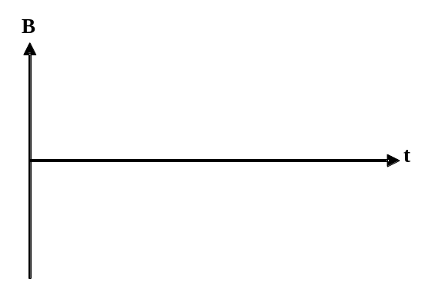

Activity 2: Electromagnetic Waves

Refer to a copy of the electromagnetic spectrum, e. g. on p. 726 of the text.

1. How is the creation of electromagnetic waves related to activity 1?

2. To create or detect electromagnetic waves with a reasonable amount of power, you need an object roughly the size of the wavelength. Determine the size of an object that could detect or emit the following wavelengths. Also, provide an example of an object of that size for each.

Radio Waves

Infrared Radiation

Visible Light

Ultraviolet Radiation

X-Rays

Gamma Rays
Activity 3: Polarization

From the supply table, obtain a light source, an optics bench, three component holders, a viewing screen, and two polarizers. Note these experiments may require the room to be darkened.

1. Attach the light source to one end of the optics bench. Attach the viewing screen to one of the component holders. Arrange the component holders on the optics bench as shown.

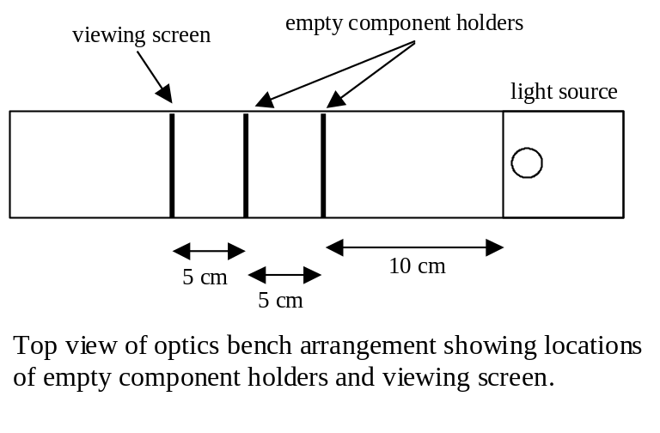

2. Turn the light source ON.

3. Describe what you see on the viewing screen as one polarizer is placed on the component holder located near the light source. Why do you think this is happening? What do we know about the intensity of light on the viewing screen compared to the intensity of the light source?

- Rotate the polarizer until the 0° mark is aligned with the notch on the top of the component holder. Place the second polarizer on the middle component holder and align the 0° mark with the notch.

- What happens to the intensity of light on the viewing screen as the second polarizer is rotated? Rotate the polarizer until the 90° mark is aligned with the notch. What is the intensity on the viewing screen? How is Malus’ Law related to this activity?

Activity 4: Applications of Polarization

In this experiment, you will be using the two polarizers you used in Activity 3 and a calculator (which you provide).

- Place a polarizer over the LCD display of a calculator that is displaying information. Rotate the polarizer. What do you observe? Between your observations and the material in your text, explain how the display works. The LCD is an example of an optically active material—one that changes the axis of polarized light.

- Go outdoors and look at the sky through your polarizer, and rotate it. (Note: Do not look at the Sun!) What do you see? For scattering angles of about 90°, light that scatters off molecules in the air will be polarized. Where is that in comparison to the Sun? Bees use polarized sunlight to navigate.

