PHY 145 Lab 8: Reflection and Mirrors

Goals

 Develop ideas about reflection from mirrored and non-mirrored surfaces.

Gain an understanding of parallax.

Determine the image location for a plane mirror and a curved mirror using parallax.

Activity 1: Plane Mirror Reflection

From an optics kit select a light box, single-slit mask and holder, plane mirror, optics bench, ray table and base. This experiment should be performed in a darkened room so a desk lamp is helpful.

1. Place the single-slit mask on the light box and position a mirror on the ray table as in the example setup.

2. Arrange the mirror so the beam reaches the mirror at an angle. Draw a diagram of the path of the light both toward and away from the mirror. Identify the angle of incidence and the angle of reflection.

3. Use the protractor on the ray table to measure the angle at which the beam strikes the mirror and the angle at which it leaves the mirror. How do these angles compare?
4. Rotate the ray table so that the light beam strikes the mirror at a different angle of incidence; repeat step 3.

5. Summarize your observations in this experiment as a rule describing how to predict the path of a beam of light that is aimed at a mirror.

6. Is your rule true for all angles or only for certain angles? Does your rule describe the behavior of each edge of the beam as well as the center of the beam?

Activity 2: Reflection from Paper

Additional materials you will need for this experiment are colored construction paper, white paper, a light source such as a light box from optics kit or flashlight. This experiment should be performed in a darkened room.

1. Place a mask on the front of the light so that there is a narrow beam.

2. Place a white sheet of construction paper flat on the table and hold a white sheet of paper near it as shown below. Aim the light at the construction paper, not the paper you are holding.

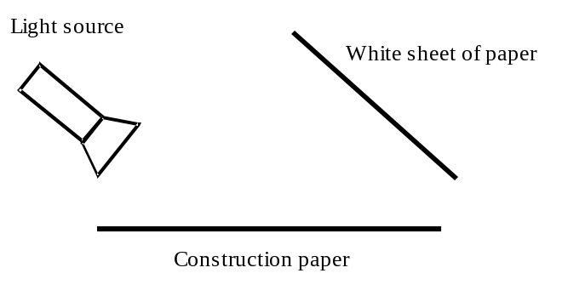
3. How does the appearance of the paper you are holding change as the light is turned on and off? Why do you think this is happening?

4. Replace the white construction paper with red construction paper. Does this change affect the appearance of the sheet you are holding?

5. Repeat step 4 with other colors of construction paper. How does the color of the construction paper affect what you see in the white paper you are holding? How can you account for your observations?

6. Suppose a mirror replaced the construction paper in the above set up. Predict how that would change what you see in the sheet of paper you are holding? Check you prediction.

7. Suppose you removed the white sheet of paper and placed your eye where the paper had been located. Predict what you would see if you were to look in the mirror with your eye. Explain you prediction to you partner. Check your prediction.

8. Suppose you moved the white sheet of paper behind the flashlight as shown below.

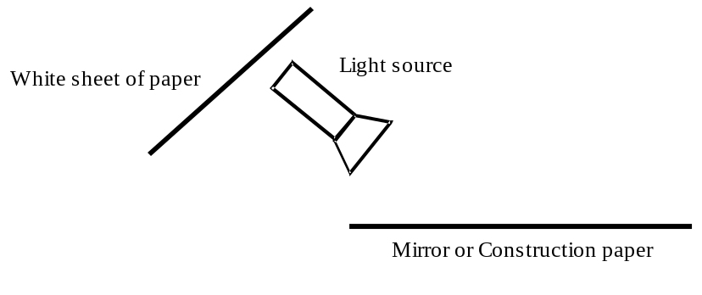

9. Predict what you would see in the white sheet of paper if the flashlight were aimed at a mirror. Predict what you would see in the white sheet of paper if the flashlight were aimed at a piece of construction paper.

10. Test your predictions.

11. Compare and contrast how light is reflected by mirrored surfaces and by non-mirrored surfaces.

- How should the rule you developed in activity 1 be modified to account for your observations of light reflecting from non-mirrored surfaces?

Activity 3: Image Location

Obtain two identical nails from the supply table.

1. Hold the nails vertical, one in each hand. Extend your arms in front of your face, still holding the nails vertical. Move one nail closer to you and align the nails so that one is directly behind the other.

2. Close one eye and move your head from side to side. Describe what you observe.

3. If you move your head to the right, which nail appears to be on the right: the one closer to you or farther from you?

4. If you move your head to the left, which nail appears to be on the left: the one closer to you or farther from you?

5. Now move the nails closer together. How does this change affect what you observe when you move your head from side to side?

6. If you place one nail on top of the other, what do you see when you move your head from side to side?

The apparent change in the relative location of the two nails when you move your head from side to side is due to parallax.
7. Place the mirror on some paper covering the tabletop. Balance one nail on its head about 10 cm in front of the mirror. This will be the “object nail”.
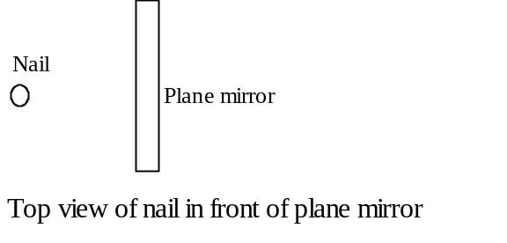

8. Place your head so that you can see the image of the object nail. Move your head from side to side and describe what you see.

9. Where does the image appear to be located? Does the image stay in the same location or does it change as you move your head from side to side?

10. Place you head so that you can see the image of the object nail. Apply the strategy for using parallax to place the second nail at the location of the image of the object nail. Mark this location of the paper.

11. Move your head to a new location and repeat the above procedure. Is there one location where all observers would agree that the image is located?

- How is the location of the object nail related to the location of the image?

13. Repeat the experiment using a curved mirror as shown below.

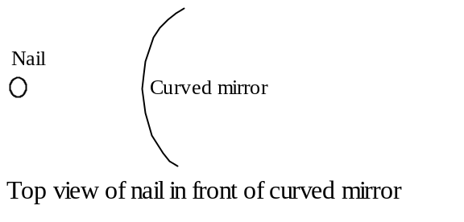
14. How is this image location different than for a plane mirror?

