PHY 145 Lab 9: Refraction

Goals

 Develop ideas about refraction from air to water and water to air interfaces.

Gain an understanding of Snell’s Law.

Determine the index of refraction for a material.

Gain an appreciation for the relationship between index of refraction and incident light color.

Activity 1: Refraction I

From the supply table, obtain a light box, single-slit mask, large sheet of white paper, a straight-sided plastic container, and a thick piece of glass. This experiment should be performed in a darkened room.

- Cover the tabletop with the large piece of white paper. Fill the plastic container with water.

- Shine the light from the light box through the container. Draw the path of the light through the container on the white paper for several different arrangements and angles.

- Can you arrange the container and the light box so that the beam does not bend at all in passing through the container? How is this done?

- On the basis of your observations, would you say it is the water or the side of the container that is responsible for the bend in the beam?

- Stand the thick piece of glass on edge and shine light through it. Draw the path of the light through the glass on the white paper. Are your observations consistent with your response to step 4 above?

- From your observations, sketch the path of the beam of light that is incident on the side of a transparent container of water shown below. Make additional observations if necessary.

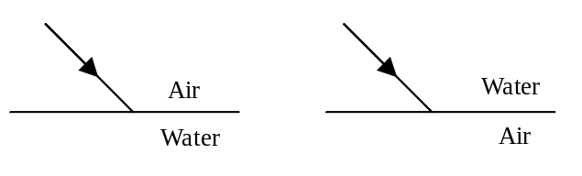

- Recall that the normal to a surface is a line perpendicular to the surface. Draw the normal on the above diagrams passing through the point where the beam strikes the surface. Does the beam bend toward or away from the normal when passing from air to water? How about from water to air?

Activity 2: Refraction II

Additional materials you will need for this experiment are a semi-cylindrical plastic (“cylindrical lens”), the optics bench, ray table and base, slit mask, slit plate and holder, all from the optics kit. This experiment should be performed in a darkened room.

- Position the semi-cylindrical plastic on the ray table with the flat side along the component line of the ray table.

- Shine the beam through the plastic, orienting it so that the beam always strikes the center of the flat side first. Slowly rotate the ray table always keeping the beam in the center of the flat side.

- Does the beam bend at both the flat side and the curved side of the dish? If it does not bend, can you explain why?

- Orient the plastic so that the beam always strikes the curved side first, but passes through and strikes the center of the flat side. Slowly rotate the ray table always keeping the beam in the center of the flat side.

- Can you orient the table so that no refracted beam emerges from the flat side of the plastic? This phenomenon is known as total internal reflection.

- The angle of incidence is the angle between the surface normal and the incident beam while the angle of refraction is the angle between the surface normal and the refracted beam. In the diagram below, label the angles of incidence and refraction.

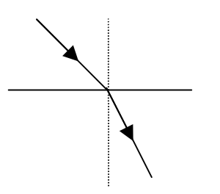

- Arrange the light beam so that it strikes the center of the flat side of the plastic first. Measure the beams incident and refracted at the flat surface of the plastic. If you are unsure of the arrangement, ask your instructor.

- Aim the light box at the center of the flat side of the dish so that the angle of incidence is 0°. Measure and record the angle of refraction at the center of the beam.

- Rotate the ray table so that the angle of incidence is 10°. Measure and record the angle of refraction by finding the angle of the center of the refracted beam.

Observe  θ_{i} (°) | Measure  θ_{r} (°) | Calculate  sin θ_{i} | Calculate  sin θ_{r}
0
10
20
30
40
50
60
70
80
85

- Repeat step 9 for angles of incidence from 20° to 85°.

- Is the angle of incidence directly proportional to the angle of refraction for all angles on incidence? Explain your conclusion.

Activity 3: Index of Refraction

In this activity, you will analyze your data from Activity 2 to determine the index of refraction of plastic. You will need graph paper and a transparent ruler.

- Complete the table of values you started in Activity 2 by calculating sin θ_{i} and sin θ_{r}. Check that your calculator is in degree mode.

- Obtain a piece of graph paper. Plot sin θ_{r} along the x axis and sin θ_{i} on the y axis. Make sure your plot takes up most of the page.

- Using a ruler, draw a line of best fit. This is a straight line that does not necessarily go through any of your data points. The line should have roughly half of the data points above the line, and half of the points below the line.

- Determine the slope of your graph. Snell’s Law states n_{i} sin θ_{i} = n_{r} sin θ_{r}. The n_{i} is the index of refraction for the material on the incidence side, in this case air, while n_{r} indicates the index of refraction for the material on the refraction side, in this case plastic. The index of refraction is the ratio of the speed of light in a vacuum to the speed of light in a material. Since the speed of light in air is nearly equal the speed of light in a vacuum, this means that in our case, n_{i} = 1. The slope of the line then is equal to the index of refraction for the material, in this case plastic.

- Write your index of refraction for plastic on the board. Determine the class average value.

Activity 4: Dispersion

For this activity, you will need the red and blue colored filters from the optics kit in addition to the materials used in Activities 2 and 3.

- Repeat the steps in Activities 2 and 3, this time placing the red and blue colored filters over the slit mask in turn. Just perform measurements for θ_{i} = 30, 45, 60, and 75°. (You can assume that θ_{r} = 0° for θ_{i} = 0°.)

- Find values for the index of refraction for the material for red and blue light. Write your values on the board. Determine the class average values. Which is larger n_{red} or n_{blue}?

