CHAPTER 18 | ELECTRIC FORCES AND ELECTRIC FIELDS

PROBLEMS

4. REASONING AND SOLUTION Object A is negative because of an excess of electrons, while object B is positive because of a deficiency of electrons. The mass difference between the charged objects arises because the mass of A is greater due to the additional electrons, while the mass of object B is less due to the loss of electrons. Since q = Ne, where e is the magnitude of the charge on one electron, the number of excess electrons on object A is

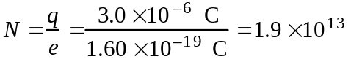

This corresponds to an increase in mass given by

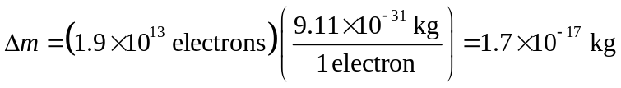

Since both objects carry charge of the same magnitude, N is also equal to the number of electrons lost by object B. Hence, the mass of B is reduced by the amount Δm. If M is the mass of either object when they are electrically neutral, then the mass of each charged object is:
MA = M + Δm while MB = M – Δm

The mass difference between the charged objects is, therefore,

ΔM = MA – MB = (M + Δm) – (M – Δm)

= 2Δm = 2(1.7 × 10–17 kg) = 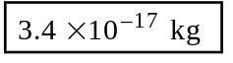

From the discussion above, 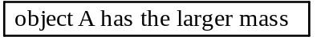.
______________________________________________________________________________

5. REASONING Identical conducting spheres equalize their charge upon touching. When spheres A and B touch, an amount of charge +q, flows from A and instantaneously neutralizes the –q charge on B leaving B momentarily neutral. Then, the remaining amount of charge, equal to +4q, is equally split between A and B, leaving A and B each with equal amounts of charge +2q. Sphere C is initially neutral, so when A and C touch, the +2q on A splits equally to give +q on A and +q on C. When B and C touch, the +2q on B and the +q on C combine to give a total charge of +3q, which is then equally divided between the spheres B and C; thus, B and C are each left with an amount of charge +1.5q.

SOLUTION Taking note of the initial values given in the problem statement, and summarizing the final results determined in the Reasoning above, we conclude the following:
a. Sphere C ends up with an amount of charge equal to 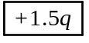.

b. The charges on the three spheres before they were touched, are, according to the problem statement, +5q on sphere A, –q on sphere B, and zero charge on sphere C. Thus, the total charge on the spheres is 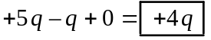.

c. The charges on the spheres after they are touched are +q on sphere A, +1.5q on sphere B, and +1.5q on sphere C. Thus, the total charge on the spheres is 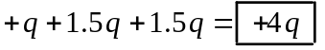.
______________________________________________________________________________

9. REASONING AND SOLUTION The electrostatic forces decreases with the square of the distance separating the charges. If this distance is increased by a factor of 5 then the force will decrease by a factor of 25. The new force is, then,

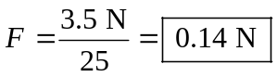
______________________________________________________________________________

12. REASONING
a. The magnitude of the electrostatic force that acts on each sphere is given by Coulomb’s law as 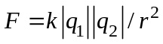, where 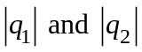 are the magnitudes of the charges, and r is the distance between the centers of the spheres.

b. When the spheres are brought into contact, the net charge after contact and separation must be equal to the net charge before contact. Since the spheres are identical, the charge on each after being separated is one-half the net charge. Coulomb’s law can be applied again to determine the magnitude of the electrostatic force that each sphere experiences.

SOLUTION
a. The magnitude of the force that each sphere experiences is given by Coulomb’s law as:

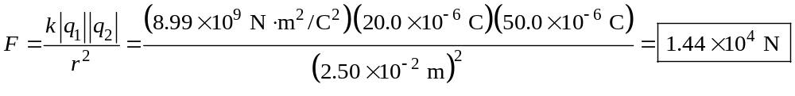

Because the charges have opposite signs, the force is 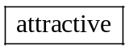.

b. The net charge on the spheres is −20.0 μC + 50.0 μC = +30.0 μC. When the spheres are brought into contact, the net charge after contact and separation must be equal to the net charge before contact, or +30.0 μC. Since the spheres are identical, the charge on each after being separated is one-half the net charge, so 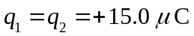. The electrostatic force that acts on each sphere is now

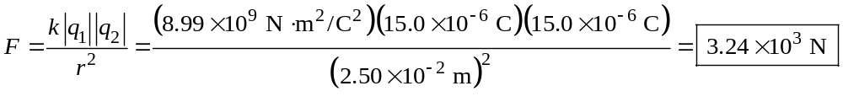

Since the charges now have the same signs, the force is 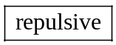

17. REASONING The unknown charge q must be positive. To see why, consider the unknown charge at the upper right corner in the drawing at the right (the unknown charge at the lower left corner could also be used). Three forces act on this charge: (1) FO is the repulsive force due to the other unknown charge on the opposite corner, (2) FB is the attractive force due to the negative charge at the lower right corner, and (3) FL is the attractive force due to the negative charge at the upper left corner. These three forces add to give a net force of zero. The unknown charge can not be negative, because then FB and FL would have directions opposite to | 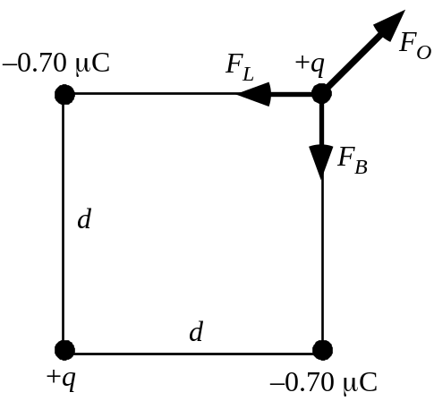
those shown in the shown in the drawing, and the sum of FO, FB, and FL could not be zero. We note that the magnitudes of FB and FL are equal according to Coulomb’s law (Equation 18.1), since the sides of the square have equal lengths and the charge magnitudes are 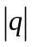 and 0.70 μC in each case. We also note that the directions of FB and FL are perpendicular. Thus, the resultant of FB and FL is given by the Pythagorean theorem and points along the diagonal of the square, directly opposite to the direction of FO. Since the vector sum of FO, FB, and FL is zero, the magnitude of the resultant of FB and FL must equal the magnitude of FO, and it is with this fact in mind that we begin our solution.

SOLUTION Using the Pythagorean to express the magnitude of the resultant of FB and FL, which is equal to FO, we have
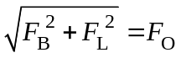 | (1)

Coulomb’s law indicates that

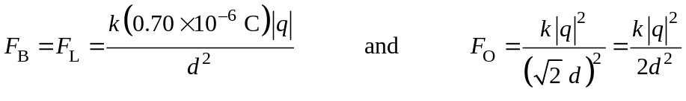

where we have used d for the length of a side of the square and the fact that the diagonal of the square has a length of 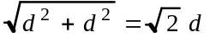. Substituting these expressions for FO, FB, and FL into Equation (1), we find

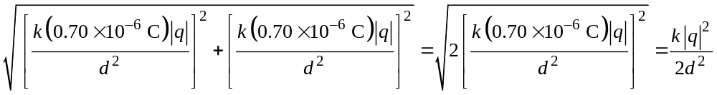

Simplifying this result shows that

As discussed in the REASONING, the algebraic sign of the charge is positive .
______________________________________________________________________________
18. REASONING
a. There are two electrostatic forces that act on q1; that due to q2 and that due to q3. The magnitudes of these forces can be found by using Coulomb’s law. The magnitude and direction of the net force that acts on q1 can be determined by using the method of vector components.

b. According to Newton’s second law, Equation 4.2b, the acceleration of q1 is equal to the net force divided by its mass. However, there is only one force acting on it, so this force is the net force.
q1
q3
q2
F13
+x
+y
F12
1.30 m
1.30 m
23.0°
23.0°
SOLUTION
a. The magnitude F12 of the force exerted on q1 by q2 is given by Coulomb’s law, Equation 18.1, where the distance is specified in the drawing:

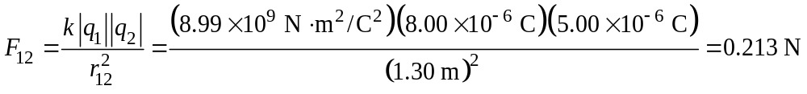

Since the magnitudes of the charges and the distances are the same, the magnitude of F13 is the same as the magnitude of F12, or F13 = 0.213 N. From the drawing it can be seen that the x-components of the two forces cancel, so we need only to calculate the y components of the forces.

Force | y component
F12 | +F12 sin 23.0° = +(0.213 N) sin 23.0° = +0.0832 N
F13 | +F13 sin 23.0° = +(0.213 N) sin 23.0° = +0.0832 N
F | Fy = +0.166 N

Thus, the net force is 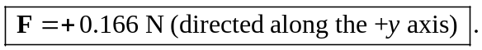

b. According to Newton’s second law, Equation 4.2b, the acceleration of q1 is equal to the net force divided by its mass. However, there is only one force acting on it, so this force is the net force:
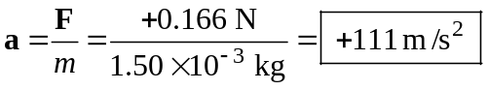

where the plus sign indicates that 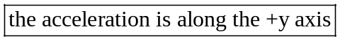.
______________________________________________________________________________

24. REASONING AND SOLUTION In order for the net force on any charge to be directed inward toward the center of the square, the charges must be placed with alternate + and – signs on each successive corner. The magnitude of the force on any charge due to an adjacent charge located at a distance r is

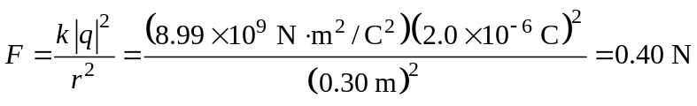

The forces due to two adjacent charges are perpendicular to one another and produce a resultant force that has a magnitude of

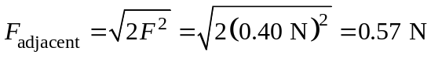

The magnitude of the force due to the diagonal charge that is located at a distance of 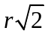 is

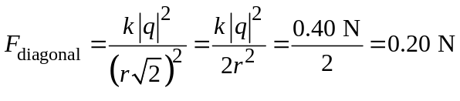

since the diagonal distance is . The force Fdiagonal is directed opposite to Fadjacent (since the diagonal charges are of the same sign). Therefore, the net force acting on any of the charges is directed inward and has a magnitude

Fnet = Fadjacent – Fdiagonal = 0.57 N – 0.20 N =
______________________________________________________________________________

30. REASONING AND SOLUTION
a. In order for the field to be zero, the point cannot be between the two charges. Instead, it must be located on the line between the two charges on the side of the positive charge and away from the negative charge. If x is the distance from the positive charge to the point in question, then the negative charge is at a distance (3.0 m + x) meters from this point. For the field to be zero here we have

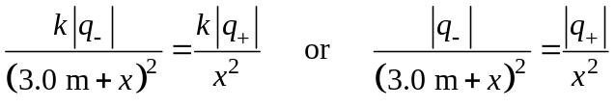

Solving for the ratio of the charge magnitudes gives

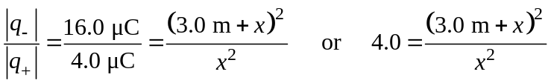

Suppressing the units for convenience and rearranging this result gives

Solving this quadratic equation for x with the aid of the quadratic formula (see Appendix C.4) shows that
x = 3.0 m or x = 1.0 m

We choose the positive value for x, since the negative value would locate the zero-field spot between the two charges, where it can not be (see above). Thus, we have x = 3.0 m .

b. Since the field is zero at this point, the force acting on a charge at that point would be 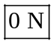.

76. CONCEPT QUESTIONS
a. The drawing at the right shows the electric fields at point P due to the two charges in the case that the second charge is positive. The presence of the | +q1  q2  P  d  d  +  E2  E1
second charge causes the magnitude of the net field at P to be twice as great as it is when only the first charge is present. Since both fields have the same direction, the magnitude of E2 must, then, be the same as the magnitude of E1. But the second charge is further away from point P than is the first charge, and more distant charges create weaker fields. To offset the weakness that comes from the greater distance, the second charge must have a greater magnitude than that of the first charge.

b. The drawing at the right shows the electric fields at point P due to the two charges in the case that the second charge is negative. The presence of the | +q1  q2  P  d  d    E1  E2
second charge causes the magnitude of the net field at P to be twice as great as it is when only the first charge is present. Since the fields now have opposite directions, the magnitude of E2 must be greater than the magnitude of E1. This is necessary so that E2 can offset E1 and still lead to a net field with twice the magnitude as E1. To create this greater field E2, the second charge must now have a greater magnitude than it did in question (a).

SOLUTION
a. The magnitudes of the field contributions of each charge are given according to Equation 18.3 as 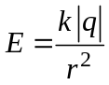. With q2 present, the magnitude of the net field at P is twice what it is when only q1 is present. Using Equation 18.3, we can express this fact as follows:
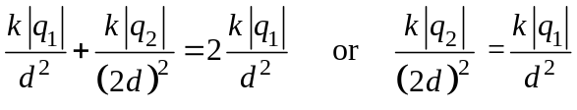

Solving for 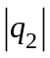 gives
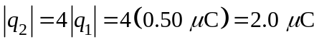

Thus, the second charge is q2 = +2.0 μC , which is consistent with our answer to Concept Question (a).

b. Now that the second charge is negative, we have

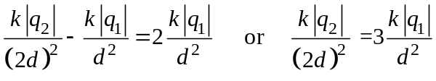

Solving for gives
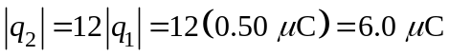

Thus, the second charge is q2 = 6.0 μC , which is consistent with our answer to Concept Question (b).

