CHAPTER 19 | ELECTRIC POTENTIAL ENERGY AND THE ELECTRIC POTENTIAL

PROBLEMS
______________________________________________________________________________
___________________________________________________________________________

7. REASONING The energy to accelerate the car comes from the energy stored in the battery pack. Work is done by the electric force as the charge moves from point A (the positive terminal), through the electric motor, to point B (the negative terminal). The work WAB done by the electric force is given by Equation 19.4 as the product of the charge and the potential difference VA − VB, or WAB = q0(VA − VB). The power supplied by the battery pack is the work divided by the time, as expressed by Equation 6.10a.

SOLUTION According to Equation 6.10a, the power P supplied by the battery pack is

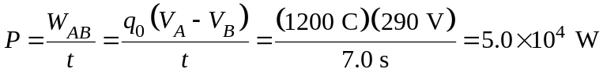

Since 745.7 W = 1 hp (see the page facing the inside of the front cover of the text), the power rating, in horsepower, is

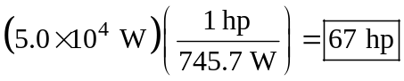
______________________________________________________________________________
______________________________________________________________________________

16. REASONING The electric potential at a distance r from a point charge q is given by Equation 19.6 as 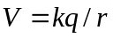. The total electric potential at location P due to the four point charges is the algebraic sum of the individual potentials.
d
d
d
d
q
q
−q
−q
P

SOLUTION The total electric potential at P is (see the drawing)

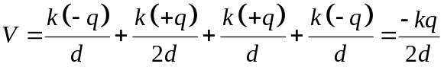

Substituting in the numbers gives

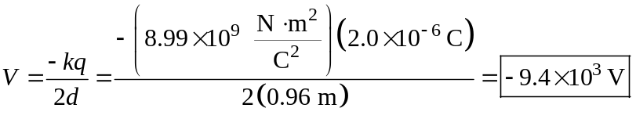
______________________________________________________________________________

18. REASONING AND SOLUTION Let the first spot where the potential is zero be a distance x to the left of the negative charge. Then,

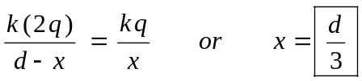

Let the second spot where the potential is zero be a distance x to the right of the negative charge. Then,
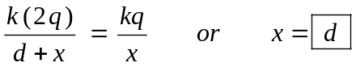
______________________________________________________________________________

20. REASONING It will not matter in what order the group is assembled. For convenience, we will assemble the group from one end of the line to the other. The potential energy of each charge added to the group will be determined and the four values added together to get the total. At each step, the electric potential energy of an added charge q0 is given by Equation 19.3 as EPE = q0VTotal, where VTotal is the potential at the point where the added charge is placed. The potential VTotal will be determined by adding together the contributions from the charges previously put in position, each according to Equation 19.6 (V = kq/r).

SOLUTION The first charge added to the group has no electric potential energy, since the spot where it goes has a total potential of VTotal = 0 J, there being no charges in the vicinity to create it:
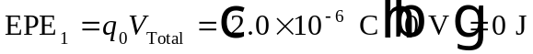

The second charge experiences a total potential that is created by the first charge:

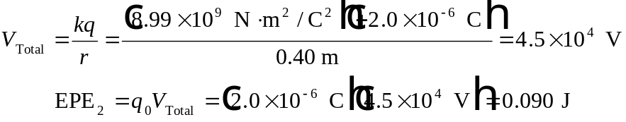

The third charge experiences a total potential that is created by the first and the second charges:
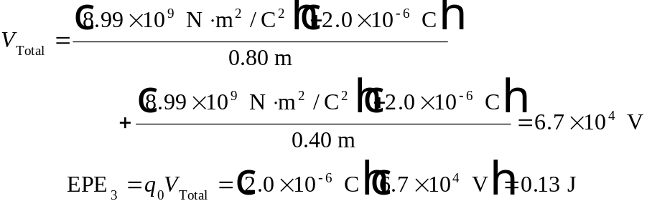

The fourth charge experiences a total potential that is created by the first, second, and third charges:
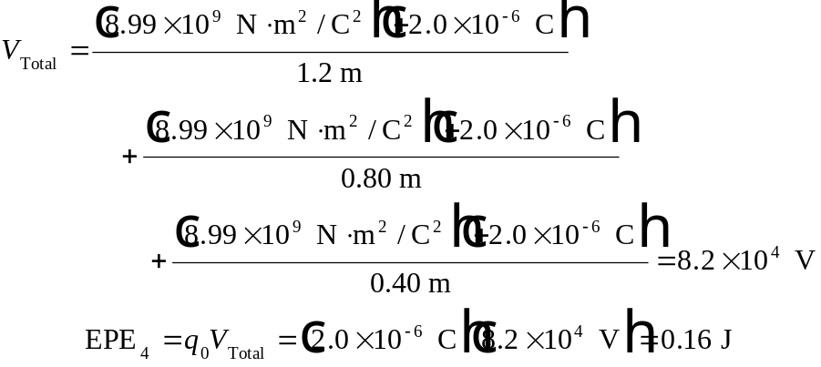

The total electric potential energy of the group is

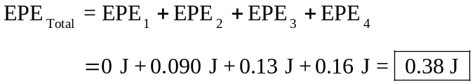
______________________________________________________________________________

30. REASONING AND SOLUTION From Equation 19.7 we know that 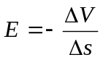, where ΔV is the potential difference between the two surfaces of the membrane, and Δs is the distance between them. If A is a point on the positive surface and B is a point on the negative surface, then ΔV = VA − VB = 0.070 V. The electric field between the surfaces is

34. REASONING The electric field E that exists between two points in space is, according to Equation 19.7, proportional to the electric potential difference ΔV between the points divided by the distance Δx between them: E = − ΔV/ Δx.

SOLUTION
a. The electric field in the region from A to B is

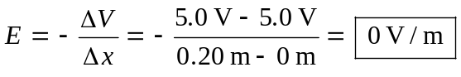

b. The electric field in the region from B to C is

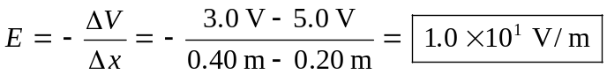

c. The electric field in the region from C to D is

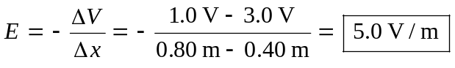
___________________________________________________________________________________

38. REASONING AND SOLUTION The capacitance is given by

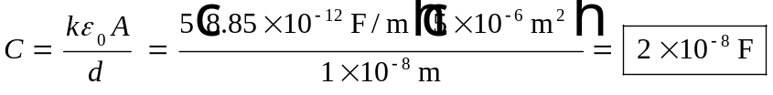
______________________________________________________________________________

42. REASONING The energy used to charge up a capacitor is stored in the capacitor as electrical energy. The energy stored depends on the capacitance C of the capacitor and the potential difference V between its plates; 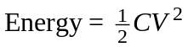 (Equation 19.11). Inserting a dielectric between the plates of a capacitor increases its capacitance by a factor of κ, where κ is the dielectric constant of the material. We will use these two pieces of information to find the potential difference across the plates of the capacitor filled with the dielectric.

SOLUTION The energy stored in the empty capacitor is 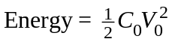, where C0 is its capacitance and V0 is the potential difference between its plates. Similarly, the energy stored in the capacitor filled with the dielectric is , where C is its capacitance and V is the potential difference between its plates. Since the two energies are equal,

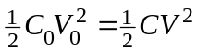

Since C = κC0 (see Equation 19.10 and the discussion that follows), we have

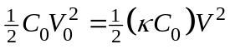

Solving for the potential difference V, gives

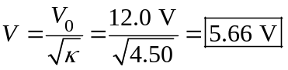
______________________________________________________________________________

44. REASONING AND SOLUTION From Equations 19.9 and 18.4, we have

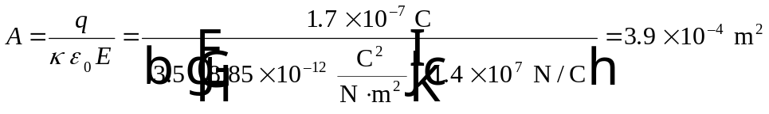

Since A = πr 2 , the radius of the plates is

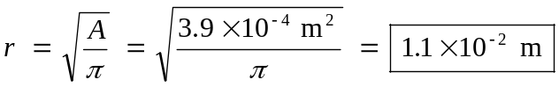
______________________________________________________________________________

_________________________

51. REASONING The charge that resides on the outer surface of the cell membrane is 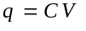, according to Equation 19.8. Before we can use this expression, however, we must first determine the capacitance of the membrane. If we assume that the cell membrane behaves like a parallel plate capacitor filled with a dielectric, Equation 19.10 (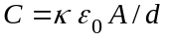) applies as well.

SOLUTION The capacitance of the cell membrane is

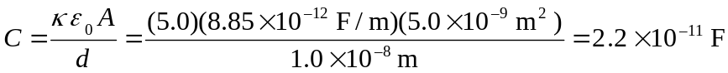

a. The charge on the outer surface of the membrane is, therefore,

b. If the charge in part (a) is due to 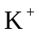 ions with charge +e (e = 1.6 × 10−19 C), the number of ions present on the outer surface of the membrane is

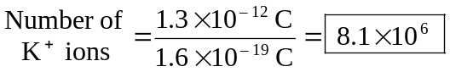
______________________________________________________________________________

54. REASONING The electric potential at a distance r from a point charge q is given by Equation 19.6 as . The total electric potential at location P due to the six point charges is the algebraic sum of the individual potentials.
d
+7.0q
P
d
d
d
d
d
+3.0q
+5.0q
−5.0q
−3.0q
+7.0q

SOLUTION Starting at the upper left corner of the rectangle, we proceed clockwise and add up the six contributions to the total electric potential at P (see the drawing):

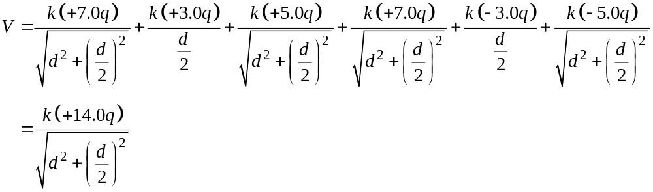

Substituting q = 9.0 × 10−6 C and d = 0.13 m gives

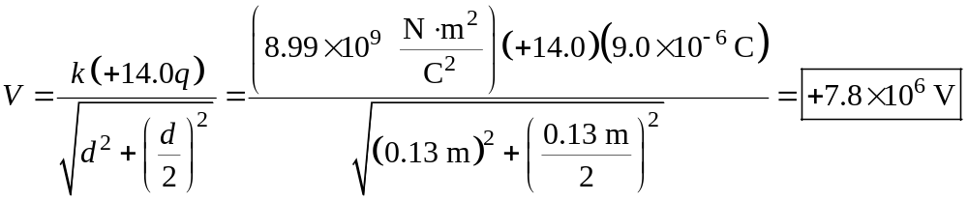

b. 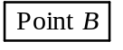 is at the higher potential, because a negative charge accelerates from a lower potential to a higher potential.
______________________________________________________________________________

