CHAPTER 20 | ELECTRIC CIRCUITS

PROBLEMS
______________________________________________________________________________

2. REASONING The current I is defined in Equation 20.1 as the amount of charge Δq per unit of time Δt that flows in a wire. Therefore, the amount of charge is the product of the current and the time interval. The number of electrons is equal to the charge that flows divided by the magnitude of the charge on an electron.

SOLUTION
a. The amount of charge that flows is

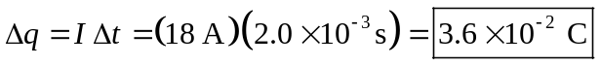

b. The number of electrons N is equal to the amount of charge divided by e, the magnitude of the charge on an electron.
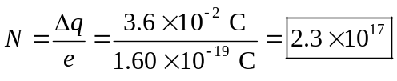
______________________________________________________________________________

7. REASONING As discussed in Section 20.1, the voltage gives the energy per unit charge. Thus, we can determine the energy delivered to the toaster by multiplying the voltage V by the charge Δq that flows during a time Δt of one minute. The charge can be obtained by solving Equation 20.1, I = (Δq)/(Δt), since the current I can be obtained from Ohm’s law.

SOLUTION Remembering that voltage is energy per unit charge, we have

Energy = V Δq

Solving Equation 20.1 for Δq gives Δq = I Δt, which can be substituted in the previous result to give
Energy = V Δq = VI Δt

According to Ohm’s law (Equation 20.2), the current is I = V/R, which can be substituted in the energy expression to show that

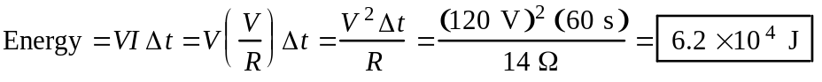
______________________________________________________________________________

12. REASONING The resistance R of a wire that has a length L and a cross-sectional area A is given by Equation 20.3 as 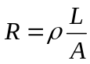. Both wires have the same length and cross-sectional area. Only the resistivity ρ of the wire differs, and Table 20.1 gives the following values: ρAluminum = 2.82 × 108 Ω·m and ρCopper = 1.72 × 108 Ω·m. Applying Equation 20.3 to both wires and dividing the two equations will allow us to eliminate the unknown length and cross-sectional area algebraically and solve for the resistance of the copper wire.

SOLUTION Applying Equation 20.3 to both wires gives
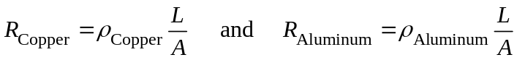

Dividing these two equations, eliminating L and A algebraically, and solving the result for RCopper give
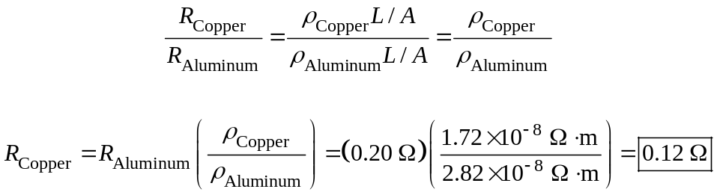

25. REASONING AND SOLUTION The power delivered is P = VI so

a. Pbd = VIbd = (120 V)(11 A) =

b. Pvc = VIvc = (120 V)(4.0 A) =

c. The energy is E = Pt so,

Ebd/Evc = (Pbdtbd)/(Pvctvc) = (1300 W)(15 min)/[(480 W)(30.0 min)] =
_____________________________________________________________________________

35. REASONING AND SOLUTION The total amount of energy needed is

E = Pt = I2Rt = (25 A)2(5.3 Ω)(31 d)[(9 h)/(1 d)][(3600 s)/(1 h)] = 3.3 × 109 J

To find the cost, then,

Cost = [$0.10/(1 kWh)](3.3 × 109 J)(1 kWh)/(3.6 × 106 J) =
______________________________________________________________________________
55. REASONING The equivalent resistance of the three devices in parallel is 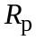, and we can find the value of by using our knowledge of the total power consumption of the circuit; the value of can be found from Equation 20.6c, 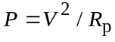. Ohm's law (Equation 20.2, ) can then be used to find the current through the circuit.

SOLUTION
a. The total power used by the circuit is P = 1650 W + 1090 W +1250 W = 3990 W. The equivalent resistance of the circuit is

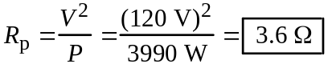

b. The total current through the circuit is

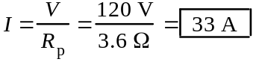

This current is larger than the rating of the circuit breaker; therefore, the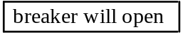.
______________________________________________________________________________

58. REASONING We will approach this problem in parts. The resistors that are in series will be combined according to Equation 20.16, and the resistors that are in parallel will be combined according to Equation 20.17.

SOLUTION The 1.00 Ω, 2.00 Ω and 3.00 Ω resistors are in series with an equivalent resistance of Rs = 6.00 Ω. | 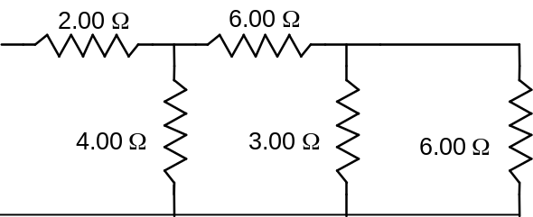
This equivalent resistor of 6.00 Ω is in parallel with the 3.00-Ω resistor, so  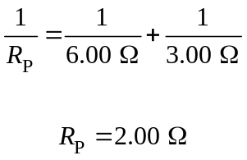 | 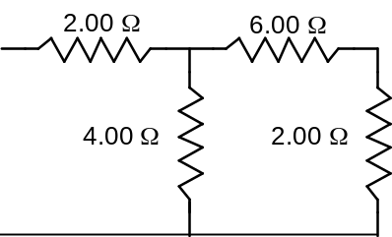
This new equivalent resistor of 2.00 Ω is in series with the 6.00-Ω resistor, so Rs' = 8.00 Ω. | 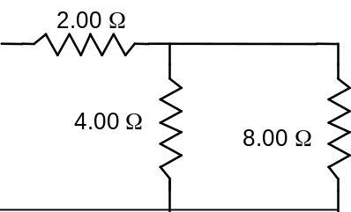
Rs' is in parallel with the 4.00-Ω resistor, so  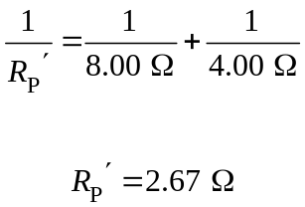 | 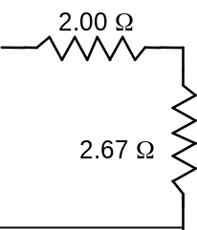

Finally, Rp' is in series with the 2.00-Ω, so the total equivalent resistance is 4.67 Ω .
_________________________________________________________________________

64. REASONING The power P dissipated in each resistance R is given by Equation 20.6b as 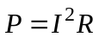, where I is the current. This means that we need to determine the current in each resistor in order to calculate the power. The current in R1 is the same as the current in the equivalent resistance for the circuit. Since R2 and R3 are in parallel and equal, the current in R1 splits into two equal parts at the junction A in the circuit.

SOLUTION To determine the equivalent resistance of the circuit, we note that the parallel combination of R2 and R3 is in series with R1. The equivalent resistance of the parallel combination can be obtained from Equation 20.17 as follows:

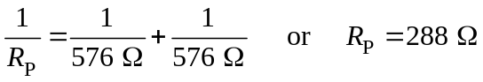

This 288-Ω resistance is in series with R1, so that the equivalent resistance of the circuit is given by Equation 20.16 as

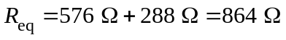

To find the current from the battery we use Ohm’s law:

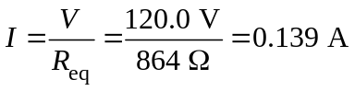

Since this is the current in R1, Equation 20.6b gives the power dissipated in R1 as

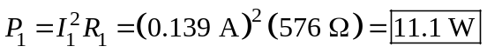

R2 and R3 are in parallel and equal, so that the current in R1 splits into two equal parts at the junction A. As a result, there is a current of 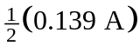 in R2 and in R3. Again using Equation 20.6b, we find that the power dissipated in each of these two resistors is

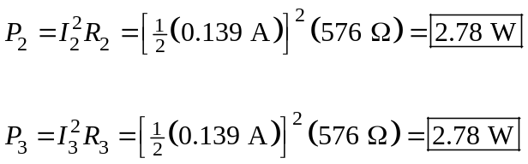

76. REASONING AND SOLUTION Label the currents with the resistor values. Take I3 to the right, I2 to the left and I1 to the right. Applying the loop rule to the top loop (suppressing the units) gives
I1 + 2.0 I2 = 1.0 | (1)

and to the bottom loop gives

2.0 I2 + 3.0 I3 = 5.0 | (2)

Applying the junction rule to the left junction gives

I2 = I1 + I3 | (3)

Solving Equations (1) , (2) and (3) simultaneously, we find I2 = .

The positive sign shows that the assumed direction is correct. That is, to the .
______________________________________________________________________________

86. REASONING A capacitor with a capacitance C stores a charge q when connected between the terminals of a battery of voltage V, according to q = CV (Equation 19.8). This equation can be used to calculate the voltage if q and C are known. In this problem we know that the two capacitors together store a total charge of 5.4 × 105 C. This is also the charge stored by the equivalent capacitor, which has the equivalent capacitance CP of the parallel combination, or CP = C1 + C2 (Equation 20.18). Thus, we can determine the battery voltage by using Equation 19.8 with the given total charge and the equivalent capacitance obtained from Equation 20.18.

SOLUTION With q = qTotal and C = CP = C1 + C2 Equation 19.8 becomes

87. REASONING Our approach to this problem is to deal with the arrangement in parts. We will combine separately those parts that involve a series connection and those that involve a parallel connection.

SOLUTION The 24, 12, and 8.0-μF capacitors are in series. Using Equation 20.19, we can find the equivalent capacitance for the three capacitors:

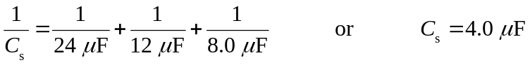

This 4.0-μF capacitance is in parallel with the 4.0-μF capacitance already shown in the text diagram. Using Equation 20.18, we find that the equivalent capacitance for the parallel group is
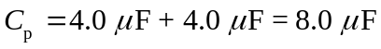

This 8.0-μF capacitance is between the 5.0 and the 6.0-μF capacitances and in series with them. Equation 20.19 can be used, then, to determine the equivalent capacitance between A and B in the text diagram:

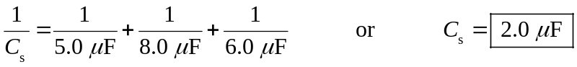
______________________________________________________________________________

99. REASONING In either part of the drawing the time constant τ of the circuit is 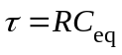, according to Equation 20.21, where R is the resistance and Ceq is the equivalent capacitance of the capacitor combination. We will apply this equation to both circuits. To obtain the equivalent capacitance, we will analyze the capacitor combination in parts. For the parallel capacitors 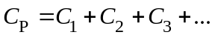 applies (Equation 20.18), while for the series capacitors 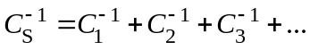 applies (Equation 20.19).
(b)
R
C
C
C
C
+
−
(a)
C
C
C
C
R
+
−

SOLUTION Using Equation 20.21, we write the time constant of each circuit as follows:

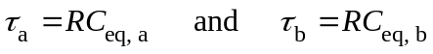

Dividing these two equations allows us to eliminate the unknown resistance algebraically:

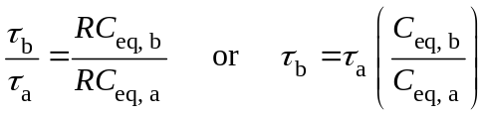 (1)

To obtain the equivalent capacitance in part a of the drawing, we note that the two capacitors in series in each branch of the parallel combination have an equivalent capacitance CS that can be determined using Equation 20.19

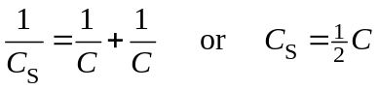 (2)

Using Equation 20.18, we find that the parallel combination in part a of the drawing has an equivalent capacitance of

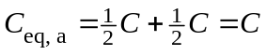 (3)

To obtain the equivalent capacitance in part b of the drawing, we note that the two capacitors in series have an equivalent capacitance of 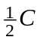, according to Equation (2). The two capacitors in parallel have an equivalent capacitance of 2C, according to Equation 20.18. Finally, then, we have a series combination of and 2C, for which Equation 20.19 applies:

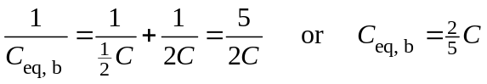 (4)

Using Equations (3) and (4) in Equation (1), we find that

