CHAPTER 21 | MAGNETIC FORCES  AND MAGNETIC FIELDS

PROBLEMS
______________________________________________________________________________
2. REASONING AND SOLUTION The magnitude of the force can be determined using Equation 21.1, F = qvB sin θ, where θ is the angle between the velocity and the magnetic field. The direction of the force is determined by using Right-Hand Rule No. 1.

a. F = qvB sin 30.0° = (8.4 × 10–6 C)(45 m/s)(0.30 T) sin 30.0° = 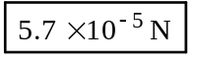, directed 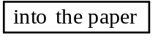.

b. F = qvB sin 90.0° = (8.4 × 10–6 C)(45 m/s)(0.30 T) sin 90.0° = 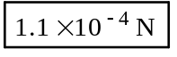,
directed .

c. F = qvB sin 150°= (8.4 × 10–6 C)(45 m/s)(0.30 T) sin 150° = , directed .
______________________________________________________________________________

4. REASONING According to Equation 21.1, the magnetic force has a magnitude of F = qvB sin θ. The field B and the directional angle θ are the same for each particle. Particle 1, however, travels faster than particle 2. By itself, a faster speed v would lead to a greater force magnitude F. But the force on each particle is the same. Therefore, particle 1 must have a smaller charge to counteract the effect of its greater speed.

SOLUTION Applying Equation 21.1 to each particle, we have

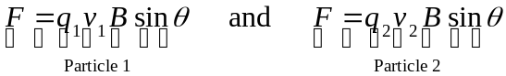

Dividing the equation for particle 1 by the equation for particle 2 and remembering that v1 = 3v2 gives

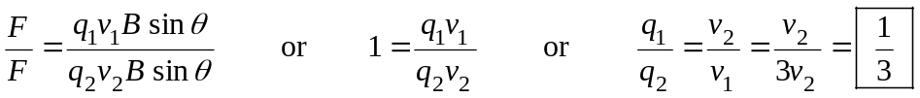
______________________________________________________________________________

8. REASONING The positive plate has a charge q and is moving downward with a speed v at right angles to a magnetic field of magnitude B. The magnitude F of the magnetic force exerted on the positive plate is F = qvB sin 90.0°. The charge on the positive plate is related to the magnitude E of the electric field that exists between the plates by (see Equation 18.4) q = ε0AE, where A is the area of the positive plate. Substituting this expression for q into the expression for the magnetic force gives the answer in terms of known quantities.

SOLUTION

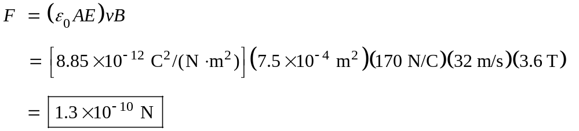

An application of Right-Hand Rule No. 1 shows that the magnetic force is perpendicular to the plane of the page and 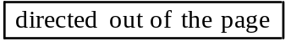, toward the reader.
______________________________________________________________________________

14. REASONING AND SOLUTION The radius of the circular path of a charged particle in a magnetic field is given by r = mv/qB.

a. For an electron
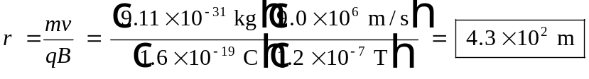

b. For a proton, only the mass changes in the calculation above. Using m = 1.67 × 10–27 kg, we obtain r = 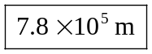.
______________________________________________________________________________

16. REASONING AND SOLUTION The magnitudes of the magnetic and electric forces are equal. Therefore, FB = FE, or qvB = qE. Solving for v yields,

v = 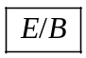
______________________________________________________________________________

______________________________________________________________________________

29. REASONING AND SOLUTION The force on each side can be found from F = ILB sin θ. For the top side, θ = 90.0°, so

F = (12 A)(0.32 m)(0.25 T) sin 90.0° = 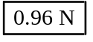

The force on the bottom side (θ = 90.0°) is the same as that on the top side, F = .

For each of the other two sides θ = 0°, so that the force is F = 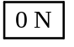.
______________________________________________________________________________

______________________________________________________________________________

50. REASONING The magnitude of the magnetic force acting on the particle is
F = q0vB sin θ (Equation 21.1), where q0 and v are the charge magnitude and speed of the particle, respectively, B is the magnitude of the magnetic field, and θ is the angle between the particle’s velocity and the magnetic field. The magnetic field is produced by a very long, straight wire, so its value is given by Equation 21.5 as 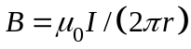. By combining these two relations, we can determine the magnitude of the magnetic force.

SOLUTION The direction of the magnetic field B produced by the current-carrying wire can be found by using Right-Hand Rule No. 2. At the location of the charge, this field points perpendicularly into the page, as shown in the drawing. Since the direction of the particle’s velocity is perpendicular to the magnetic field, θ = 90.0°. Substituting into F = q0vB sin θ gives
I
v
q
×
B (into
page)
F

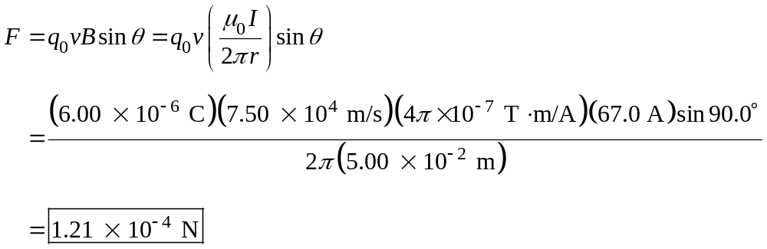

The direction of the magnetic force F exerted on the particle can be determined by using Right-Hand Rule No. 1. This direction, which is shown in the drawing, is

.
______________________________________________________________________________

53. REASONING AND SOLUTION The magnetic field due to the circular loop alone is 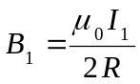. The field due to the straight wire is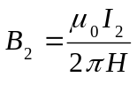. These two fields cancel at the center of the loop, so that their magnitudes must be equal:

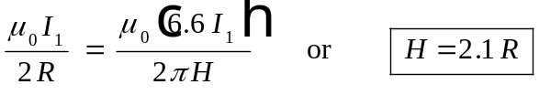
______________________________________________________________________________
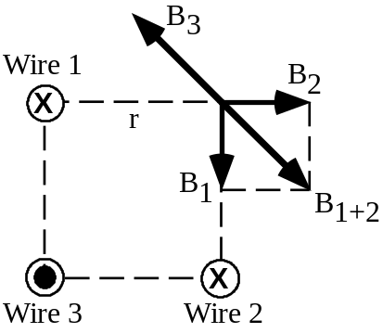
59. REASONING AND SOLUTION The currents in wires 1 and 2 produce the magnetic fields B1 and B2 at the empty corner, as shown in the drawing. The directions of these fields can be obtained using RHR-2. Since there are equal currents in wires 1 and 2 and since these wires are each the same distance r from the empty corner, B1 and B2 have equal magnitudes. Using Equation 21.5, we can write the field magnitude as 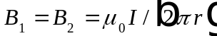. Since B1 and B2 are perpendicular, it follows from the Pythagorean theorem that they combine to produce a net magnetic field that has the direction shown in the following drawing and has a magnitude B1+2 given by

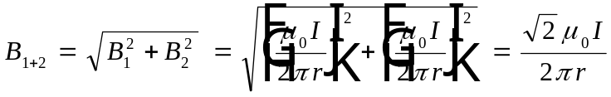

The current in wire 3 produces a field B3 at the empty corner. Since B3 and B1+2 combine to give a zero net field, B3 must have a direction opposite to that of B1+2. Thus, B3 must point upward and to the left, and RHR-2 indicates that

.

Moreover, the magnitudes of B3 and B1+2 must be the same. Recognizing that wire 3 is a distance of 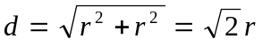 from the empty corner, we have




