CHAPTER 22 | ELECTROMAGNETIC INDUCTION

PROBLEMS

______________________________________________________________________________

2. REASONING The situation in the drawing is analogous to that in Figure 22.4b in the text. The blood flowing at a speed v corresponds to the moving rod, and the diameter of the blood vessel corresponds to the length L of the rod in the figure. The magnitude of the magnetic field is B, and the measured voltage is the emf induced by the motion. Thus, we can apply 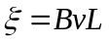 (Equation 22.1).

SOLUTION Using Equation 22.1, we find that

____________________________________________________________________________

4. REASONING AND SOLUTION The motional emf generated by a conductor moving perpendicular to a magnetic field is given by Equation 22.1 as Emf = vBL, where v and L are the speed and length, respectively, of the conductor, and B is the magnitude of the magnetic field. The emf would have been

______________________________________________________________________________

10. REASONING The definition of magnetic flux Ф is 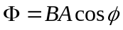 (Equation 22.2), where B is the magnitude of the magnetic field, A is the area of the surface, and is the angle between the magnetic field vector and the normal to the surface. The values of B and A are the same for each of the surfaces, while the values for the angle are different. The z axis is the normal to the surface lying in the x, y plane, so that 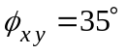. The y axis is the normal to the surface lying in the x, z plane, so that 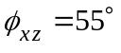. We can apply the definition of the flux to obtain the desired ratio directly.

SOLUTION Using Equation 22.2, we find that

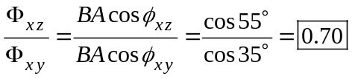

16. REASONING AND SOLUTION The change in flux ΔΦ is given by ΔΦ = Β ΔΑ cos φ, where ΔΑ is the area of the loop that leaves the region of the magnetic field in a time Δt. This area is the product of the width of the rectangle (0.080 m) and the length v Δt of the side that leaves the magnetic field, ΔA = (0.080 m) v Δt.

ΔΦ = B ΔA cos φ = (2.4 T) (0.080 m)(0.020 m/s)(2.0 s) cos 0.0° = 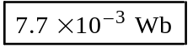
______________________________________________________________________________
22. REASONING We will use Faraday’s law of electromagnetic induction, Equation 22.3, to find the emf induced in the loop. Once this value has been determined, we can employ Equation 22.3 again to find the rate at which the area changes.

SOLUTION
a. The magnitude of the induced emf is given by Equation 22.3 without the minus sign:

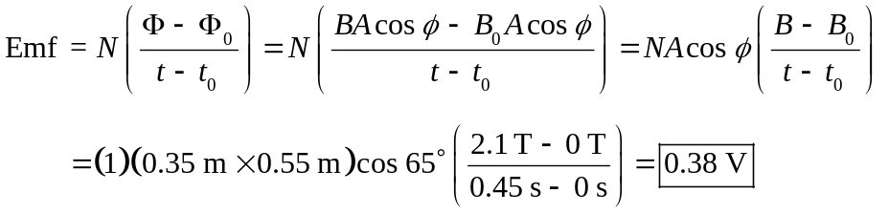

b. When the magnetic field is constant and the area is changing in time, Faraday’s law can be written as (again, without the minus sign)

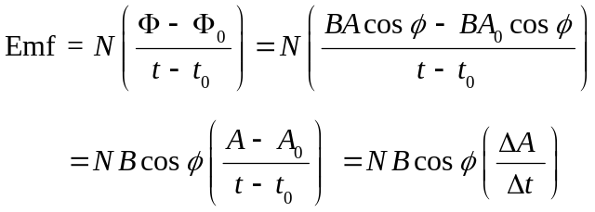

Solving this equation for ΔA/Δt and substituting in the value of 0.38 V for the emf, we find that

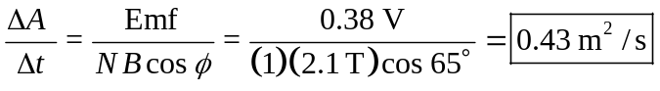
______________________________________________________________________________

23. REASONING The energy dissipated in the resistance is given by Equation 6.10b as the power dissipated multiplied by the time, E = Pt. The power, according to Equation 20.6c, is the square of the induced emf divided by the resistance, P = (Emf)2/R. The induced emf can be determined from Faraday’s law of electromagnetic induction, Equation 22.3.

SOLUTION Expressing the energy consumed as E = Pt, and substituting in P = (Emf)2/R, we find
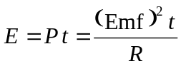

The induced emf is given by Faraday’s law as 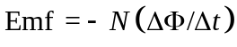, and the resistance R is equal to the resistance per unit length (3.3 × 10–2 Ω/m) times the length of the circumference of the loop, 2π r. Thus, the energy consumed is

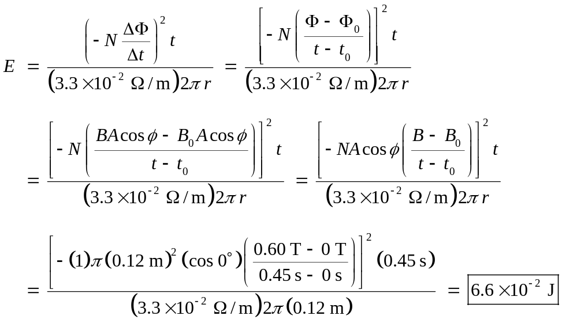
______________________________________________________________________________

______________________________________________________________________________

38. REASONING When the motor is running at normal speed, the current is the net emf divided by the resistance R of the armature wire. The net emf is the applied voltage V minus the back emf developed by the rotating coil. We can use this relation to find the back emf. When the motor is just turned on, there is no back emf, so the current is just the applied voltage divided by the resistance of the wire. To limit the starting current to 15.0 A, a resistor R1 is placed in series with the resistance of the wire, so the equivalent resistance is
R + R1. The current to the motor is equal to the applied voltage divided by the equivalent resistance.

SOLUTION
a. According to Equation 22.5, the back emf generated by the motor is

b. When the motor has been just turned on, the back emf is zero, so the current is

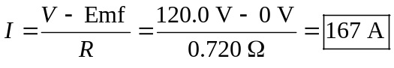

c. When a resistance R1 is placed in series with the resistance R of the wire, the equivalent resistance is R1 + R. The current to the motor is

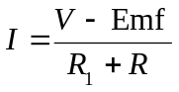
Solving this expression for R1 gives

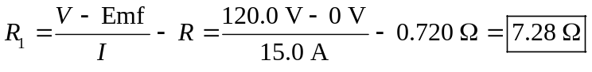
______________________________________________________________________________

46. REASONING When the current through an inductor changes, the induced emf is given by Equation 22.9 as
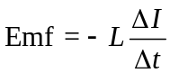
where L is the inductance, ΔI is the change in the current, and Δt is the time interval during which the current changes. For each interval, we can determine ΔI and Δt from the graph.

SOLUTION

a. | 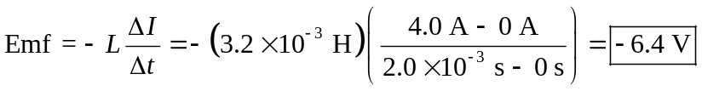

b. | 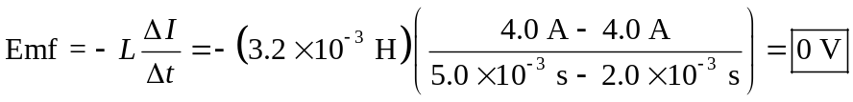

c. | 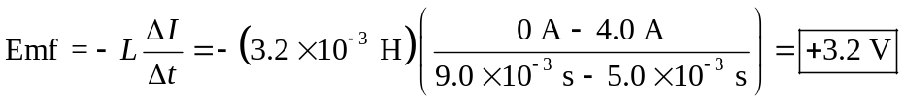
______________________________________________________________________________

56. REASONING AND SOLUTION The step down transformer reduces the voltage by a factor of 13.
V2 = (120 V)/13 =
_

___________________________________________________________________________

76. CONCEPT QUESTIONS
a. The induced emf is zero during the second interval, 3.0 – 6.0 s. According to Faraday’s law of electromagnetic induction, Equation 22.3, an induced emf arises only when the magnetic flux changes. During this interval, the magnetic field, the area of the loop, and the orientation of the field relative to the loop are constant. Thus, the magnetic flux does not change, so there is no induced emf.

b. An emf is induced during the first and third intervals, because the magnetic field is changing in time. The time interval is the same (3.0 s) for the two cases. However, the magnitude of the field changes more during the first interval. Therefore, the magnetic flux is changing at a greater rate in that interval, which means that the magnitude of the induced emf is greatest during the first interval.

c. During the first interval the magnetic field in increasing with time. During the third interval, the field is decreasing with time. As a result, the induced emfs will have opposite polarities during these intervals. If the direction of the induced current is clockwise during the first interval, it will be counterclockwise during the third interval.

SOLUTION
a. The induced emf is given by Equations 22.3 and 22.3:

0–3.0 s:
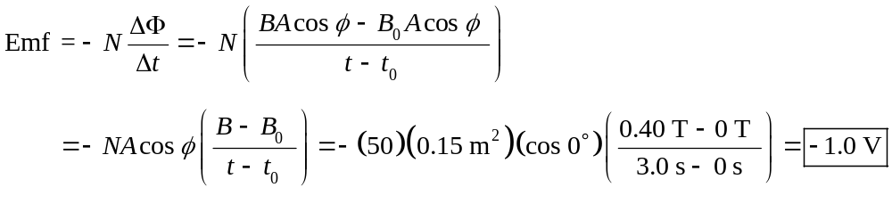
3.0–6.0 s:
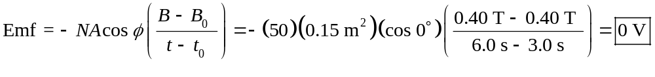
6.0–9.0 s:
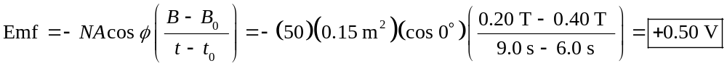

b. The induced current is given by Equation 20.2 as I = (Emf)/R.

0–3.0 s: 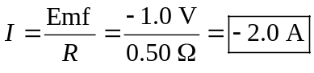

6.0–9.0 s: 