Australian Retirement Planning Tool
User Guide & Technical Reference
Version 15.9 - February 2026

What’s New in Version 15.9
Non-Super Assets for Age Pension: A new “Assessable Assets Outside Super” field allows you to enter financial assets held outside superannuation (bank accounts, term deposits, shares, managed funds, investment property equity). These are added to your super balance for both the Centrelink assets test and deeming calculation, providing a more accurate Age Pension estimate. The field appears when Age Pension is enabled and values are automatically indexed to inflation. Income from these assets (rent, dividends) should be entered in the existing “Other Net Income” field.
Age Pension Calculation Details Panel: A new collapsible panel in the results column shows a year-by-year breakdown of how your Age Pension is calculated. For each year from age 67 onwards, it displays: total assessable assets, asset test threshold and result, deemed income, total testable income, income test free area and result, which test is binding (assets or income), and the final pension amount. Values respect the Real/Nominal dollars toggle. Rows are colour-coded: amber highlights the binding test, green marks full pension rate, and red indicates nil pension (above asset cutoff).
Security & Analytics: Added Vercel Analytics for privacy-friendly visitor tracking. Content Security Policy (CSP) headers and other security hardening measures protect against common web vulnerabilities.
Additional Income Streams: You can now add multiple income sources, each with its own description, amount, start year, duration, and CPI indexing setting. This solves a key limitation where users with both indexed and non-indexed income (e.g., a CPI-indexed rental income and a fixed overseas pension) could not model them correctly with a single field. Each stream is independently calculated and flows into the income charts, spending waterfall, and Age Pension income test. The original “Other Net Income” field remains for backward compatibility; additional streams appear below it via the “Add Income Stream” button.
What-If Panel Cleanup: The “Run Comprehensive Analysis” and “Save Current Scenario” buttons have been moved inside the What-If Comparison panel, reducing visual clutter when the panel is collapsed.

Version 15.8 (February 2026)
Recalibrates the JP Morgan spending curve to align with Blanchett (2014) and JP Morgan (2024) research, adjusted for Australia: a gentler 1.0%/yr decline in the go-go years, accelerating to 1.5%/yr in the slow-go years, then tapering to 0.5%/yr in the no-go years. Stochastic irregular expenses are now enabled by default (with pre-loaded manual expenses removed to avoid double-counting) and can run simultaneously with manual one-off expenses for planned costs like gifts or holidays. A new 🎲 Reshuffle Expense Timing button lets you explore different stochastic expense paths without running full Monte Carlo. Several simulation stability fixes resolve issues where charts could jump around during editing (unseeded random values in aged care probability and the stochastic expense engine), the Monte Carlo stale detection "orange button" warning now works as documented, and debt repayment changes correctly update the spending charts. Chart tooltips now display age alongside year.

Version 15.7 (February 2026)
Two-Column Layout: Calculator now uses a side-by-side layout on desktop screens. Input parameters appear in the left column (approximately 33% width), while test scenarios, charts, and results appear in the right column (approximately 67% width). This allows you to see inputs and results simultaneously without scrolling back and forth. Test scenario buttons are now positioned at the top of the right column for easy access. The single-row button arrangement at the top (Save/Load, Quick Help, Tax Assumptions, Key Assumptions, Export CSV, Export Word) reduces vertical space and keeps all controls visible. On mobile devices and tablets, the layout automatically stacks vertically for optimal viewing.

Version 15.6 (February 2026)
Annual Spending Breakdown Chart: New stacked bar chart shows the composition of your annual spending by funding source. Each bar displays how much comes from Super withdrawals (blue), Cash (yellow), Sequencing Buffer (orange), Age Pension (dark green), Defined Benefit pension (medium green), and Other Income (light green). In single-scenario mode, a minimum required super withdrawal line overlays the chart, making it easy to verify whether your super withdrawals meet the legal minimum. This visualization reveals when Age Pension kicks in, shows the impact of large one-time expenses like RAD payments, and helps assess the sustainability of your drawdown strategy.
Age Pension Improvements: Comprehensive Age Pension modeling now includes Centrelink deeming rules (financial assets deemed to earn 0.25% on first portion, 2.25% on balance) and complete income testing (counts private pensions, deemed income, Other Net Income from rental/work, and pre-retirement income). Added clear warnings about modeling assumptions and verification with Centrelink.
Historical Monte Carlo Success Rates: Updated success rate guidance to reflect that Historical MC typically shows 5-15 percentage points higher than Parametric MC. Historical MC "Good" threshold raised to 85-89% (from 80-89%) to reflect that it's bounded by actual historical data. Added comparative explanation panel when both methods are run.
Other Net Income: Model additional income sources (part-time work, rental properties, investments) with flexible start year and duration controls. Works in both single and couple modes with year-based timing.
Couple Mode Fixes: Real dollar year now displays correctly using earliest retirement age. Retirement year shown next to age in couple tracking panel.

Version 15.5 (February 2026)
Terminology Updates: Renamed “PSS/CSS Pension” to “Defined Benefit/Superannuation Annuity” throughout to be more inclusive of all pension types (PSS, CSS, DFRDB, commercial lifetime annuities). Renamed “Base Annual Spending” to “Base Annual Spending in Retirement” for clarity. Renamed “Current Age” to “Age turning this year” to avoid confusion with birthdays during the year. Updated “Withdrawal remainder” to “Withdrawal order” in strategy description for better clarity.
Word Document Export: Generate comprehensive retirement plan reports as professional Word documents. Includes executive summary with traffic light status indicators, financial assumptions, year-by-year projections (constant return scenario), Monte Carlo risk analysis, actionable recommendations with priority coding, and detailed test scenario results. Reports are fully editable, 8-12 pages, with professional styling. Export button located next to CSV Export for easy access.

Version 15.4 (February 2026)
Save/Load Scenarios: Save multiple retirement scenarios to browser storage with custom names. Load previously saved scenarios instantly. Export scenarios as JSON files for backup or sharing. Import scenarios from JSON files. Auto-save draft every 30 seconds with recovery on page load.
Stochastic Irregular Expenses Enhanced: Now works with ALL test scenarios (Constant Returns, Historical Periods, Monte Carlo, Historical Monte Carlo). Previously only worked with Monte Carlo. Generates realistic lumpy expenses (vehicles, home repairs, medical) for single-run scenarios with proper inflation calculation from retirement year.
Enhanced Warning System: Comprehensive early depletion warning when portfolio fails in first 5 years. Identifies root causes (low returns, high spending, stochastic expense spikes, couple retirement gaps). Provides specific actionable fixes including pre-retirement income guidance for staggered retirement scenarios.
Manual Expense Visibility Improved: Manual one-off expenses now always visible even when stochastic is enabled, with clear warnings about which system is active. Orange warning when using manual expenses with Monte Carlo explains limitation (same expenses in every simulation).
Stale Results Detection: Monte Carlo and Historical Monte Carlo buttons turn orange and pulse when settings change after running. Clear "🔄 Re-Run" prompts with warning messages ensure users know when results are outdated.
Streamlined Interface: Removed Quick Start Templates from Scenario Manager to reduce clutter. Focus on user-created scenarios with enhanced save/load functionality.

Version 15.2 (February 2026)
Executive Summary Dashboard: Collapsible panel above charts showing success/fail status, portfolio metrics, income summary, risk assessment with traffic lights (🔴🟡🟢), Monte Carlo analysis, and couple tracking. Scenario-aware with hover tooltips on all metrics.

Version 15.1 (February 2026)
Monte Carlo Percentile Bands: Visualize outcome uncertainty with 10th, 25th, 75th, 90th percentile boundary lines.
Individual Partner Charts: Track each partner's super balance and pension income separately with couple tracking.
Accurate Age Pension: Implements real Centrelink rules for couples with different ages and eligibility.

Version 15.0 (February 2026)
Couple Tracking: Complete individual partner management with different ages, retirement dates, super balances, and pensions. Includes death scenarios and reversionary pension modeling.

Contents
What’s New in Version 15.9 1
Version 15.8 (February 2026) 1
Version 15.7 (February 2026) 2
Version 15.6 (February 2026) 2
Version 15.5 (February 2026) 3
Version 15.4 (February 2026) 3
Version 15.2 (February 2026) 4
Version 15.1 (February 2026) 4
Version 15.0 (February 2026) 4
PART 1: GETTING STARTED 9
1.1 Overview 9
Key Features 9
1.3 Save/Load Scenarios 9
Saving a Scenario 10
Loading a Scenario 10
Export/Import (JSON Backup) 10
Auto-Save Draft 11
Best Practices 11
1.2 Quick Start Guide 12
Basic Setup (5 minutes) 12
Understanding Results 13
1.3 Understanding the Interface 14
Display Mode Toggle 14
Collapsible Sections 14
1.4 Enhanced Warning Systems 15
Early Portfolio Depletion Warning 15
Stale Results Detection (Monte Carlo) 15
Insufficient Accessible Funds (Couple Tracking) 16
PART 2: CORE INPUTS 17
2.1 Initial Financial Situation 17
Age Turning This Year & Retirement Age 17
Portfolio Buckets 17
Homeownership Status 18
2.2 Retirement Spending 18
Base Annual Spending in Retirement 18
Spending Patterns 18
Splurge Spending 18
2.3 Pension Income 18
Private Pension (Annuity/Defined Benefit) 18
Age Pension 19
2.4 Other Net Income (v15.6) 19
Configuration Fields 19
Common Scenarios 19
Timing and Indexing 20
2.5 Couple Tracking (v15.0) 20
Partner Configuration 21
Year 1 Anchoring 21
Super Withdrawal Logic 22
Death Scenario Modeling 22
Age Pension for Couples 23
PART 3: ADVANCED FEATURES 24
3.1 Irregular and One-Off Expenses 24
Stochastic Irregular Expenses (Recommended) 24
Included expense categories: 24
Manual One-Off Expenses 25
Using Both Together 25
3.2 Debt Repayment at Retirement 25
3.3 Aged Care Planning 26
Cost Components 26
Modeling Approaches 26
Couple Mode Integration 26
3.4 Dynamic Spending Guardrails 26
When to Use 27
Limitations 27
PART 4: RUNNING SCENARIOS 28
4.1 Test Scenario Types 28
Constant Return 28
How it works 28
Historical Periods 28
Monte Carlo Simulation 29
Historical Monte Carlo 29
Formal Stress Tests 29
4.2 Understanding Results 29
Success Criteria 29
Interpreting Monte Carlo Success Rates 29
4.3 Executive Summary Dashboard (v15.2) 30
Components 31
PART 5: WHAT-IF SCENARIO COMPARISON 32
5.1 Overview 32
5.2 Basic Workflow 32
5.3 Comprehensive Analysis 32
5.4 Understanding the Comparison Metrics 33
5.5 Key Parameters to Vary 33
5.6 Managing Saved Scenarios 33
PART 6: CHARTS & ANALYSIS 34
6.1 Chart Types & Interpretation 34
Portfolio Balance Chart 34
Income vs Spending Chart 34
Annual Spending Breakdown Chart 35
Individual Super Balances (Couple Tracking) 36
Individual Pension Income (Couple Tracking) 36
6.2 Monte Carlo Percentile Bands 37
6.3 CSV Export & Analysis 37
6.4 Word Document Export 38
How to Generate 38
File Details 39
When to Export 39
Tips 39
Differences from CSV Export 39
PART 7: TECHNICAL REFERENCE 41
7.1 Annual Simulation Sequence 41
7.2 Withdrawal Hierarchy (Waterfall) 41
7.3 Age Pension Calculation 41
7.4 Minimum Drawdown Rules 44
7.5 Returns & Inflation Modeling 45
Contact & Support 46

PART 1: GETTING STARTED
The calculator uses a two-column layout on desktop: inputs on the left, scenarios and results on the right. This allows simultaneous viewing of your parameters and outcomes without scrolling.

1.1 Overview
The Australian Retirement Planning Tool is a comprehensive Monte Carlo-based retirement calculator designed for Australian retirees. It models superannuation drawdowns, age pension eligibility, spending patterns, aged care costs, and death scenarios to project portfolio sustainability over retirement.

Key Features
• Monte Carlo simulation with 1,000+ scenarios and historical back testing (1928-2025)
• Couple tracking with individual partner management and death scenarios
• Australian Age Pension modeling with accurate asset and income tests
• Aged care cost modeling (RAD and annual fees)
• Dynamic spending guardrails with automatic adjustments
• Multiple test scenarios: constant return, historical periods, formal stress tests
• Real vs nominal dollar display modes
• Comprehensive charts with percentile bands and executive summary dashboard

1.3 Save/Load Scenarios
The Save/Load feature allows you to save multiple retirement scenarios, compare different strategies, and backup your planning work. All scenarios are stored locally in your browser with optional JSON export for permanent backup.
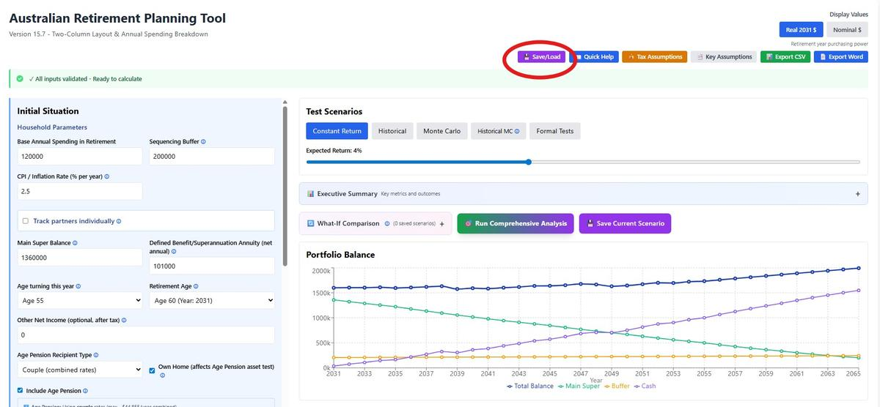

Saving a Scenario
1. Configure all calculator settings (ages, super balance, spending, test scenarios, etc.)
2. Click the "💾 Save/Load" button at the top of the page
3. Enter a descriptive scenario name (e.g., "Base Case", "Conservative 6% Returns", "Retire at 65")
4. Click "💾 Save"
5. Your scenario is saved to browser storage and appears in the "Saved Scenarios" list
Saved scenarios persist across browser sessions and include ALL calculator settings: financial inputs, test scenario selection, Monte Carlo settings, couple tracking, aged care, debts, and display preferences.

Loading a Scenario
1. Click "💾 Save/Load" button
2. Find your scenario in the "Saved Scenarios" list
3. Click the "Load" button next to the scenario name
4. All settings are instantly restored
5. The Scenario Manager closes automatically
Note: Loading a scenario overwrites your current unsaved work. Auto-save creates a draft every 30 seconds to prevent accidental loss.

Export/Import (JSON Backup)
Export to JSON: Creates a downloadable .json file containing your scenario. Use this for:
• Permanent backup (not tied to browser)
• Sharing scenarios with financial advisors or family
• Transferring between computers/browsers
• Version control (save multiple versions with dates)
Import from JSON: Restores a previously exported scenario.
1. Click "💾 Save/Load"
2. Click "📥 Import"
3. Select your .json file
4. Settings load immediately
JSON files are human-readable text files containing all scenario data. They're small (typically 5-15 KB) and can be stored anywhere.
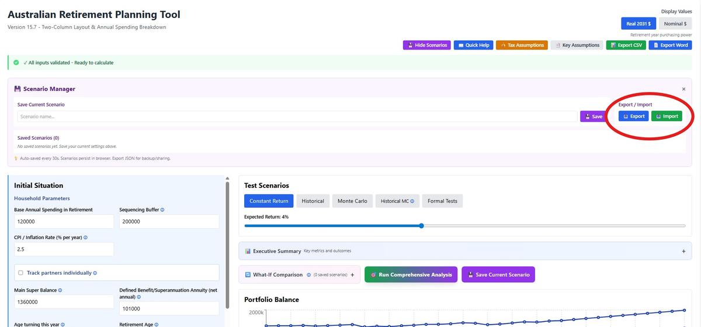

Auto-Save Draft
The calculator automatically saves a draft of your work every 30 seconds. If you close your browser and return within 24 hours, you'll be prompted: "Found auto-saved work from [time]. Restore it?"
• Click OK to restore your unsaved work
• Click Cancel to start fresh
• Drafts older than 24 hours are automatically discarded
Auto-save is separate from named scenarios. It's a safety net for preventing accidental data loss, not a replacement for explicitly saving important scenarios.

Best Practices
Naming Scenarios: Use descriptive names that explain the key differences:
• "Base Case 2026" - Your most realistic scenario
• "Conservative 6% Returns" - Lower return assumption
• "Retire 2030 Age 60" - Specific retirement timing
• "With Aged Care" - Including aged care costs
Avoid generic names like "Scenario 1" or "Test"
Backup Strategy:
• Save important scenarios in browser (quick access)
• Export to JSON monthly (permanent backup)
• Store JSON files in cloud storage (Google Drive, Dropbox)
• Name files descriptively: "Retirement_BaseCase_2026-02.json"
Comparing Scenarios:
1. Configure and save "Base Case"
2. Change one variable (e.g., return from 7% to 6%)
3. Save as "Conservative Returns"
4. Load each scenario to compare results side-by-side
5. Export both for records
Browser Storage: Scenarios stored in browser localStorage (5-10MB limit). Can store 100-500 scenarios typically. Export old scenarios to JSON and delete from browser if you approach limits.

1.2 Quick Start Guide

Basic Setup (5 minutes)
1. Initial Situation
• Age turning this year: The age you will turn (or have turned) this calendar year
• Retirement Age: When you plan to retire (pension starts)
• Main Super: Total superannuation balance at retirement
• Sequencing Buffer: Cash for sequence risk
2. Spending
• Base Annual Spending in Retirement: Essential plus discretionary spending in retirement
• Spending Pattern: Choose constant (increasing with CPI) or declining (U-shaped) (based on JP Morgan research)
3. Pension
• Private Pension: annuity/defined benefit amount (if applicable)
• Include Age Pension: Enable to model government pension (recommended)
• Single or Couple: Affects age pension rates and asset test thresholds
• Assessable Assets Outside Super: Financial assets outside super (bank, shares, investment property equity) counted in the Age Pension means test. Enter in today’s dollars.
4. Other Income (Optional)
• Other Net Income: Primary income source like part-time work, rental income, dividends (if applicable)
• Start Year: When it begins (default 1 = immediate)
• Duration: How many years it lasts (blank = indefinite)
• Additional Income Streams: Click “Add Income Stream” for extra sources (e.g., overseas pension, second rental). Each has its own amount, start year, duration, and CPI indexing toggle.
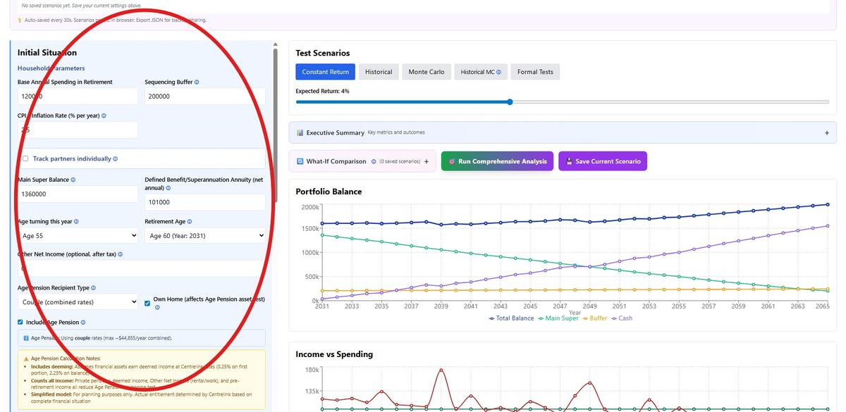

5. Run Simulation
• Select test scenario: Start with 'Constant Return' at 7%
• Review charts: Portfolio Balance and Income vs Spending
• Check Executive Summary: Expand to see success/fail status and key metrics
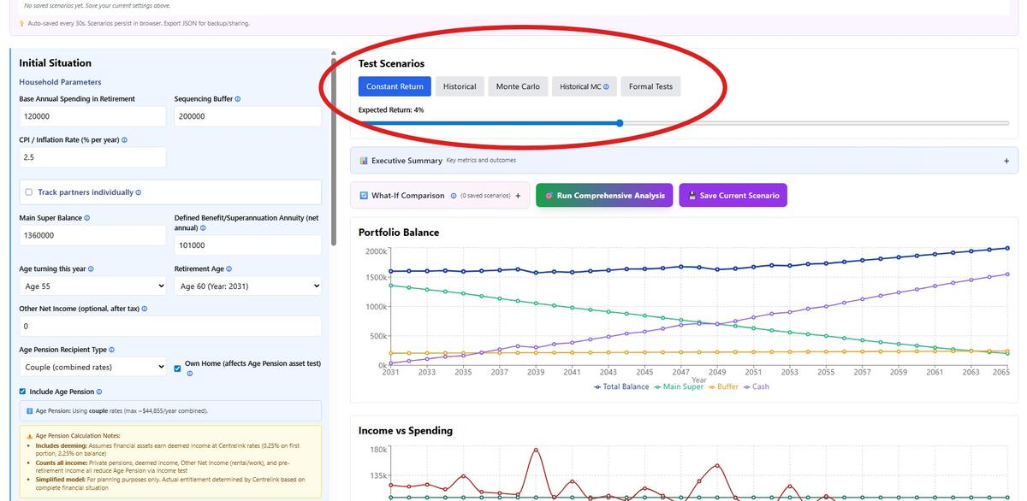

Understanding Results
Success = Portfolio lasts to target age (typically 95) with balance ≥ $0
Failure = Portfolio depleted before target age
After reviewing basic results, explore Monte Carlo simulation for uncertainty analysis or formal stress tests to evaluate resilience.

1.3 Understanding the Interface

Display Mode Toggle
Choose between Real and Nominal dollar display in the top-right corner:
Real 2030 $ (Retirement Year): Values adjusted to retirement year purchasing power. Example: $100,000 in Year 10 shows as $82,035 assuming 2.5% inflation. Use this to understand true buying power.
Nominal $: Future dollar amounts without inflation adjustment. Example: $100,000 in Year 10 stays $100,000. Use this to match bank statements and projections.
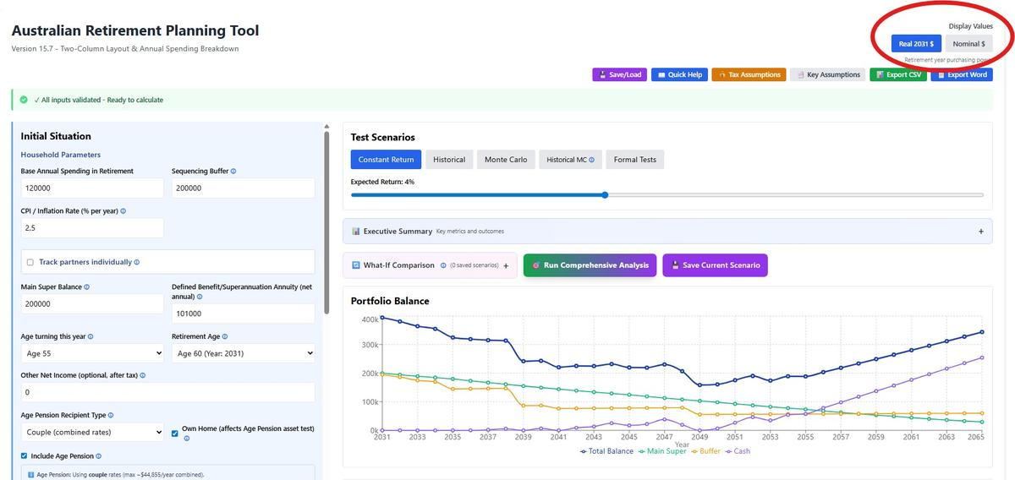

Collapsible Sections
Most input sections can be expanded/collapsed using +/- buttons. This keeps the interface clean while allowing deep configuration when needed.

1.4 Enhanced Warning Systems

Early Portfolio Depletion Warning
If your portfolio depletes in the first 5 years, a comprehensive red warning banner appears explaining WHY and HOW to fix it.
The warning identifies specific causes:
• Returns too low for spending rate
• Annual spending exceeds sustainable withdrawal rate
• Large stochastic irregular expense in early years
• Insufficient starting capital
• Couple tracking gap: Partner hasn't retired yet, super not accessible
• Missing pre-retirement income during staggered retirement
Actionable Solutions Provided:
• Increase expected return to realistic levels (6-7% for balanced portfolios)
• Reduce annual spending
• Increase sequencing buffer to cover retirement gaps
• Add pre-retirement income for working partner
• Align retirement ages to eliminate gaps
• Toggle off stochastic to test if large expense caused failure
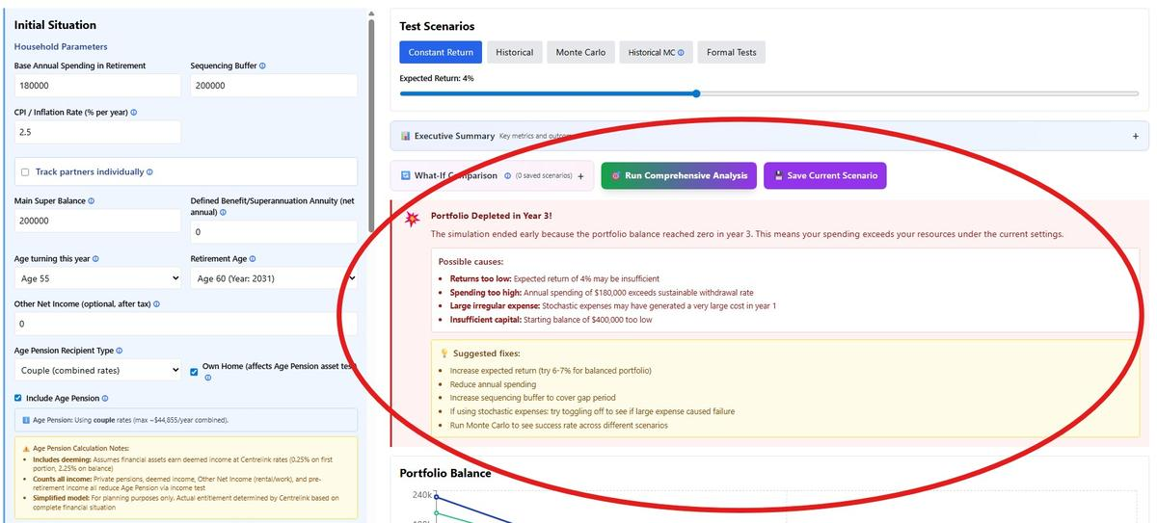
Special Couple Tracking Guidance: For staggered retirements, the warning explains that super is NOT accessible until retirement. If Partner 1 retires at 56 but Partner 2 at 60, Partner 2's super is locked for 4 years. Solution: add Partner 2's salary as pre-retirement income.

Stale Results Detection (Monte Carlo)
Monte Carlo and Historical Monte Carlo simulations take 5-15 seconds to run, so they don't auto-update when you change settings. Version 15.4 introduces visual stale detection:
When Settings Change:
• Run Monte Carlo button turns ORANGE and PULSES
• Button text changes: "🔄 Re-Run Monte Carlo (Settings Changed)"
• Warning appears: "⚠️ Settings have changed. Click above to update results."
• Charts still show OLD results (before the change)
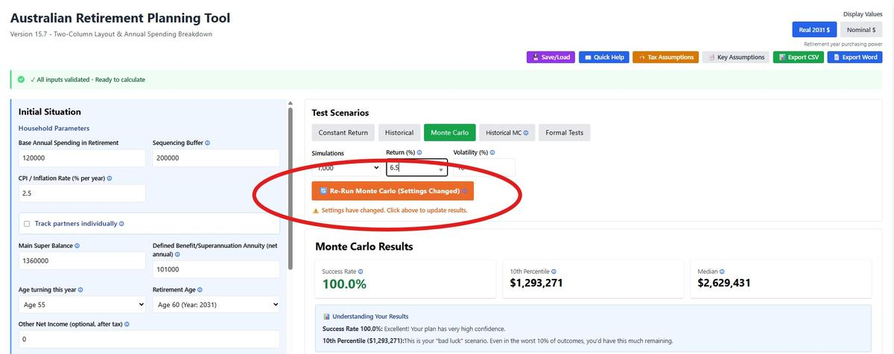
When You Re-Run:
• Button returns to GREEN
• Warning disappears
• Charts update with NEW results
Monitored Settings: Financial inputs (super, pension, spending), ages, return assumptions, spending patterns, expenses (stochastic toggle, one-off), aged care, couple tracking, debts, guardrails. Basically ANY setting that affects simulation results.
Why Manual Updates? Monte Carlo is computationally expensive. Auto-running on every input change would freeze the interface constantly. Stale detection gives you control while making it obvious when results are outdated.

Insufficient Accessible Funds (Couple Tracking)
Appears when couple tracking is enabled and expenses cannot be fully covered because:
• One partner hasn't retired yet (super locked)
• Retired partner's resources (super + buffer + cash) insufficient
• Pre-retirement income + pension income doesn't cover expenses

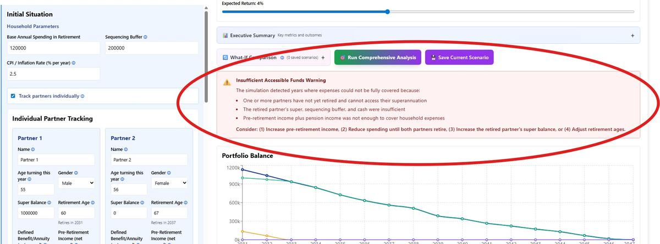
Example Scenario:
Partner 1: Age 55, retires at 60, $1M super
Partner 2: Age 56, retires at 60, $0 super, $108k PSS pension
Year 1 (Partner 2 age 60, retired; Partner 1 age 59, working):
Available: $200k buffer + $108k pension = $308k
Partner 1's $1M super: LOCKED (not retired yet)
If spending + expenses > $308k → Insufficient funds warning
Solution: Add Partner 1's pre-retirement income (salary while working) to cover the 1-year gap until their super becomes accessible at age 60.

PART 2: CORE INPUTS

2.1 Initial Financial Situation

Age Turning This Year & Retirement Age
Age Tuning This Year determines life expectancy calculations. Retirement Age marks Year 1 of the simulation when superannuation access begins and private pensions commence. For couples, Year 1 starts when the FIRST partner retires (see Section 2.5).

Portfolio Buckets
Main Super: Primary retirement savings. Subject to minimum drawdown rules (4-14% based on age). Earns returns based on selected scenario. Drawn down in withdrawal waterfall (see Section 6.2).
Sequencing Buffer: Conservative allocation (cash) earning fixed 3% real return. Provides protection against sequence-of-returns risk by funding spending during market downturns. Typical: 1-2 years spending.
Cash Account: Emergency fund earning 3% real. Accessed first in withdrawal hierarchy. Holds overflow cash when pension income plus minimum super drawdowns exceed expenses.

Homeownership Status
Affects Age Pension asset test thresholds. Homeowners have lower thresholds ($314,000 vs $566,000 for singles) as principal residence is exempt from asset test. Choose 'Yes' if you own your home at retirement.

2.2 Retirement Spending

Base Annual Spending in Retirement
Essential plus discretionary expenses in retirement. Automatically adjusted each year in accordance with the selected spending pattern (CPI (Level) or JP Morgan (Declining)). Includes: groceries, utilities, transport, entertainment, travel, insurance, rates. Excludes: mortgage (use debt repayment), aged care (modeled separately), one-off expenses, and splurge spending.

Spending Patterns
CPI (Level): Constant spending adjusted for inflation only.
JP Morgan (Declining): Spending curve declines gradually with age (relative to CPI) with an increase in the later years (due to aged health costs). Based on research into actual retiree spending behavior, this models three phases. In the early "go-go" years (years 1–10), real spending declines ~1.8% per year as initial retirement enthusiasm moderates. In the "slow-go" years (years 11–20), the decline slows to ~1.4% per year as activity reduces further. In the "no-go" years (21+), spending nearly flattens with just ~0.1% annual real decline. Note that aged care costs (if enabled) are modelled separately on top of this curve, which can cause total spending to rise again in later years.

Splurge Spending
Additional spending for major purchases or lifestyle upgrades. Configure start age, duration, annual amount, and ramp-down period. Example: $30k/year for 10 years starting at 65 for international travel, ramping down over final 3 years.

2.3 Pension Income

Private Pension (Annuity/Defined Benefit)
Enter your annual defined benefit pension or superannuation annuity income (after tax) that will start at retirement. This includes:
• Public sector pensions: PSS, CSS, DFRDB • Commercial lifetime annuities: From super or investment • Other defined benefit schemes: Any guaranteed lifetime income
The calculator automatically indexes this income to inflation (CPI) each year. Enter the net annual amount (after tax) you expect to receive starting from your retirement year. If you have an annuity or pension that is not linked to CPI, you can use the Other Net Income feature below.

Age Pension
Government payment for eligible retirees aged 67+. Eligibility determined by:
Asset Test: Total assessable assets excluding principal residence. Homeowner threshold: $314k (single), $451k (couple). Pension reduces $3 per fortnight for every $1,000 above threshold. Full cutoff: $695k (single), $986k (couple).
Income Test: Annual income including deemed investment income. Free area: $212/year (single), $368/year (couple). Pension reduces 50c per dollar above threshold.
Maximum Rates (2025): $29,754/year (single), $44,855/year (couple combined)
Calculator applies the lower result of asset or income test. For couples with different ages, uses single rate ($29,754) until both reach 67, then couple rate.

2.4 Other Net Income (v15.6)
Model additional income sources during retirement beyond pensions and Age Pension. Examples include part-time work, rental properties, investment income, trust distributions, or consulting. Income can start at any year and run for a specified duration or indefinitely.

Configuration Fields
Annual Amount: Income per year after tax. Examples: $30,000 for part-time work, $25,000 for rental income, $15,000 for trust distributions.
Start Year: Which year of retirement this income begins (1-35). Year 1 = first year of retirement. Default is 1 (starts immediately). Example: Enter 5 if income starts in the 5th year of retirement.
Duration: How many years the income lasts (1-35 years). Leave blank for indefinite income that continues throughout retirement. Examples: 10 years for part-time work, 15 years for rental property, blank for ongoing trust income.
Index to CPI: When enabled (default), income increases with inflation each year. Disable for fixed contracts or annuities that don't adjust for inflation. Examples of indexed income: part-time work wages, rental properties. Examples of fixed income: fixed annuity contracts, non-indexed leases, fixed bond income.

Common Scenarios
Part-Time Work (Indexed): Amount $30,000, Start Year 1, Duration 10, CPI Indexed ✓ → Work part-time for first 10 years, wages increase with inflation (Year 1: $30,000, Year 10: ~$37,500 at 2.5% CPI)
Rental Property: Amount $25,000, Start Year 1, Duration 15 → Rental income until property sold in Year 15
Delayed Consulting: Amount $40,000, Start Year 3, Duration 5 → Take 2 years off, then consult for 5 years
Trust Distributions: Amount $20,000, Start Year 1, Duration (blank) → Ongoing income throughout retirement
Partner's Work (Couple Mode): Amount $25,000, Start Year 5, Duration 8 → Second partner works for 8 years after retiring 4 years later
Fixed Annuity: Amount $25,000, Start Year 1, Duration (blank), CPI Indexed ☐ → Lifetime fixed annuity that doesn't adjust for inflation, stays at $25,000/year throughout retirement

Timing and Indexing
Year-Based System: Both single and couple modes use the same year-based system. Years are relative to the simulation start (Year 1 = first retirement in couple mode).
Automatic Indexing: By default, income amounts are automatically indexed to inflation (CPI) each year while active. You can disable indexing using the "Index to CPI" checkbox for fixed contracts or annuities.
Chart Display: Income appears as an orange stacked area in the Income vs Spending chart, showing exactly when it starts and stops.
Export Support: Other Income appears in What-If Comparison tables, CSV exports, and Executive Summary (when amount > $0).
Age Pension Impact: Other Net Income is counted in the Age Pension income test and will reduce your Age Pension entitlement. For planning accuracy, always verify your Age Pension estimate with Centrelink if you have rental income or part-time work.

2.5 Couple Tracking (v15.0)
Enable comprehensive modeling for couples with different ages, retirement dates, super balances, and pensions. Each partner is tracked individually with automatic handling of death scenarios.
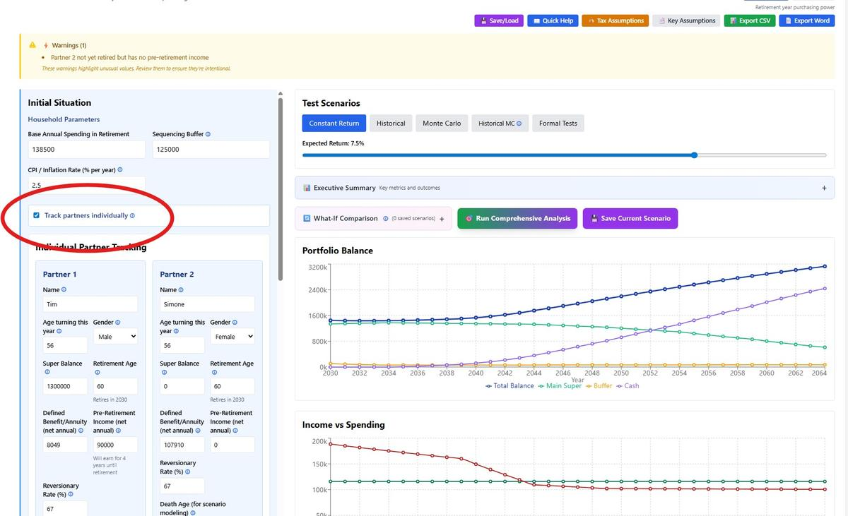

Partner Configuration
Configure each partner with:
• Name: For chart identification
• Age Turning This Year: Age turned this year for life expectancy
• Retirement Age: When pension starts and pre-retirement income stops
• Super Balance: Individual superannuation at retirement
• Pension Income: net annuity/defined benefit annual amount (indexed)
• Reversionary Rate: Percentage continuing to survivor (typically 67% for PSS)
• Gender: For life expectancy calculations
• Death Age: For scenario modeling
• Pre-Retirement Income: Salary if still working when other partner retires

Year 1 Anchoring
Critical Concept: Year 1 starts when the FIRST partner retires (earliest retirement age). Partners retiring later continue earning pre-retirement income until their retirement. Pensions start at each partner's individual retirement age.
Example:
Partner 1: Current age 55, retires at 60
Partner 2: Current age 56, retires at 65
Year 1: Partner 1 is 60 (retired), Partner 2 is 61 (working, earning pre-retirement income)
Year 6: Partner 1 is 65, Partner 2 is 66 (just retired, pension starts)

Super Withdrawal Logic
Each partner's super is tracked separately. Withdrawals are proportional to accessible balances:
Example:
Partner 1 super: $800,000 (retired - accessible)
Partner 2 super: $200,000 (retired - accessible)
Total accessible: $1,000,000
Need to withdraw: $50,000
→ Partner 1 withdraws: $50,000 × 80% = $40,000
→ Partner 2 withdraws: $50,000 × 20% = $10,000
Important: Pre-retirement partners cannot access their super. Only retired partners' balances are accessible.

Death Scenario Modeling
This feature lets you explore "what if one of us dies early?" as a planning scenario. It does not model life expectancy or mortality probability — it's a manual toggle to stress-test your plan.
Important: "Both Alive" does not mean "both die at their death ages." It means both partners are assumed to be alive for the entire simulation period. The death ages you set have no effect in this mode — they only activate when you select a death scenario.
Three scenarios:
- Both Alive (default): Both partners are alive throughout the entire simulation. Couple spending, couple pension rates, and both income streams continue for the full period. Death ages are ignored.
- Partner 1 Dies (at specified death age): Models the financial impact of Partner 1 dying at their set death age. At that point: superannuation balance transfers to Partner 2, defined benefit/annuity pension reduces to the reversionary rate, household spending drops to the single-person rate (default 65% of couple spending), and age pension switches from couple to single rate. Partner 2 continues as sole survivor for the remainder of the simulation.
- Partner 2 Dies: Same logic, with Partner 2 dying and Partner 1 as survivor.
Why it works this way: Modelling both partners dying at specific ages would just truncate the simulation — there'd be nobody left to spend. The real planning question is: "Can the surviving partner sustain themselves financially if one of us goes first?" That's what these scenarios answer.
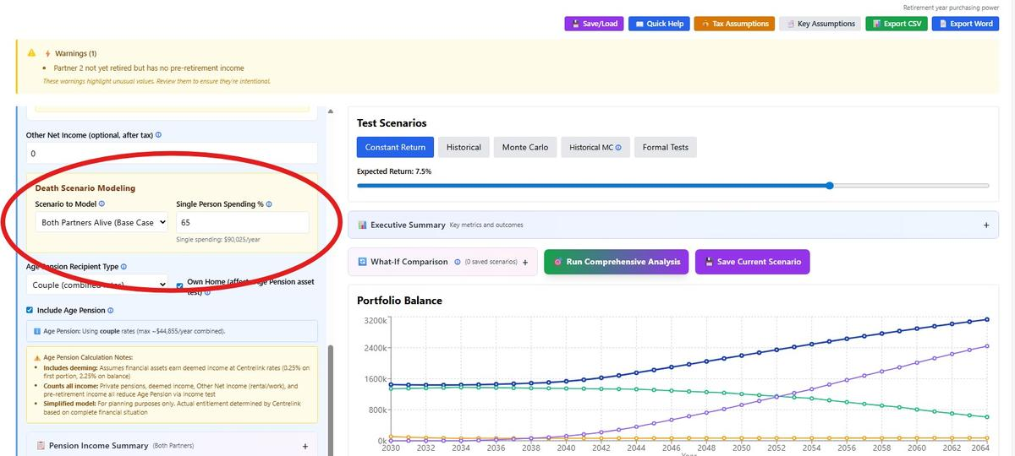

Age Pension for Couples
Accurately models Centrelink rules based on individual eligibility:
• Both under 67: No age pension
• One 67+, one under: Single rate (~$29,754/year) for eligible partner only
• Both 67+: Couple rate (~$44,855/year combined), split 50/50 in individual charts
• After death: Survivor receives single rate
Asset and income test thresholds automatically adjust based on whether single or couple rates apply.

PART 3: ADVANCED FEATURES

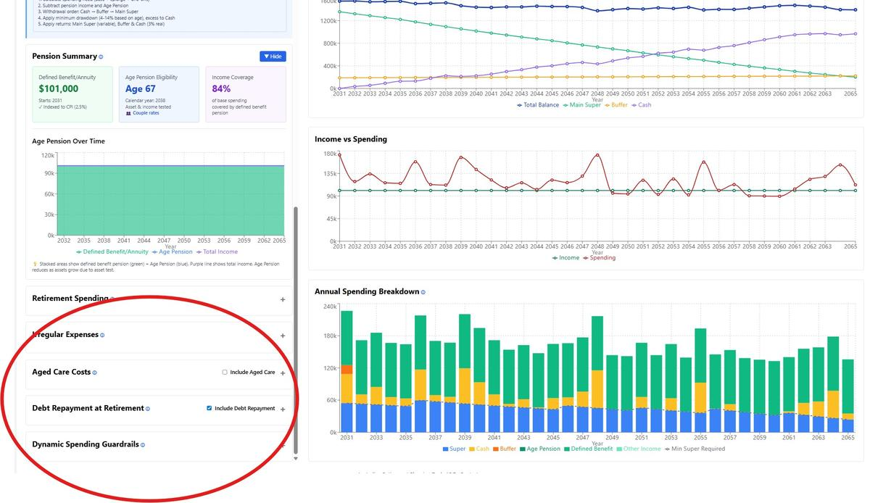

3.1 Irregular and One-Off Expenses
The calculator offers two complementary approaches to modelling expenses outside your regular annual spending: Stochastic Irregular Expenses (recommended) and Manual One-Off Expenses. Both can be used simultaneously.

Stochastic Irregular Expenses (Recommended)
Stochastic irregular expenses model the unpredictable but inevitable costs of retirement — vehicle replacements, home maintenance, medical expenses, and accessibility modifications. Rather than guessing exactly when your roof will need replacing, the model uses probability-based timing and cost variation to generate realistic expense paths.

Included expense categories:
- Transport: Vehicle replacement approximately every 10 years ($50k base, varies ±15%)
- Housing: Roof, HVAC, painting cycles plus emergency repairs (1.5% annual probability)
- Medical: Dental work, hearing aids, hospital excess (increases with age)
- Home modifications: Accessibility updates (age-dependent probability, one-time $30k base)
- Expected range: ~$7-10k/year median, ~$12-16k/year at the 90th percentile
Note: Aged care costs are not included in stochastic expenses. Use the dedicated Aged Care section for modelling RAD deposits, annual fees, and refunds.
How it works across test scenarios:
- Constant Return / Historical Period: Generates one deterministic expense path using a fixed seed. Results are reproducible — you'll see the same expenses in the same years every time. This provides a realistic "middle-ground" scenario for quick planning.
- Monte Carlo: Generates a different expense path for each of the 1,000 simulations. Each run has unique timing and amounts, capturing uncertainty in both market returns and irregular expenses. This is the recommended approach for comprehensive planning.
- Historical Monte Carlo: Generates a different expense path for each simulation combined with actual historical return sequences, providing maximum realism.
Reshuffling expense timing: The 🎲 Reshuffle Expense Timing button generates a new randomised expense path by changing the seed. Each seed produces a different but reproducible pattern — useful for checking whether your plan is sensitive to expense timing without running a full Monte Carlo. The seed number is displayed and can be reset to the default at any time.

Manual One-Off Expenses
Manual one-off expenses are for specific planned expenditures at known ages — a gift to family at 65, a major holiday at 70, paying off the mortgage at 62. These are expenses you can reasonably predict the timing and cost of.
IMPORTANT: Amounts are entered in nominal (future) dollars — the dollar value in the year the expense occurs, not in today's dollars. For example, $50,000 for a car at age 70 means $50,000 in age-70 dollars. This differs from base spending, which is entered in today's dollars and automatically inflated.
No default expenses are pre-loaded. Add items as needed using the "+ Add One-Off Expense" button, specifying a description, the age it occurs, and the amount.

Using Both Together
Stochastic and manual expenses can run simultaneously. When both are enabled, a warning reminds you to avoid double-counting: stochastic expenses already cover vehicle replacements, home maintenance, and medical costs, so manual entries should be limited to planned expenses outside those categories (e.g., gifts, holidays, mortgage payoff, lifestyle purchases).
With Monte Carlo simulations, note that manual one-off expenses use the same fixed amounts in every run, while stochastic expenses vary across simulations.

3.2 Debt Repayment at Retirement
Model mortgages, personal loans, or other debts carried into retirement. Each debt requires: balance, interest rate, minimum payment. Calculator simulates monthly minimum payments with excess funds paying down principal. Interest calculated monthly. Balance cannot go negative.

3.3 Aged Care Planning

Cost Components
RAD (Refundable Accommodation Deposit): Lump sum paid on entry (typical: $400k-$550k). Refunded when exiting care. Withdrawn from, and refunded to, super balance.
Annual Care Costs: Daily fees, means-tested fees, extra services (typical: $60k-$80k/year). Indexed to inflation.

Modeling Approaches
Deterministic: Enter specific age and duration. Use for planned entry scenarios.
Probabilistic: Risk-based entry using actuarial data. Use for Monte Carlo simulations to model uncertainty.

Couple Mode Integration
In couple tracking, aged care applies to SURVIVING PARTNER only. Both assumed healthy while both alive. After first partner dies, survivor may enter care at specified age.

3.4 Dynamic Spending Guardrails
Automatic spending adjustments based on portfolio performance relative to initial withdrawal rate percentiles. The guardrails dynamically adjust your spending up or down to maintain portfolio sustainability while maximizing lifestyle when markets perform well.
How Guardrails Are Calculated:
1. Initial Percentile Calculation: At retirement (Year 1), the calculator determines what percentile your initial withdrawal rate represents. For example, if withdrawing $80k from a $1.2M portfolio (6.67% rate), this might be at the 50th percentile of sustainable withdrawal rates.
2. Annual Percentile Tracking: Each year, the calculator recalculates what percentile your current withdrawal rate represents based on your remaining portfolio balance and years to target age.
3. Upper Guardrail Trigger (Default: 80th percentile): If your withdrawal rate drops below the 80th percentile (meaning your portfolio is performing better than expected), spending increases by the adjustment amount (default: 10%). This happens when markets perform well or you're spending less than planned.
4. Lower Guardrail Trigger (Default: 20th percentile): If your withdrawal rate exceeds the 20th percentile (portfolio performing worse than expected), spending decreases by the adjustment amount (default: 10%). This protects against portfolio depletion during market downturns.
5. Spending Floor Protection: Spending can never fall below total pension income (annuity/defined benefit + Age Pension), ensuring a minimum income regardless of market performance.
Example: Starting with $1.2M and $80k spending (6.67% rate = 50th percentile)
• Year 5: Great returns, portfolio now $1.5M, $84k spending = only 5.6% rate (now at 85th percentile) → Exceeds upper guardrail → Increase spending to $92.4k (10% increase)
• Year 10: Market crash, portfolio down to $900k, $92k spending = 10.2% rate (now at 15th percentile) → Below lower guardrail → Decrease spending to $83k (10% decrease)
• Year 15: Portfolio recovers to $1.1M, spending $83k = 7.5% rate, back at 45th percentile → No adjustment, within guardrails
Configuration Parameters:
• Upper Guardrail: Default 20% (= 80th percentile). Higher values (e.g., 30%) make it easier to trigger spending increases.
• Lower Guardrail: Default 15% (= 20th percentile). Lower values (e.g., 10%) provide more protection before cutting spending.
• Adjustment Amount: Default 10%. How much to increase/decrease spending when triggered. Smaller adjustments (5%) create smoother changes.
Note: Guardrails apply from Year 2 onwards and do NOT affect one-off expenses, aged care costs, or debt payments - only base living expenses.
Used to demonstrate the impact of adjusting spending when markets perform poorly. Should be used with caution. The algorithm may drive spending below bare minimum expenses.

When to Use
• Prefer flexibility over certainty
• Want dynamic adjustments based on market performance
• Have reliable pension income as safety floor

Limitations
• Requires discipline to cut spending in downturns
• May trigger frequent small adjustments
• Not suitable if committed to fixed expenses
• May result in unrealistic spending in order to achieve portfolio longevity

PART 4: RUNNING SCENARIOS

4.1 Test Scenario Types



Constant Return
Fixed annual return (e.g., 7%). Simplest scenario for baseline testing. Useful for: initial planning, comparing to rules of thumb, understanding basic dynamics. CRITICAL: The Constant Return slider represents NOMINAL returns (before adjusting for inflation).
The simulation always runs in NOMINAL dollars with your selected CPI rate built in.

How it works
If you select a 5% constant return with 2.5% CPI:
- Main Super grows at 5% NOMINAL each year
- But spending increases by 2.5% (inflation)
- Net REAL return = 5% - 2.5% = 2.5% real

Historical Periods
Actual S&P 500 Total Return data (1928-2025, Shiller/Ibbotson). Enables the user to test their retirement plan during actual historical market events: 1929-1931 (Great Depression), 1973-1975 (Oil Crisis), 2000-2002 (Dot-com), 2008-2010 (GFC). Shows how plan would have performed in real market conditions.

Monte Carlo Simulation
1,000+ scenarios with normally distributed returns (default: 7% mean, 18% volatility). Provides success rate and outcome range (P10-P90). Use for: uncertainty quantification, risk assessment, confidence levels.

Historical Monte Carlo
Randomly samples actual historical returns (98 years of S&P 500 data, 1928-2025). Combines historical accuracy with Monte Carlo uncertainty. More conservative than parametric Monte Carlo.

Formal Stress Tests
Structured scenarios testing specific failure modes:
• A1 Base Case: 5% constant (baseline)
• A2 Low Returns: 3.5% constant (structural low)
• B1 Crash: -25%, -15% then 5% (immediate crash)
• B2 Bear Market: 10 years at 0% (extended stagnation)
• B3 High Volatility: Alternating +/- returns, 5% average (volatility drag)
• C1 High Inflation: 5% CPI throughout
• D1 Extreme Longevity: 45 years to age 105
• G1 Health Shock: $30k/year from age 75
• H1 Worst Case: Crash + high CPI + health costs

4.2 Understanding Results

Success Criteria
Success: Portfolio lasts to target years (typically 35 = age 95) AND ending balance ≥ $0
Failure: Portfolio depletes before target years
Note: Ending with exactly $0 at target age = SUCCESS (perfect timing)

Interpreting Monte Carlo Success Rates
Monte Carlo simulations express results as a "success rate" - the percentage of scenarios where your portfolio lasted through retirement.
Recommended Success Rate Guidelines:
Parametric Monte Carlo:
• 90%+: Excellent - very robust plan
• 80-89%: Good - meets industry standard
• 70-79%: Moderate - consider adjustments
• Below 70%: Needs attention
Historical Monte Carlo:
• 90%+: Excellent - succeeded in nearly all historical periods
• 85-89%: Good - survived most of history including major crashes
• 75-84%: Moderate - some challenging periods
• Below 75%: Needs attention
Why the difference? Historical Monte Carlo uses actual market data from 1928-2025, bounded by real events (worst year: -43% in 1931). Parametric Monte Carlo uses statistical models that can generate theoretical scenarios worse than any real historical period. This means Historical MC typically shows 5-15 percentage points higher success rates than Parametric MC for the same portfolio.
Which to trust? Historical Monte Carlo is more reliable for planning because it's based on what actually happened, not theoretical extremes. If both methods are available, focus on the Historical MC result.

4.3 Executive Summary Dashboard (v15.2)
Collapsible panel above charts providing comprehensive at-a-glance analysis. Click '📊 Executive Summary' to expand.
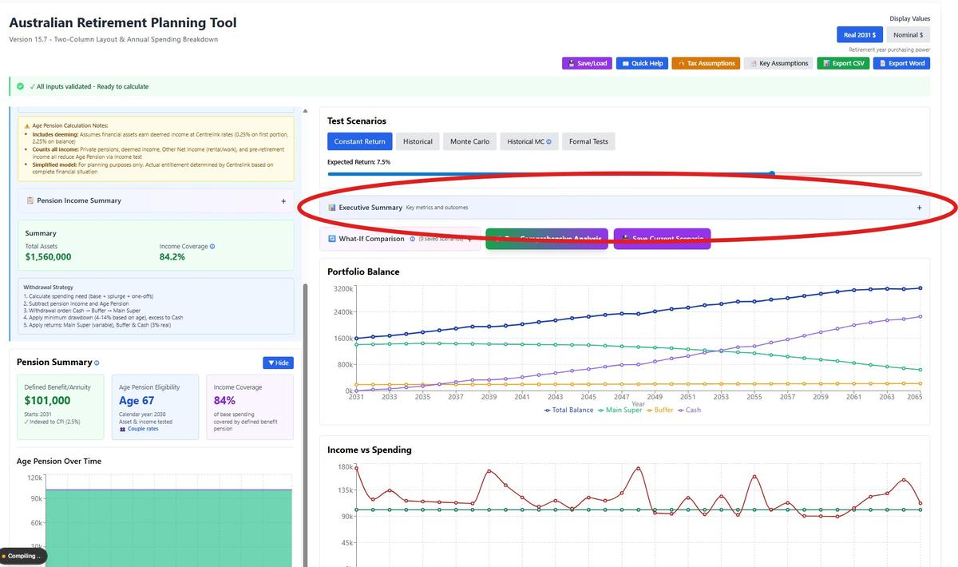

Components
Scenario Indicator: Shows which test is active (Constant Return Monte Carlo, Historical Monte Carlo , Formal Test, Historical Period)
NOTE: For the Monte Carlo and Historical Monte Carlo, the Summary Dashboard shows the results for the medium (P50) result.
Success/Fail Banner: Green ✅ or Red ❌ with years lasted and ending balance. Context-aware messaging.
Portfolio Summary: Starting/ending balance, total withdrawn, avg return, safety margin
Income Summary: Private pension, age pension timing, average/peak spending
Risk Assessment: Traffic lights (🔴🟡🟢) for sequence risk, longevity risk, inflation risk, health costs
Monte Carlo Analysis: Success rate, P10/P50/P90 outcomes (appears for MC scenarios only)
Individual Partner Summary: Final super and pension for each partner (appears for couple tracking only)
Every metric has hover tooltips (blue ⓘ icon). Display respects Real/Nominal toggle.

PART 5: WHAT-IF SCENARIO COMPARISON

5.1 Overview
The What-If Scenario Comparison feature allows you to save and compare up to 5 different retirement scenarios side-by-side. This helps you understand how changes in key parameters (super balance, spending, retirement age, returns) affect your retirement outcomes.
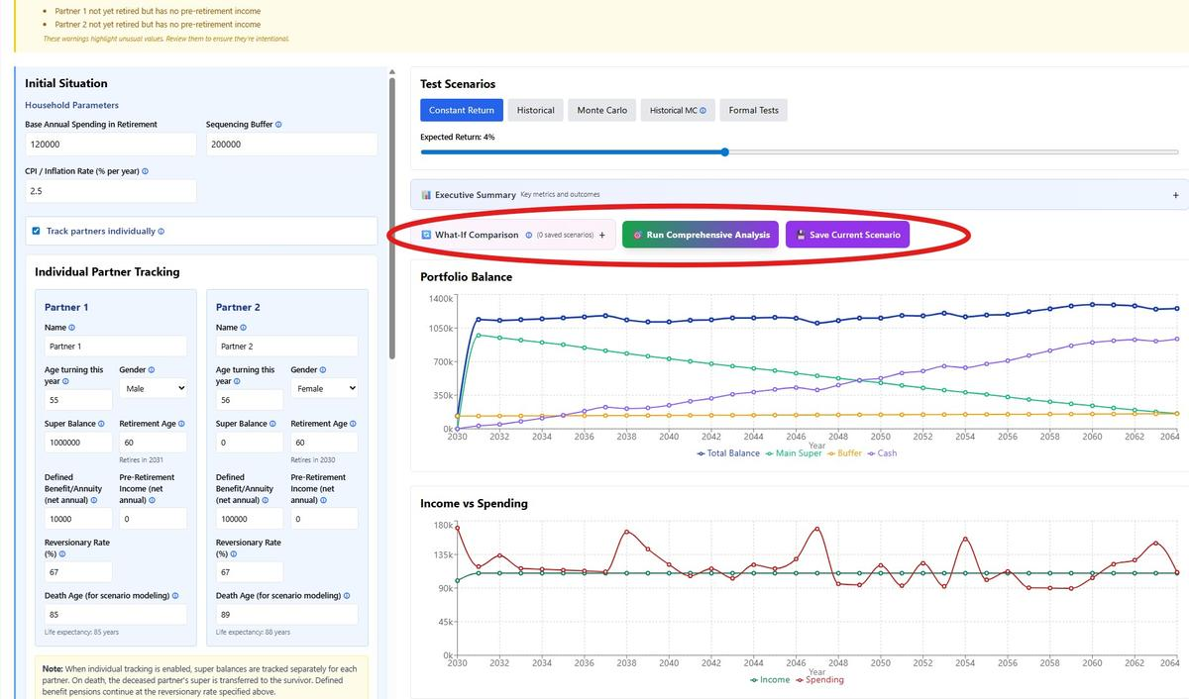

5.2 Basic Workflow
To use What-If Comparison:
1. Set up your baseline scenario with initial parameters. Run the applicable Test Scenario.
2. Click "💾 Save Current Scenario" to capture the baseline
3. Modify one or more parameters (e.g., reduce spending by $10k/year). Rerun the Test Scenario.
4. Click "💾 Save Current Scenario" again to save the variant
5. Repeat for up to 5 total scenarios
6. Compare results side-by-side in the comparison table
The comparison table shows both key results (Success/Fail, Ending Balance, Years Lasted, MC Success Rate, Formal Tests Passed) and input parameters for each scenario.

5.3 Comprehensive Analysis
The "🎯 Run Comprehensive Analysis" button (located at the top of the What-If panel) provides complete risk assessment by running BOTH Parametric Monte Carlo AND all 9 Formal Stress Tests in a single operation.
What it does:
• Runs 1,000 parametric Monte Carlo simulations using your Expected Return & Volatility settings
• Runs all 9 Formal Stress Tests (crash scenarios, longevity tests, inflation tests, etc.)
• Automatically saves a scenario with BOTH MC success rate and formal tests results
• Takes approximately 5-10 seconds to complete
This is ideal when you need complete risk assessment across both statistical probability (Monte Carlo) and specific failure modes (Formal Tests). For faster comparisons using only one test type, use the individual scenario buttons (Constant Return, Historical, Monte Carlo, or Formal Tests) with the "Save Current Scenario" button.

5.4 Understanding the Comparison Metrics
The comparison table displays five key result metrics:
• Success/Fail: Whether the portfolio lasted to target age with balance ≥ $0
• Ending Balance: Portfolio value at end of simulation (in real or nominal dollars as per display setting)
• Years Lasted: How many years the portfolio sustained spending
• Parametric MC Success Rate: Percentage of parametric Monte Carlo simulations that succeeded (uses Expected Return ± Volatility). Shows "—" if not applicable
• Formal Tests Passed: Number of formal stress tests passed out of total (X / Y format). Shows "—" if not applicable
Green ▲ indicators show improvement over the current scenario, red ▼ shows worse performance, and gray ═ shows equal performance.

5.5 Key Parameters to Vary
Common parameters to test in What-If scenarios:
• Super Balance: Test the impact of higher or lower starting superannuation balances
• Base Spending: Compare more frugal versus more generous lifestyle spending
• Retirement Age: Compare retiring at different ages (e.g., 60 vs 65)
• Defined Benefit/Annuity: Model different pension income amounts
• Splurge Spending: Test major one-time expense scenarios
• Return Scenarios: Compare optimistic vs pessimistic return assumptions (Constant, Historical, Monte Carlo)

5.6 Managing Saved Scenarios
Scenario management features:
• Rename: Click on any scenario name to edit it (e.g., "Conservative", "Aggressive", "Base Case")
• Delete: Click the 🗑️ button next to individual scenarios to remove them
• Clear All: Remove all saved scenarios at once with the "Clear All" button
• Maximum: Up to 5 scenarios can be saved simultaneously - delete one to add more
The help section within the What-If panel can be collapsed/expanded using the + / − button for a cleaner interface.

PART 6: CHARTS & ANALYSIS

6.1 Chart Types & Interpretation

Portfolio Balance Chart
Shows total portfolio value over time. Lines: Total Balance (blue), Main Super (green), Buffer (orange), Cash (purple). For Monte Carlo, median line shown. Automatic hide of component lines when percentile bands active.
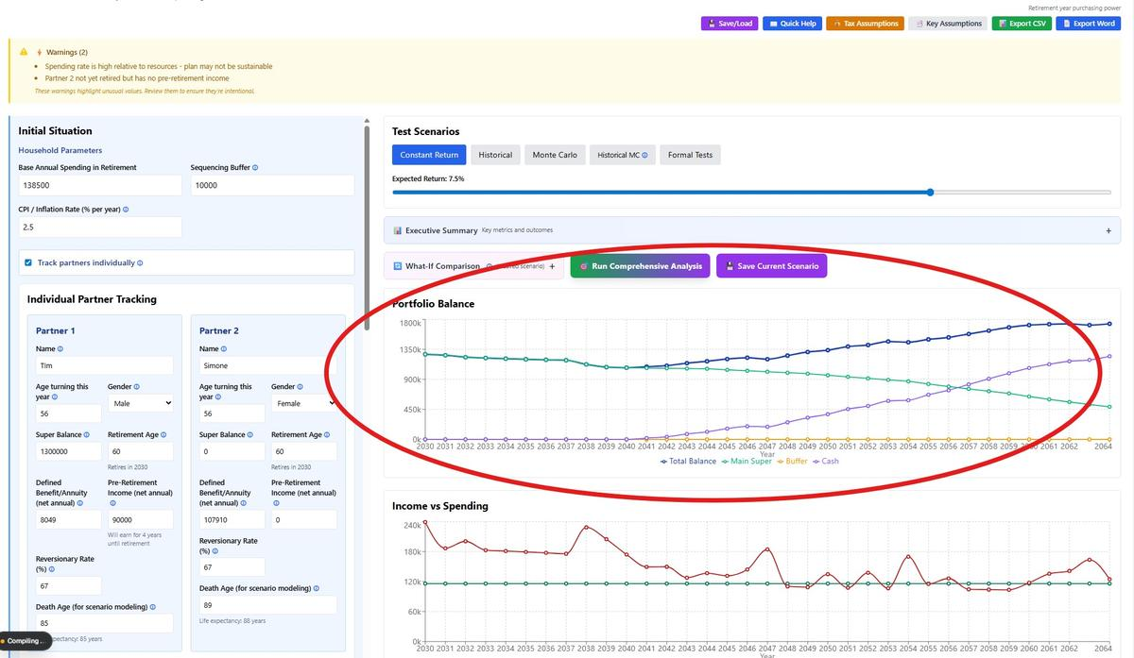

Income vs Spending Chart
Annual income (green) vs spending (red). Income sources: pension, age pension. Spending includes: base, splurge, aged care, debt payments. Gap filled by portfolio withdrawals.
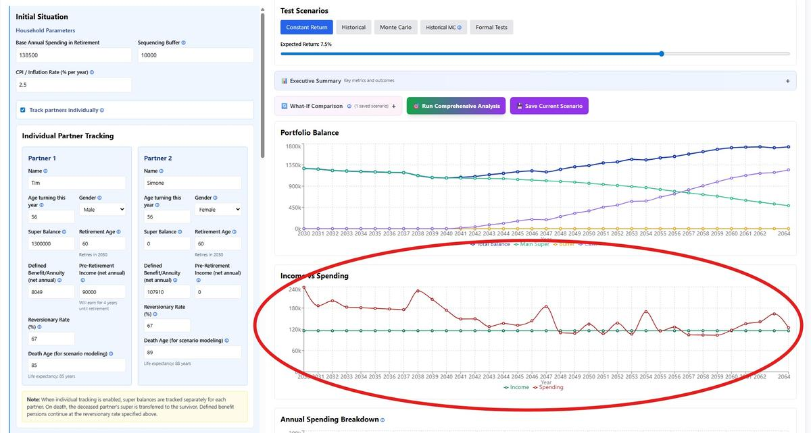

Annual Spending Breakdown Chart
Shows the composition of your annual spending by funding source. Stacked bars display how much comes from each source (bottom to top): Super withdrawals (blue), Cash (yellow), Sequencing Buffer (orange), Age Pension (dark green), Defined Benefit pension (medium green), and Other Income (light green).
The gray dashed line shows the minimum required super withdrawal based on your age. The blue Super section at the bottom of each bar should meet or exceed this line to comply with government requirements.
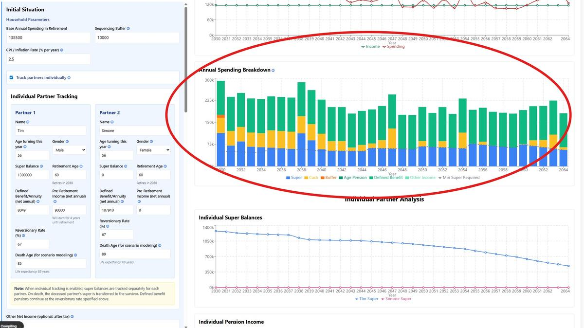
Key insights:
• Early retirement: Large blue (Super) section before Age Pension starts
• Age 67+: Green sections grow as Age Pension reduces reliance on Super
• RAD payments: Dramatic spike in bar height when entering aged care
• Source depletion: Watch Cash and Buffer sections disappear over time
• Sustainability: If bars are mostly green (pension income), your plan is highly sustainable
This chart complements the Income vs Spending chart by showing not just the gap between income and spending, but exactly where the money comes from to fund your lifestyle.

Individual Super Balances (Couple Tracking)
Partner 1 (blue) and Partner 2 (pink) super balances tracked separately. Shows proportional withdrawals, death transfers, and depletion timeline.

Individual Pension Income (Couple Tracking)
Total pension for each partner: private pension + age pension allocation. Accounts for reversionary reductions and age pension rule changes.
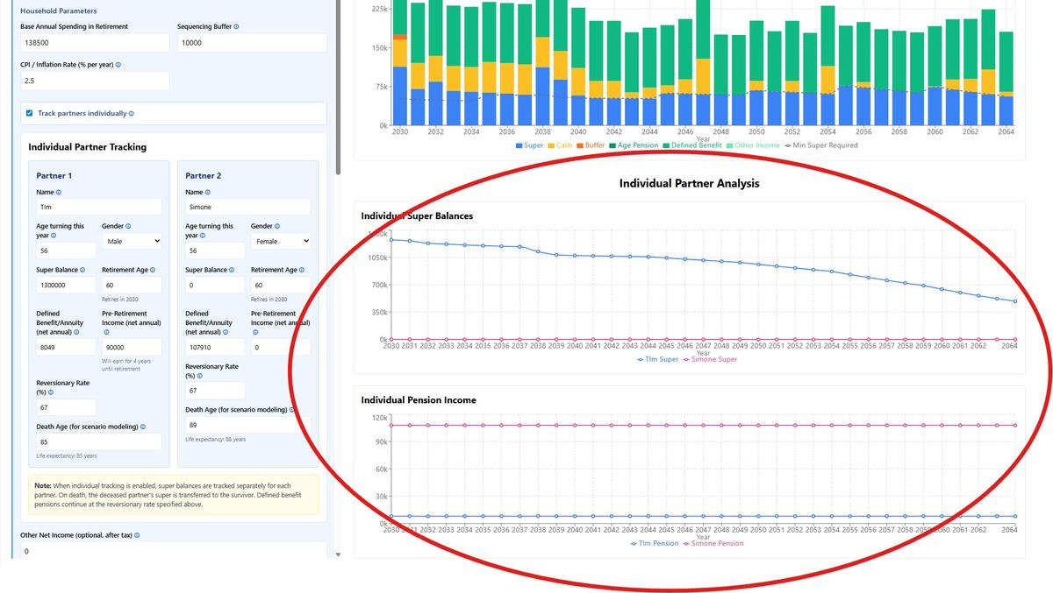

6.2 Monte Carlo Percentile Bands
Visualizes outcome uncertainty with dashed boundary lines. Toggle with '📊 Show/Hide Bands' button.
• 10th-90th percentile (light blue): 80% of scenarios fall within
• 25th-75th percentile (medium blue): 50% of scenarios fall within (likely range)
• 50th percentile (dark blue solid): Median outcome - most typical
For Monte Carlo scenarios, median line shows actual P50 calculated across all simulations at each year, not a single 'representative' run.

6.3 CSV Export & Analysis
Download detailed year-by-year data for external analysis. Includes: balances, income, spending, pensions, withdrawals, returns, ages, debt details. For couple tracking: individual partner data.
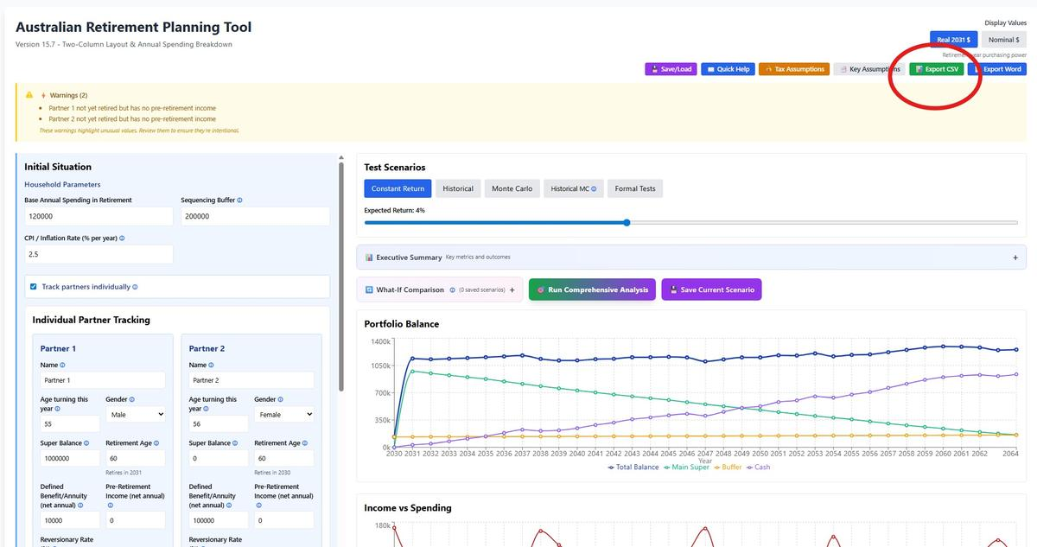

6.4 Word Document Export
Generate comprehensive retirement plan reports as editable Word (.docx) documents. The report includes executive summary, financial assumptions, year-by-year projections, risk analysis, and actionable recommendations.
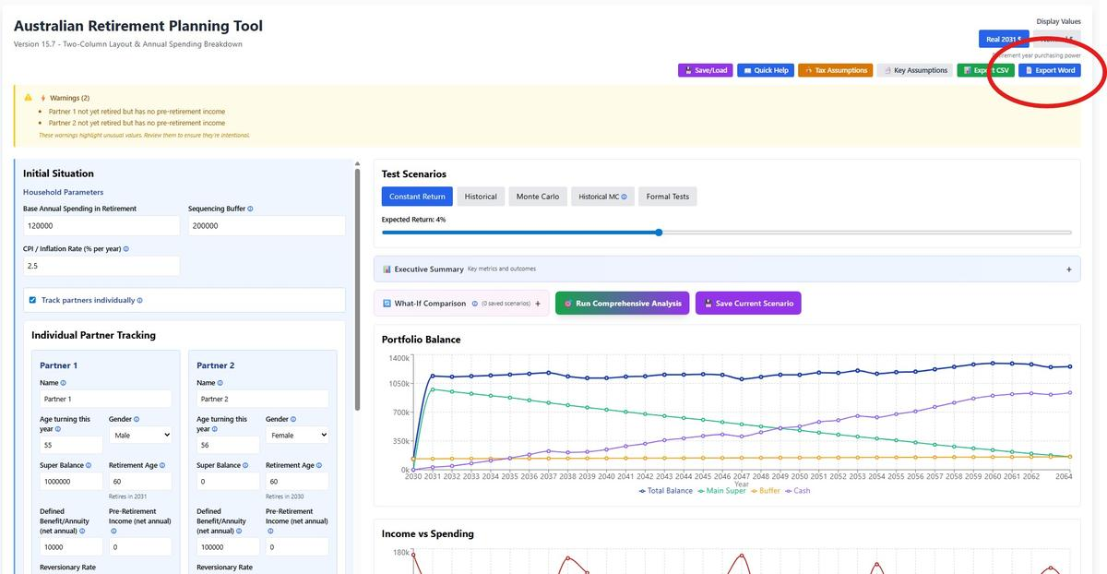

How to Generate
- Configure your retirement scenario
- Run desired test scenarios:
  - Monte Carlo (recommended for risk analysis)
  - Formal Tests (optional stress testing)
- Click “📄 Export Word” button (top right, next to CSV Export)
- Document downloads automatically

File Details
• Format: Microsoft Word (.docx) - fully editable • Size: Typically 8-12 pages • Filename: retirement-plan-YYYY-MM-DD.docx • Professional styling: Calibri font, consistent formatting, color-coded status

When to Export
Before Major Decisions • Changing jobs or retiring • Making large withdrawals • Adjusting spending plans • Reviewing with financial advisor
Periodic Reviews • Annually to track progress • After significant market changes • When updating assumptions (returns, inflation) • Before/after running different test scenarios
For Sharing • Send to financial advisor for review • Discuss with spouse/partner • Include in estate planning documents • Archive for historical comparison

Tips
Best Results: Run Monte Carlo simulation before exporting - the report includes success rates and risk analysis based on these results.
Comparing Scenarios: Export multiple reports with different assumptions (conservative returns, higher spending, etc.) to compare side-by-side.
Editable Format: Unlike PDF, Word documents can be edited. Add your own notes, highlight key findings, or customize for your specific needs.
Archival: Export and date your reports monthly or quarterly. Store in cloud storage to track how your plan evolves over time.

Differences from CSV Export
Feature | Word Report | CSV Export
Purpose | Comprehensive analysis document | Raw data for custom analysis
Format | Polished report with summaries | Year-by-year detailed data
Audience | Financial advisors, personal review | Excel power users, researchers
Content | Narrative + key insights | All calculated values
Editability | Easy to annotate | Requires spreadsheet

PART 7: TECHNICAL REFERENCE

7.1 Annual Simulation Sequence
Each year processes in this order:
1. Increment ages and year counter
2. Check partner mortality (if death scenario active)
3. Apply dynamic guardrails (if enabled, from Year 2)
4. Calculate total spending: base + splurge + aged care + debt + one-off expenses
5. Calculate total income: pension + age pension + other net income + additional income streams + pre-retirement income
6. Apply minimum drawdown from Main Super (mandatory, age-based percentage)
7. Cover spending using withdrawal waterfall (Section 6.2)
8. Process debt payments (interest monthly, excess to principal)
9. Process RAD payment (aged care entry) or refund (exit)
10. Apply investment returns to portfolio buckets
11. Index spending and pensions to CPI
12. Record year data
13. Check termination: balance ≤ $0 or target years reached

7.2 Withdrawal Hierarchy (Waterfall)
Funds withdrawn in priority order to minimize tax and preserve growth potential:
1. Cash Account (tax-free, no penalties)
2. Sequencing Buffer (defensive, lower volatility)
3. Main Super (or individual partner supers in couple mode)
Minimum drawdown from Main Super applied FIRST (mandatory), then additional withdrawals follow waterfall. Couple mode: proportional withdrawals from retired partners only.

7.3 Age Pension Calculation
The calculator models Age Pension using Centrelink's asset test, income test, and deeming rules. The lower result from the two tests determines your entitlement.

What's Modeled
Deeming Rules: Financial assets (super, cash, buffer, and assessable assets outside super) are deemed to earn income at Centrelink rates regardless of actual earnings:
- Single: 0.25% on first $60,400, then 2.25% on balance
- Couple: 0.25% on first $100,200, then 2.25% on balance
- Deeming thresholds and rates are indexed to CPI each year
Income Test - All Sources Counted:
- Private pensions and annuities (Defined Benefit/Superannuation Annuity)
- Deemed income from financial assets (calculated above)
- Other Net Income and Additional Income Streams (rental income, part-time work, dividends, overseas pensions, and other non-super investment income)
- Pre-retirement income (in couple mode if one partner still working)
Note: Account-based pension minimum drawdowns are NOT counted as income (correctly excluded per Centrelink rules).
Asset Test
Assessable assets = Main Super + Sequencing Buffer + Cash Account + Assessable Assets Outside Super (excludes principal residence). Non-super assets are entered in today’s dollars and automatically indexed to inflation.
Homeowner Thresholds:
- Single: $314,000 (full pension), $695,500 (cutoff)
- Couple: $451,500 (full pension), $986,500 (cutoff)
Non-homeowner: Add $252,000 to all thresholds
Taper: Pension reduces $3 per fortnight ($78/year) for each $1,000 above threshold
Income Test
Income Free Area (indexed to CPI):
- Single: $5,512/year
- Couple: $8,736/year (combined)
Taper: Pension reduces 50c for every dollar of income above the free area
Example (Single, $400,000 super, $25,000 rental income):
- Deemed income: ($60,400 × 0.0025) + ($339,600 × 0.0225) = $7,792
- Rental income: $25,000
- Total testable income: $32,792
- Excess over free area: $32,792 - $5,512 = $27,280
- Reduction: $27,280 × 50% = $13,640
- Income test result: $29,754 - $13,640 = $16,114/year
Final Calculation
Age Pension = Min(asset test result, income test result)
Couple Mode:
- Both partners 67+: Uses couple rate (max ~$44,855/year combined)
- Only one partner 67+: Uses single rate for eligible partner
- Neither 67+: No Age Pension
All thresholds, free areas, and maximum pension rates are automatically indexed to CPI each year.
Age Pension Calculation Details Panel
A collapsible panel in the results column (labelled “Age Pension Calculation Details”) shows how the Age Pension is calculated for each year of retirement. This panel only appears when the Age Pension is enabled and a simulation has been run. It provides full transparency into the means testing logic so you can verify the calculator’s output against Centrelink estimates.
The table displays the following columns for each year from age 67 onwards:
- Rate Type: Whether couple or single rates are being applied (changes automatically if a partner dies in couple tracking mode)
- Assessable Assets: Total assets counted for means testing (super + buffer + cash + non-super assets, all inflation-indexed)
- Asset Test Threshold and Asset Test Pension: The lower threshold and the pension amount resulting from the assets test
- Deemed Income: Income calculated via Centrelink deeming rates on total financial assets
- Private Pension + Other: All non-deemed income sources (defined benefit pension, Other Net Income, pre-retirement income)
- Total Testable Income, Income Free Area, and Income Test Pension: The income test inputs and resulting pension amount
- Binding Test: Which test (assets or income) produces the lower pension and therefore determines the payment. Highlighted in amber.
- Final Age Pension: The annual pension amount. Shows “FULL” in green when receiving the maximum rate. Red rows indicate nil pension (assets above the cutoff threshold).
All values in the table respect the Real/Nominal dollars toggle, so you can view the calculations in either today’s purchasing power or future nominal dollars.
Important Limitations
What's NOT Modeled:
- Work Bonus: $11,800 work income exemption for over-67s not included
- Pension Loan Scheme: Voluntary reverse mortgage option not modeled
- Energy Supplement: ~$365/year supplement not added
- Commonwealth Seniors Health Card: Concessions not quantified
Verification Required: This is a planning tool. Actual Age Pension entitlement is determined by Centrelink based on your complete financial situation. Always verify estimates with Centrelink or a financial advisor, especially if you have:
- Rental income or investment income outside super
- Part-time work during retirement
- Complex asset structures (trusts, companies, etc.)
- Income from overseas sources

7.4 Minimum Drawdown Rules
Mandatory annual withdrawal percentages from Main Super:
• Age < 65: 4%
• Age 65-74: 5%
• Age 75-79: 6%
• Age 80-84: 7%
• Age 85-89: 9%
• Age 90-94: 11%
• Age 95+: 14%
Applied to Main Super balance at start of year. If minimum > available, withdraw full balance. Couple mode: separate minimums for each partner based on individual age and balance.

7.5 Returns & Inflation Modeling
Constant Return slider represents NOMINAL returns (before inflation). Real return = Nominal - CPI. Example: 7% nominal with 2.5% CPI = 4.5% real growth.
Main Super earns scenario-based returns (constant, historical, or Monte Carlo). Buffer and Cash earn fixed 3% REAL (automatically adds CPI).
All spending and pensions indexed to CPI annually. Display mode (Real/Nominal) affects chart presentation only, not calculations.

Contact & Support
Email: aust-retirement-calculator@proton.me
Documentation: Available in calculator (Help & Guide section)
User Guide: Download PDF or DOCX from calculator interface

Important: This tool is for educational and planning purposes only. It does not provide financial, tax, or retirement advice and does not consider your personal circumstances. Consult qualified professionals for personalized advice.

━━━━━━━━━━━━━━━━━━━━━━━━━━━━━━━━━━━━━━━━━━━━━━━━━━

End of User Guide

Australian Retirement Planning Tool v15.9

