Assessing the biological relevance of conclusions drawn from ABC analysis along a continuum of divergence
Migration between two related gene pools is a major component of demographic history shaping patterns of polymorphism and divergence. However, the lack of direct observation of past demographic events makes their detection from current genomic data a central challenge in evolutionary biology. Recently, two simulation studies highlighed the difficulty to correctly reject the SI model when the time of speciation is small compared to effective population sizes (ref and ref). More precisely, Hey et al. (2015) analyzed 100 pseudo-observed datasets (PODs) simulated under the SI model with θ = 4Nu = 5 and a time of split t = 0.5.

.Loop over 100 values of speciation time t in {0.01, 0.02, … , 1}; θ=5 :
.Loop over 100 replicated inferences for a given t value :
.Random simulation of the multilocus pseudo-obvserved dataset POD_{i} under the SI model.
.Estimation of the relative posterior probabilities pSI_{i} and pIM_{i} for the simulated POD_{i}.
.If pSI_{i} > pIM_{i} :
.robustness = P( pSI_{i} | SI ) / [ P( pSI_{i} | SI ) + P( pSI_{i} | IM ) ]
.if robustness ≥ 0.95 :
True discovery of SI.
.else :
Statistical support is considered as ambiguous.
.If pIM_{i} > pSI_{i} :
.robustness = P( pIM_{i} | IM ) / [ P( pIM_{i} | IM ) + P( pIM_{i} | SI ) ]
.If robustness ≥ 0.95 :
False discovery of IM.
.else :
Statistical support is considered as ambiguous.

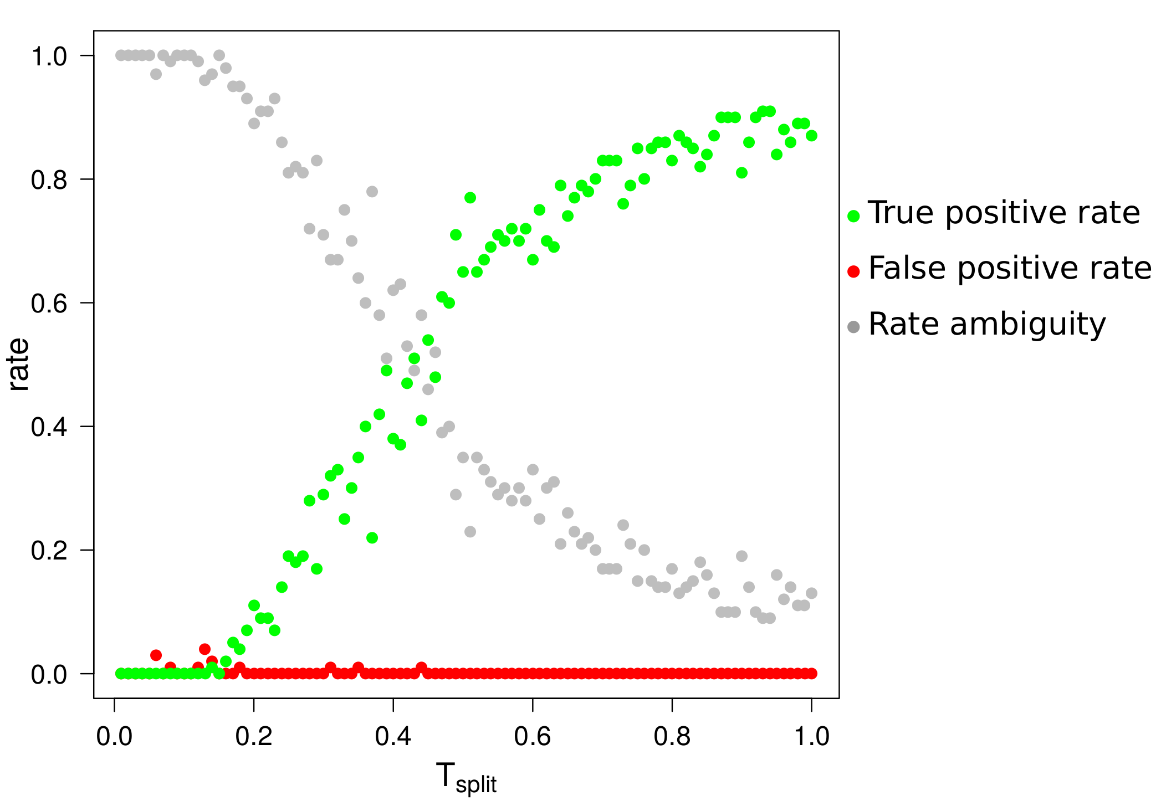Figure 1: accuracy to correctly support SI as a function of the time of split using ABC.
For each of the 100 tested time of split, 100 PODs were simulated under the SI model. θ values for the ancestral and daughter populations are fixed to five. For each time of split, we count the number of PODs correctly supported with a robustness ≥ 0.95 (green dots), the number of PODs wrongly supported with a robustness ≥ 0.95 (red dots) and the number of PODs for which ABC analysis is poorly supported (robustness < 0.95, grey dots).

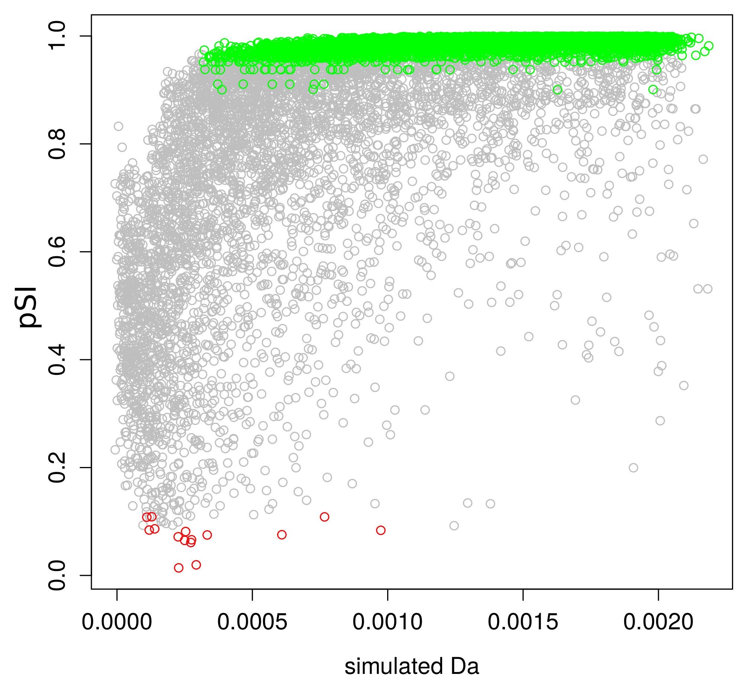Figure 2: relative posterior probability pSI over 10,000 PODs simulated under the SI model as a function of the measured net divergence Da.
Green dots : PODs correctly supported as being SI with robustness ≥ 0.95. Red dots : PODs wrongly supported as being IM with robustness ≥ 0.95. Grey dots : ambiguous ABC inferences with robustness < 0.95.

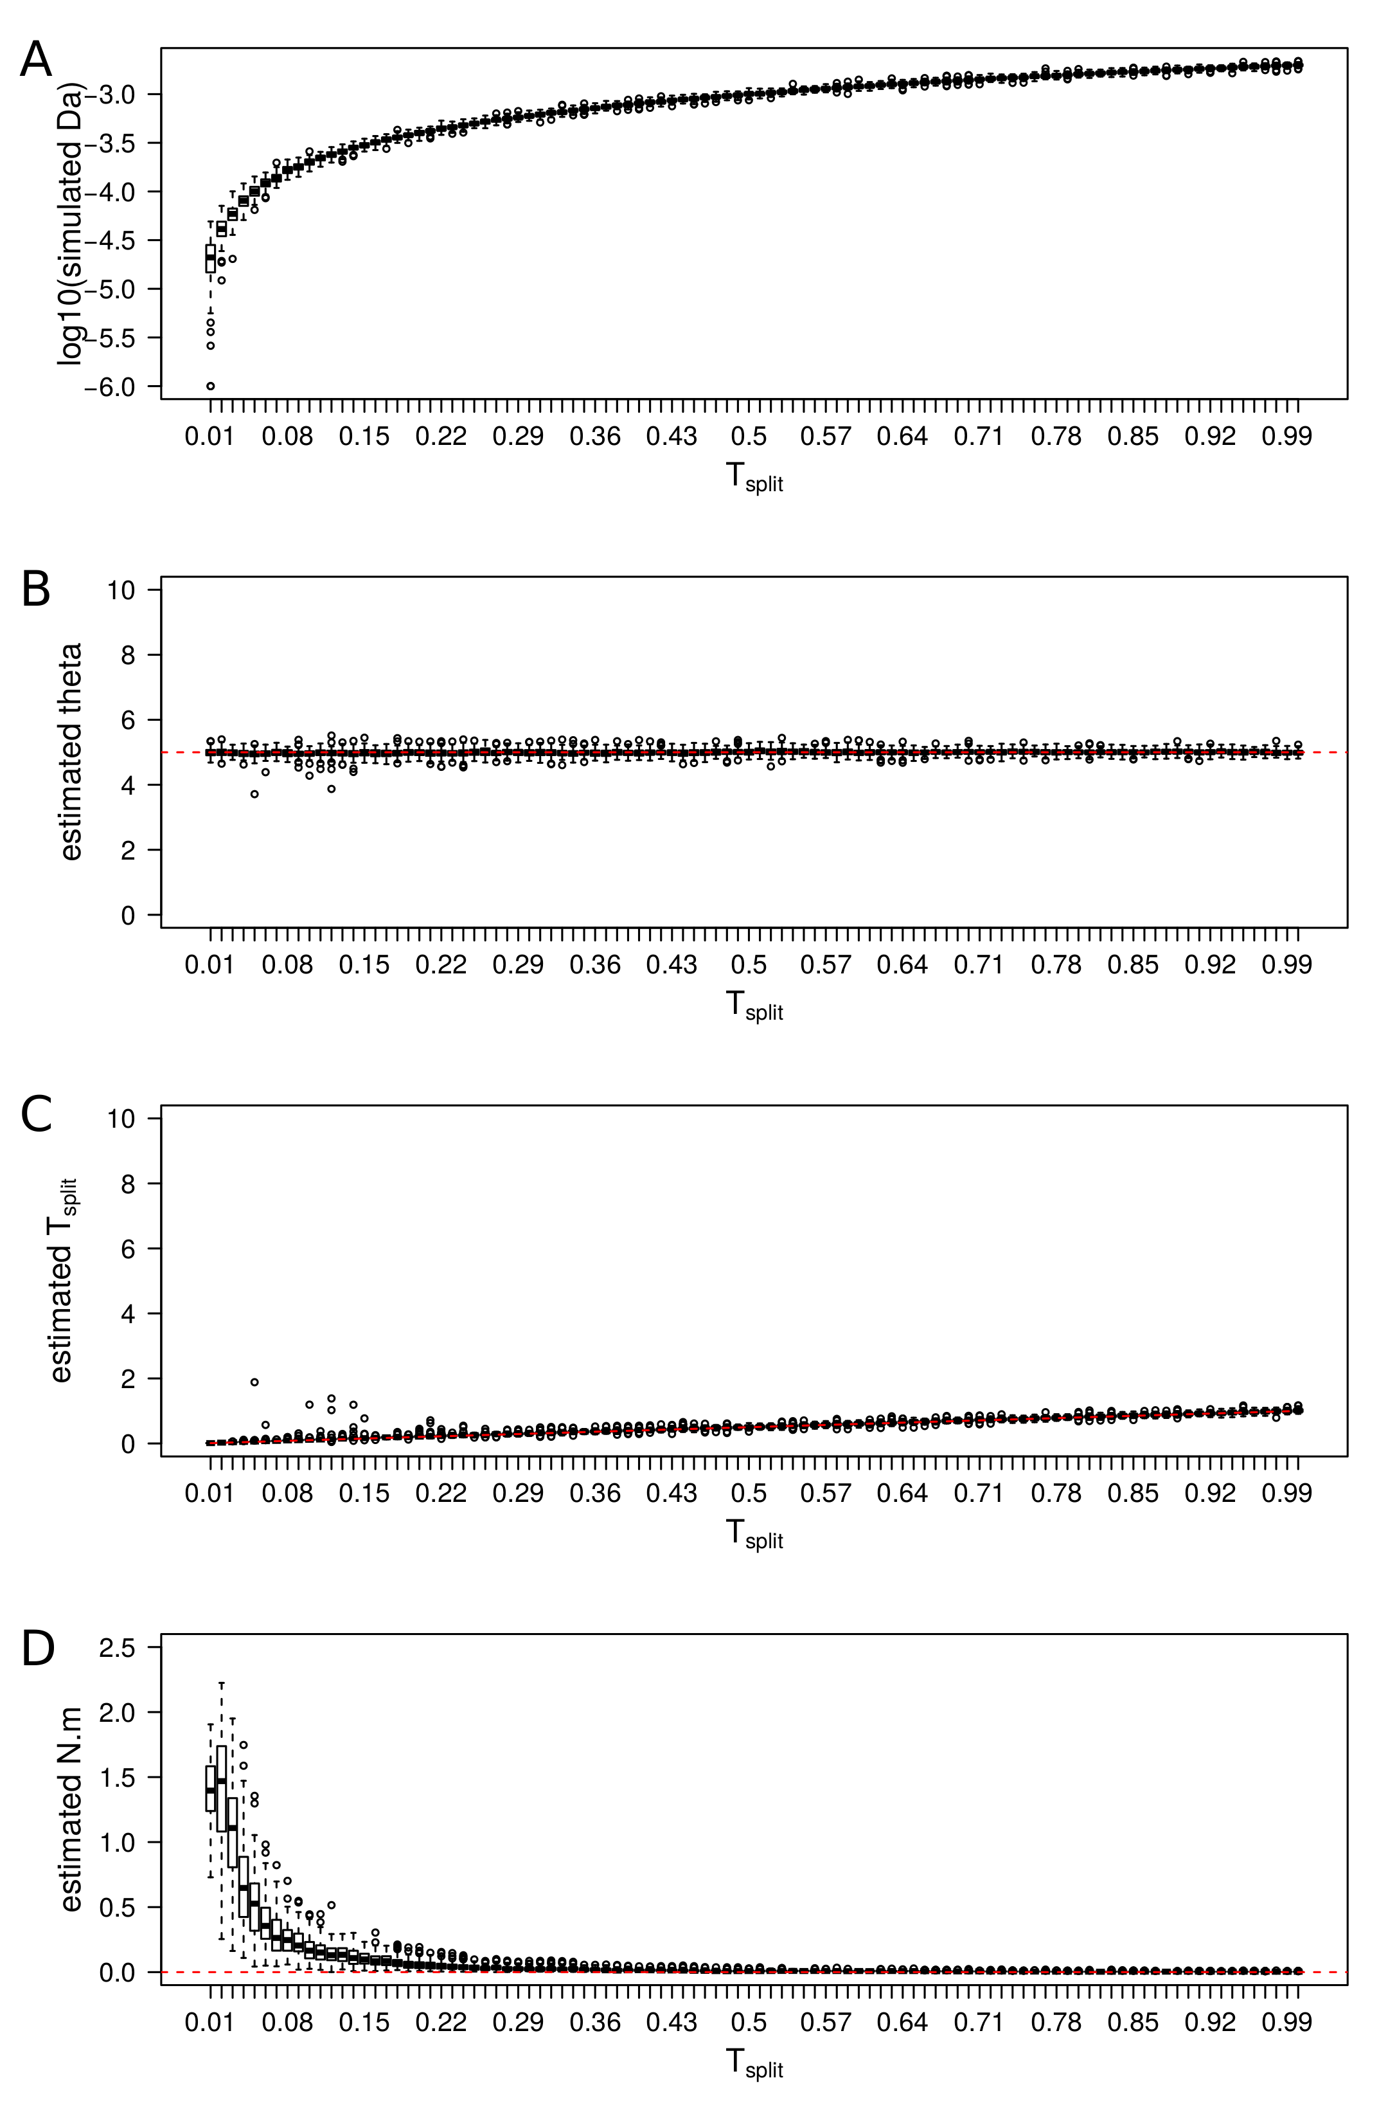Figure 3: estimated parameters of the IM model for PODs simulated under SI .
Each boxplot represents observed values over 100 PODs simulated under the SI model with a fixed T_{split} value. A) Distribution of the average net divergence Da between simulated pairs of gene pools. B) Distribution of estimated θ by taking the median of posterior distributions of parameters. The red line shows the real value. C) Distribution of estimated Tsplit. D) Distribution of estimated migration rates. Y-axis enconcompasses the range of prior distributions.

