**PROJECT-4: COMPUTER NETWORKS**

**DESCRIPTION:** We wish to use a proxy server to access the url: <http://engineering.case.edu/eecs> and we have successfully completed using the python code. The step by step process to run the code and get the desired results is mentioned below.

**First**: Unzip the folder.

**Second**: Open a Terminal and run the python file main.py giving the correct path where the file is located.

Once you run the file you can observe-

**Third**: Now run the python file client.py along with the URL, in another terminal.



Once you run the file you can observe-

If you wait for long time to execute the client.py then the timer timeout and you get an error. Hence, you’ll have to execute again.

**Fourth**: Now, we wish to confirm if the content we obtained using the proxy server is the same as the content on the URL. Hence, we can run this command to download the actual content on the URL in ‘actual_content.txt’ using the below command in the terminal.



Once, you run the command, a ‘actual_content.txt’ file downloads in the current working directory.

Now, to check the difference between the two text files, the ‘actual_content.txt’ and ‘proxy_content.txt’. Run the below command-

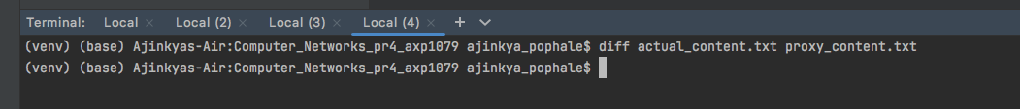

We can observe that there’s no difference between the two files.

**Dependencies and Version:**

