Readme file

**Project 2: Reliable Data Transfer Project Description**

In this project, you will build a simple reliable transport protocol **on top of UDP**. Your RDT implementation must provide in order, reliable delivery of UDP datagrams in the presence of events like packet loss, delay, corruption, duplication, and reordering.

This project is implemented using python in PyCharm IDE.

The project basically contains four .py(python) files namely main.py, utility.py, sender.py and receiver.py

To help run the code with the help of the terminal -

1. Open terminal - Change the working directory as per the folder directory

cd /Users/a_p/Downloads/cn_project_2

1. Once change in directory- check for python version as this project was done on python--version

3. Then run the receiver file on the terminal -

python receiver.py <ip_address> <port> <window size>

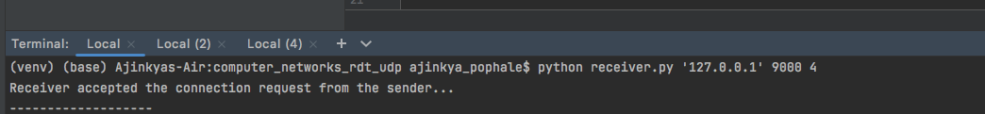

4. Then run the sender file on the terminal -

python sender.py <ip_address> <port> <window size>

5. Now test the difference between the download.txt and the original file

diff download.txt alice.txt

returns <blank>.

It means that there isn’t difference between the two files and the data is transferred successfully with packet loss.

#Requirements

