ECA5403-ELECTROMAGNETIC FILEDS AND WAVES
K.POOJA SREE
192512245
C01-5
EXPERIMENT 5
AIM:
To write program for Electric potential difference between two points in free space medium using MATLAB.
Test case (i) Determination of electric potential difference between two points for a given charge
Program:
clc;
clear;
q=input("Enter the q value:");
epsilon=8.854*10^-12;
k=1/(4*pi*epsilon);
ax=input('Enter the value of ax=');
ay=input('Enter the value of ay=');
r1=sqrt(ax^2+ay^2);
v1=k*q/r1;
disp('The value of v1');
disp(v1);
bx=input ('Enter the value of bx=');
by=input ('Enter the value of by=');
r2=sqrt(bx^2+by^2);
v2=k*q/r2;
disp('The value of v2');
disp(v2);
v=v1-v2;
disp ('The electric potential difference is');
disp (v);
% Plot: potential versus radial distance and potential difference between r1 and r
r = linspace(0.1,10,50);
V = k*q./r; % V = kq/r
figure;
plot(r,V,'LineWidth',2); hold on;
plot(r1,v1,'ro','MarkerFaceColor','r'); grid on;
xlabel('Radial distance r (m)'); ylabel('Potential V (V)');
title('Potential V = kq/r'); legend('V(r)','V1 at r1');
figure;
plot(r,k*q*(1/r1 - 1./r),'LineWidth',2); grid on;
xlabel('Radial distance r (m)'); ylabel('Potential difference V1 - V(r) (V)');
title('Potential difference between r1 and r');
% Independent check: E = -dV/dr (numerical gradient) compared with E = kq/r^2
rc = linspace(1,10,2000);
E_num = -gradient(k*q./rc,rc);
E_th = k*q./rc.^2;
dev = max(abs(E_num(2:end-1) - E_th(2:end-1))./E_th(2:end-1))*100;
fprintf('Maximum deviation between -dV/dr and kq/r^2 = %.4f %%\n', dev);

OUTPUT:
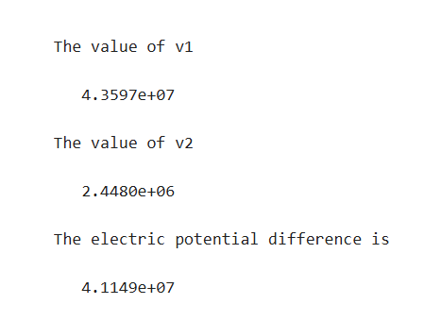
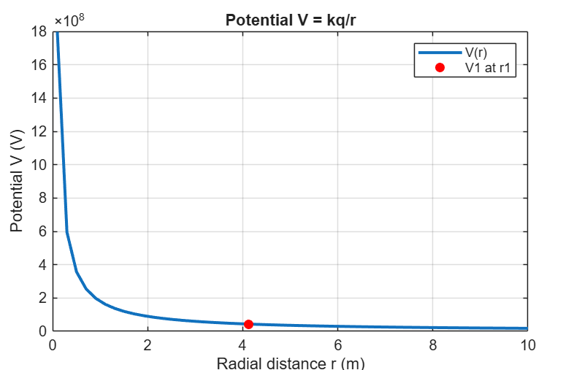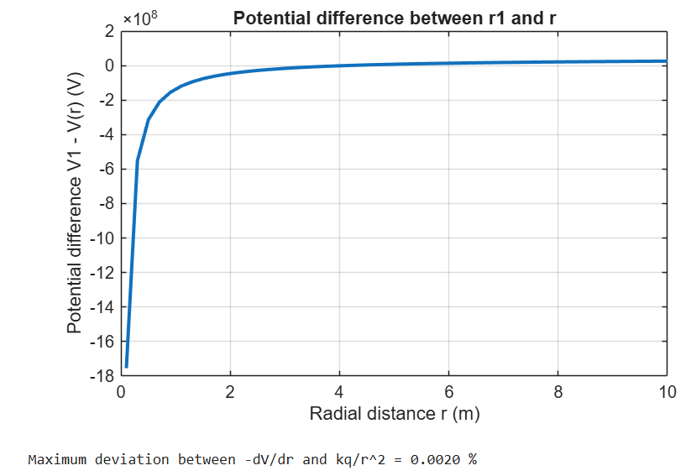
Test case (ii) A positive charge with fixed r₁ = 1 m and r₂ varying.
PROGRAM:
clc;
epsilon=8.854e-12;
k=1/(4*pi*epsilon);
q=1e-6;
r1=1;
r2=linspace(1.1,10,100);
V=k*q*(1/r1 - 1./r2);
plot(r2,V,'LineWidth',2);
xlabel('r2 (m)');
ylabel('Potential Difference (V)');
title('Positive charge, fixed r1');

OUTPUT:
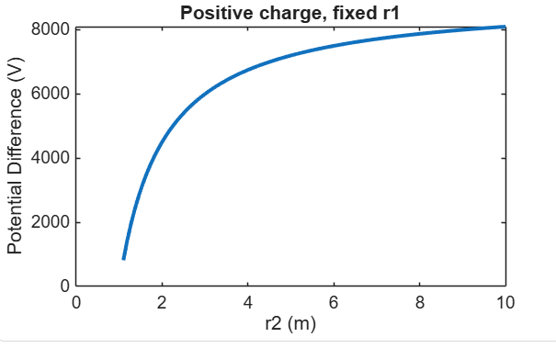
Test case (iii) A negative charge with fixed r₁ and varying r₂:
Program:
clc;
epsilon=8.854e-12;
k=1/(4*pi*epsilon);
q=-1e-6;
r1=1;
r2=linspace(1.1,10,100);
V=k*q*(1/r1 - 1./r2);
plot(r2,V,'LineWidth',2);
xlabel('r2 (m)');
ylabel('Potential Difference (V)');
title('Negative charge, fixed r1');
OUTPUT:
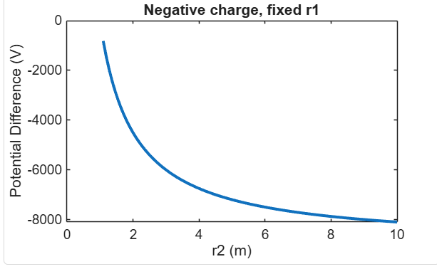
Test case (iv) Both r₁ and r₂ varying with positive charge 3:
Program:
clc;
epsilon=8.854e-12;
k=1/(4*pi*epsilon);
q=1e-6;
r1=linspace(0.5,5,100);
r2=linspace(5,10,100);
V=k*q*(1./r1 - 1./r2);
plot(r1,V,'LineWidth',2);
xlabel('r1 (m)');
ylabel('Potential Difference (V)');
title('Both r1 and r2 varying');
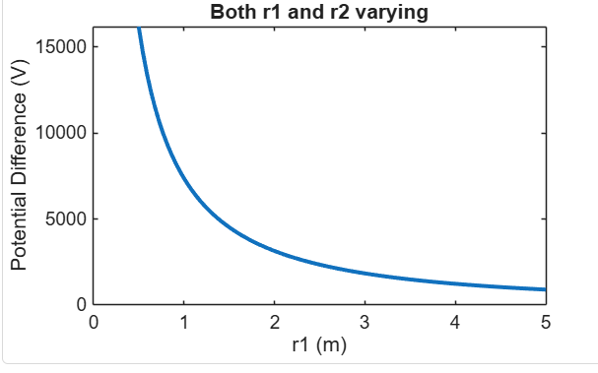

Result :
Thus the program was verified for Electric potential difference between two points in free space medium using MATLAB successfully.

Objective | Assessment Criterion | Excellent – 4 | Good – 3 | Satisfactory – 2 | Needs Improvement – 1 | Weighting | Marks given | Marks obtained
Define charge, reference and observation points | Define charge, reference and observation points | Correctly identifies charge distribution, point locations, distance and reference convention. | Setup is correct with minor clarification needed. | Some input or reference details are unclear. | Uses an incorrect setup or reference. | 25 | 2.5
Calculate potential and potential difference | Calculate potential and potential difference | Calculates potential at both points and signed difference correctly with units. | Results are mostly correct with minor arithmetic errors. | Partial calculations require support. | Potential calculations are incorrect or absent. | 25 | 2.5
Verify potential relationship | Verify potential relationship | Checks results against analytical equations and, where relevant, the relation between E and potential. | Validation is mostly correct with minor omissions. | Validation is incomplete. | No valid theoretical check is provided. | 30 | 3
Interpret and report findings | Interpret and report findings | Explains the sign and physical meaning of potential difference with clear tables/conclusion. | Explanation is correct with minor omissions. | Explanation is limited or unclear. | Cannot explain or document the result. | 20 | 2
TOTAL |  |  |  |  |  | 100 | 10

