ECA5403-ELECTROMAGNETIC FILEDS AND WAVES
K.POOJA SREE
192512245
C01-3
EXPERIMENT 3
AIM:
To determine and plot the Force of attraction between two electric Charges and two parallel conductors separated by varying distance between them using MATLAB.
Test case (i) Determination and plotting of force between two electric charges with varying distance
clc;
clear;
q1 = input('Enter the charge q1=');
q2 = input('Enter the charge q2=');
epsilon = 8.854e-12;
k = 1/(4*pi*epsilon);
r = linspace(0.1,10,100);
F = k*q1*q2./(r.^2);
disp('Force at r = 1 m is:');
disp(k*q1*q2/(1^2));
plot(r,F,'LineWidth',2);
xlabel('Distance (m)');
ylabel('Force (N)');
title('Force between two electric charges');
OUTPUT:
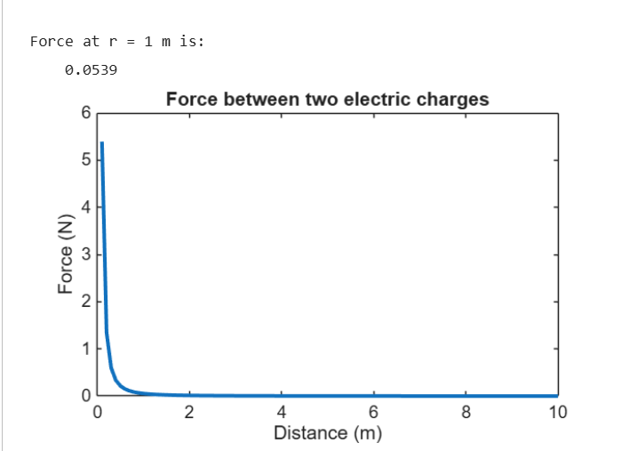
Test case (ii) Determination and plotting of force between two electric charges with different
magnitudes
Code:
clc;
q1 = 5e-6;
q2 = 2e-6;
epsilon = 8.854e-12;
k = 1/(4*pi*epsilon);
r = linspace(0.5,5,100);
F = k*q1*q2./(r.^2);
plot(r,F,'LineWidth',2);
xlabel('Distance (m)');
ylabel('Force (N)');
title('Force between two charges (different magnitudes)');
Output:
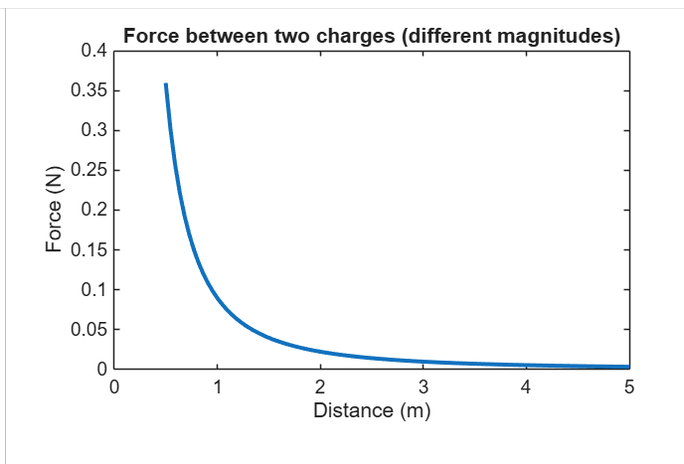

Test case (iii) Determination and plotting of force per unit length between two parallel conductors with varying distance
Code:
clc;
mu0 = 4*pi*1e-7;
I1 = 5;
I2 = 10;
d = linspace(0.1,10,100);
F = (mu0*I1*I2)./(2*pi*d);
plot(d,F,'LineWidth',2);

xlabel('Distance (m)');
ylabel('Force per unit length (N/m)');
title('Force between two parallel conductors');

OUTPUT:
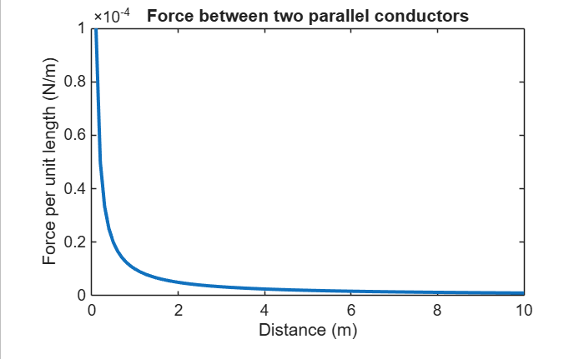

Test case (iv) Determination and plotting of force between two parallel conductors carrying equal currents
Code:
clc;
mu0 = 4*pi*1e-7;
I1 = 3;
I2 = 3;
d = linspace(0.1,2,100);
F = (mu0*I1*I2)./(2*pi*d);
plot(d,F,'LineWidth',2);
xlabel('Distance (m)');
ylabel('Force per unit length (N/m)');
title('Force between conductors (equal currents)');

OUTPUT:
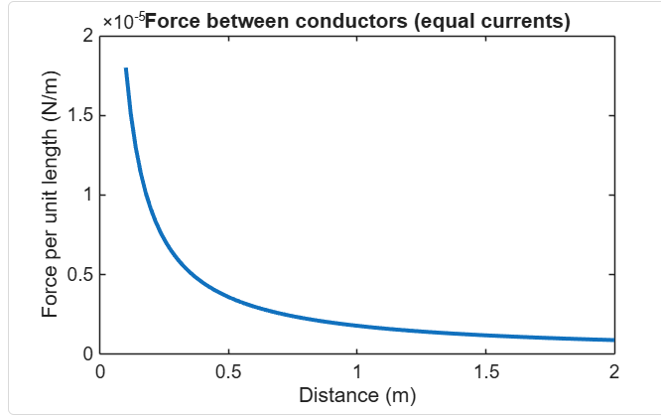

RESULT:

Thus the plot and determination of the Force of attraction between two electric Charges and two parallel conductors separated by varying distance between them using MATLAB.

Objective | Assessment Criterion | Excellent – 4 | Good – 3 | Satisfactory – 2 | Needs Improvement – 1 | Weightage | Marks given | Marks  Obtained
Identify physical quantities and force models | Identify physical quantities and force models | Correctly identifies charge/current, separation, medium and force direction for both cases. | Identifies most quantities and models correctly. | Needs guidance in selecting the correct relation or direction. | Uses incorrect force models or quantities. | 25 | 2.5
Calculate electric and magnetic forces | Calculate electric and magnetic forces | Implements Coulomb-force and parallel-current force calculations correctly with units. | Calculations are mostly correct with minor errors. | Some calculations are correct but require assistance. | Force calculations are invalid or absent. | 25 | 2.5
Evaluate force versus separation | Evaluate force versus separation | Correctly varies separation, plots trends and checks theoretical distance dependence. | Trend and plots are correct with minor omissions. | Limited sweep or incomplete trend interpretation. | Does not establish a valid relationship. | 30 | 3
Explain and report results | Explain and report results | Explains attraction/repulsion and reports assumptions, units and conclusions clearly. | Conclusion is correct with minor documentation gaps. | Conclusion is incomplete or partly inaccurate. | Conclusion is missing or incorrect. | 20 | 2
TOTAL |  |  |  |  |  | 100 | 10

