ECA5403-ELECTROMAGNETIC FILEDS AND WAVES
K.POOJA SREE
192512245
C01-4
EXPERIMENT 4
Aim:
To write program for continuous Charge Distribution in electric field. The different types of charge density are (a) Linear Charge Density, (b) Surface Charge Density, (c) Volume Charge Density using MATLAB.
Test case (i) Determination of line, surface and volume charge density for given charge, length and radius
PROGRAM:
clc;
clear;
q=input("Enter the charge value is:");
l=input("Enter the length value is:");
% Line charge density
rho_l = q/l;
disp('the line charge density is');
disp(rho_l);
% Surface charge density
r=input("Enter the radius value is:");
rho_s = q/(4*pi*r^2);
disp('the surface charge density is');
disp(rho_s);
% Volume charge density
rho_v = q/((4/3)*pi*r^3);
disp('the volume charge density is');
disp(rho_v);
% Plot
x = linspace(0.1,10,50);
y = rho_l./x;
z = rho_s./(x.^2);
v = rho_v./(x.^3);
figure;
subplot(1,3,1);
plot(x,y,'LineWidth',2);
title('Line charge density');
xlabel('Length');
subplot(1,3,2);
plot(x,z,'LineWidth',2);
title('Surface charge density');
xlabel('Radius');
subplot(1,3,3);
plot(x,v,'LineWidth',2);
title('Volume charge density');
xlabel('Radius');

OUTPUT:
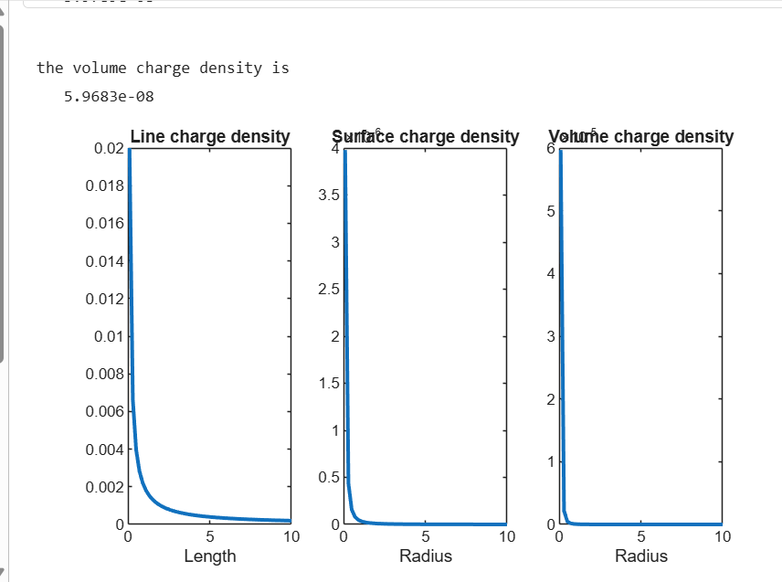
Test case (ii) A long wire of length L = 10 m carries a uniform charge of Q = 50 μC. Calculate the line charge density and plot electric field variation
Program:
clc;
L = 10;
Q = 50e-6;
lambda = Q/L;
disp("Line charge density:");
disp(lambda);
r = linspace(0.1,5,100);
k = 9e9;
E = k*lambda./r;
plot(r,E,'LineWidth',2);
xlabel('Distance (m)');
ylabel('Electric Field (N/C)');
title('Electric Field due to Line Charge');
OUPUT:
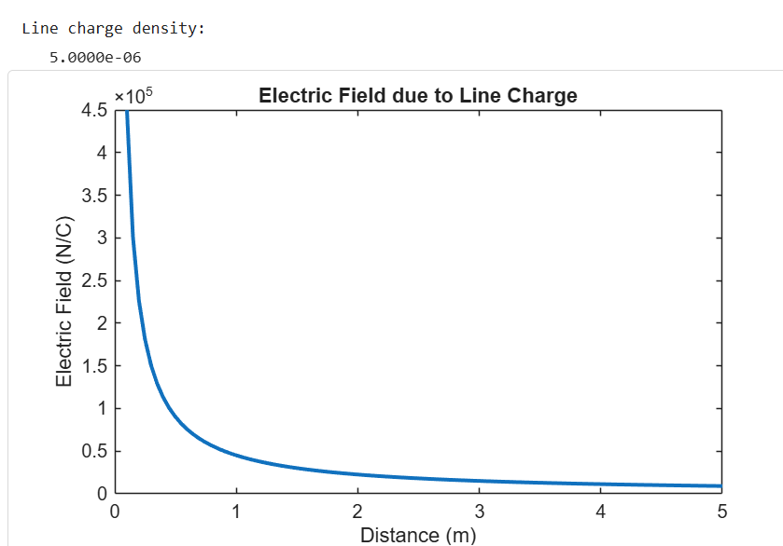

Test case (iii) A uniformly charged disk of radius R = 0.5 m with total charge Q = 10 μC. Calculate surface charge density and electric field
Program:
clc;
R = 0.5;
Q = 10e-6;
A = pi*R^2;
sigma = Q/A;
disp("Surface charge density:");
disp(sigma);
z = linspace(0.1,2,100);
k = 9e9;
E = (k*sigma*R^2)./(2*(z.^2 + R^2).^(3/2));
plot(z,E,'LineWidth',2);
xlabel('Distance (m)');
ylabel('Electric Field (N/C)');
title('Electric Field due to Charged Disk');
OUTPUT:
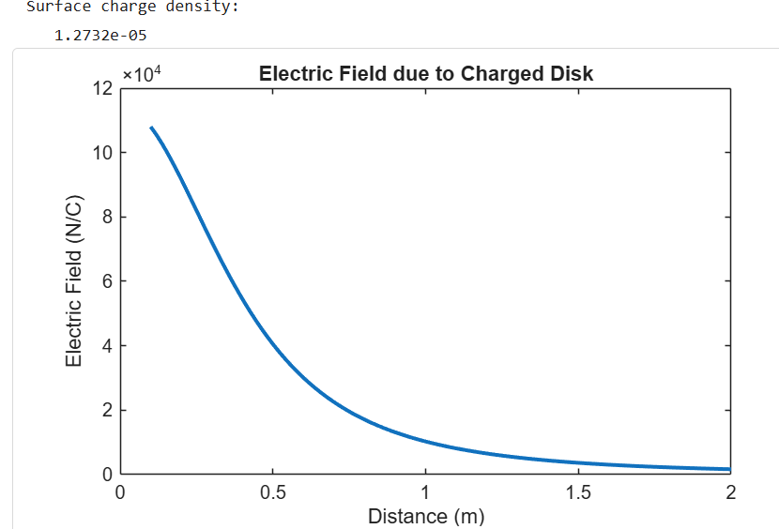
Test case (iv) A uniformly charged sphere of radius R = 2 m with total charge Q = 20 μC. Calculate volume charge density and electric field inside and outside 3
Program:
clc;
R = 2;
Q = 20e-6;
V = (4/3)*pi*R^3;
rho = Q/V;
disp("Volume charge density:");
disp(rho);
r = linspace(0.1,3,100);
epsilon0 = 8.854e-12;
k = 1/(4*pi*epsilon0);
E_inside = (rho.*r)/(3*epsilon0);
E_outside = k*Q./(r.^2);
plot(r,E_inside,'LineWidth',2); hold on;
plot(r,E_outside,'LineWidth',2);
xlabel('Distance (m)');
ylabel('Electric Field (N/C)');
title('Electric Field inside and outside sphere');
legend('Inside','Outside');
OUTPUT:
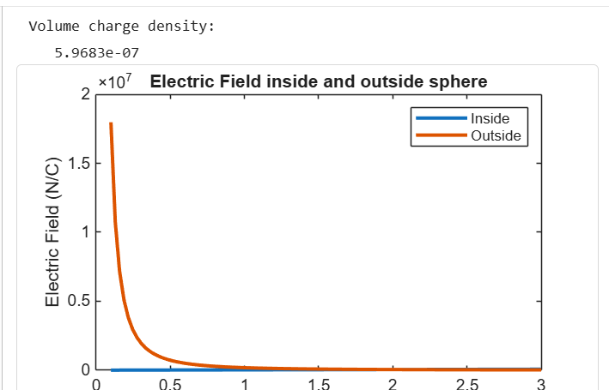

RESULTS:
The different types of charge density are (a) Linear Charge Density, (b) Surface Charge Density, (c) Volume Charge Density has been done using MATLAB.

Objective | Assessment Criterion | Excellent – 4 | Good – 3 | Satisfactory – 2 | Needs Improvement – 1 | Weightage | Marks given | Marks  Obtai-  ned
Identify physical quantities and force models | Identify physical quantities and force models | Correctly identifies charge/current, separation, medium and force direction for both cases. | Identifies most quantities and models correctly. | Needs guidance in selecting the correct relation or direction. | Uses incorrect force models or quantities. | 25 | 2.5
Calculate electric and magnetic forces | Calculate electric and magnetic forces | Implements Coulomb-force and parallel-current force calculations correctly with units. | Calculations are mostly correct with minor errors. | Some calculations are correct but require assistance. | Force calculations are invalid or absent. | 25 | 2.5
Evaluate force versus separation | Evaluate force versus separation | Correctly varies separation, plots trends and checks theoretical distance dependence. | Trend and plots are correct with minor omission2s. | Limited sweep or incomplete trend interpretation. | Does not establish a valid relationship. | 30 | 3
Explain and report results | Explain and report results | Explains attraction/repulsion and reports assumptions, units and conclusions clearly. | Conclusion is correct with minor documentation gaps. | Conclusion is incomplete or partly inaccurate. | Conclusion is missing or incorrect. | 20 | 2
Total |  |  |  |  |  | 100 | 10

