**PART II**

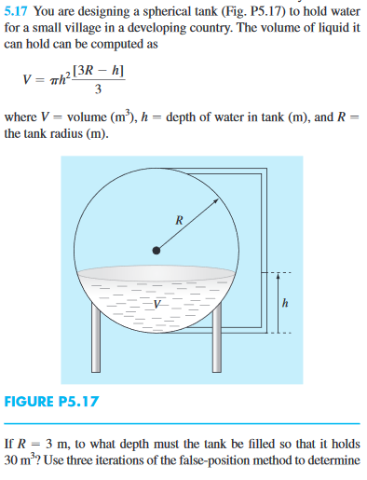

The problem needs to find the depth of the water(h) in the tank that hold the water to $30 m^{3}$. First, we need to find the function of this equation which is

$$f(x) = πh^{2}\frac{[3R - h]}{3} - V$$

Then we need to find the root of the function by using either Bisection Method or Newton-Raphson Method.

For **Bisection Method** we need to choose 2 initial guesses $x_{l}$ and ${ x}_{u}$ where ${f(x}_{l}){f(x}_{u}) < 0$ or by using Graphical method and mark where the root is in the interval.

According to the graph, there are 3 roots which is around x = [-2, -1],

x = [2, 3] and x = [8, 9]. Then calculate halfway points $x_{0}$, check which one of ${f(x}_{l}){f(x}_{0}) < 0$ or ${f(x}_{u}){f(x}_{0}) < 0.$ Repeat this process by using while loop until the stopping criterion is met which in this case is approximate error of 0.001%.

For **Newton-Raphson Method** we need to choose only 1 initial guess, $x_{i}$. We also need to differentiate the function which we can do that in MATLAB using Symbolic tools box.

|  |
| --- |
| syms x;  V = 30; R = 3;  f = @(x) (pi .* (x .^ (2)) .* (3 .* R - x) ./ 3) - V;  fd = eval(['@(h)' vectorize(char(diff(f(h))))]); |

Then we can apply these variable into the formula $x_{i+1} = x_{i} - \frac{f(x_{i})}{f'(x_{i})}$. According to the graph, there are 3 roots which is around x = -2, x = 2 and x = 8. Calculate successive x values using the formula. Repeat this process by using while loop until the stopping criterion is met which in this case is approximate error of 0.001%.

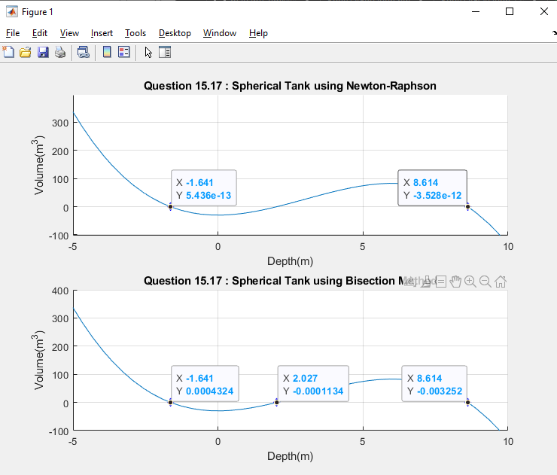

**Newton-Raphson Method**

$The answer ≈ -1.641 or 8.614$ but skipping the middle root. That means there is an error where the method skipped the root point because there are multiples root points close to each other.

Number of iterations of this method are 10, 8 and 11 where the first and last are the same result.

**Bisection Method**

$The answer ≈ -1.641 or 2.027 or 8.614$. This method works but the iteration number are higher which are 15, 15 and 13. Which are higher comparing to Newton-Raphson Method.

The answer of this solution should be in a range of 0 to 6, because the radius of the tank is 3 meters which the diameter or the highest depth possible is only up to 6 meters. Then $The water ≈ 2.027 meters depth$