**Question 2:**

**Bisection Method**

Bisection method is one of the bracketed methods that is used for root finding of an any continuous functions. This method needs two guess values $x_{l}$ and ${ x}_{u}$ where $x_{l }≠ { x}_{u}$ and ${f(x}_{l}){f(x}_{u}) < 0.$ This method is done by repeatedly bisecting the interval between $x_{l}$ and ${ x}_{u}$ then select two appropriate points where the sign is changed either from negative to positive or positive to negative. Therefore, the root must be in the between of two points.

This method usually faster than incremental search because instead of keeping increase the x values by the steps size. This method halves the interval where the root is in. This method is also called the interval halving method.

**Implementation**

1. Choose initial points $x_{l}$ and ${ x}_{u}$ then check if ${f(x}_{l}){f(x}_{u}) < 0.$
2. If not must choose other points (These points can be guessed by using incremental search or graphical method).
3. Calculate halfway points $x_{0}$.
4. Check which one of ${f(x}_{l}){f(x}_{0}) < 0$ or ${f(x}_{u}){f(x}_{0}) < 0.$
5. Repeat this process until the stopping criterion is met (relative error, approximate error, etc.).

**Result**

Using the same point $x_{l}$ and ${ x}_{u}$ does not work, because this method is finding the midpoint between 2 initial points. If 2 points are in the same position, this method will not work, this can be fixed by guessing new points. From question one we can see that root is in the interval between $x = 0 and x = 1$. So, let’s change 2 guessing point to $x_{l }= 0 and { x}_{u} = 1$.

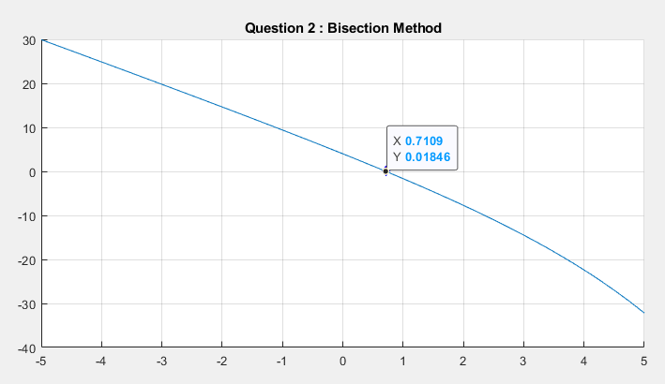

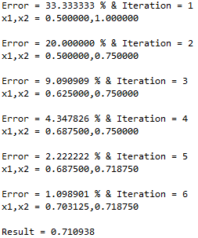

This method can find the root of 2% of approximate error by 6 iterations, but the difference from the result and 0 is quite big. This method might need to repeat many times to get enough accuracy. The result of this method converges to $x ≈ 0.710938$.

**Newton-Raphson method**

The Newton-Raphson Method is one of the most used methods. This method is a way to find a root of a function. This method uses the straight tangent line to approximate the graph by take one initial guess point and draw a tangent line of the function using that point. The point where the tangent line intersect with the x-axis is the new x value.

$$x_{i+1} = x_{i} - \frac{f(x_{i})}{f'(x_{i})}$$

This method usually converges quickly when it works. However, this method could diverge or oscillate.

1. Near a point of inflection can cause divergence.
2. Near a local minimum or maximum can cause oscillations.
3. Root skipping occur especially if roots are close together.
4. A zero derivative causes division by 0 in the formula causes divergence to infinity.

**Implementation**

1. Pick initial value by guessing.
2. Check if derivative of the function is not zero.
3. Calculate successive x values using $x_{i+1} = x_{i} - \frac{f(x_{i})}{f'(x_{i})}$
4. Repeat this process until the stopping criterion is met (relative error, approximate error, etc.).

**Result**

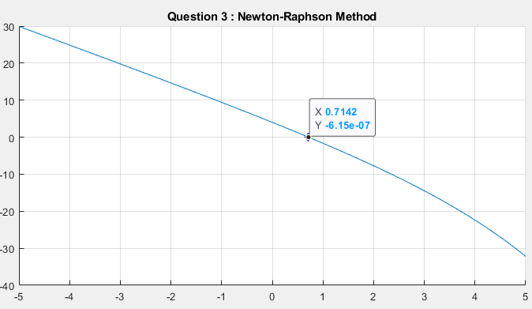

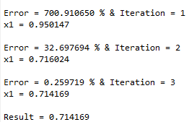

This method can find root faster than the bisection method which need 6 iterations until it reaches under 2% of approximate error while Newton-Raphson method need only 3 iterations and the result of the function using the root point is very close to zero. The result converges to $x ≈ 0.710938$.

**References**

* <http://amsi.org.au/ESA_Senior_Years/SeniorTopic3/3j/3j_2content_1.html>
* Steven C. Chapra-Applied Numerical Methods with MatLab-McGraw-Hill (2017) page 172