**Question 2:**

**Bisection Method**

Bisection Method is one of the most basic bracket root finding method that is based on the Bolzano’s theorem for any continuous function. This method is done by halving the x values which is initial guessed.

This method looks to find the value of x where ${f(x}_{0})=0$. This method is a bracketed method, which will need 2 initial guesses to proceed $x_{l}$ and ${ x}_{u}$. Two initial guesses can be use in this method if only if ${f(x}_{l}){f(x}_{u}) < 0$ which means that the root point is in between $x_{l}$ and ${ x}_{u}$.

**Implementation**

1. Guess two values $x_{l}$ and ${ x}_{u}$ where ${f(x}_{l}){f(x}_{u}) < 0$
2. Calculate midway points $x_{0}$.
3. Check which one of ${f(x}_{l}){f(x}_{0}) < 0$ or ${f(x}_{u}){f(x}_{0}) < 0$
   1. If ${f(x}_{l}){f(x}_{0}) < 0$ then replace $x_{u}$ with $x_{0}$.
   2. If ${f(x}_{u}){f(x}_{0}) < 0$ then replace $x_{l}$ with $x_{0}$.
4. Go back to step 2 and repeat until we reach satisfied error or found a root.

**Result**

Choosing $x_{l }= 0 and { x}_{u} = 0$ will not work. This method is required to use 2 different points to find a root between interval, If $x_{l}$ and ${ x}_{u}$ are the same point then this method could not find the midway point.

It is needed to choose other initial points, using graphical method the root point is in the interval between $x = -1 and x = 1$. Choosing new points will work.

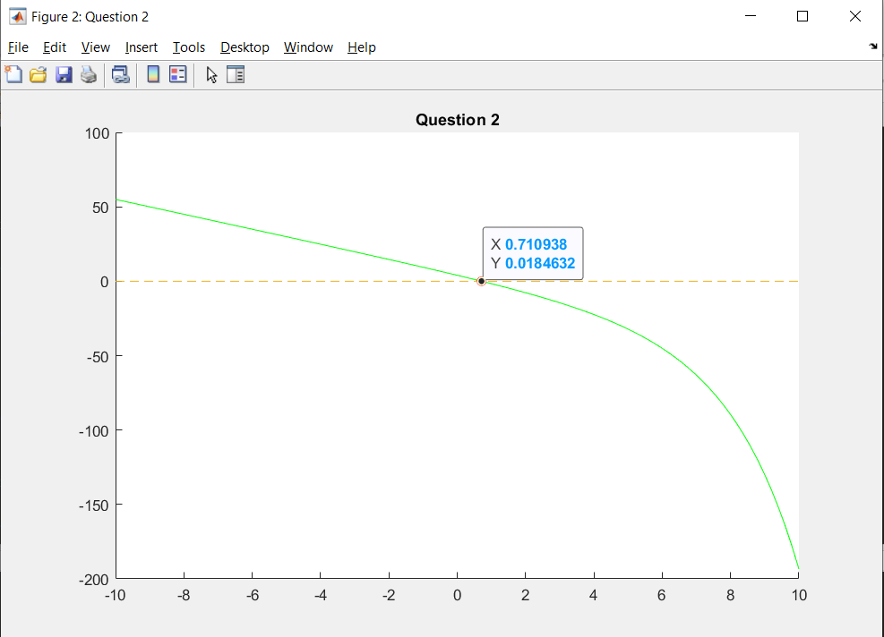

Choosing 2% of approximate error for this method is not enough to get close to ${f(x}_{0})=0$ because the more iteration the slower this method to find a root will be. To use this method efficiently we need to choose a small interval where the root is in between them.

The result x value using this method where approximate error is less than 2% ≈ **0.710938**

**Newton-Raphson method**

Newton-Raphson Method is open method where there is no limited interval. Unlike bracket method where you need to guess two points and find the root in the interval, this method only needs one initial guess. This method usually converges quickly but may not find a root of the function. This method uses a straight tangent line of a function to find the intersection with x-axis to get a new x value. This method may diverge or oscillate. Sometime this error can be fixed by choosing other point. This method follows the formula:

$$x_{n+1} = x_{n} - \frac{f(x_{n})}{f'(x_{n})}$$

**Implementation**

1. Pick initial value by guessing or using graphical method. Choose the value which is closed to the root.
2. Check if $f^{'}\left(x_{n}\right)≠0$. If $f^{'}\left(x_{n}\right)=0$, choose other point.
3. Calculate new x value using the formula ${ x}_{i+1} = x_{i} - \frac{f(x_{i})}{f'(x_{i})}$
4. Go back to step 2 and repeat until we reach satisfied error or found a root.

**Result**

This method can converge to the root fast comparing to bisection method. The result by using this method when the criteria is less than 2% is almost reach $f\left(x\right)=0$.

The x value using this method where approximate error is less than 2% ≈ **0.714169**

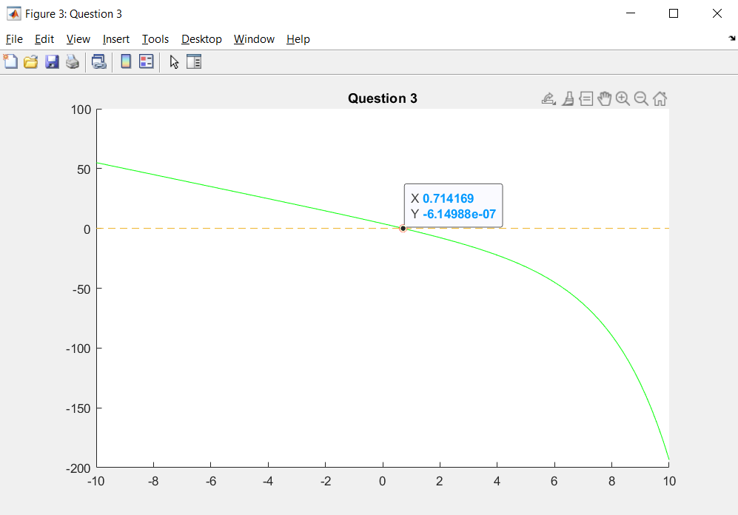

**References**

* <https://x-engineer.org/undergraduate-engineering/advanced-mathematics/numerical-methods/the-bisection-method-for-root-finding/>
* http://spiff.rit.edu/classes/phys317/lectures/open_root/open_root.html