**Question 2:**

**Bisection Method**

Bisection Method is a root finding method that based on the fact that a root of equation is the point where the line of a function intersects with the x-axis. This method will search for the root, which is located between two values of x, but this method will work only if two values of y from x have different signs.

This method will find the middle point of the interval between two x, then it will choose which points should it use to make a new interval for finding another middle point again. This progress will keep continue until it reaches enough accuracy or found a root.

**Implementation**

1. Choose two points to create the interval [$x_{a}, x_{b}$]
2. Check ${f(x}_{a})$ and $f(x_{b})$ have different sign.
3. Calculate midway points $x_{c}$.
4. Check where is the root in the interval
   * If ${f(x}_{a}){f(x}_{c}) < 0$ then the root is between $x_{a}$ and $x_{c}$.
   * If ${f(x}_{b}){f(x}_{c}) < 0$ then the root is between $x_{b}$ and $x_{c}$.
5. Repeat the process until find the root or enough accuracy.

**Result**

This method must choose an appropriate interval and $x_{a }, { x}_{b}$ are the same point thus the interval cannot be created. In order to solve the problem using bisection method we need to choose another interval. By looking at the graph we can guess that the root is exist in between x = 0.5 and x = 1.

The root of the function using bisection method where approximate error must fall under 2% is **0.7109.**

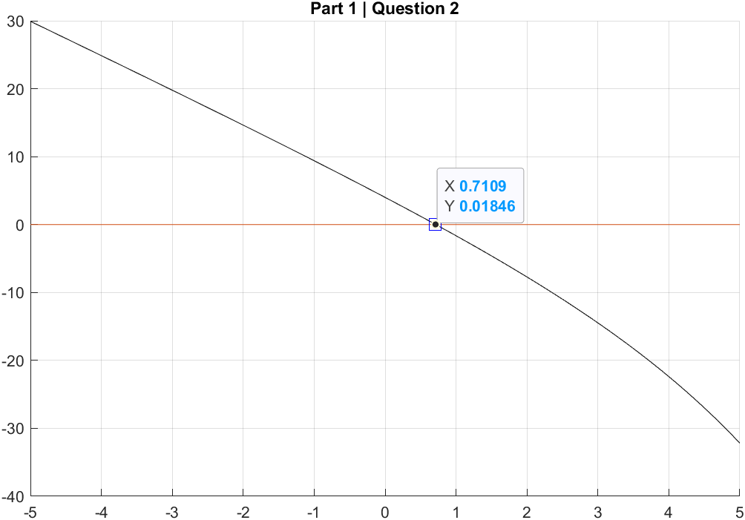

**Question 3:**

**Newton-Raphson method**

Newton-Raphson method unlike bisection method where bisection method needs two points to create interval where the root is in that interval, but Newton-Raphson method will use only one guess point of x where that point is close to the root.

This method will create a tangent line at point x which we choose at the first time. Then get new x value where that tangent line we just created crossed to the x-axis of the graph. Using new x value to create another tangent line to find a new x and the process will repeat until we find the root. Newton-Raphson method formula is

$$x_{n+1} = x_{n} - \frac{f(x_{n})}{f'(x_{n})}$$

**Implementation**

1. Find the derivative of the function
2. Use the formula to create new x
3. Repeat the process until find the root or enough accuracy.

**Result**

This have higher accuracy than the bisection method, with approximate error at least 2% of Newton-Raphson method it can get very close to the root point.

The root of the function using bisection method where approximate error must fall under 2% is **0.7142.**

