**Question 2:**

**Bisection Method**

Bisection Method is one of the simplest root finding method which using the bracket or the limited boundaries to find a root of the function within the boundaries. The more iteration number it repeats the slower it will converge to the point x where $f(x) = 0$.

This method will work only if the root is existing in the interval. This can be checked by check by $f(x_{1})×f(x_{2}) < 0$. This means the y values of the boundaries has different sign, thus there is a point where $f(x) = 0$.

This method will halve the interval and choose the new interval where the root is existing. The interval range will converge slowly compare to other open methods.

**Implementation**

1. Create an interval [$x_{a}, x_{b}$] where $x_{0} > x_{1} and x_{0} < x_{2}$ and $f(x) = 0$.
2. Calculate the half of the interval.
3. Choose the appropriate interval where $x_{0}>x_{1} and x_{0}<x_{2}$ and $f(x) = 0$.
4. Go back to step two and repeat until the criteria is met or found a root point.

**Result**

If $f(x_{1})=f(x_{2})$ then $f(x_{1})×f(x_{2})$ will be zero or positive value. This is not met the basic requirement of the method. Then the root points this method return will be the $x_{1}$.

To find the root of the equation we need to choose new interval, in this case let us choose the interval between 0 and 5.

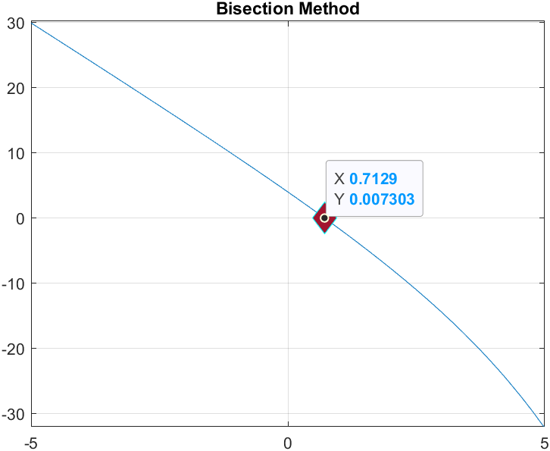

The root of the function using bisection method where approximate error must fall under 2% is **0.7129.**

**Question 3:**

**Newton-Raphson method**

Newton-Raphson method is an open method unlike a close method like bisection method. This method need only one initial guess point x where the point is close to the root.

This method will take the initial point and create the tangent line out of that point. The tangent line will be used to choose a new point x. The way this method chooses the point is the point where the tangent line is crossed with the x-axis. Newton-Raphson method’s formula can be written as

$$x_{n+1} = x_{n} - \frac{f(x_{n})}{f'(x_{n})}$$

This method will not work all the time. Sometimes this method will diverge or when the differentiated value is zero this will occur error in the code. Changing the initial point may fix the problem.

**Implementation**

1. Find the derivative of the function.
2. Substitute the values into the formula to find the new x value.
3. Go back to step two and repeat until the criteria is met or found a root point.

**Result**

This method will converge faster than the bisection method, that is why even though we choose the approximate error for 2%, the point that is returned by this method is almost reach 0. Comparing to bisection method, this method converges to the result very fast.

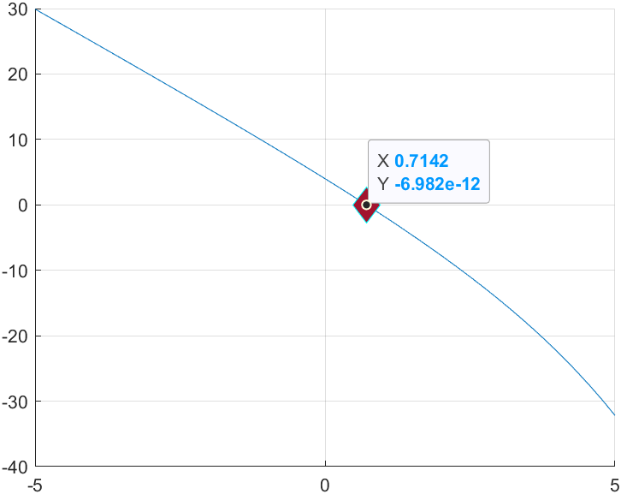

The root of the function using bisection method where approximate error must fall under 2% is **0.7142.**