**PART II**

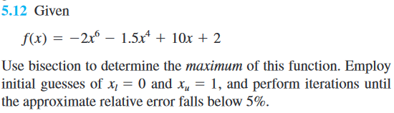

The problem wants to find the maximum of the function by using bisection method. By finding maximum or the minimum of the function that means there is a point where the derivative of the function is equal to zero.

To find the maximum we need to find the root of the $f'(x)$ where

$$f'(x) = -12x^{5} - 6x^{3} +10$$

We got two values of x to create an interval with 5% of approximate relative error. So, we can implement the bisection method easily.

1. Calculate midway point by $x_{c} =\frac{0 + 1}{2}$.
2. Check which interval we should use next.
3. Use while loop to repeat the method until we reach minimum 5% of approximate error.

The root we get from the bisection method of the derivative function is equal to **0.7188.**

Then we use the root we got from the derivative of the function to plot the point on the original function, we will get the maximum value of the function.

