**PART II**

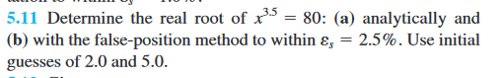

The problem wants to find the root of the equation $x^{3.5}=80$ This can be done by MATLAB by creating a function of the equation.

$$f\left(x\right)=80-x^{3.5}$$

Then we use either Bisection Method or Newton-Raphson Method. In this case we will use Bisection Method.

Bisection Method is required two initial points $x_{l}$ and ${ x}_{u}$. But from the question there are two points given which are 2.0 and 5.0. We can use these points to create an interval and find root of the function in this interval.

We can implement this method by

1. Calculate midway point by using the formula $x_{0} =\frac{x_{l} {+ x}_{u}}{2}$.
2. Check which one of ${f(x}_{l}){f(x}_{0}) < 0$ or ${f(x}_{u}){f(x}_{0}) < 0$
   1. If ${f(x}_{l}){f(x}_{0}) < 0$ then replace $x_{u}$ with $x_{0}$.
   2. If ${f(x}_{u}){f(x}_{0}) < 0$ then replace $x_{l}$ with $x_{0}$.
3. Then repeat until we reach the error of 2%.

By using this method, the result will converge slowly, 2% of error is not enough to get the root of the function. The root of the function by using this method $≈ 3.45313$

