**Question 2:**

**Bisection Method**

Bisection Method is one of the easiest methods to find the root which is used with a continuous function and we will get the root if the root is the range of our initial guess.

We use our initial guess as the boundary. Then we get the middle point, we use the middle point with the left and right boundary to find which side have root in between (${f(x}_{b}){f(x}_{m}) < 0$). If we know which side the root is located, we can eliminate another side and use the middle point as a new boundary. Then this method will repeat until we find the root or we get a satisfied error.

**Implementation**

1. Define the boundary points (initial guess).
2. Calculate points $x_{m}=\frac{x_{bl}+ x_{br}}{2}$
3. Check if ${f(x}_{bl}){f(x}_{m}) < 0$ or ${f(x}_{br}){f(x}_{m}) < 0$
4. Chose the point $x_{bl}$ or $x_{br}$ that satisfied the step 3.
5. Repeat the process until we find the root or the error is small enough.

The question asks to use the same point to be the boundary. It is not possible to use the same point. If we use the same point, that point must be a root.

The root of the function fell between $x_{bl}=0 and x_{br}=1$. This will be the boundary we will use to find the root, and the approximate result is **0.703125**.

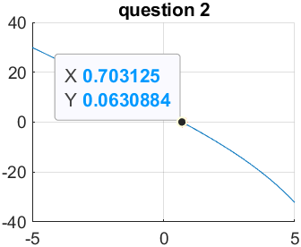

**Newton-Raphson method**

Newton-Raphson Method is an open root finding method, this method is different from the bisection method where there is a boundary, but this method will have no boundary. This method is needed to identify the initial point where the point is close to the root of the function.

This method will converge faster than the bisection method, but this method will fail If derivative of the function is zero. This can be fixed by choosing the initial point.

The formula of Newton Raphson is:

$$x_{n+1} = x_{n} - \frac{f(x_{n})}{f'(x_{n})}$$

**Implementation**

1. Choosing the initial point where the point is close to the root.
2. Use the formula to find where the tangent line intersected with the x-axis. $x_{n+1} = x_{n} - \frac{f(x_{n})}{f'(x_{n})}$
3. Repeat the process until we find the root or the error is small enough.

**Result**

Comparing to the bisection method, the y value from the result of this method is very close to the root. The result of x ≈ **0.714169.**

