**PART II**

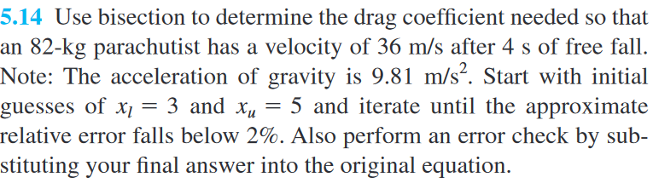

Use the function from the question 5.13 to create the function.

$$y=\frac{gm}{c}\left(1-e^{-\left(\frac{c}{m}\right)t}\right)-v$$

Substitute the value given by the question.

$$f\left(c\right)=\frac{9.81*82}{c}\left(1-e^{-\left(\frac{c}{82}\right)*4}\right)-36$$

The question also gave us the boundary, we can use that boundary for our bisection method.

First, calculate the point $x_{0}$ which Is the middle point of the interval. Then we choose the right interval. Repeat the process until the approximate error fell under 2%.

The result from using bisection method is **c = 3.5625 kg.**

